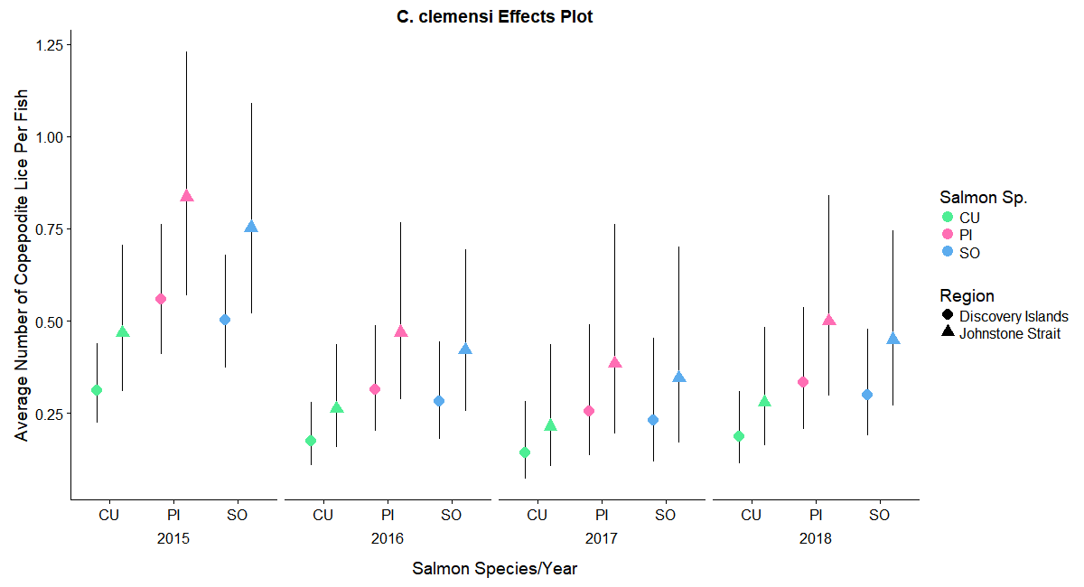

**Figure 1:** The average number of *C. clemensi* lice per salmon (chum, pink or sockeye), year (2015-2018) and geographic region (Discovery Islands or Johnstone Strait). These values were estimated using the additive effects described in Table 1.

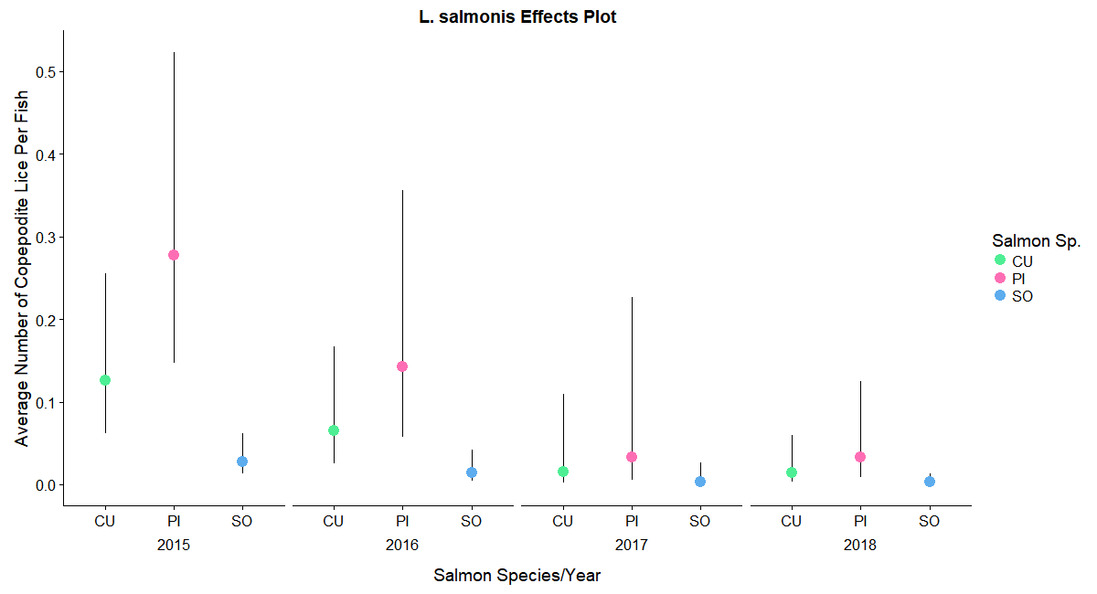

**Figure 2:** The average number of *L. salmonis* lice per salmon (chum, pink or sockeye), in four years (2015-2018). These values were estimated using the additive effects described in Table 2.

**Table 1:** Model output of the top-rated model describing the variance in *C. clemensi* infection on three different species of pacific salmon.

|  |  |  |  |
| --- | --- | --- | --- |
| ***C. clemensi*  Output** | **Coefficient** | **Standard Error** | **Reverse Trans. Est.** |
| **Chum** | -1.161 | 0.173 | 0.313 (0.222, 0.443) |
| **Pink** | -0.581 | 0.158 | 0.559 (0.408, 0.767) |
| **Sockeye** | -0.686 | 0.153 | 0.504 (0.371, 0.684) |
| **2016** | -0.579 | 0.158 | 0.560 (0.409, 0.769) |
| **2017** | -0.778 | 0.285 | 0.459 (0.260, 0.812) |
| **2018** | -0.516 | 0.177 | 0.597 (0.419, 0.850) |
| **Johnstone Strait** | 0.402 | 0.126 | 1.495 (1.162, 1.923) |

**Table 2:** Model output of the top-rated model describing the variance in *L. salmonis* infection on three different species of pacific salmon.

|  |  |  |  |
| --- | --- | --- | --- |
| ***L. salmonis*  Output** | **Coefficient** | **Standard Error** | **Reverse Trans. Est.** |
| **Chum** | -2.074 | 0.362 | 0.126 (0.061, 0.259) |
| **Pink** | -1.283 | 0.324 | 0.277 (0.145, 0.530) |
| **Sockeye** | -3.572 | 0.403 | 0. 028 (0.013, 0.063) |
| **2016** | -0.662 | 0.392 | 0.516 (0.236,1.130) |
| **2017** | -2.108 | 0.900 | 0.121 (0.020, 0.735) |
| **2018** | -2.138 | 0.518 | 0.118 (0.042, 0.332) |