**Introduction:**

Many parasites are known to infect more than one host, with multi-host dynamics often involving a reservoir host that may or may not be pathogenic (Haydon et al. 2002). These reservoir hosts can allow parasites to maintain high levels of abundance as the critical community size, or the minimum number of individuals in a population needed for a pathogen to persist (Bartlett, 1960), will be smaller for the focal host species. By facilitating the maintenance of high parasite abundance and subsequent infection pressure even in the face of a decline in the focal host population, reservoir hosts effectively remove the typical density-dependent transmission dynamics that usually exist between a single host and parasite (Anderson & May 1979), thus allowing said parasites to pose a threat to the long-term viability of the focal host population (Cleaveland et al. 2002). The effects of the parasite on the reservoir host span the range of potential virulence (Brunner et al. 2004), but if the size of the reservoir population is large enough, the parasite will be maintained at high abundance despite high virulence to the reservoir host. Reservoir hosts, which can be both domestic and/or wild populations (e.g. Quinnell & Courtenay 2009), often allow spillback infection, re-infecting the population(s) that originally infected the reservoir (Daszak et al. 2001). Reservoirs thus can facilitate a type of apparent competition when the reservoir is a wild population (Power & Mitchell 2004; Kelly et al. 2009) by negatively affecting the focal host species simply due to the reservoir’s presence and the subsequent increase in abundance of the shared parasites (Holt 1977; Hold & Lawton, 1994).

Spillback from reservoir hosts (and subsequent apparent competition) has been shown in multiple aquatic systems (Arkush et al. 1998; Krkošek 2010; Hartigan et al. 2011; Adhard et al. 2015), and is commonly associated with invasive species (Adhard et al. 2015). However, spillback from domestic populations is shown to be a concern, particularly with economically valuable wild populations wherein a native parasite flourishes in a domestic reservoir population, subsequently increasing the infection pressures on the native hosts.

Parasitism has been known to play a strong role in fish recruitment for decades, with the effects ranging from behavioural to reproductive and others in between (Williams 1964; Barber et al. 2000; Longshaw et al. 2010). Understanding how parasitism affects even one population of fish can be problematic, but understanding the dynamics of a multi-host, multi-parasite system can prove challenging from not only a scientific perspective, but more importantly from a conservation and management perspective. Such is the case on the Pacific coast of British Columbia, Canada, where five species of Pacific salmon, and numerous other commercial fish species are infected by multiple parasites whose infection pressures have been shown to increase with the growth of commercial fish farms in the region (Krkosek et al. 2005; Krkosek et al. 2007).

Pacific salmon make up some of the most important fisheries in Canada, not only with respect to their economic importance but also from a cultural and historical perspective (Cooke et al. 2004. Eliason et al. 2011; FAO 2015). Yet despite the importance placed on them, these fisheries have seen significant declines in recent decades. Indeed, the Fraser River sockeye salmon (*Oncorhynchus nerka*) in particular have seen large population declines, resulting in a federal judicial inquiry by the Canadian government into the causes of this decline (Cohen 2012). The current consensus is that multiple intertwined factors impact the survival and growth of these populations (Peterman et al. 2010). It has been posited that threats specific to these fish during their juvenile life stage might be most important in determining the number of fish that return as adults and are subsequently available to fisheries and natural predators that rely on them (Godwin et al. 2017). Fraser River sockeye salmon in British Columbia begin their lives in freshwater spawning environments, and subsequently migrate out to the marine environment where they traverse up through the Strait of Georgia, the Discovery Island and Johnstone Strait, and then out through Queen Charlotte Sound to the open ocean (Fig. 1). When the juveniles leave their freshwater spawning areas, they encounter a whole host of stressors including a lack of sufficient food, as well as numerous parasites and pathogens (Hunt et al. 2018).

The Hakai Juvenile Salmon Marine Survival Program was set up in 2015 and is centred around the Fraser River sockeye salmon, as well as two other species of pacific salmon, pink (*O. gorbuscha*), and chum salmon (*O. keta*). The goal of the program is to quantitatively answer questions regarding juvenile salmon condition, relevant threats to their survival, and ultimately the mortality rates of juvenile salmon during their migration from natal spawning grounds to the open ocean (Hunt et al. 2018). One of the most important factors affecting juvenile salmon survival, and a focus of this program, is parasitism of these juvenile salmon by two species of sea lice, *Caligus clemensi* a generalist parasite infecting multiple fish species, and *Lepeophtheirus salmonis,* a salmon specialist (Johnson & Albright 1991)*.* These ectoparasitic copepods are native to the region, and feed on the soft tissues and musculature of numerous species of marine fishes (Costello 1993; Krkosek 2009). Unable to survive in freshwater environments (Bricknell et al. 2006), sea lice naturally infect juvenile pink, chum, and sockeye salmon once they move out of their natal freshwater environments. Because the parasites here are marine only, the abundances observed on juveniles are a result of transmission of the parasites by other fish species in the environment, and not a maintenance of the parasite populations on the juvenile salmon themselves as not enough time has elapsed for the population of lice to actually establish on the juveniles.

Sea lice infect juvenile chum, pink, and sockeye from a variety of sources, primarily from farmed Atlantic salmon (*Salmo salar*) with respect to the specialist *L. salmonis* (Morton et al. 2004; Krkosek et al. 2005) but likely less so for the generalist louse, *C. clemensi*. In a form of apparent competition, wild Pacific herring (*Clupea pallasii*) likely play a large role in transmitting *C. clemensi* to juvenile salmon (Groner et al. 2016), and these generalists also host-switch from sympatric subadult coho and chinook salmon (Krkosek 2009). Typically, adult pink, chum, and sockeye reside offshore during spring/early summer as the juvenile salmon migrate northwards up the coast. The juveniles become sympatric with their in-migrating adult conspecifics the northern end of their coastal migration towards the end of summer, when the juveniles are typically 10-100 times larger than when they first emerged into the marine environment, and have developed scales (Krkosek et al. 2007b). At this point in their migration, juveniles are prepared to deal with the increased infection pressure that will come with adult salmon who have been harbouring significant parasite loads out at sea (Nagasawa 2001). However, research has shown that with the addition of fish farms along the western coast of mainland British Columbia and the eastern coast of Vancouver island, this whole dynamic has changed. These farms, which hold large numbers of Atlantic salmon, can act as reservoirs for both species of lice, thereby eliminating the spatio-temporal allopatry between the adult salmon with their high levels of infection, and the vulnerable juvenile salmon. This elimination vastly increases the infection pressure on the juveniles during their northern migration, likely contributing significantly to population decline (Krkosek et al. 2005; Krkosek et al. 2007a; Krkosek et al. 2007b; Costello 2009; Price et al. 2011).

While evidence suggests that population-level declines are directly related to increased infection pressure from these parasites, there are still many unknowns surrounding the host-pathogen dynamics in this system (Hunt et al. 2018). Indeed, there is little known about the patterns of infection across the different species of fish and lice. Questions still remain as to whether or not different species of salmon show higher infection loads of *C. clemensi* vs. *L. salmonis* as well as what environmental and life history traits affect parasite loads in these focal salmon species. While some previous work has suggested that sockeye juveniles are infected primarily by *C. clemensi* (Price et al. 2011; Godwin et al. 2015), estimates for pink and chum salmon do not exist, and information regarding what other factors affect parasite load for these three species is still relatively sparse. The present study attempts to shed some light on the relationships between pink, chum, and sockeye juvenile salmon and their sea lice parasites using data from the Hakai Juvenile Salmon Marine Survival program, collected between 2015 and 2018. Specifically, the goals of this study are to 1) determine the parasite loads of both *C. clemensi* and *L. salmonis* on pink, chum, and sockeye salmon and investigate what factors contribute to the differences in infection across the different salmon species, and 2) explore the spatial differences in infection patterns between the Discovery Islands and Johnstone Strait to lend further insight into which possible infection pathways could be most important to determining lice load for these juvenile salmon.

**Methods:**

*Field Observations*

In order to obtain data on species-specific lice abundances on the three focal species of juvenile salmon, an extensive sampling regime was maintained over the course of 4 years (2015-2018) as part of broader work on juvenile Pacific salmon survival (Hunt et al. 2018). Individuals were sampled during the peak of juvenile salmon outwards migration from May to July, at entry points to the Discovery Islands from the Strait of Georgia, and exit points from Johnstone Strait to Queen Charlotte Sound (Fig. 1). Sites were visited every 4-7 days in 2015/16, and then weekly in 2017/18. Purse seine nets (bunt: 27m x 9m with 13mm mesh; tow: 46m x 9m with 76mm mesh) were deployed from small, 6-8m twin-outboard research vessels to capture samples of heterospecific schools comprised of juvenile pink (*Oncorhynchus gorbuscha)*, chum (*Oncorhynchus keta*)and sockeye (*Oncorhynchus nerka*) salmon. The purse seine netting often also captured some sub-adult coho (*Oncorhynchus kisutch*) and chinook (*Oncorhynchus tshawytscha*) salmon, as well as Pacific herring (*Clupea pallasi*). During sampling, observers on the research vessel would conduct a visual survey transect to assess the surface activity of juvenile salmon. If no surface activity was observed after 20 minutes, the seine net was not deployed at that location.

Once the seine had been deployed, it was used to corral the fish beside the boat, and juveniles were scooped up individually using a 4L plastic jug and transferred to a sampling bag. Some individuals were euthanized using a 250 mg • L-1 concentration of tricaine methanesulfonate, and retained for laboratory analysis, while the other captured fish underwent examination using a hand lens on the boat and then were released. Information regarding fish body size, as well as number, life stage, and species of any sea lice present were recorded, along with relevant environmental data. During field observations *in situ*, two methods were used to identify sea lice. The ‘Motile’ method, comprised of identifying only the motile lice (pre-adult females, females, gravid females, and males for *C. clemensi,* and pre-adult females, females, gravid females, pre-adult males, and males for *L. salmonis*  lice), and the ‘All Stages’ method that also categorized the copepodite- and chalimus-staged lice as *C. clemensi*, *L. salmonis,* or ‘unidentified species’. Fish that were sacrificed for lab analysis were dissected at the Hakai Institute Quadra Island Field Station, where they were also examined for the presence, number, species, and life stage of sea lice, corresponding to either ‘Fine-Scale’ (chalimus- and copepodite-stage lice identified as either *C. clemensi* or *L. salmonis,* as well as the motile lice being identified aspre-adult females, females, gravid females, and males for *C. clemensi* lice, and pre-adult females, females, gravid females, pre-adult males, and males for *L. salmonis*  lice) or ‘Motile’ (identical to fine-scale classification, but with all chalimus/copepodite lice ignored) methods. Fish were also weighed to the nearest 0.1g and it’s fork length and standard length were taken to the nearest mm. This resulted in a dataset of over 1,800 individual fish, collected at eight different sites, across 52 individual collections, with a collection representing a unique sampling site/date combination, where at least five individuals of pink, chum, and sockeye juvenile salmon were sampled. In addition, a less species-balanced dataset was compiled, totalling almost 6,000 observations divided between the two sampling regions, the Discovery Islands, and Johnstone Strait.

*Statistical Analyses*

To investigate potential differences in lice parasitism between the three salmon species, we fit a series of generalized linear mixed-effects models (GLMMs) to our data using the glmmTMB package (Brooks et al. 2017) in R statistical software (R Core Team, 2018), with salmon species, sampling year, and fish fork length as predictive variables, along with collection as a random effect. These models were run separately for *C. clemensi* and *L. salmonis,* so as to more firmly parse out drivers of abundance of the two lice species in our study system. Due to different lice identification regimes used at different points in the study, motile life stages were the only ones easily identifiable by species on each and every fish, and as such, only motile data were retained for the purposes of our analyses. While the initial model set included all three predictor variables, including fork length resulted in a dataset with fewer observations, since fork length measurements were not taken for every fish. As such, this the variable was removed in favour of including a larger number of observations. Therefore, the full model set we used in our analysis incorporated salmon species and sampling year, as fixed effects (Table 1, 2).

The models employed a negative binomial error for the response distribution, as well as a log link function. The GLMMs were fit such that the number of lice per fish was treated as the response variable, and Akaike Information Criterion (AIC) was used to perform model comparison and selection. The results of these models were used to determine the predicted effect of each of the fixed effects variables on the number of lice per fish for each species of louse. This was done by back-transforming the coefficients from the models, and creating a 95% confidence interval using the ‘ggeffects’ package (Lüdecke, 2018), representing the estimated number of lice per fish between the two species.

In addition to our models relating louse infections to the three salmon species, we wanted to determine the effect that sampling region had on infection levels. The two distinct sampling regions (Fig. 1), are traversed successively, moving from south to north by the majority of the juvenile salmon in the region. As such, the Johnstone Strait represents a region wherein fish sampled will have typically had longer exposure to lice from all potential sources. To investigate any relevant differences, we ran a separate set of GLMMs, using the lice species as the response variable, with the site regions and years as fixed effects, and the week of the year (with 1 delineating the first week in January and counting numerically forwards from there) as a random effect. This resulted in two models, one for *L. salmonis* and one for *C. clemensi* for each of the three species of salmon.*.* Akaike Information Criterion (AIC) was again used to perform model comparison and selection.

In addition, we used hierarchical bootstrapping to pair our model-driven estimates with data-based measurements of the data to confirm that our model predictions were appropriate given the data for our region-level models. For each unique salmon species, lice species, year, and site region combination (48 separate combinations, ex. Sockeye salmon, *L. salmonis,* 2015 and Discovery Islands), we bootstrapped the average number of lice per fish in an individual collection 10,000 times. This involved sampling all of the collections that each unique combination occurred in, with replacement, and calculating the mean number of lice per fish for that collection, allowing us to garner a better understanding of the spread of our data.

**Results:**

The average number of lice per individual fish varied from more than 4 lice per fish in some collections, to less than 0.5 in other collections (Fig. 2), with each collection showing at least some lice present, though not each collection showed lice on each species of salmon (Fig. 3). When looking separately at the two louse species, it is clear that not only is *C. clemensi* present at many more collections than *L. salmonis* but also generally present at higher numbers (Fig. 3). Additionally, the highest average numbers of lice per collection for *C. clemensi* were just under three lice per fish, while for *L. salmonis*, the highest average number of lice per fish was just under 2.5 fish. In addition, there were very few *L. salmonis* lice present on sockeye salmon, compared to both pink and chum salmon.

Our species-level results indicated that both *C. clemensi* and *L. salmonis* infections were shown to be predicted most strongly by the full model with the additive combination of both fixed effects (Tables 3 & 4), indicating a clear signal of species-level differences in terms of salmon infection for both species of sea lice. The model results show estimates that *C. clemensi* was present at higher per-fish averages across the whole dataset (Fig. 3), with the highest frequencies being shown on pink and sockeye salmon. *L. salmonis* lice were present at lower numbers on each of the three salmon species, but were highest on pink salmon. These results are contrary to previous field observations which indicated that sockeye salmon exhibit the highest levels of *C. clemensi*, however they do confirm field observations that suggested pink salmon carry the highest levels of *L. salmonis.* Infection of the two lice species are notably more similar in 2015 and 2016 than they are in 2017 and 2018, with the levels of infection for *L. salmonis* being comparatively closer to that of *C. clemensi* during 2015 and 2016 than for the later two year. Sampling year differences are marked between both *C. clemensi* and *L. salmonis*, with estimated per-fish infections being highest in 2015, then seeing a relative decline in 2016/17 for both, with a small up-tick in 2018 for *C. clemensi*.

For the region-level models, AIC scores showed that the full model (both year and site region) provided the best fit for five out of the six models, with the model for *L. salmonis* and sockeye salmon showing a better fit model when only site region was included (Tables 5-10). The results of these models did lend insight into region-level differences, specifically showing that the much more abundant *C. clemensi* was estimated to be present at substantially higher infection rates in the Johnstone Strait than in the Discovery Islands for all three salmon (Table 6, Figs. 5 & 6). The less abundant *L. salmonis* was present at slightly lower levels in Johnstone Strait than in the Discovery Islands for both pink and chum salmon, but was present at marginally higher levels in Johnstone Strait than in the Discovery Islands for sockeye salmon. These region-level estimates confirm the low abundance of *L. salmonis* on sockeye salmon. For *C. clemensi* estimates, it was also apparent that within each salmon species the ratios of lice in the two regions stayed fairly consistent across the four years sampled, despite fluctuations in lice abundances overall, the relative abundances between the two regions stayed more or less consistent throughout the sampling periods.

Bootstrap results showed that our model estimates were well within the 95% confidence limits displayed by our data (Fig. 7). These results confirmed the relatively low abundance estimates of *L. salmonis* in the system, with all median values for *L. salmonis* being equal to zero with only three exceptions. General infection patterns were present for the bootstrapped data as well, with *C. clemensi* showing high prevalence on pink salmon, and intermediate prevalence on the other two species. Generally, these results confirmed the appropriate estimates of our models with respect to the data themselves.

Overall, we show here that in fact species-level differences are present between our three species of salmon with respect to the abundance, and species of lice causing the infections. Site region also appears to play an important role in determining the infection levels for both species of sea lice, indicating that the overall patterns of infection likely fluctuate from year to year, but that some general patterns remain through time.

**Discussion:**

* *C. clemensi* is likely higher for a number of reasons
  + In the absence of very high very high infestations of *L. salmonis* in salmon farms, there are comparatively few alternate hosts for this specialist species other than juvenile salmon. This is likely to result in moderate to low levels of *L. salmonis* in the absence of high densities on farms, as the generalist louse should maintain a relatively constant level of infection through years (albeit with some fluctuation) compared to the specialist. We do in fact see less variation in the yearly and species level differences in *C. clemensi* (Figs. 4 & 6), compared to *L. salmonis* (Figs. 5 & 6).
  + Pacific herring, who often carry very high abundances of *C. clemensi*, could play a larger role than previously thought in determining the lice load of this generalist louse species.
  + The fact that infection levels by *C. clemensi* are so much higher than *L. salmonis* indicates a few things. First, if herring are a primary source of infection to these juvenile salmon, this indicates that baseline infection levels of *C. clemensi* on these juveniles are potentially higher than previously thought. If this is true, when taken with previous work by Krkosek et al. (2005) that shows only a few lice per fish can cause serious consequences, it could be that, particularly for pink and sockeye salmon who face high infection pressures from *C. clemensi* according to our analysis, even relatively small increases in *L. salmonis* transmission from farmed fish could cause population level effects by pushing the number of lice per fish past a ‘threshold’ beyond which the infections lead to severe loss of fitness and increased mortality
* It’s important to note that this is a major out-migration by multiple species in the same location at the same time, so these species-level results are revealing that these lice are showing a host preference or specificity, or perhaps the three hosts in our data differ in terms of their susceptibility in some way
  + Particularly with respect to the huge differences in infection levels between pink and chum salmon, who both enter marine environments at similarly early development (Groot & Margolis 1991). However, although fork length did not improve the fit of any of our models, it is possible that the smaller size of pink salmon relative to chum salmon upon entering marine environments could play a role in determining their susceptibility to lice infections.
* There’s also clearly a temporal aspect to these results, indicating that various important factors could be affecting lice abundance in a given year
  + Treatment of fish in salmon farms
  + Environmental conditions
* There seems to be a coupling between the ratio of lice abundance between years – this could indicate that whatever conditions result in high levels of infection on juvenile salmon affect both species of lice relatively equally such that high infection years are combined in a way and thus present an even greater challenge to the salmon
* Perhaps the most noticeable species-level result is that pink salmon take the brunt of infection from both *C. clemensi* and *L. salmonis,* and contrary to that, infection of chum salmon is nearly non-existent in *L. salmonis* and still relatively low in *C. clemensi*.
* Region-level results that show almost identical ratios between the regions throughout the years indicates some sort of constant pattern in terms of what’s determining the infection levels in those regions relative to each other
  + This could suggest some sort of autocorrelation (potentially deterministically driven) that relates lice abundances in both regions to each other. That is, it doesn’t appear as though lice abundances in the two regions fluctuate independently of each other
  + This is significant as it means that in years of high lice abundance such as 2015 (Fig. 5) the juvenile salmon face high infection pressures along their entire migration route, not only in a single region, and thus when infection pressures are high, they are high throughout the entire migration route
* The fact that Johnstone Strait numbers are higher for *C. clemensi* indicates that perhaps pacific herring are a greater source of sea lice infections to juvenile salmon than previously thought. If salmon farms were indeed responsible for most of the *C. clemensi* infection to juvenile wild salmon, we would expect to see higher infection rates in the Discovery Islands, closer in proximity to salmon farms, then lower lice abundances in the north, with many of the highly infected individuals having died before reaching Johnstone Strait.

**Table 1:** AIC table for *L. salmonis* and *C. clemensi* full model set.

|  |  |  |  |  |  |  |
| --- | --- | --- | --- | --- | --- | --- |
| **Model Fixed Effects** | **Lice Species** | **Negative Log Likelihood** | **AIC value** | | **Delta-AIC value** | |
| **Null** | *C. clemensi* | -1509.7 | 3025.5 | | 27.9 | |
| **Year** | *C. clemensi* | -1502.8 | 3017.7 | | 20.1 | |
| **Species** | *C. clemensi* | -1497.3 | 3004.7 | | 7.1 | |
| **Species, Year** | *C. clemensi* | -1490.7 | 2997.6 | | 0.0 | |
| **Null** | *L. salmonis* | -461.3 | | 928.7 | 75.8 |
| **Year** | *L. salmonis* | -452.4 | | 916.7 | 63.9 |
| **Species** | *L. salmonis* | -427.8 | | 865.7 | 12.8 |
| **Species, Year** | *L. salmonis* | -418.4 | | 852.8 | 0.0 |

**Table 2:** Model results for the highest ranked models according to the AIC results

|  |  |  |  |
| --- | --- | --- | --- |
| **Model Output** | **Lice Species** | **Coefficient** | **Standard Error** |
| **Chum** | *L. salmonis* | -2.0747 | 0.3620 |
| **Pink** | *L. salmonis* | -1.2833 | 0.3241 |
| **Sockeye** | *L. salmonis* | -3.5723 | 0.4034 |
| **2016** | *L. salmonis* | -0.6621 | 0.3923 |
| **2017** | *L. salmonis* | -2.1076 | 0.9000 |
| **2018** | *L. salmonis* | -2.1381 | 0.5178 |
| **Chum** | *C. clemensi* | -0.9367 | 0.1667 | |
| **Pink** | *C. clemensi* | -0.3512 | 0.1508 | |
| **Sockeye** | *C. clemensi* | -0.4703 | 0.1467 | |
| **2016** | *C. clemensi* | -0.6012 | 0.1735 | |
| **2017** | *C. clemensi* | -0.8461 | 0.3117 | |
| **2018** | *C. clemensi* | -0.5259 | 0.1935 | |

**Table 3:** AIC table for region level effects of data for *C. clemensi* and chum salmon

|  |  |  |  |  |  |
| --- | --- | --- | --- | --- | --- |
| **Fixed Effects** | **Lice Species** | **Salmon Species** | **Negative Log Likelihood** | **AIC value** | **Delta-AIC value** |
| **Null** | *C. clemensi* | Chum | -1062.0 | 2130.0 | 9.2 |
| **Site Region** | *C. clemensi* | Chum | -1060.2 | 2128.4 | 7.6 |
| **Year** | *C. clemensi* | Chum | -1055.8 | 2123.6 | 2.8 |
| **Site Region, Year** | *C. clemensi* | Chum | -1053.4 | 2120.8 | 0.0 |
| **Null** | *C. clemensi* | Pink | -907.8 | 1821.6 | 26.0 |
| **Site Region** | *C. clemensi* | Pink | -894.3 | 1796.5 | 1.0 |
| **Year** | *C. clemensi* | Pink | -907.0 | 1819.9 | 24.4 |
| **Site Region, Year** | *C. clemensi* | Pink | -890.8 | 1795.5 | 0.0 |
| **Null** | *C. clemensi* | Sockeye | -3281.3 | 6568.5 | 101.1 |
| **Site Region** | *C. clemensi* | Sockeye | -3275.3 | 6558.5 | 91.1 |
| **Year** | *C. clemensi* | Sockeye | -3229.9 | 6471.7 | 4.3 |
| **Site Region, Year** | *C. clemensi* | Sockeye | -3226.7 | 6467.4 | 0.0 |
| **Null** | *L. salmonis* | Chum | -258.7 | 523.5 | 12.9 |
| **Site Region** | *L. salmonis* | Chum | -256.8 | 521.5 | 11.0 |
| **Year** | *L. salmonis* | Chum | -251.1 | 514.2 | 3.7 |
| **Site Region, Year** | *L. salmonis* | Chum | -248.3 | 510.6 | 0.0 |
| **Null** | *L. salmonis* | Pink | -385.5 | 777.1 | 48.9 |
| **Site Region** | *L. salmonis* | Pink | -384.6 | 777.2 | 49 |
| **Year** | *L. salmonis* | Pink | -359.1 | 730.2 | 2.0 |
| **Site Region, Year** | *L. salmonis* | Pink | -357.1 | 728.2 | 0.0 |
| **Null** | *L. salmonis* | Sockeye | -392.3 | 790.5 | 6.7 |
| **Site Region** | *L. salmonis* | Sockeye | -387.9 | 783.8 | 0.0 |
| **Year** | *L. salmonis* | Sockeye | -390.1 | 792.3 | 8.5 |
| **Site Region, Year** | *L. salmonis* | Sockeye | -386.7 | 787.5 | 3.7 |

**Table 6:** Model results for the region-level models for all three species of salmon

|  |  |  |  |  |  |
| --- | --- | --- | --- | --- | --- |
| **Fixed Effect** | ***Lice Species*** | Salmon Species | Coefficient | Standard Error | |
| **Discovery Islands** | ***C. clemensi*** | Chum | -0.8537 | 0.1846 | |
| **Johnstone Strait** | ***C. clemensi*** | Chum | -0.6314 | 0.1926 | |
| **2016** | ***C. clemensi*** | Chum | -0.5131 | 0.1637 | |
| **2017** | ***C. clemensi*** | Chum | -0.2677 | 0.1306 | |
| **2018** | ***C. clemensi*** | Chum | -0.3880 | 0.1352 | |
| **Discovery Islands** | ***C. clemensi*** | Pink | -0.7243 | 0.1773 | |
| **Johnstone Strait** | ***C. clemensi*** | Pink | -0.1891 | 0.1751 | |
| **2016** | ***C. clemensi*** | Pink | -0.4151 | 0.1591 | |
| **2017** | ***C. clemensi*** | Pink | -0.0865 | 0.1647 | |
| **Discovery Islands** | ***C. clemensi*** | Sockeye | -0.5722 | 0.0929 | |
| **Johnstone Strait** | ***C. clemensi*** | Sockeye | -0.4152 | 0.0926 | |
| **2016** | ***C. clemensi*** | Sockeye | -0.5296 | 0.0710 | |
| **2017** | ***C. clemensi*** | Sockeye | -0.7348 | 0.1012 | |
| **Discovery Islands** | ***L. salmonis*** | Chum | -2.3025 | 0.2821 | |
| **Johnstone Strait** | ***L. salmonis*** | Chum | -3.1487 | 0.3838 | |
| **2016** | ***L. salmonis*** | Chum | 0.4227 | 0.4203 | |
| **2017** | ***L. salmonis*** | Chum | -1.2784 | 0.4857 | |
| **Discovery Islands** | ***L. salmonis*** | Pink | -0.8806 | 0.1975 |
| **Johnstone Strait** | ***L. salmonis*** | Pink | -1.3489 | 0.2128 |
| **2016** | ***L. salmonis*** | Pink | -0.6860 | 0.2576 |
| **2017** | ***L. salmonis*** | Pink | -1.6262 | 0.4798 |
| **2018** | ***L. salmonis*** | Pink | -2.2009 | 0.3248 |
| **Discovery Islands** | ***L. salmonis*** | Sockeye | -4.5724 | 0.322 |
| **Johnstone Strait** | ***L. salmonis*** | Sockeye | -3.8232 | 0.296 |

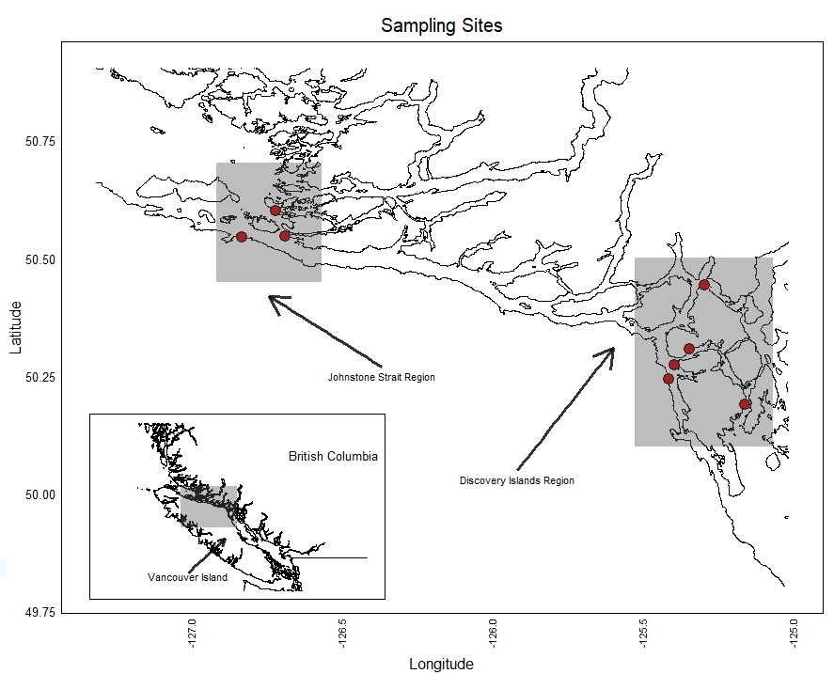

**Figure 1:** The study region, on the west coast of British Columbia, Canada. All sites lie in the Discovery Islands or Johnstone Strait regions, wedged between the western coast of the mainland, and the east coast of Vancouver Island. This is the region that is most heavily developed for fish farming.

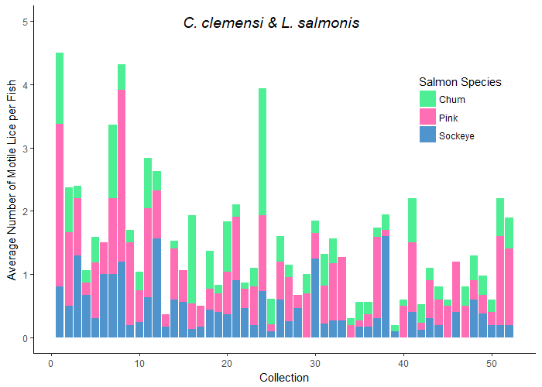

**Figure 2:** Here we see the average number of lice per fish (both lice species as well as individuals at unidentified stages combined), for each collection across the data. The colours in each collection represent the species of salmon**.**

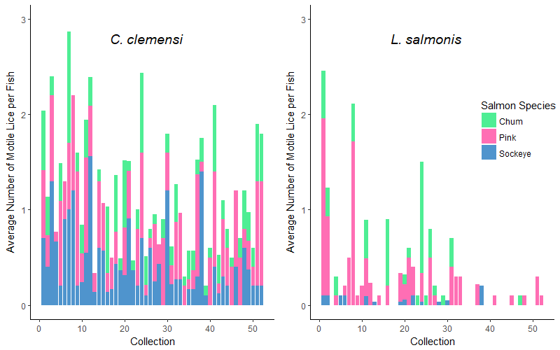

**Figure 3:** Here we see the average number of lice per fish in each collection, divided into two plots to separate by louse species, and divided by colour to separate by fish species.. Visually, pink salmon seem to have higher average numbers of *L. salmonis*.

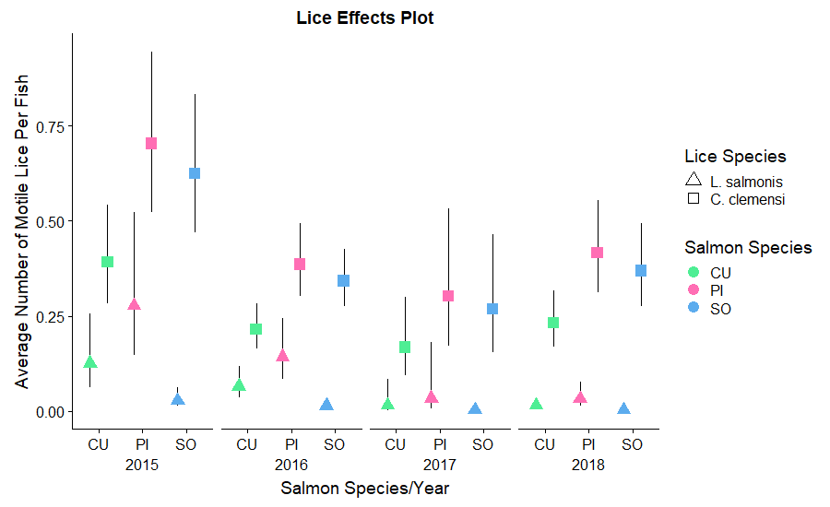

**Figure 4:** Estimated number of lice per fish for *C. clemensi* & *L. salmonis,* divided by sampling year, as well as by salmon species, and grouped by site region. These estimates were derived from the model output of our best model according to AIC analysis, and thus give estimates relative to each of the significant predictor variables.

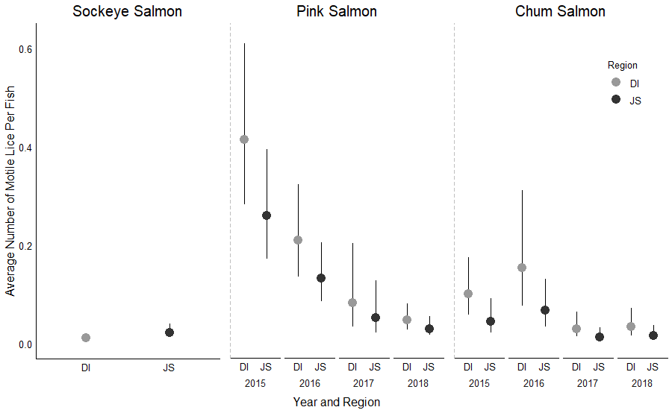

**Figure 5:** Estimated number of lice per fish for the two study regions, Johnstone Strait and the Discovery Islands, compared within salmon species for *L. salmonis* lice only. These estimates area a result of our region-level models. The sockeye-*L. salmonis* data combination AIC scores indicated that a model with only site region effects fit better than a model with site region and year, whereas all other AIC scores indicated that the full model with both fixed effects was preferred.

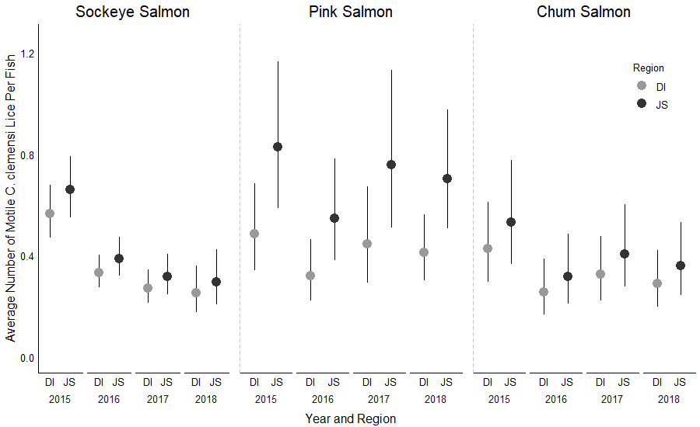

**Figure 6:** Estimated number of lice per fish for the two study regions, Johnstone Strait and the Discovery Islands, compared within salmon species for *C. clemensi* lice only, and across the four sampling years.

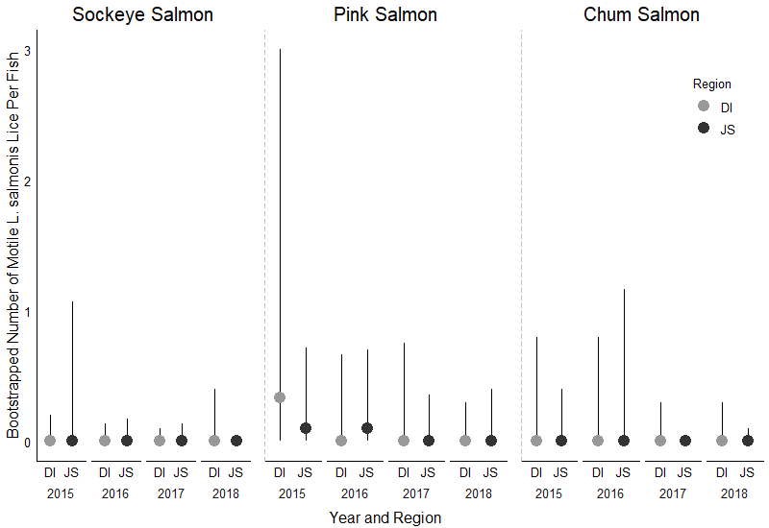

**Figure 7:** Bootstrapped median and 95% confidence intervals for the number of *L. salmonis* per fish for the two study regions, Johnstone Strait and the Discovery Islands, compared within salmon species.

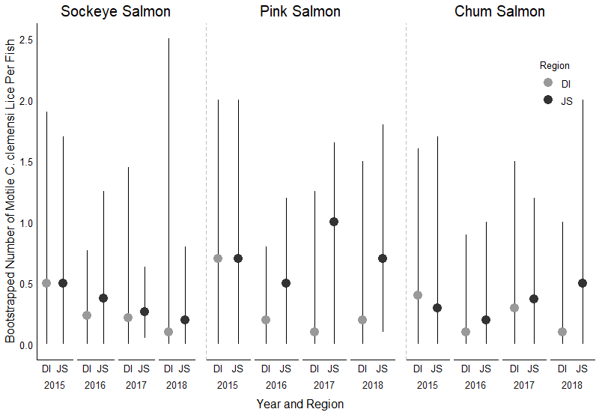

**Figure 7:** Bootstrapped median and 95% confidence intervals for the number of *C. clemensi* per fish for the two study regions, Johnstone Strait and the Discovery Islands, compared within salmon species.