**Methods:**

*Field Observations*

In order to obtain data on species-specific lice abundances on the three focal species of juvenile salmon, an extensive sampling regime was maintained over the course of 4 years (2015-2018) as part of broader work on juvenile Pacific salmon survival (Hunt et al. 2018). Individuals were sampled during the peak of juvenile salmon outwards migration from May to July, at entry points to the Discovery Islands from the Strait of Georgia, and exit points from Johnstone Strait to Queen Charlotte Sound (Fig. 1). Sites were visited every 4-7 days in 2015/16, and then weekly in 2017/18. Purse seine nets (bunt: 27m x 9m with 13mm mesh; tow: 46m x 9m with 76mm mesh) were deployed from small, 6-8m twin-outboard research vessels to capture samples of heterospecific schools comprised of juvenile pink (*Oncorhynchus gorbuscha)*, chum (*Oncorhynchus keta*)and sockeye (*Oncorhynchus nerka*) salmon. The purse seine netting often also captured some sub-adult coho (*Oncorhynchus kisutch*) and chinook (*Oncorhynchus tshawytscha*) salmon, as well as Pacific herring (*Clupea pallasi*). During sampling, observers on the research vessel would conduct a visual survey transect to assess the surface activity of juvenile salmon. If no surface activity was observed after 20 minutes, the seine net was not deployed at that location.

Once the seine had been deployed, it was used to corral the fish beside the boat, and juveniles were scooped up individually using a 4L plastic jug and transferred to a sampling bag. Some individuals were euthanized using a 250 mg • L-1 concentration of tricaine methanesulfonate, and retained for laboratory analysis, while the other captured fish underwent examination using a hand lens on the boat and then were released. Information regarding fish body size, as well as number, life stage, and species of any sea lice present were recorded, along with relevant environmental data. During field observations *in situ*, two methods were used to identify sea lice. The ‘Motile’ method, comprised of identifying only the motile lice (pre-adult females, females, gravid females, and males for *C. clemensi,* and pre-adult females, females, gravid females, pre-adult males, and males for *L. salmonis*  lice), and the ‘All Stages’ method that also categorized the copepodite- and chalimus-staged lice as *C. clemensi*, *L. salmonis,* or ‘unidentified species’. Fish that were sacrificed for lab analysis were dissected at the Hakai Institute Quadra Island Field Station, where they were also examined for the presence, number, species, and life stage of sea lice, corresponding to either ‘Fine-Scale’ (chalimus- and copepodite-stage lice identified as either *C. clemensi* or *L. salmonis,* as well as the motile lice being identified aspre-adult females, females, gravid females, and males for *C. clemensi* lice, and pre-adult females, females, gravid females, pre-adult males, and males for *L. salmonis*  lice) or ‘Motile’ (identical to fine-scale classification, but with all chalimus/copepodite lice ignored) methods. Fish were also weighed to the nearest 0.1g and it’s fork length and standard length were taken to the nearest mm. This resulted in a dataset of over 1,800 individual fish, collected at eight different sites, across 52 individual collections, with a collection representing a unique sampling site/date combination, where at least five individuals of pink, chum, and sockeye juvenile salmon were sampled. In addition, a less species-balanced dataset was compiled, totalling almost 6,000 observations divided between the two sampling regions, the Discovery Islands, and Johnstone Strait.

*Statistical Analyses*

To investigate potential differences in lice parasitism between the three salmon species, we fit a series of generalized linear mixed-effects models (GLMMs) to our data using the glmmTMB package (Brooks et al. 2017) in R statistical software (R Core Team, 2018), with salmon species, sampling year, and fish fork length as predictive variables, along with collection as a random effect. These models were run separately for *C. clemensi* and *L. salmonis,* so as to more firmly parse out drivers of abundance of the two lice species in our study system. Due to different lice identification regimes used at different points in the study, motile life stages were the only ones easily identifiable by species on each and every fish, and as such, only motile data were retained for the purposes of our analyses. While the initial model set included all three predictor variables, including fork length resulted in a dataset with fewer observations, since fork length measurements were not taken for every fish. As such, this the variable was removed in favour of including a larger number of observations. Therefore, the full model set we used in our analysis incorporated salmon species and sampling year, as fixed effects (Table 1, 2).

The models employed a negative binomial error for the response distribution, as well as a log link function. The GLMMs were fit such that the number of lice per fish was treated as the response variable, and Akaike Information Criterion (AIC) was used to perform model comparison and selection.The results of these models were used to determine the predicted effect of each of the fixed effects variables on the number of lice per fish for each species of louse. This was done by back-transforming the coefficients from the models, and creating a 95% confidence interval using the ggeffects package (Lüdecke, 2018), representing the estimated number of lice per fish between the two species.

In addition to our models relating louse infections to the three salmon species, we wanted to determine the effect that sampling region had on infection levels. The two distinct sampling regions (Fig. 1), are traversed successively, moving from south to north by the majority of the juvenile salmon in the region. As such, the Johnstone Strait represents a region wherein fish sampled will have typically had longer exposure to lice from all potential sources. To investigate any relevant differences, we ran a separate set of GLMMs, using the lice species as the response variable, with the site regions and years as fixed effects, and the week of the year (with 1 delineating the first week in January and counting numerically forwards from there) as a random effect. This resulted in two models, one for *L. salmonis* and one for *C. clemensi* for each of the three species of salmon.*.* Akaike Information Criterion (AIC) was again used to perform model comparison and selection.

In addition, we used hierarchical bootstrapping to pair our model-driven estimates with data-based measurements of the data to confirm that our model predictions were appropriate given the data for our region-level models. For each unique salmon species, lice species, year, and site region combination (48 separate combinations, ex. Sockeye salmon, *L. salmonis,* 2015 and Discovery Islands), we bootstrapped the average number of lice per fish in an individual collection 10,000 times. This involved sampling all of the collections that each unique combination occurred in, with replacement, and calculating the mean number of lice per fish for that collection, allowing us to garner a better understanding of the spread of our data.

**Results:**

The average number of lice per individual fish varied from more than 4 lice per fish in some collections, to less than 0.5 in other collections (Fig. 2), with each collection showing at least some lice present, though not each collection showed lice on each species of salmon (Fig. 3). When looking separately at the two louse species, it is clear that not only is *C. clemensi* present at many more collections than *L. salmonis* but also generally present at higher numbers (Fig. 3). Additionally, the highest average numbers of lice per collection for *C. clemensi* were just under three lice per fish, while for *L. salmonis*, the highest average number of lice per fish was just under 2.5 fish. In addition, there were very few *L. salmonis* lice present on sockeye salmon, compared to both pink and chum salmon.

Our species-level results indicated that both *C. clemensi* and *L. salmonis* infections were shown to be predicted most strongly by the full model with the additive combination of both fixed effects (Tables 3 & 4), indicating a clear signal of species-level differences in terms of salmon infection for both species of sea lice. The model results show estimates that *C. clemensi* was present at higher per-fish averages across the whole dataset (Fig. 3), with the highest frequencies being shown on pink and sockeye salmon. *L. salmonis* lice were present at lower numbers on each of the three salmon species, but were highest on pink salmon. These results are contrary to previous field observations which indicated that sockeye salmon exhibit the highest levels of *C. clemensi*, however they do confirm field observations that suggested pink salmon carry the highest levels of *L. salmonis.* Infection of the two lice species are notably more similar in 2015 and 2016 than they are in 2017 and 2018, with the levels of infection for *L. salmonis* being comparatively closer to that of *C. clemensi* during 2015 and 2016 than for the later two year. Sampling year differences are marked between both *C. clemensi* and *L. salmonis*, with estimated per-fish infections being highest in 2015, then seeing a relative decline in 2016/17 for both, with a small up-tick in 2018 for *C. clemensi*.

For the region-level models, AIC scores showed that the full model (both year and site region) provided the best fit for five out of the six models, with the model for *L. salmonis* and sockeye salmon showing a better fit model when only site region was included (Tables 5-10). The results of these models did lend insight into region-level differences, specifically showing that the much more abundant *C. clemensi* was estimated to be present at substantially higher infection rates in the Johnstone Strait than in the Discovery Islands for all three salmon (Table 6, Figs. 5 & 6). The less abundant *L. salmonis* was present at slightly lower levels in Johnstone Strait than in the Discovery Islands for both pink and chum salmon, but was present at marginally higher levels in Johnstone Strait than in the Discovery Islands for sockeye salmon. These region-level estimates confirm the low abundance of *L. salmonis* on sockeye salmon. For *C. clemensi* estimates, it was also apparent that within each salmon species the ratios of lice in the two regions stayed fairly consistent across the four years sampled, despite fluctuations in lice abundances overall, the relative abundances between the two regions stayed more or less consistent throughout the sampling periods.

Bootstrap results showed that our model estimates were well within the 95% confidence limits displayed by our data (Fig. 7). These results confirmed the relatively low abundance estimates of *L. salmonis* in the system, with all median values for *L. salmonis* being equal to zero with only three exceptions. General infection patterns were present for the bootstrapped data as well, with *C. clemensi* showing high prevalence on pink salmon, and intermediate prevalence on the other two species. Generally, these results confirmed the appropriate estimates of our models with respect to the data themselves.

Overall, we show here that in fact species-level differences are present between our three species of salmon with respect to the abundance, and species of lice causing the infections. Site region also appears to play an important role in determining the infection levels for both species of sea lice, indicating that the overall patterns of infection likely fluctuate from year to year, but that some general patterns remain through time.

**Table 1:** AIC table for *C. Clemensi* full model set.

|  |  |  |  |
| --- | --- | --- | --- |
| ***C. clemensi*  Model** | **Negative Log Likelihood** | **AIC value** | **Delta-AIC value** |
| **Null** | -1509.7 | 3025.5 | 27.9 |
| **Year** | -1502.8 | 3017.7 | 20.1 |
| **Species** | -1497.3 | 3004.7 | 7.1 |
| **Species, Year** | -1490.7 | 2997.6 | 0.0 |

**Table 2:** AIC table for *L. salmonis* full model set.

|  |  |  |  |
| --- | --- | --- | --- |
| ***L. salmonis*  Model** | **Negative Log Likelihood** | **AIC value** | **Delta-AIC value** |
| **Null** | -461.3 | 928.7 | 75.8 |
| **Year** | -452.4 | 916.7 | 63.9 |
| **Species** | -427.8 | 865.7 | 12.8 |
| **Species, Year** | -418.4 | 852.8 | 0.0 |

**Table 3:** Model results for the highest ranked model according to the AIC results, from the *L. salmonis* analysis.

|  |  |  |
| --- | --- | --- |
| ***L. salmonis*  Output** | **Coefficient** | **Standard Error** |
| **Chum** | -2.0747 | 0.3620 |
| **Pink** | -1.2833 | 0.3241 |
| **Sockeye** | -3.5723 | 0.4034 |
| **2016** | -0.6621 | 0.3923 |
| **2017** | -2.1076 | 0.9000 |
| **2018** | -2.1381 | 0.5178 |

**Table 4:** Model results for the highest ranked model according to the AIC results, from the *C. clemensi* analysis.

|  |  |  |
| --- | --- | --- |
| ***C. clemensi*  Output** | **Coefficient** | **Standard Error** |
| **Chum** | -0.9367 | 0.1667 |
| **Pink** | -0.3512 | 0.1508 |
| **Sockeye** | -0.4703 | 0.1467 |
| **2016** | -0.6012 | 0.1735 |
| **2017** | -0.8461 | 0.3117 |
| **2018** | -0.5259 | 0.1935 |

**Table 5:** AIC table for region level effects of data for *C. clemensi* and chum salmon

|  |  |  |  |
| --- | --- | --- | --- |
| **Chum & *C. clemensi*  Model** | **Negative Log Likelihood** | **AIC value** | **Delta-AIC value** |
| **Null** | -1062.0 | 2130.0 | 9.2 |
| **Site Region** | -1060.2 | 2128.4 | 7.6 |
| **Year** | -1055.8 | 2123.6 | 2.8 |
| **Site Region, Year** | -1053.4 | 2120.8 | 0.0 |

**Table 6:** AIC table for region level effects of data for *L. salmonis* and chum salmon

|  |  |  |  |
| --- | --- | --- | --- |
| **Chum & *L. Salmonis*  Model** | **Negative Log Likelihood** | **AIC value** | **Delta-AIC value** |
| **Null** | -258.7 | 523.5 | 12.9 |
| **Site Region** | -256.8 | 521.5 | 11.0 |
| **Year** | -251.1 | 514.2 | 3.7 |
| **Site Region, Year** | -248.3 | 510.6 | 0.0 |

**Table 7:** AIC table for region level effects of data for *C. clemensi* and pink salmon

|  |  |  |  |
| --- | --- | --- | --- |
| **Pink & *C. clemensi*  Model** | **Negative Log Likelihood** | **AIC value** | **Delta-AIC value** |
| **Null** | -907.8 | 1821.6 | 26.0 |
| **Year** | -907.0 | 1819.9 | 24.4 |
| **Site Region** | -894.3 | 1796.5 | 1.0 |
| **Site Region, Year** | -890.8 | 1795.5 | 0.0 |

**Table 8:** AIC table for region level effects of data for *L. salmonis* and pink salmon

|  |  |  |  |
| --- | --- | --- | --- |
| **Pink & *L. Salmonis*  Model** | **Negative Log Likelihood** | **AIC value** | **Delta-AIC value** |
| **Site Region** | -384.6 | 777.2 | 49 |
| **Null** | -385.5 | 777.1 | 48.9 |
| **Year** | -359.1 | 730.2 | 2.0 |
| **Site Region, Year** | -357.1 | 728.2 | 0.0 |

**Table 9:** AIC table for region level effects of data for *C. clemensi* and sockeye salmon

|  |  |  |  |
| --- | --- | --- | --- |
| **Sockeye & *C. clemensi*  Model** | **Negative Log Likelihood** | **AIC value** | **Delta-AIC value** |
| **Null** | -3281.3 | 6568.5 | 101.1 |
| **Site Region** | -3275.3 | 6558.5 | 91.1 |
| **Year** | -3229.9 | 6471.7 | 4.3 |
| **Site Region, Year** | -3226.7 | 6467.4 | 0.0 |

**Table 10:** AIC table for region level effects of data for *L. salmonis* and sockeye salmon

|  |  |  |  |
| --- | --- | --- | --- |
| **Sockeye & *L. Salmonis*  Model** | **Negative Log Likelihood** | **AIC value** | **Delta-AIC value** |
| **Year** | -390.1 | 792.3 | 8.5 |
| **Null** | -392.3 | 790.5 | 6.7 |
| **Site Region, Year** | -386.7 | 787.5 | 3.7 |
| **Site Region** | -387.9 | 783.8 | 0.0 |

**Table 6:** Model results for the region-level models for all three species of salmon

|  |  |  |  |
| --- | --- | --- | --- |
| **Chum Salmon** | | | |
| ***L. salmonis* Output** | **Coefficient** | **Standard Error** | |
| **Discovery Islands** | -2.3025 | 0.2821 | |
| **Johnstone Strait** | -3.1487 | 0.3838 | |
| **2016** | 0.4227 | 0.4203 | |
| **2017** | -1.2784 | 0.4857 | |
| **2018** | -1.1277 | 0.4742 | |
| ***C. clemensi*  Output** | **Coefficient** | **Standard Error** | |
| **Discovery Islands** | -0.8537 | 0.1846 | |
| **Johnstone Strait** | -0.6314 | 0.1926 | |
| **2016** | -0.5131 | 0.1637 | |
| **2017** | -0.2677 | 0.1306 | |
| **2018** | -0.3880 | 0.1352 | |
| **Pink Salmon** | | |
| ***L. salmonis*  Output** | **Coefficient** | **Standard Error** |
| **Discovery Islands** | -0.8806 | 0.1975 |
| **Johnstone Strait** | -1.3489 | 0.2128 |
| **2016** | -0.6860 | 0.2576 |
| **2017** | -1.6262 | 0.4798 |
| **2018** | -2.2009 | 0.3248 |
| ***C. clemensi*  Output** | **Coefficient** | **Standard Error** |
| **Discovery Islands** | -0.7243 | 0.1773 |
| **Johnstone Strait** | -0.1891 | 0.1751 |
| **2016** | -0.4151 | 0.1591 |
| **2017** | -0.0865 | 0.1647 |
| **2018** | -0.1644 | 0.1220 |
| **Sockeye Salmon** | | |
| ***L. salmonis*  Output** | **Coefficient** | **Standard Error** |
| **Discovery Islands** | -4.5724 | 0.322 |
| **Johnstone Strait** | -3.8232 | 0.296 |
| ***C. clemensi*  Output** | **Coefficient** | **Standard Error** |
| **Discovery Islands** | -0.5722 | 0.0929 |
| **Johnstone Strait** | -0.4152 | 0.0926 |
| **2016** | -0.5296 | 0.0710 |
| **2017** | -0.7348 | 0.1012 |
| **2018** | -0.8054 | 0.1684 |

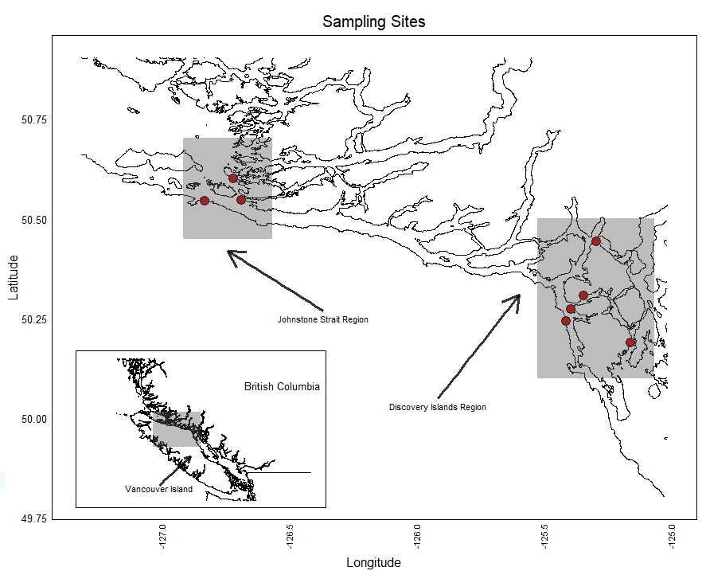

**Figure 1:** The study region, on the west coast of British Columbia, Canada. All sites lie in the Discovery Islands or Johnstone Strait regions, wedged between the western coast of the mainland, and the east coast of Vancouver Island. This is the region that is most heavily developed for fish farming.

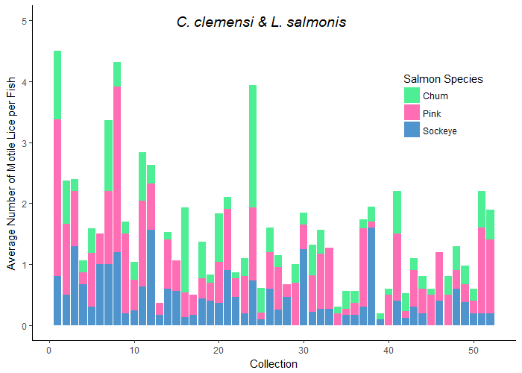

**Figure 2:** Here we see the average number of lice per fish (both lice species as well as individuals at unidentified stages combined), for each collection across the data. The colours in each collection represent the species of salmon**.**

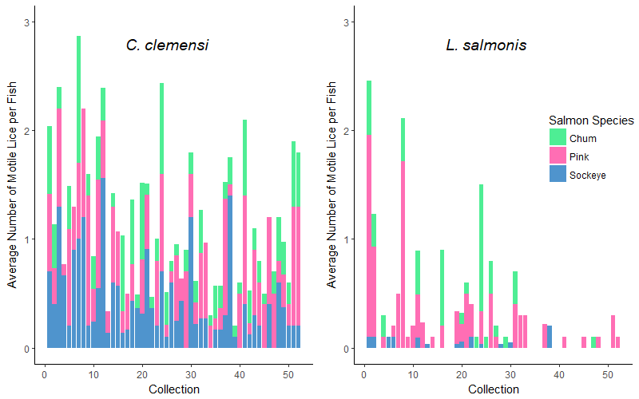

**Figure 3:** Here we see the average number of lice per fish in each collection, divided into two plots to separate by louse species, and divided by colour to separate by fish species.. Visually, pink salmon seem to have higher average numbers of *L. salmonis*.

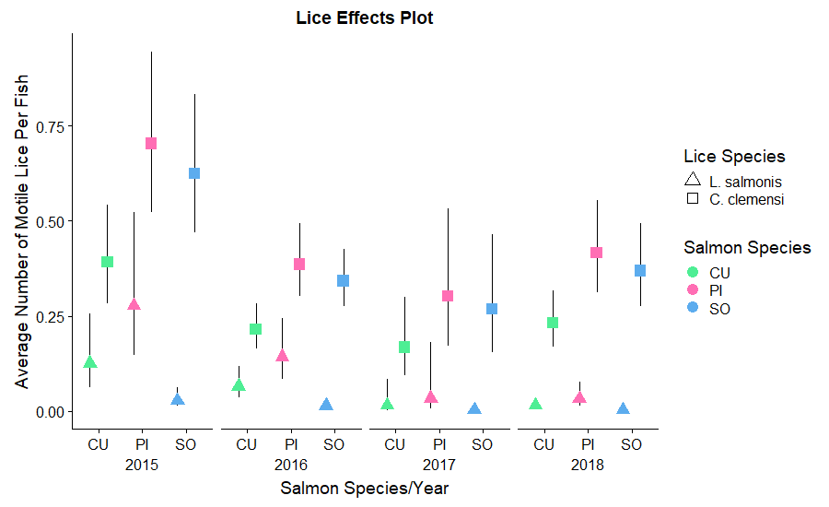

**Figure 4:** Estimated number of lice per fish for *C. clemensi,* divided by sampling year, as well as by salmon species, and grouped by site region. These estimates were derived from the model output of our best model according to AIC analysis, and thus give estimates relative to each of the significant predictor variables.

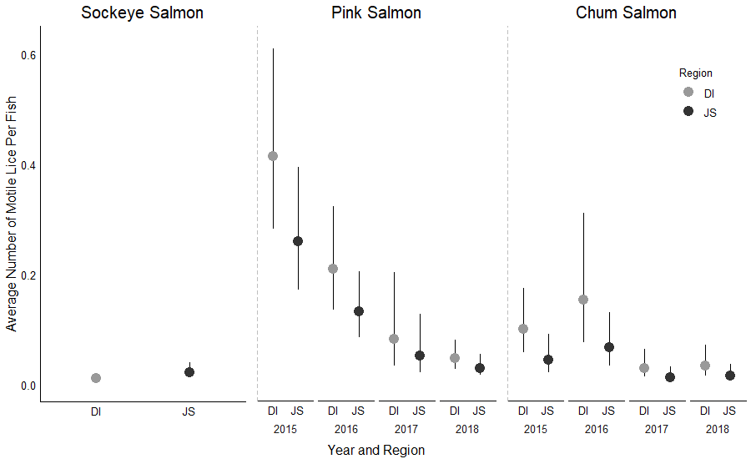

**Figure 5:** Estimated number of lice per fish for the two study regions, Johnstone Strait and the Discovery Islands, compared within salmon species for *L. salmonis* lice only. These estimates area a result of our region-level models. The sockeye-*L. salmonis* data combination AIC scores indicated that a model with only site region effects fit better than a model with site region and year, whereas all other AIC scores indicated that the full model with both fixed effects was preferred.

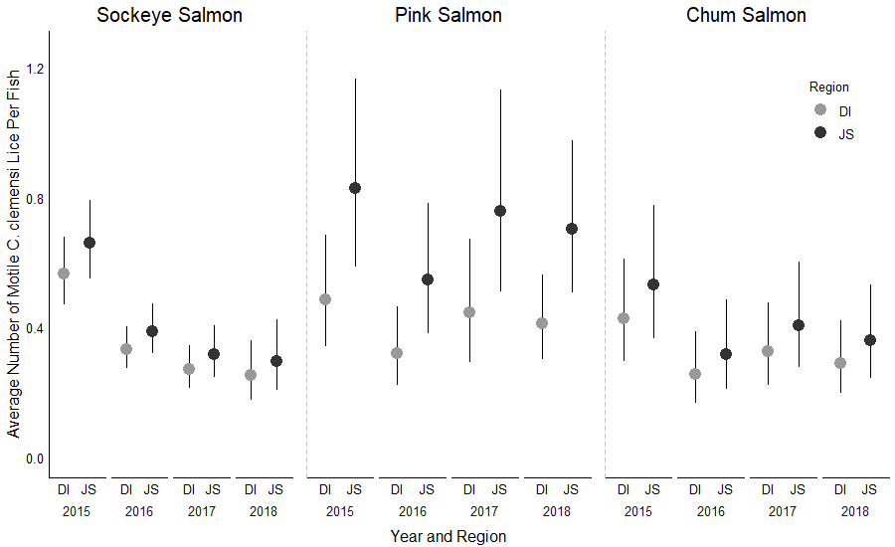

**Figure 6:** Estimated number of lice per fish for the two study regions, Johnstone Strait and the Discovery Islands, compared within salmon species for *C. clemensi* lice only, and across the four sampling years.

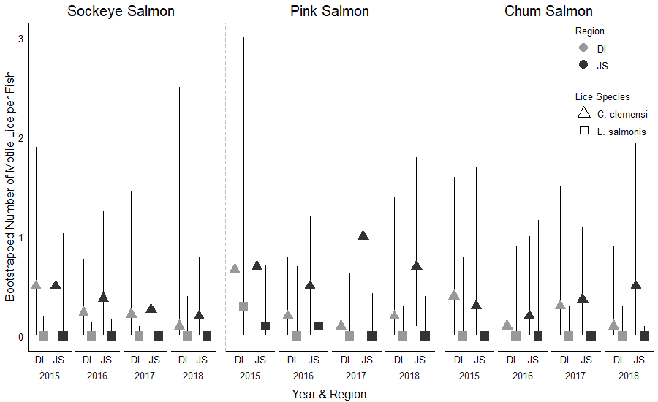

**Figure 7:** Bootstrapped median and 95% confidence intervals for the number of lice per fish for the two study regions, Johnstone Strait and the Discovery Islands, compared within salmon species for both lice sepcies.