**Cuz Methods:**

*Field Observations*

In order to obtain data on species-specific lice abundances on the three focal species of juvenile salmon, an extensive sampling regime was maintained over the course of 4 years (2015-2018). For a more detailed account of the field methods, refer to Hunt et al. (2018). A summarized version follows.

Individuals were sampled during the peak of juvenile salmon outwards migration from May to July, at entry points to the Discovery Islands from the Strait of Georgia, and exit points from Johnstone Strait to Queen Charlotte Sound (Fig. 1). Sites were visited every 4-7 days in 2015/16, and then weekly in 2017/18. Purse seine nets (bunt: 27m x 9m with 13mm mesh; tow: 46m x 9m with 76mm mesh) were deployed from small, 6-8m twin-outboard research vessels to capture samples of heterospecific schools comprised of juvenile pink (*Oncorhynchus gorbuscha)*, chum (*Oncorhynchus keta*)and sockeye (*Oncorhynchus nerka*) salmon. The purse seine netting often also captured some sub-adult coho (*Oncorhynchus kisutch*) and chinook (*Oncorhynchus tshawytscha*) salmon, as well as Pacific herring (*Clupea pallasi*). During sampling, observers on the research vessel would conduct a visual survey transect to assess the surface activity of juvenile salmon. If no surface activity was observed after 20 minutes, the seine net was not deployed at that location.

Once the seine had been deployed, it was used to corral the fish beside the boat, and juveniles were scooped up individually using a 4L plastic jug and transferred to a sampling bag. Some individuals were euthanized using a 250 mg • L-1 concentration of tricaine methanesulfonate, and retained for laboratory analysis, while the other captured fish underwent examination using a hand lens on the boat and then were released. Information regarding fish body size, as well as number, life stage, and species of any sea lice present were recorded, along with relevant environmental data. During field observations *in situ*, two methods were used to identify sea lice. The ‘Motile’ method, comprised of identifying only the motile lice (pre-adult females, females, gravid females, and males for *C. clemensi,* and pre-adult females, females, gravid females, pre-adult males, and males for *L. salmonis*  lice), and the ‘All Stages’ method that also categorized the copepodite- and chalimus-staged lice as *C. clemensi*, *L. salmonis,* or ‘unidentified species’. Fish that were sacrificed for lab analysis were dissected at the Hakai Institute Quadra Island Field Station, where they were also examined for the presence, number, species, and life stage of sea lice, corresponding to either ‘Fine-Scale’ (chalimus- and copepodite-stage lice identified as either *C. clemensi* or *L. salmonis,* as well as the motile lice being identified aspre-adult females, females, gravid females, and males for *C. clemensi* lice, and pre-adult females, females, gravid females, pre-adult males, and males for *L. salmonis*  lice) or ‘Motile’ (identical to fine-scale classification, but with all chalimus/copepodite lice ignored) methods. Fish were also weighed to the nearest 0.1g and it’s fork length and standard length were taken to the nearest mm. This resulted in a dataset of over 1,800 individual fish, collected at eight different sites, across 52 individual collections, with a collection representing a unique sampling site/date combination, where at least five individuals of pink, chum, and sockeye juvenile salmon were sampled.

*Statistical Analyses*

To determine investigate potential species-level differences in lice parasitism between the three salmon species, we fit a series of generalized linear mixed-effects models (GLMMs) to our data, with salmon species, sampling year, fish fork length, as predictive variables, along with collection number as a random effect. These models were run separately for *C. clemensi* and *L. salmonis,* so as to more firmly parse what is driving the abundance of the two lice species in our study system. Due to different lice identification regimes, motile life stages were the only ones easily identifiable by species on each and every fish, and as such, only motile data were retained for the purposes of our analyses. While the initial model set included all three predictive variables, including fork length as a predictor variable resulted in a dataset with fewer observations, since fork length measurements were not taken for every fish. As such, this the variable was removed in favour of including a larger number of observations. Therefore, the full model set we used in our analysis incorporated salmon species and sampling year, as fixed effects (Table 1, 2).

The models employed a negative binomial error for the response distribution, as well as a log link function. The GLMMs were calculated such that the number of lice per fish was treated as the response variable, and species of salmon, sampling year, and site region were fixed effects. The results of these models were used to determine the predicted effect of each of the predictive variables on the number of lice per fish for each species of louse. This was done by reverse transforming the coefficients from the models, and creating a 95% confidence interval, representing the estimated number of lice per fish between the two species. In total, 16 models were run, 8 for each species including the null model.

In addition to our models relating the species of the lice to the three salmon species, we wanted to determine the effect that sampling region had on infection levels. The two distinct sampling regions (Fig. 1), are traversed successively, moving from south to north by the majority of the juvenile salmon in the region. As such, the Johnstone Strait represents a region wherein fish sampled will have typically had longer exposure to lice from all potential sources. To determine any relevant differences, we ran a separate set of GLMMs, using the lice species as the response variable, with the site region as a fixed effect, and the week of the year (with 1 delineating the first week in January and counting numerically forwards from there) as a random effect. This resulted in two models, one for *L. salmonis* and one for *C. clemensi* for each species of salmon. To determine any relevant differences, we ran a separate set of GLMMs for each fish species, using the lice species as the response variable, with the site region as a fixed effect, and the week of the year (with 1 delineating the first week in January and counting numerically forwards from there) as a random effect*.* The models again employed a negative binomial error for the response distribution, as well as a log link function.

**Results:**

Our model results indicated that both *C. clemensi* and *L. salmonis* infections were shown to be predicted most strongly by the full model with the additive combination of all fixed effects, salmon species and sampling year (Table 2 and Table 3). This indicates a clear signal of species-level differences in terms of salmon infection for both species of sea lice.

The average number of lice per individual fish varied from more than 4 lice per fish in some collections, to less than 0.5 in other collections (Fig. 2), with each collection showing at least some lice present, though not each collection showed lice on each species of salmon (Fig. 3). When looking separately at the two lice species, it is clear that not only is *C. clemensi* present at many more collections than *L. salmonis* but it is also generally present at higher numbers (Fig. 3). Additionally, the highest numbers of lice per collection for *C. clemensi* were just under three lice per fish, while for *L. salmonis*, the highest average number of lice per fish was just under 2.5 fish. It is also clear that there are very few *L. salmonis* lice present on sockeye salmon, compared to both pink and chum salmon.

The results of our analyses show that *C. clemensi* is present at higher per-fish averages across the whole dataset (Figs. 4 & 6), with the highest frequencies being shown on pink and sockeye salmon. *L. salmonis* lice were present at lower numbers on each of the three salmon species, but were highest on pink salmon (Fig. 5/6). These results are contrary to previous field observations which indicated that sockeye salmon exhibit the highest levels of *C. clemensi*, however they do confirm field observations that suggested pink salmon carry the highest levels of *L. salmonis.* Infection levels are distinctly different between the two species of louse in the years 2017 and 2018, with 2015 and 2016 showing a closer relationship between the estimated number of lice per fish. Sampling year differences are marked between both *C. clemensi* and *L. salmonis*, with estimated per-fish infections being highest in 2015, then seeing a relative decline in 2016/17 for both, with a small up-tick in 2018 for *C. clemensi*.

Region-level models showed that the much more abundant *C. clemensi* was present at substantially higher infection estimates in the Johnstone Strait than in the Discovery Islands for all three salmon (Table 6). The less abundant *L. salmonis* was present at slightly lower levels in Johnstone Strait than in the Discovery Islands for both pink and sockeye salmon, but was present at higher levels in Johnstone Strait than in the Discovery Islands for sockeye salmon (Fig. 8, 9, 10).

Overall, we show that there are in fact species level differences between our three species of salmon with respect to the abundance, and species of lice causing the infections. Sampling year also had an effect on the number of *L. salmonis* lice infections, and both sampling year and site region had an effect on *C. clemensi* lice infections.

**Table 1:** AIC table for *C. Clemensi* full model set.

|  |  |  |  |
| --- | --- | --- | --- |
| ***C. clemensi*  Model** | **Negative Log Likelihood** | **AIC value** | **Delta-AIC value** |
| **Null** | -1509.74 | 3025.5 | 27.9 |
| **Year** | -1502.83 | 3017.7 | 20.1 |
| **Species** | -1497.33 | 3004.7 | 7.1 |
| **Species, Year** | -1490.78 | 2997.6 | 0.0 |

**Table 2:** AIC table for *L. salmonis* full model set.

|  |  |  |  |
| --- | --- | --- | --- |
| ***L. salmonis*  Model** | **Negative Log Likelihood** | **AIC value** | **Delta-AIC value** |
| **Null** | -461.325 | 928.6 | 75.8 |
| **Year** | -452.366 | 916.7 | 63.9 |
| **Species** | -427.833 | 865.7 | 12.8 |
| **Species, Year** | -418.419 | 852.8 | 0.0 |

**Table 3:** Model results for the highest ranked model according to the AIC results, from the *L. salmonis* analysis.

|  |  |  |  |
| --- | --- | --- | --- |
| ***L. salmonis*  Output** | **Coefficient** | **Standard Error** | **Reverse Trans. Est.** |
| **Chum** | -2.074 | 0.362 | 0.126 (0.061, 0.259) |
| **Pink** | -1.283 | 0.324 | 0.277 (0.145, 0.530) |
| **Sockeye** | -3.572 | 0.403 | 0. 028 (0.013, 0.063) |
| **2016** | -0.662 | 0.392 | 0.516 (0.236,1.130) |
| **2017** | -2.108 | 0.900 | 0.121 (0.020, 0.735) |
| **2018** | -2.138 | 0.518 | 0.118 (0.042, 0.332) |

**Table 4:** Model results for the highest ranked model according to the AIC results, from the *C. clemensi* analysis.

|  |  |  |  |
| --- | --- | --- | --- |
| ***C. clemensi*  Output** | **Coefficient** | **Standard Error** | **Reverse Trans. Est.** |
| **Chum** | -0.937 | 0.167 | 0.391 (0.281, 0.547) |
| **Pink** | -0.351 | 0.151 | 0.704 (0.520, 0.952) |
| **Sockeye** | -0.470 | 0.147 | 0. 625 (0.466, 0.839) |
| **2016** | -0.601 | 0.174 | 0.548 (0.387,0.776) |
| **2017** | -0.846 | 0.312 | 0.429 (0.223, 0.801) |
| **2018** | -0.526 | 0.193 | 0.591 (0.402, 0.869) |

**Table 5:** AIC table for region level differences between the two lice species.

|  |  |  |
| --- | --- | --- |
| **Model** | **Negative Log Likelihood** | **AIC value** |
| ***C. clemensi*** | -1.098.61 | 2205.2 |
| ***L. salmonis*** | -5261.17 | 10530.3 |

**Table 6:** Model results for the region-level models for all three species of salmon

|  |  |  |  |
| --- | --- | --- | --- |
| **Chum Salmon** | | | |
| ***L. salmonis*  Output** | **Coefficient** | **Standard Error** | **Reverse Trans. Est.** |
| **Discovery Islands** | -3.065 | 0.158 | 0.047 (0.034,0.064) |
| **Johnstone Strait** | -3.192 | 0.171 | 0.041 (0.029, 0.057) |
| ***C. clemensi*  Output** | **Coefficient** | **Standard Error** | **Reverse Trans. Est.** |
| **Discovery Islands** | -1.102 | 0.183 | 0.332 (0.232,0.476) |
| **Johnstone Strait** | -0.910 | 0.189 | 0.403 (0.278, 0.583) |

|  |  |  |  |
| --- | --- | --- | --- |
| **Pink Salmon** | | | |
| ***L. salmonis*  Output** | **Coefficient** | **Standard Error** | **Reverse Trans. Est.** |
| **Discovery Islands** | -1.798 | 0.156 | 0.166(0.122, 0.225) |
| **Johnstone Strait** | -2.126 | 0.180 | 0.119 (0.084, 0.170) |
| ***C. clemensi*  Output** | **Coefficient** | **Standard Error** | **Reverse Trans. Est.** |
| **Discovery Islands** | -0.909 | 0.171 | 0.403 (0.288,0.563) |
| **Johnstone Strait** | -0.380 | 0.172 | 0.684 (0.488, 0.958) |

|  |  |  |  |
| --- | --- | --- | --- |
| **Sockeye Salmon** | | | |
| ***L. salmonis*  Output** | **Coefficient** | **Standard Error** | **Reverse Trans. Est.** |
| **Discovery Islands** | -4.664 | 0.341 | 0.010(0.005, 0.019) |
| **Johnstone Strait** | -3.783 | 0.307 | 0.023 (0.012, 0.042) |
| ***C. clemensi*  Output** | **Coefficient** | **Standard Error** | **Reverse Trans. Est.** |
| **Discovery Islands** | -0.843 | 0.119 | 0.430 (0.340,0.545) |
| **Johnstone Strait** | -0.662 | 0.121 | 0.516 (0.407, 0.654) |

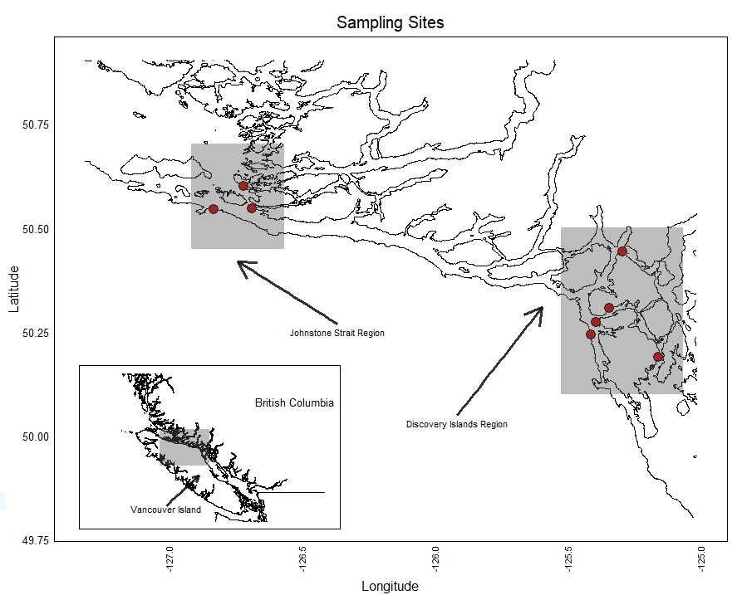

**Figure 1:** The study region, on the west coast of British Columbia, Canada. All sites lie in the Discovery Islands or Johnstone Strait regions, wedged between the western coast of the mainland, and the east coast of Vancouver Island. This is the region that is most heavily developed for fish farming.

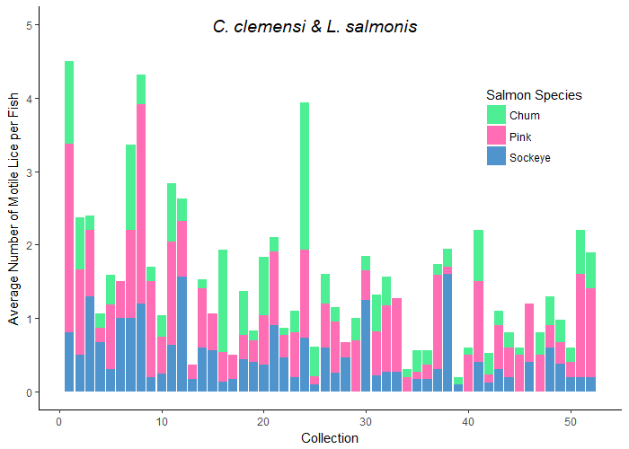

**Figure 2:** Here we see the average number of lice per fish (both lice species as well as individuals at unidentified stages combined), for each collection across the data. The colours in each collection represent the species of salmon**.**

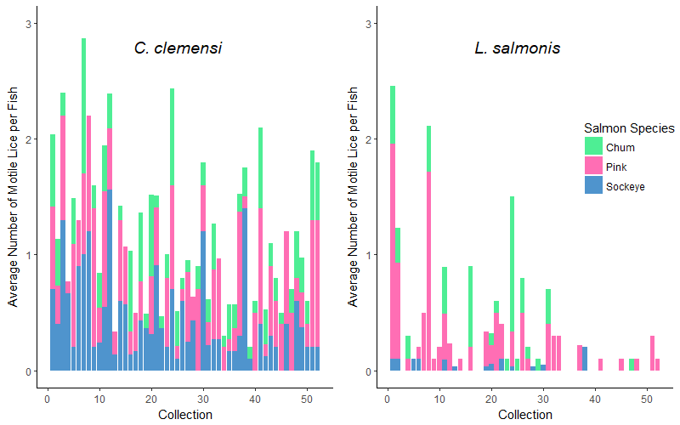

**Figure 3:** Here we see the average number of lice per fish in each collection, divided into two plots to separate by louse species, and divided by colour to separate by fish species.. Visually, pink salmon seem to have higher average numbers of *L. salmonis*.

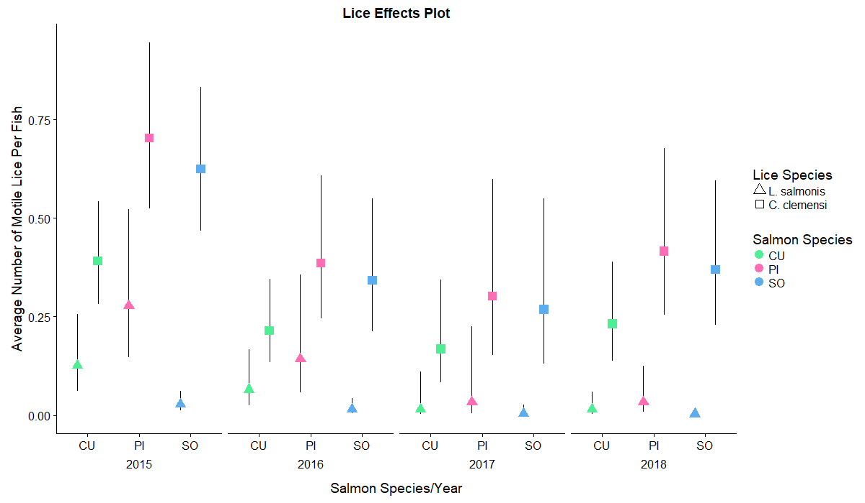

**Figure 4:** Estimated number of lice per fish for *C. clemensi,* divided by sampling year, as well as by salmon species, and grouped by site region. These estimates were derived from the model output of our best model according to AIC analysis, and thus give estimates relative to each of the significant predictor variables.

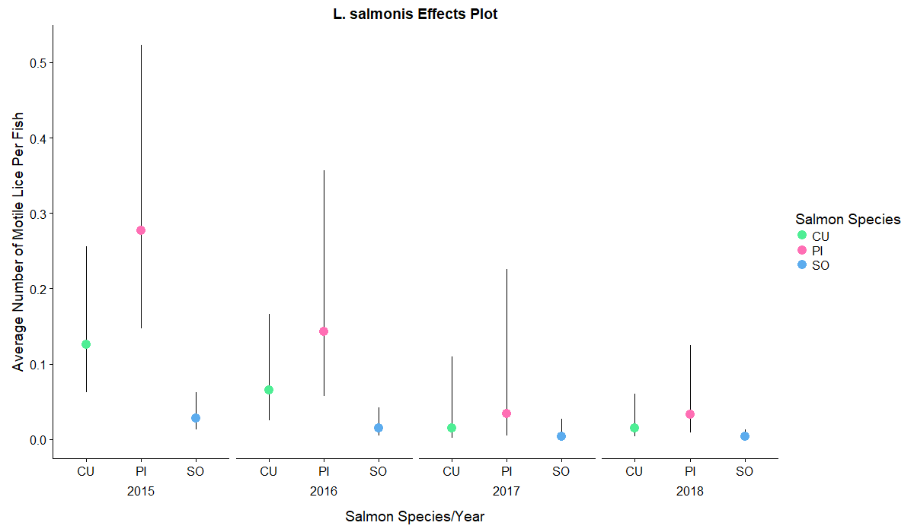

**Figure 5:** Estimated number of lice per fish for *L. salmonis,* divided by sampling year, as well as by salmon species, and grouped by site region. These estimates were derived from the model output of our best model according to AIC analysis, and thus give estimates relative to each of the significant predictor variables.



**Figure 6:** Estimated number of lice per fish for both *C. clemensi* and *L. salmonis,* divided by the two lice species, as well as sampling year and salmon species, and further grouped by site region for *C. clemensi* only. These estimates were derived from the model output of our best model according to AIC analysis, and thus give estimates relative to each of the significant predictor variables.

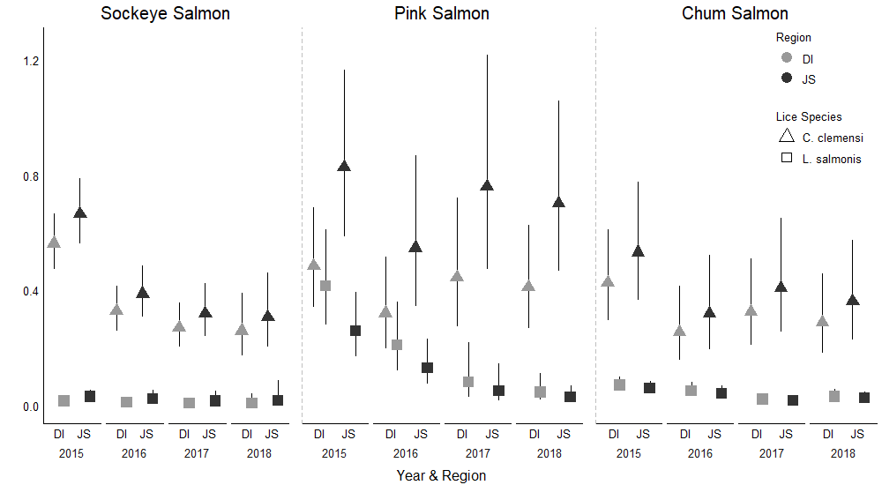

**Figure 7:** Estimated number of lice per fish for the two study regions, Johnstone Strait and the Discovery Islands, compared within both species of lice species through separate models run only on one species at a time.

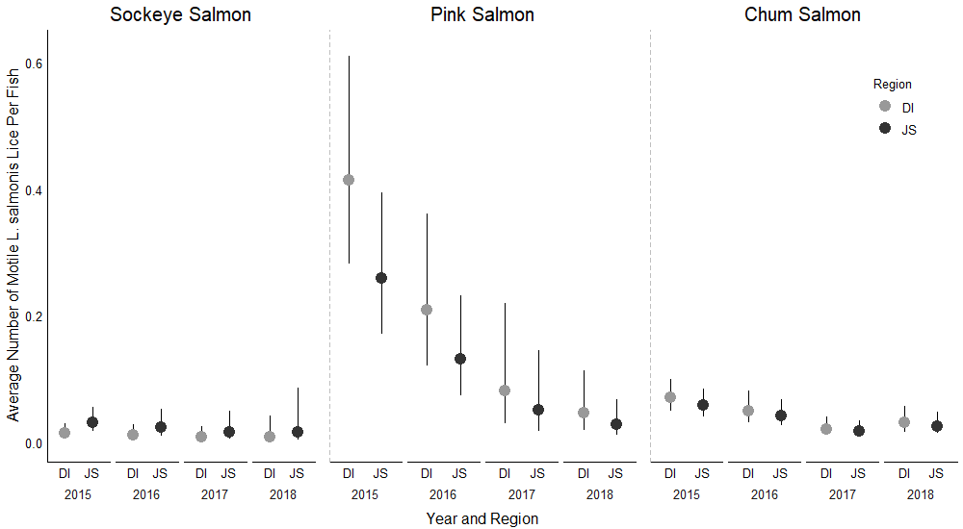

**Figure 8:** Estimated number of lice per fish for the two study regions, Johnstone Strait and the Discovery Islands, compared within salmon species for L. salmonis lice only.

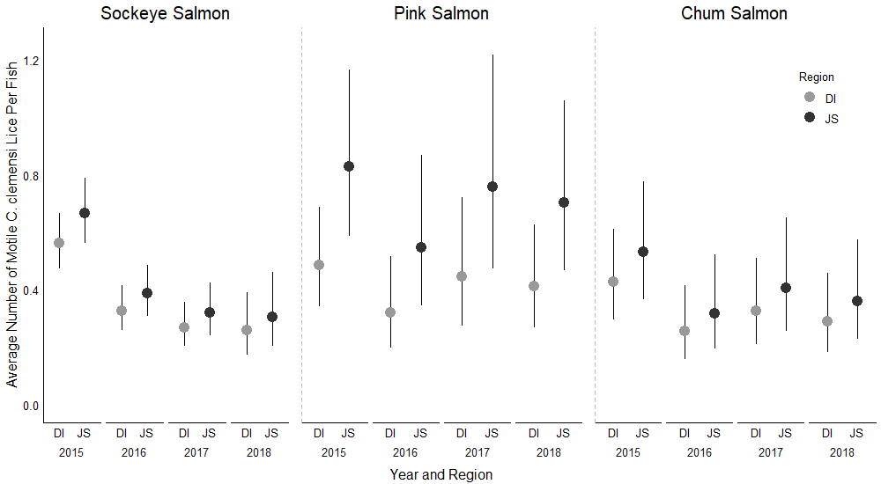

**Figure 8:** Estimated number of lice per fish for the two study regions, Johnstone Strait and the Discovery Islands, compared within salmon species for C. clemensi lice only.

**Greyscale Versions of all plots:**

