**Title**:

**Differential Infection of Juvenile Salmon by Parasitic Sea Lice (*Caligus clemensi* and *Lepeophtheirus salmonis*) in the Discovery Islands and Johnstone Strait, British Columbia**

**Authors:**

**Affiliations:**

**Abstract:**

Pacific salmon species represent some of most economically and culturally important fisheries in Canada. However, these species have seen significant decline in recent decades. Parasitism from sea lice (*Caligus clemensi* and *Lepeophtheirus salmonis*) likely plays a role in this decline.Understanding how sea lice parasitism affects this system is important for the survival and management of wild fish stocks as well as the management of farmed fish on the Pacific coast of Canada. To understand the species and region-level dynamics of this multi-host parasite system, we used a series of generalized linear mixed-effects models to compare infection loads of the two lice species among juvenile pink, chum, and sockeye salmon collected in the Discovery Islands and Johnstone Strait area of British Columbia. We show that *C. clemensi* were present at higher per-fish averages than *L. salmonis* with the highest levels on pink and sockeye salmon. *L. salmonis* were present at lower numbers on each of the three salmon species, but were higher on pink salmon than sockeye or chum salmon. *C. clemensi* was estimated to be present at higher rates in the Johnstone Strait than in the Discovery Islands for all three salmon. These results suggest that differences in host preference between the two lice or susceptibility between the three salmon species could be driving differences in lice abundance among these three species of Pacific salmon. Our results also indicate that the role of reservoir hosts and the possibility of apparent competition between wild Pacific herring and Pacific salmon should be considered to fully understand the dynamics of sea lice infection on juvenile Pacific salmon.

**Introduction:**

Many parasites infect more than one host species, and multi-host dynamics often involve a reservoir host (Haydon et al. 2002) that can maintain high levels of the parasite in the environment and in other smaller host populations. By facilitating the maintenance of high infection pressure and parasite abundance in small host populations, reservoir hosts effectively remove the typical density-dependent transmission dynamics that would otherwise either cause an epidemic or allow the parasite population to fade out (Anderson and May 1979). This allows said parasites to pose a threat to the long-term viability of the focal host population (Cleaveland et al. 2002, de Castro and Bolker 2005). When reservoir hosts are wild populations, apparent competition can arise between the host populations that share the parasite (Holt 1977, Holt and Lawton 1994, Power and Mitchell 2004, Kelly et al. 2009) When reservoir hosts are domesticated species, transmission dynamics involve spill-over and spill-back of infection between wild and domesticated hosts – a key mechanism underlying the emergence of infectious disease (Daszak et al. 2001).

In aquatic ecosystems, parasitism may play a role in fish recruitment, via direct mortality as well as effects on host behaviour, growth, predation risk, and reproductive success (Williams 1964, Barber et al. 2000, Longshaw et al. 2010, Krkosek et al. 2013). For fish, understanding the dynamics of multi-host parasite systems can be of importance for the health and management of farmed fish as well as the survival and management of wild fish stocks. Such is the case on the Pacific coast of British Columbia, Canada, where five species of wild Pacific salmon (*Oncorhynchus* sp*.*), farmed Atlantic salmon (*Salmo salar*), and possibly wild Pacific herring (*Clupea pallasii*), may indirectly interact via their shared ectoparasitic sea lice (*Lepeiotheirus salmonis* for the salmonids and *Caligus clemensi* for all species). All of the host species are of commercial importance, and the wild fish are also a focus of significant conservation and management efforts. Infection pressure of *L. salmonis and C. clemensi* on wild juvenile salmon has been linked with salmon farm activity in this region (Krkošek et al. 2005, 2007, Price et al. 2010), but how the dynamics of *L. salmonis* and *C. clemensi* vary among Pacific salmon species is not well resolved, nor is the role of herring in the system, which may provide a wild refuge host population for *C. clemensi.*

Pacific salmon make up some of the most important fisheries in Canada, not only with respect to their economic importance but also from a cultural and historical perspective (Cooke et al. 2004, Eliason et al. 2011, FAO 2015). However, these fisheries have seen significant declines in recent decades. The Fraser River sockeye salmon (*Oncorhynchus nerka*) in particular have seen large population declines, resulting in a federal judicial inquiry by the Canadian government (Cohen 2012). The current consensus is that multiple factors impact the survival and growth of these populations (Peterman et al. 2010, Connors et al. 2012). It is considered that threats during their early marine life might be most important in determining recruitment (Cohen 2012, Godwin et al. 2017). Fraser River sockeye salmon enter the marine environment together with pink and chum salmon where they collectively migrate through the Strait of Georgia, the Discovery Islands and Johnstone Strait, and then out through Queen Charlotte Sound to the open ocean (Fig. 1). When the juveniles leave their freshwater spawning areas, they encounter multiple factors including variable food availability, predators, and parasites (Hunt et al. 2018).

*Caligus clemensi* is a generalist parasite infecting multiple fish species, including salmonids and herring, whereas *Lepeophtheirus salmonis,* is considered a salmonid specialist (Johnson and Albright 1991)*.* These ectoparasitic copepods are native to the region, and feed on the surface tissues, musculature, and blood of their host fish (Costello 1993, Krkošek et al. 2009). Unable to survive in freshwater environments (Bricknell et al. 2006), sea lice naturally infect juvenile pink, chum, and sockeye salmon once they move out of their natal streams and rivers and into the marine environment. The abundances of sea lice observed on juvenile salmon in spring are a result of transmission primarily from other wild fish species and farmed fish in the shared marine environment because juvenile salmon enter the sea uninfected and most adult salmon have not yet returned to coastal waters. While some previous work has suggested that sockeye juveniles are infected primarily by *C. clemensi* (Price et al. 2011, Godwin et al. 2015), comparable estimates of both *C. clemensi* and *L. salmonis* among wild Pacific salmon species do not exist. To compare the multi-host dynamics of *C. clemensi and L. salmonis*, we conducted a comparative analysis of infection loads of the two species among juvenile pink, chum, and sockeye salmon collected as co-migrating groups in the Discovery Islands and Johnstone Strait area of British Columbia.

**Methods:**

These data come from the Hakai Juvenile Salmon Marine Survival Program which was set up in 2015 and is focussed on juvenile sockeye, pink, and chum salmon in the Discovery Islands region of British Columbia (Hunt et al. 2018). The program involves collection of juvenile salmon via purse seine at standard stations in the region, once or twice weekly during the spring outmigration season over four years (2015-2018). Individuals were sampled during the juvenile salmon seaward migration from May to July, at entry points to the Discovery Islands from the Strait of Georgia, and exit points from Johnstone Strait to Queen Charlotte Sound (Fig. 1). Sites were visited every 4-7 days in 2015/16, and then weekly in 2017/18. Purse seine nets (bunt: 27m x 9m with 13mm mesh; tow: 46m x 9m with 76mm mesh) were deployed from small, 6-8m twin-outboard research vessels to capture samples of heterospecific schools comprised of juvenile pink chum and sockeye salmon. The purse seine netting often also captured some sub-adult coho and chinook salmon, as well as Pacific herring. During sampling, observers on the research vessel would conduct a visual survey transect to assess the surface activity of juvenile salmon. If no surface activity was observed after 20 minutes, the seine net was not deployed at that location.

Once the seine had been deployed, it was used to corral the fish beside the boat, and juveniles were scooped up individually in seawater using a 4L plastic jug and transferred to a sampling bag. Some individuals were euthanized using a 250 mg • L-1 concentration of tricaine methanesulfonate, and retained for laboratory analysis, while the other captured fish underwent examination using a hand lens on the boat and then were released. Information regarding fish body size, as well as number, life stage, and species of any sea lice present were recorded, along with relevant environmental data. In years 2015/16 sea lice were counted and identified to all species-life stage combinations in a lab using a dissecting microscope whereas in 2018 motile-stage sea lice were counted and identified to species for motile-stage lice after capture by studying the fish in a seawater-filled plastic bag using a hand lens. Both methods were used in 2017.

We aggregated these parasite data and analyzed them at the level of motile stage *C. clemensi* and motile stage *L.* salmonis. For comparative analyses among the salmon species, we filtered the dataset for collections that had at least five individuals of each pink, chum, and sockeye salmon in, so that differences estimated were at the level of comigrating fish groups. This resulted in a dataset of over 1,800 individual fish. For comparison between regions, a larger dataset was used, totalling almost 6,000 observations divided between the two sampling regions, the Discovery Islands, and Johnstone Strait.

*Statistical Analyses*

To investigate potential differences in lice parasitism between the three salmon species, we fit a series of generalized linear mixed-effects models (GLMMs) to our data using the glmmTMB package (Brooks et al. 2017) in R statistical software (R Core Team, 2018), with salmon species, sampling year, and fish fork length as fixed effects, and collection as a random effect. These models were run separately for *C. clemensi* and *L. salmonis*. While the initial model set included all three fixed effects, including fork length resulted in a dataset with fewer observations, since fork length measurements were not taken for every fish. We therefore removed this variable in favour of including a larger number of observations. In addition, controlling for collection allowed us to account for abiotic differences between samples. Therefore, the full model set we used in our analysis incorporated salmon species and sampling year, as fixed effects (Table 1, 2).

The models employed a negative binomial error for the response distribution, as well as a log link function. The GLMMs were fit such that the number of lice per fish was treated as the response variable, and Akaike Information Criterion (AIC) was used to perform model comparison and selection. The results of these models were used to determine the predicted effect of each of the fixed effects on the number of lice per fish for each species of louse. This was done by back-transforming the coefficients from the models, and creating a 95% confidence interval using the ‘ggeffects’ package (Lüdecke 2018), representing the estimated number of lice per fish between the two species.

In addition to our models relating louse infections to the three salmon species, we wanted to determine the effect that sampling region had on infection levels. The two distinct sampling regions (Fig. 1), are traversed successively by the fish, moving from south to north in the region. As such, the Johnstone Strait represents a region wherein fish sampled will have typically had longer exposure to lice from all potential sources. To investigate any relevant differences, we ran a separate set of GLMMs, using the abundance of lice as the response variable, with the regions and years as fixed effects, and the week of the year (with 1 delineating the first week in January and counting numerically forwards from there) as a random effect. This resulted in two models, one for *L. salmonis* and one for *C. clemensi* for each of the three species of salmon*.* Akaike Information Criterion (AIC) was again used to perform model comparison and selection.

Finally, we used hierarchical bootstrapping to pair our model-driven estimates with estimates directly from the data to confirm that our predictions were appropriate given the data for our region-level models. For each unique salmon species, lice species, year, and site region combination (48 separate combinations, ex. Sockeye salmon, *L. salmonis,* 2015 and Discovery Islands), we bootstrapped the average number of lice per fish in an individual collection 10,000 times. This involved sampling all of the collections that each unique combination occurred in, with replacement, and calculating the mean number of lice per fish for that collection, allowing us to estimate the sampling distribution of the mean parasite abundances.

**Results:**

The average number of lice per individual fish varied from more than 4 lice per fish in some collections, to less than 0.5 in other collections (Fig. 2), with each collection showing at least some lice present, though not each collection showed lice on each species of salmon (Fig. 3). When looking separately at the two louse species, it is clear that not only is *C. clemensi* present at many more collections than *L. salmonis* but also generally present at higher numbers (Fig. 3). Additionally, the highest average numbers of lice per collection for *C. clemensi* were just under three lice per fish, while for *L. salmonis*, the highest average number of lice per fish was just under 2.5 per fish. In addition, there were very few *L. salmonis* present on sockeye salmon, compared to both pink and chum salmon.

Our species-level results indicated that both *C. clemensi* and *L. salmonis* infections were shown to be predicted most strongly by the full model with the additive combination of both fixed effects (Tables 3 & 4), indicating a clear signal of differences among salmon species in the abundances of the sea lice. The model results show estimates that *C. clemensi* was present at higher per-fish averages than *L. salmonis* (Fig. 3), with the highest levels on pink and sockeye salmon. *L. salmonis* were present at lower numbers on each of the three salmon species, but were higher on pink salmon than sockeye or chum salmon. Infection of the two lice species are notably more similar in 2015 and 2016 than they are in 2017 and 2018, with the levels of infection for *L. salmonis* being comparatively closer to that of *C. clemensi* during 2015 and 2016 than for the later two years. Sampling year differences are marked between both *C. clemensi* and *L. salmonis*, with estimated per-fish infections being highest in 2015, then seeing a relative decline in 2016/17 for both, with a small up-tick in 2018 for *C. clemensi*.

For the region-level models, AIC scores showed that the full model (both year and region) was the most supported by the data for five out of the six host-parasite species combinations. The one exception was the model for *L. salmonis* and sockeye salmon, which showed a better fit when only region was included (Tables 5-10). These models show that the much more abundant *C. clemensi* was estimated to be present at higher infection rates in the Johnstone Strait than in the Discovery Islands for all three salmon (Table 6, Figs. 5 & 6). The less abundant *L. salmonis* was present at slightly lower levels in Johnstone Strait than in the Discovery Islands for both pink and chum salmon, but was present at marginally higher levels in Johnstone Strait than in the Discovery Islands for sockeye salmon.

Bootstrap results showed that our model estimates were well within the 95% confidence limits displayed by the data (Fig. 7). These results confirmed the relatively low abundance estimates of *L. salmonis* in the system, with all median values for *L. salmonis* being equal to zero with only three exceptions. General infection patterns were present for the bootstrapped data as well, with *C. clemensi* showing high prevalence on pink salmon, and intermediate prevalence on the other two species.

**Discussion:**

Our results reveal large differences in the relative contribution of *C. clemensi* versus *L. salmonis* to the total sea lice burden on juvenile Pacific salmon. *C. clemensi* was much more abundant than *L. salmonis* across nearly all collections and across all three salmon species, indicating that this generalist parasite comprises most of the overall infection pressure of sea lice on juvenile Pacific salmon in this area. One explanation for this pattern is that there are more host species for *C. clemensi* in this system, as it is a generalist that infects salmonids as well as other hosts, including wild Pacific herring, which are abundant in the region (Beamish et al. 2009). Although outbreaks of *L. salmonis* from salmon farms have been shown to affect fitness of juvenile salmon (Krkošek et al. 2006) and are negatively correlated with marine survival (Krkošek et al. 2007), these specialist lice have fewer competent hosts and were much less abundant than *C. clemensi* in the study area and time period. The two main reservoir hosts that could explain the high abundance of *C. clemensi* observed on juvenile salmon are wild Pacific herring and farmed Atlantic salmon.

Our results also suggest that pink salmon are a more competent host for both species of louse than sockeye or chum salmon. However, it is not possible to determine from the data whether these differences arise due to a) differential contact or infection rates of newly-attached copepodites, b) differential subsequent survival of parasites amongst host fish species, or c) both of these phenomena in concert. In addition, Fig. 5 clearly shows that sockeye salmon experience the largest difference in parasite abundance between the two louse species. These results reinforce the idea that *C. clemensi* is the primary louse infecting juvenile wild Pacific salmon in this area (Price et al. 2011, Godwin et al. 2017), and that this is particularly the case for sockeye salmon relative to pink or chum salmon.

Management of sea lice on salmon farms is primarily focussed on *L.* salmonis rather than *C. clemensi*. If we expect lice coming from salmon farms to be primarily *L. salmonis*, then our results suggest there is a alternative large reservoir of *C. clemensi* in the environment, likely Pacific herring (Morton et al. 2008, Beamish et al. 2009, Godwin et al. 2017). While Pacific herring are common in the environment and are known to carry infections of *C. clemensi* (Krkošek et al. 2007, Morton et al. 2008, Krkošek 2017), some sources have reported very high abundances of *C. clemensi* on salmon farms (Di Cicco et al. 2017) and thus suggest that salmon farms may be the major source of *C. clemensi* on juvenile Pacific salmon. However, such high abundances are likely aberrations rather than the norm, as confirmed by a comparison of louse species abundance on farmed salmon in the area (Godwin et al. i*n Prep*). In addition, Pacific herring have recently been at high abundances during the years of our study (DFO 2019). More data are needed regarding infection levels and the spatial distribution of herring to further evaluate the possibility of herring functioning as a reservoir host population for *C. clemensi*. Should Pacific herring in fact be the primary source of *C. clemensi* infections to juvenile Pacific salmon, then our results indicate that apparent competition between Pacific herring and juvenile Pacific salmon may occur, particularly for sockeye salmon.

The potential of Pacific herring to be the primary source of *C. clemensi* on juvenile salmon is reinforced via our region-level results. Fig. 6, which displays the results of our region-level model clearly shows that the generalist louse is present at higher levels in Johnstone Strait relative to the Discovery Islands. These model-driven results are confirmed by our hierarchical bootstrapping (Fig. 8) which shows the same patterns, albeit with one exception (chum salmon in 2015). The reason that higher *C. clemensi* abundances in Johnstone Strait implicate Pacific herring as a primary source is simply that it differs from our estimates for the specialist louse. Since it is reasonable to assume that a large proportion of *L. salmonis* are in fact coming from farmed Atlantic salmon, this region-level pattern should persist if this source is also the most important for *C. clemensi*. The fact that these region-level patterns differ indicates the source pathway also differs, and when combined with the fact that spawning biomass of Pacific herring has been reaching record highs (DFO 2019) these results further suggest that Pacific herring are the likely culprit.

Our study has not taken into account all of the various abiotic factors that are thought to influence sea lice infection rates. For example, *L. salmonis* has been reported to show higher rates of settlement and higher rates of survival on the host fish with increased water temperatures (Tucker et al. 2000, Stien et al. 2005). This indicates that warming climates and subsequently warming water temperatures are likely to have a negative impact with regards to infection pressure on migrating juvenile salmon, particularly during spring and early summer when juvenile salmon are at their smallest and most vulnerable. Settlement and survival of *L. salmonis* also decreases with lowered salinity (Bricknell et al. 2006), and climate-driven changes in salinity could have an effect on survival rates of host fish. Further work is also needed in this regard to gain a more complete understanding of this multi-host parasite system not only as it currently stands, but how further anthropogenic change will alter its dynamics in the future

Our data describe a sympatric outmigration of three species of Pacific salmon, all of comparable sizes, migrating in heterospecific schools through the same region, and experiencing the same infection pressures from various transmission sources. Nonetheless, our results reveal large variation in infection levels both among species of salmon and by louse species. Pink salmon clearly show the highest levels of infection from both species of louse, indicating that they likely support most of the louse population on juvenile salmon in this region and that they are likely the most competent hosts for both species of louse. These results suggest that there are differences in host preference or host specificity between these two lice, or differing susceptibility to lice among the three species of Pacific salmon. Previous work has shown that infection from *L. salmonis* results in particular negative effects in sockeye salmon that are not observed in Atlantic salmon (Long et al. 2019). While no comparative measures of differing susceptibility nor differing impact of infection exist between Pacific salmon species, previous work and the results presented here suggest that such differences are likely. For conservation management of wild salmon in this area, these results indicate that of the sea lice, *C. clemensi* may be of larger importance than *L. salmonis* – a departure from the focus on *L. salmonis* in management of farmed fish both in British Columbia and internationally. Finally, our results indicate that the role of herring and the possibility of apparent competition between herring and salmon should be considered to understand sea lice dynamics on juvenile Pacific salmon from the Fraser River.

**Acknowledgements**

**Table 1:** AIC table for *L. salmonis* and *C. clemensi* full model set.

|  |  |  |  |  |  |  |
| --- | --- | --- | --- | --- | --- | --- |
| **Model Fixed Effects** | **Lice Species** | **Negative Log Likelihood** | **AIC value** | | **Delta-AIC value** | |
| **Null** | *C. clemensi* | -1509.7 | 3025.5 | | 27.9 | |
| **Year** | *C. clemensi* | -1502.8 | 3017.7 | | 20.1 | |
| **Species** | *C. clemensi* | -1497.3 | 3004.7 | | 7.1 | |
| **Species, Year** | *C. clemensi* | -1490.7 | 2997.6 | | 0.0 | |
| **Null** | *L. salmonis* | -461.3 | | 928.7 | 75.8 |
| **Year** | *L. salmonis* | -452.4 | | 916.7 | 63.9 |
| **Species** | *L. salmonis* | -427.8 | | 865.7 | 12.8 |
| **Species, Year** | *L. salmonis* | -418.4 | | 852.8 | 0.0 |

**Table 2:** Model results for the highest ranked models according to the AIC results

|  |  |  |  |
| --- | --- | --- | --- |
| **Model Output** | **Lice Species** | **Coefficient** | **Standard Error** |
| **Chum** | *L. salmonis* | -2.0747 | 0.3620 |
| **Pink** | *L. salmonis* | -1.2833 | 0.3241 |
| **Sockeye** | *L. salmonis* | -3.5723 | 0.4034 |
| **2016** | *L. salmonis* | -0.6621 | 0.3923 |
| **2017** | *L. salmonis* | -2.1076 | 0.9000 |
| **2018** | *L. salmonis* | -2.1381 | 0.5178 |
| **Chum** | *C. clemensi* | -0.9367 | 0.1667 | |
| **Pink** | *C. clemensi* | -0.3512 | 0.1508 | |
| **Sockeye** | *C. clemensi* | -0.4703 | 0.1467 | |
| **2016** | *C. clemensi* | -0.6012 | 0.1735 | |
| **2017** | *C. clemensi* | -0.8461 | 0.3117 | |
| **2018** | *C. clemensi* | -0.5259 | 0.1935 | |

**Table 3:** AIC table for region level effects of data for *C. clemensi* and chum salmon

|  |  |  |  |  |  |
| --- | --- | --- | --- | --- | --- |
| **Fixed Effects** | **Lice Species** | **Salmon Species** | **Negative Log Likelihood** | **AIC value** | **Delta-AIC value** |
| **Null** | *C. clemensi* | Chum | -1062.0 | 2130.0 | 9.2 |
| **Site Region** | *C. clemensi* | Chum | -1060.2 | 2128.4 | 7.6 |
| **Year** | *C. clemensi* | Chum | -1055.8 | 2123.6 | 2.8 |
| **Site Region, Year** | *C. clemensi* | Chum | -1053.4 | 2120.8 | 0.0 |
| **Null** | *C. clemensi* | Pink | -907.8 | 1821.6 | 26.0 |
| **Site Region** | *C. clemensi* | Pink | -894.3 | 1796.5 | 1.0 |
| **Year** | *C. clemensi* | Pink | -907.0 | 1819.9 | 24.4 |
| **Site Region, Year** | *C. clemensi* | Pink | -890.8 | 1795.5 | 0.0 |
| **Null** | *C. clemensi* | Sockeye | -3281.3 | 6568.5 | 101.1 |
| **Site Region** | *C. clemensi* | Sockeye | -3275.3 | 6558.5 | 91.1 |
| **Year** | *C. clemensi* | Sockeye | -3229.9 | 6471.7 | 4.3 |
| **Site Region, Year** | *C. clemensi* | Sockeye | -3226.7 | 6467.4 | 0.0 |
| **Null** | *L. salmonis* | Chum | -258.7 | 523.5 | 12.9 |
| **Site Region** | *L. salmonis* | Chum | -256.8 | 521.5 | 11.0 |
| **Year** | *L. salmonis* | Chum | -251.1 | 514.2 | 3.7 |
| **Site Region, Year** | *L. salmonis* | Chum | -248.3 | 510.6 | 0.0 |
| **Null** | *L. salmonis* | Pink | -385.5 | 777.1 | 48.9 |
| **Site Region** | *L. salmonis* | Pink | -384.6 | 777.2 | 49 |
| **Year** | *L. salmonis* | Pink | -359.1 | 730.2 | 2.0 |
| **Site Region, Year** | *L. salmonis* | Pink | -357.1 | 728.2 | 0.0 |
| **Null** | *L. salmonis* | Sockeye | -392.3 | 790.5 | 6.7 |
| **Site Region** | *L. salmonis* | Sockeye | -387.9 | 783.8 | 0.0 |
| **Year** | *L. salmonis* | Sockeye | -390.1 | 792.3 | 8.5 |
| **Site Region, Year** | *L. salmonis* | Sockeye | -386.7 | 787.5 | 3.7 |

**Table 6:** Model results for the region-level models for all three species of salmon

|  |  |  |  |  |  |
| --- | --- | --- | --- | --- | --- |
| **Fixed Effect** | ***Lice Species*** | Salmon Species | Coefficient | Standard Error | |
| **Discovery Islands** | ***C. clemensi*** | Chum | -0.8537 | 0.1846 | |
| **Johnstone Strait** | ***C. clemensi*** | Chum | -0.6314 | 0.1926 | |
| **2016** | ***C. clemensi*** | Chum | -0.5131 | 0.1637 | |
| **2017** | ***C. clemensi*** | Chum | -0.2677 | 0.1306 | |
| **2018** | ***C. clemensi*** | Chum | -0.3880 | 0.1352 | |
| **Discovery Islands** | ***C. clemensi*** | Pink | -0.7243 | 0.1773 | |
| **Johnstone Strait** | ***C. clemensi*** | Pink | -0.1891 | 0.1751 | |
| **2016** | ***C. clemensi*** | Pink | -0.4151 | 0.1591 | |
| **2017** | ***C. clemensi*** | Pink | -0.0865 | 0.1647 | |
| **Discovery Islands** | ***C. clemensi*** | Sockeye | -0.5722 | 0.0929 | |
| **Johnstone Strait** | ***C. clemensi*** | Sockeye | -0.4152 | 0.0926 | |
| **2016** | ***C. clemensi*** | Sockeye | -0.5296 | 0.0710 | |
| **2017** | ***C. clemensi*** | Sockeye | -0.7348 | 0.1012 | |
| **Discovery Islands** | ***L. salmonis*** | Chum | -2.3025 | 0.2821 | |
| **Johnstone Strait** | ***L. salmonis*** | Chum | -3.1487 | 0.3838 | |
| **2016** | ***L. salmonis*** | Chum | 0.4227 | 0.4203 | |
| **2017** | ***L. salmonis*** | Chum | -1.2784 | 0.4857 | |
| **Discovery Islands** | ***L. salmonis*** | Pink | -0.8806 | 0.1975 |
| **Johnstone Strait** | ***L. salmonis*** | Pink | -1.3489 | 0.2128 |
| **2016** | ***L. salmonis*** | Pink | -0.6860 | 0.2576 |
| **2017** | ***L. salmonis*** | Pink | -1.6262 | 0.4798 |
| **2018** | ***L. salmonis*** | Pink | -2.2009 | 0.3248 |
| **Discovery Islands** | ***L. salmonis*** | Sockeye | -4.5724 | 0.322 |
| **Johnstone Strait** | ***L. salmonis*** | Sockeye | -3.8232 | 0.296 |

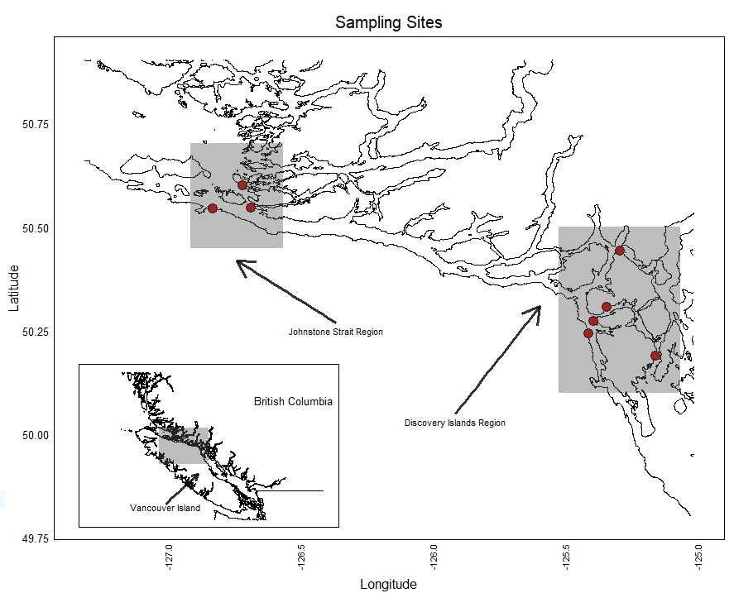

**Figure 1:** The study region, on the west coast of British Columbia, Canada. All sites lie in the Discovery Islands or Johnstone Strait regions, wedged between the western coast of the mainland, and the east coast of Vancouver Island. This is the region that is most heavily developed for fish farming.

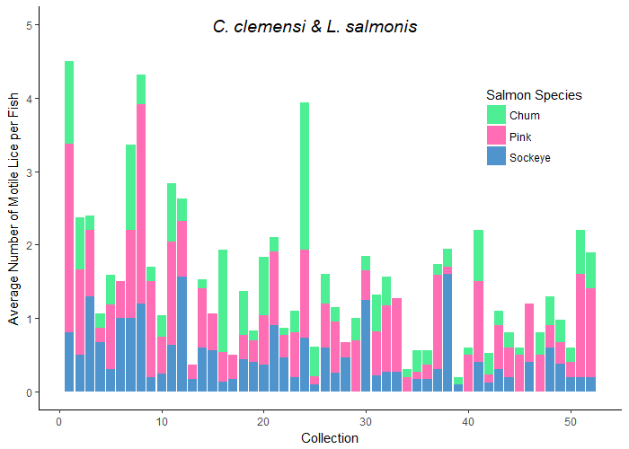

**Figure 2:** Here we see the average number of lice per fish (both lice species as well as individuals at unidentified stages combined), for each collection across the data. The colours in each collection represent the species of salmon**.**

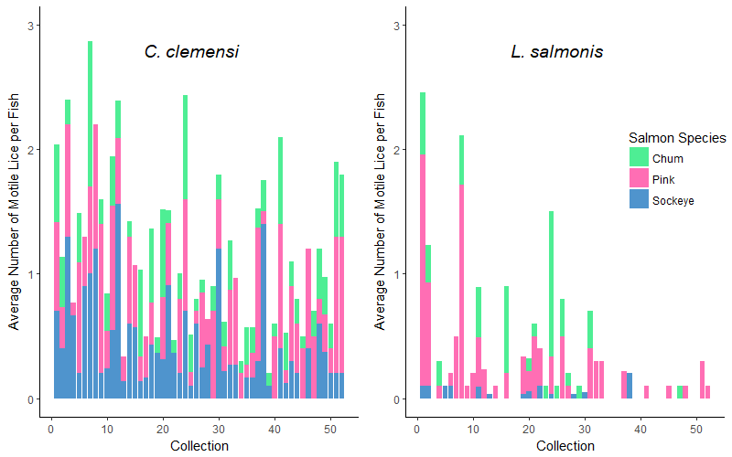

**Figure 3:** Here we see the average number of lice per fish in each collection, divided into two plots to separate by louse species, and divided by colour to separate by fish species.. Visually, pink salmon seem to have higher average numbers of *L. salmonis*.

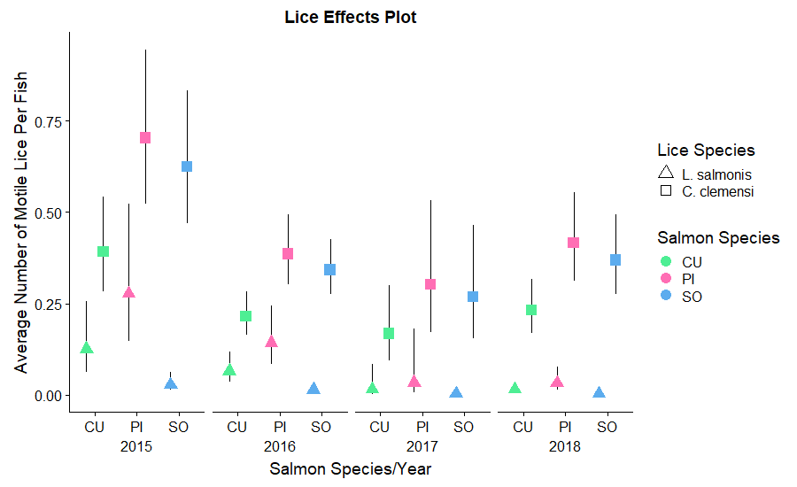

**Figure 4:** Estimated number of lice per fish for *C. clemensi* & *L. salmonis,* divided by sampling year, as well as by salmon species, and grouped by site region. These estimates were derived from the model output of our best model according to AIC analysis, and thus give estimates relative to each of the significant predictor variables.

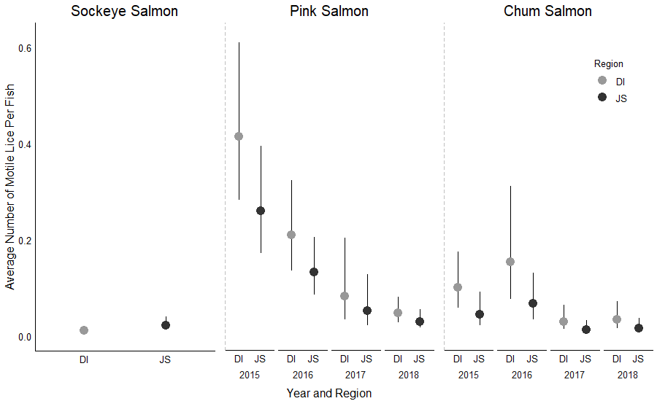

**Figure 5:** Estimated number of lice per fish for the two study regions, Johnstone Strait and the Discovery Islands, compared within salmon species for *L. salmonis* lice only. These estimates area a result of our region-level models. The sockeye-*L. salmonis* data combination AIC scores indicated that a model with only site region effects fit better than a model with site region and year, whereas all other AIC scores indicated that the full model with both fixed effects was preferred.

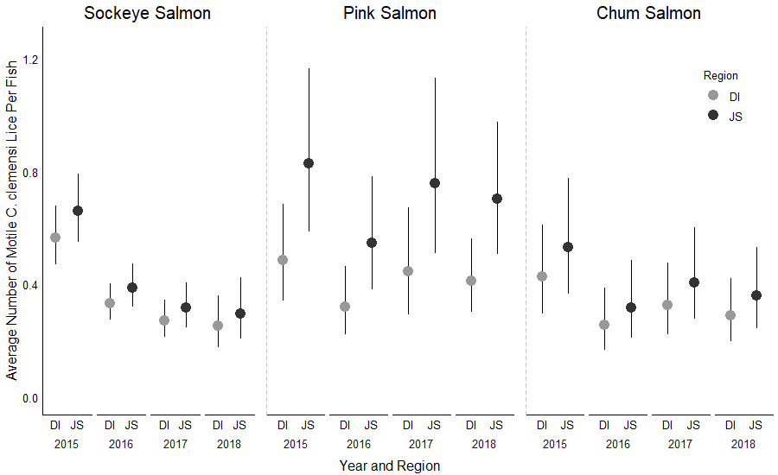

**Figure 6:** Estimated number of lice per fish for the two study regions, Johnstone Strait and the Discovery Islands, compared within salmon species for *C. clemensi* lice only, and across the four sampling years.

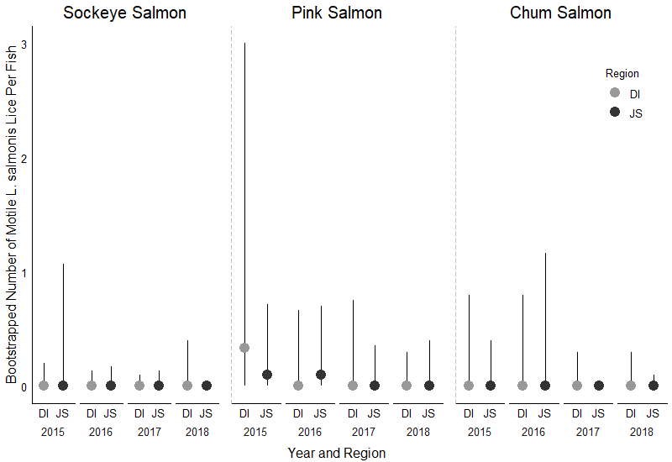

**Figure 7:** Bootstrapped median and 95% confidence intervals for the number of *L. salmonis* per fish for the two study regions, Johnstone Strait and the Discovery Islands, compared within salmon species.

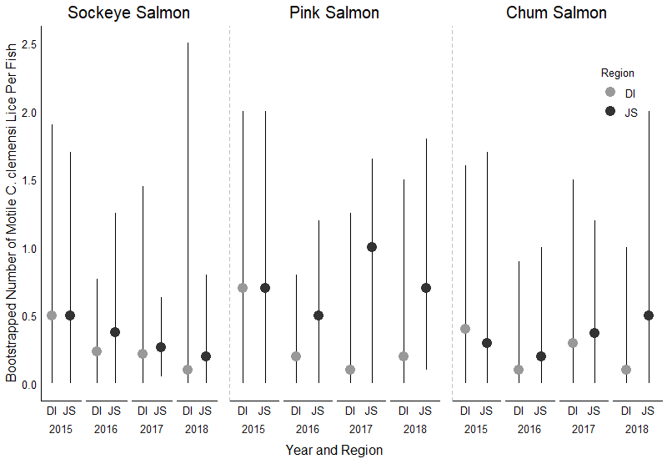

**Figure 8:** Bootstrapped median and 95% confidence intervals for the number of *C. clemensi* per fish for the two study regions, Johnstone Strait and the Discovery Islands, compared within salmon species.

**References:**

Anderson, R. M., and R. M. May. 1979. Population biology of infectios diseases: Part I. Nature 280:361–367.

Barber, I., D. Hoare, and J. Krause. 2000. Effects of parasites on fish behaviour: a review and evolutionary perspective. Reviews in Fish Biology and Fisheries 10:131–165.

Beamish, R., J. Wade, W. Pennell, E. Gordon, S. Jones, C. Neville, K. Lange, and R. Sweeting. 2009. A large, natural infection of sea lice on juvenile Pacific salmon in the Gulf Islands area of British Columbia, Canada. Aquaculture 297:31–37.

Bricknell, I. R., S. J. Dalesman, B. O’Shea, C. C. Pert, and A. J. Mordue Luntz. 2006. Effect of environmental salinity on sea lice Lepeophtheirus salmonis settlement success. Diseases of Aquatic Organisms 71:201–212.

Brooks, M. E., K. Kristensen, K. J. van Benthem, A. Magnusson, C. W. Berg, A. Nielsen, H. J. Skaug, M. Mächler, and B. M. Bolker. 2017. glmmTMB balances speed and flexibility among packages for zero-inflated generalized linear mixed modeling. The R Journal 9:378–400.

de Castro, F., and B. Bolker. 2005. Mechanisms of disease-induced extinction. Ecology Letters 8:117–126.

Cleaveland, S., G. R. Hess, A. P. Dobson, M. K. Laurenson, H. I. McCallum, M. G. Roberts, and R. Woodroffe. 2002. The role of pathogens in biological conservation. Pages 139–150 The Ecology of Wildlife Diseases.

Cohen, B. I. 2012. Commission of Inquiry into the Decline of Sockeye Salmon in the Fraser River (Canada) The uncertain future of Fraser River sockeye Final Report – October 2012.

Connors, B. M., D. C. Braun, R. M. Peterman, A. B. Cooper, J. D. Reynolds, L. M. Dill, G. T. Ruggerone, and M. Krkošek. 2012. Migration links ocean-scale competition and local ocean conditions with exposure to farmed salmon to shape wild salmon dynamics. Conservation Letters 5:304–312.

Cooke, S. J., S. G. Hinch, A. P. Farrell, M. F. Lapointe, S. R. M. Jones, S. J. Macdonald, D. A. Patterson, M. C. Healey, and G. Van Der Kraak. 2004. Abnormal migration timing and high en route mortality of Sockeye Salmon in the Fraser river, British Columbia. Fisheries 29:23–32.

Costello, M. J. 1993. Review of methods to control sea lice (Caligidae: Crustacea) infestations on salmon (Salmo salar) farms.

Daszak, P., A. A. Cunningham, and A. D. Hyatt. 2001. Anthropogenic environmental change and the emergence of infectious diseases in wildlife. Acta Tropica 78:103–116.

DFO. 2019. Stock Assessment and Management Advice for BC Pacific Herring: 2018 Status and 2019 Forecast. Page 62. DFO Can. Sci. Advis. Sec. Sci. Resp.

Di Cicco, E., H. W. Ferguson, A. D. Schulze, K. H. Kaukinen, S. Li, R. Vanderstichel, Ø. Wessel, E. Rimstad, I. A. Gardner, K. L. Hammell, and K. M. Miller. 2017. Heart and skeletal muscle inflammation (HSMI) disease diagnosed on a British Columbia salmon farm through a longitudinal farm study. PLOS ONE 12:e0171471.

Eliason, E. J., T. D. Clark, M. J. Hague, L. M. Hanson, Z. S. Gallagher, K. M. Jeffries, M. K. Gale, D. A. Patterson, S. G. Hinch, and A. P. Farrell. 2011. Differences in Thermal Tolerance Among Sockeye Salmon Populations. Science 332:109–112.

FAO. 2015. FAO Global Capture Production database updated to 2013 - Summary information.

Godwin, S. C., L. M. Dill, J. D. Reynolds, and M. Krkošek. 2015. Sea lice, sockeye salmon, and foraging competition: lousy fish are lousy competitors. Canadian Journal of Fisheries and Aquatic Sciences 72:1113–1120.

Godwin, S. C., M. Krkošek, J. D. Reynolds, L. A. Rogers, and L. M. Dill. 2017. Heavy sea louse infection is associated with decreased stomach fullness in wild juvenile sockeye salmon. Canadian Journal of Fisheries and Aquatic Sciences 75:1587–1595.

Haydon, D. T., S. Cleaveland, L. H. Taylor, and M. K. Laurenson. 2002. Identifying reservoirs of infection: a conceptual and practical challenge. Emerging infectious diseases 8:1468–73.

Holt, R. D. 1977. Predation, Apparent Competition, and the Structure of Prey Communities. Theoretical Population Biology 12:197–229.

Holt, R. D., and J. H. Lawton. 1994. The Ecological Consequences of Shared Natural Enemies. Annual Review of Ecology and Systematics 25:495–520.

Hunt, B. P. V., B. T. Johnson, S. C. Godwin, M. Krkošek, E. A. Pakhomov, and L. A. Rogers. 2018. The Hakai Institute Juvenile Salmon Program : Early Life History Drivers of Marine Survival in Sockeye , Pink and Chum Salmon in British Columbia. Page 14.

Johnson, S. C., and L. J. Albright. 1991. Development, growth, and survival of lepeophtheirus salmonis (Copepoda: Caligidae) under laboratory conditions. Journal of the Marine Biological Association of the United Kingdom 71:425–436.

Kelly, D. W., R. A. Paterson, C. R. Townsend, R. Poulin, and D. M. Tompkins. 2009. Parasite spillback: A neglected concept in invasion ecology? Pages 2047–2056.

Krkošek, M., J. S. Ford, A. Morton, S. Lele, R. A. Myers, and M. A. Lewis. 2007. Declining Wild Salmon Populations in Relation to Parasites from Farm Salmon. Science 40:1772 – 1775.

Krkošek, M., M. A. Lewis, and J. P. Volpe. 2005. Transmission dynamics of parasitic sea lice from farm to wild salmon. Proceedings of the Royal Society B: Biological Sciences 272:689–696.

Krkošek, M., M. A. Lewis, J. P. Volpe, and A. Morton. 2006. Fish Farms and Sea Lice Infestations of Wild Juvenile Salmon in the Broughton Archipelago—A Rebuttal to. Reviews in Fisheries Science 14:1–11.

Krkošek, M., Morton, J. P. Volpe, and M. A. Lewis. 2009. Sea lice and salmon population dynamics: effects of exposure time for migratory fish. Proceedings of the Royal Society B: Biological Sciences 276:2819–2828.

Krkosek, M., C. W. Revie, P. G. Gargan, O. T. Skilbrei, B. Finstad, and C. D. Todd. 2013. Impact of parasites on salmon recruitment in the Northeast Atlantic Ocean. Proceedings. Biological sciences 280:20122359.

Long, A., K. A. Garver, and S. R. M. Jones. 2019. Differential Effects of Adult Salmon Lice Lepeophtheirus salmonis on Physiological Responses of Sockeye Salmon and Atlantic Salmon. Journal of Aquatic Animal Health 31:75–87.

Longshaw, M., P. A. Frear, A. D. Nunn, I. G. Cowx, and S. W. Feist. 2010. The influence of parasitism on fish population success. Fisheries Management and Ecology 17:426–434.

Lüdecke, D. 2018. ggeffects: Tidy Data Frames of Marginal Effects from Regression Models. The Journal of Open Source Software 3.

Morton, A., R. Routledge, and M. Krkoš. 2008. Sea Louse Infestation in Wild Juvenile Salmon and Pacific Herring Associated with Fish Farms off the East-Central Coast of Vancouver Island, British Columbia. North American Journal of Fisheries Management 28:523–532.

Peterman, R. M., D. Marmorek, B. Beckman, and M. Bradford. 2010. Synthesis of evidence from a workshop on the decline of Fraser River sockeye. A Report to the Pacific Salmon Commission, Vancouver, B.C.:123pp.

Power, A. G., and C. E. Mitchell. 2004. Pathogen Spillover in Disease Epidemics. The American Naturalist 164:S79–S89.

Price, M. H. H., A. Morton, and J. D. Reynolds. 2010. Evidence of farm-induced parasite infestations on wild juvenile salmon in multiple regions of coastal British Columbia, Canada. Canadian Journal of Fisheries and Aquatic Sciences 67:1925–1932.

Price, M. H. H., S. L. Proboszcz, R. D. Routledge, A. S. Gottesfeld, C. Orr, and J. D. Reynolds. 2011. Sea louse infection of juvenile sockeye salmon in relation to marine salmon farms on Canada’s west coast. PLoS ONE 6:e16851.

Stien, A., P. A. Bjorn, P. A. Heuch, and D. A. Elston. 2005. Population dynamics of salmon lice Lepeophtheirus salmonis on Atlantic salmon and sea trout. Marine Ecology Progress Series 290:263–275.

Tucker, C. S., C. Sommerville, and R. Wootten. 2000. The effect of temperature and salinity on the settlement and survival of copepodids of Lepeophtheirus salmonis (Krøyer, 1837) on Atlantic salmon, Salmo salar L. Journal of Fish Diseases 23:309–320.

Williams, H. H. 1964. Some observations on the mass mortality of the freshwater fish Rutilus rutilus (L.)*. Parasitology 54:155–171.