**Title**:

**Differential Infestation of Juvenile Salmon by Parasitic Sea Lice (*Caligus clemensi* and *Lepeophtheirus Salmonis*) in the Discovery Islands and Johnstone Strait, British Columbia**

**Authors:**

**Affiliations:**

**Target Journal:** TAFS? *Article:* Title Page (title, names, addresses, title should be <12 words. No keywords). Abstract (<300 words). Intro. Methods. Results. Discussion. Acknowledgements. References. Tables. Figure Captions. Figures.

**Abstract:**

Pacific Salmon species represent some of most economically and culturally important fisheries in Canada. However, some populations have seen significant decline in recent decades. Parasitism from sea lice (*Caligus clemensi* and *Lepeophtheirus Salmonis*) may play a role in these declines.Understanding how sea lice parasitism affects Pacific Salmon in this region is important for the survival and management of wild fish stocks as well as the management of farmed fish on the Pacific coast of Canada. To understand the species and region-level dynamics of this multi-host parasite system, we used a series of generalized linear mixed-effects models to compare infestation loads of the two lice species among juvenile Pink, Chum, and Sockeye Salmon collected in the Discovery Islands and Johnstone Strait area of British Columbia, which represents an important migration corridor for the biggest Salmon watershed in Canada. We show that the generalist louse species, *C. clemensi,* were present at higher per-fish abundances than the specialist louse, *L. Salmonis,* with the highest levels on Pink and Sockeye Salmon. *L. Salmonis* were present at lower numbers on each of the three Salmon species, but were higher on Pink Salmon than Sockeye or Chum Salmon. *C. clemensi* was estimated to be present at higher rates in the Johnstone Strait than in the Discovery Islands during the majority of our study for all three Salmon. These results suggest that differences in host preference between the two lice or susceptibility between the three Salmon species could be driving differences in lice abundance among these three species of Pacific Salmon. Our results also indicate that the role of separate reservoir hosts and the possibility of abundant wild Pacific Herring bolstering lice populations, leading to apparent competition with Pacific Salmon, should be considered to fully understand the dynamics of sea lice infestation on juvenile Pacific Salmon.

**Introduction:**

Many parasites infect more than one host species, and multi-host dynamics often involve a reservoir host (Haydon et al. 2002) that can maintain high levels of the parasite in the environment and in other smaller host populations. By facilitating the maintenance of high infestation pressure and parasite abundance in small host populations, reservoir hosts effectively remove the typical density-dependent transmission dynamics that would otherwise either cause an epidemic or allow the parasite population to fade out (Anderson and May 1979). This allows said parasites to pose a threat to the long-term viability of the focal host population (Cleaveland et al. 2002, de Castro and Bolker 2005). Reservoir hosts can provide an alternative resource to the parasite, thus allowing growth of the parasite population, with negative implications for the focal host population – a phenomenon known as ‘apparent competition’ (Holt 1977, Holt and Lawton 1994, Power and Mitchell 2004, Kelly et al. 2009). When reservoir hosts are domesticated species, transmission dynamics involve spill-over and spill-back of infestation between wild and domesticated hosts – a key mechanism underlying the emergence of infectious disease (Daszak et al. 2001).

In aquatic ecosystems, parasitism may play a role in fish recruitment, via direct mortality as well as effects on host behaviour, growth, predation risk, and reproductive success (Williams 1964, Barber et al. 2000, Longshaw et al. 2010, Krkosek et al. 2013). For fish, understanding the dynamics of multi-host parasite systems can be of importance for the health and management of farmed fish as well as the survival and management of wild fish stocks (Hedrick 1998). Such is the case on the Pacific coast of British Columbia, Canada, where five species of wild Pacific Salmon (*Oncorhynchus* spp*.*), farmed Atlantic Salmon (*Salmo salar*), and wild Pacific Herring (*Clupea pallasii*) indirectly interact via their shared ectoparasitic sea lice (*Lepeophtheirus Salmonis* for the Salmonids and *Caligus clemensi* for all species). All of the host species are of commercial importance, and the wild fish are also a focus of significant conservation and management efforts. Infestation pressure of *L. Salmonis and C. clemensi* on wild juvenile Salmon is strongly correlated with Salmon farm activity in this region (Price et al. 2010, Marty et al. 2010), but how the dynamics of *L. Salmonis* and *C. clemensi* vary among Pacific Salmon species is not well resolved, nor is the role of Herring in the system, which may provide a wild refuge host population for *C. clemensi* (Morton et al. 2008b, Beamish et al. 2009)*.*

Pacific Salmon make up some of the most important fisheries in Canada, not only with respect to their economic importance but also from a cultural and historical perspective (Cooke et al. 2004, Eliason et al. 2011, FAO 2015). However, some populations have seen significant declines in recent decades. Fraser River Sockeye Salmon (*Oncorhynchus nerka*) in particular have seen large declines in productivity, resulting in a federal judicial inquiry by the Canadian government into the causes of these declines (Cohen 2012). The current consensus is that multiple factors impact the survival and growth of these populations (Peterman et al. 2010, Connors et al. 2012). It is possible that threats during their early marine life might be most important in determining recruitment (Cohen 2012). Fraser River Sockeye Salmon enter the marine environment together with Pink and Chum Salmon where they collectively migrate through the Strait of Georgia, the Discovery Islands and Johnstone Strait, and then out through Queen Charlotte Sound to the open ocean (Fig. 1). When the juveniles leave their freshwater spawning areas, they experience multiple stressors including variable food availability, predators, and parasites (Hunt et al. 2018).

*Caligus clemensi* is a generalist parasite infecting multiple fish species, including Salmonids and Herring, whereas *Lepeophtheirus Salmonis,* is considered a Salmonid specialist (Johnson and Albright 1991)*.* These ectoparasitic copepods are native to the region, and both the major life stages, ‘motile’ (pre-adult and adult) and ‘attached’ (copepodite and chalimus), feed on the surface tissues, musculature, and blood of their host fish (Costello 1993, Krkošek et al. 2009). Unable to survive in freshwater environments (Bricknell et al. 2006), sea lice naturally infect juvenile Pink, Chum, and Sockeye Salmon once they move out of their natal streams and rivers and into the marine environment. The abundances of sea lice observed on juvenile Salmon in spring are a result of transmission from other wild fish species and farmed Salmon in the shared marine environment because juvenile Salmon enter the sea uninfected and most adult Salmon have not yet returned to coastal waters. While some previous work has suggested that Sockeye juveniles are infected primarily by *C. clemensi* (Price et al. 2011, Godwin et al. 2015), comparable estimates of both *C. clemensi* and *L. Salmonis* among wild Pacific Salmon species do not exist. In order to understand the sources and impacts of parasitism from sea lice on these species of interest, we first need to understand how their infection dynamics differ and what the drivers of those dynamics are. Our goal was to determine the effect that host species and sampling area have on infestation levels. The two distinct sampling area (Fig. 1), are traversed successively by the fish, moving from south to north. As such, the Johnstone Strait represents an area wherein fish sampled will have typically had longer exposure to lice from all potential sources. To compare the multi-host dynamics of *C. clemensi and L. Salmonis*, we conducted a comparative analysis of infestation loads of the two louse species among juvenile Pink, Chum, and Sockeye Salmon collected as co-migrating groups in the Discovery Islands and Johnstone Strait area of British Columbia.

**Methods:**

These data come from the Hakai Institute’s Juvenile Salmon Program (JSP) which was set up in 2015 and is focused on juvenile Sockeye, Pink, and Chum Salmon in the Discovery Islands and Johnstone Strait areas of British Columbia (Hunt et al. 2018). Detailed sampling methods for the JSP are described in Hunt et al. (2018). Briefly, we collected juvenile Salmon via purse seine at standard stations in the region, once or twice weekly during the spring outmigration season over four years (2015-2018). Individuals were sampled during the juvenile Salmon seaward migration from May to July, at entry points to the Discovery Islands from the Strait of Georgia, and exit points from Johnstone Strait to Queen Charlotte Sound (Fig. 1). Sites were visited every 4-7 days in 2015/16, and then weekly in 2017/18. Purse seine nets (bunt: 27m x 9m with 13mm mesh; tow: 46m x 9m with 76mm mesh) were deployed from small, 6-8m twin-outboard research vessels to capture samples of heterospecific schools comprised of juvenile Pink, Chum, Sockeye, Chinook, and Coho Salmon, alongside Pacific Herring. During sampling, observers on the research vessel would conduct a visual survey transect to assess the surface activity of juvenile Salmon. If no surface activity was observed after 20 minutes, the seine net was not deployed at that location.

Once the seine had been deployed, it was used to corral the fish beside the boat, and juveniles were scooped up individually in seawater using a 4L plastic jug and transferred to a sampling bag. Some individuals were euthanized using a 250 mg L-1 concentration of tricaine methanesulfonate, and retained for laboratory analysis, while the other captured fish underwent examination using a hand lens on the boat. All non-examined fish were released. Information regarding fish body size, as well as number, life stage, and species of any sea lice present were recorded, along with relevant environmental data. In years 2015/16 sea lice were counted and identified to all species-life stage combinations in a lab using a dissecting microscope whereas in 2018, motile-stage (pre-adult & adult) sea lice were counted and identified to species after capture by studying the fish in a seawater-filled plastic bags using a hand lens. Both methods were used in 2017.

We aggregated these parasite data and analyzed them at the level of motile stage *C. clemensi* and motile stage *L. Salmonis*. For comparative analyses among the Salmon species, we filtered the dataset for date-site combinations (termed ‘collections’) that had at least five individuals of each Pink, Chum, and Sockeye Salmon in, so that differences estimated were at the level of comigrating fish groups. This resulted in a dataset of over 1,800 individual fish.

*Statistical Analyses*

To investigate potential differences in lice parasitism between the three Salmon species, as well as between the two sampling areas, we fit a series of generalized linear mixed-effects models (GLMMs) to the sea-louse abundance data using the glmmTMB package (Brooks et al. 2017) in R v3.5 (R Core Team, 2018), with Salmon species, sampling year, sampling area (Discovery Islands or Johnstone Strait), and fish fork length as fixed effects. These models were run separately for *C. clemensi* and *L. Salmonis*. While our initial model set included all four fixed effects, including fork length resulted in a dataset with fewer observations, since fork length measurements were not taken for every fish. We therefore removed this variable in favour of including a larger number of observations. Each model included a random effect of collection number on the intercept to account for abiotic differences between samples.

The models employed a negative binomial error distribution to account for the variance of the response variable being greater than the mean, and used a log link function. The GLMMs were fit such that the number of lice per fish was treated as the response variable, with the results representing the estimated number of lice per fish. We fit a series of ten models for each louse species with the full model containing two-way crossed effects between all the fixed effects. To respect the hierarchical nature of our data, every model included both sampling area and year as a fixed effect. We used the ggeffects package (Lüdecke 2018) to calculate model-specific estimates for all our candidate models. Since we had a number of models with similar AIC values, we used model-averaging via model weights (Anderson and Burnham 2004) to obtain the estimated number of lice per fish between the two species. We then hierarchically bootstrapped our model-averaged estimation process one thousand times to determine 99% confidence intervals.

**Results:**

The number of lice per fish varied, with the majority of fish having no attached lice, but others having more than 10 attached lice. Average numbers of lice across the years of our study were highest in 2015 (Fig. 2), with both species of louse having higher abundances on Pink Salmon on 2015 than on any other Salmon species in any year. Temporal patterns seem similar between the two louse species on Chum and Sockeye Salmon (Fig. 3), with a decline between 2015 and 2017 and a slight uptick in 2018. However, these patterns are not replicated for Pink Salmon with either louse species.

Our model results showed that the top models differed between the two louse species (Tables 1 & 2) with two crossed effects present in the top model for *C. clemensi* and only one present in the top model for *L. Salmonis.* The weights between top models differed as well with the *C. clemensi* top model weighted at 0.41 compared with 0.53 for *L. Salmonis.* All models with non-zero weights were included in our model-averaging process, as the AIC values differed by only 7 and 12 points for *C. clemensi* and *L. Salmonis* respectively between the best and worst models with non-zero weights.

Model-averaged estimates for *L. Salmonis* abundance show high relative louse loads on Discovery Islands Pink Salmon in 2015 and on Johnstone Strait Pink Salmon in 2017 (Fig. 4). Generally, Pink Salmon show the highest *L. Salmonis* abundances across all sampling area/year combinations, with Chum and Sockeye both showing low estimated *L. Salmonis* abundances. In 2015, all Salmon species showed higher *L. Salmonis* abundances in the Discovery Islands compared to Johnstone Strait, with the opposite pattern in 2016 and 2017, and nearly identical abundances in 2018. Discovery Islands Pink Salmon in 2015 had by far the highest estimate of over 0.4 *L. Salmonis* lice per fish, with most other estimates below 0.2 lice per fish. For *C. clemensi* model-averaged estimates, we see that Pink Salmon show the most lice per fish in every sampling area/year combination. Sockeye Salmon show almost equivalent estimates to Pink in the Discovery Islands in most years. Chum Salmon have the lowest estimated *C. clemensi* per fish. For *C. clemensi* infestations, we see the highest infection levels in 2015, trending down in 2016/17, and a slight uptick in 2018 on average. The Discovery Islands area shows higher per-fish estimates of *C. clemensi* compared to Johnstone Straight in 2015, but all other years show the opposite.

**Discussion:**

Our results reveal large differences in the relative contribution of *C. clemensi* versus *L. Salmonis* to the total sea lice burden on juvenile Pacific Salmon. *C. clemensi* was much more abundant than *L. Salmonis* across nearly all collections and across all three Salmon species, indicating that this generalist parasite comprises most of the overall infestation pressure of sea lice on juvenile Pacific Salmon in this region. One explanation for this pattern is that there are more host species for *C. clemensi* in the system, as it is a generalist that infects Salmonids as well as other hosts, including wild Pacific Herring, which are abundant in the region (Beamish et al. 2009). Although outbreaks of *L. Salmonis* from Salmon farms have been shown to affect fitness of juvenile Salmon (Krkošek et al. 2006) and are negatively correlated with marine survival (Krkošek et al. 2007), these specialist lice have fewer competent hosts and were much less abundant than *C. clemensi* in the study area and time period. The two main reservoir hosts that could explain the high abundance of *C. clemensi* observed on juvenile Salmon are wild Pacific Herring and farmed Atlantic Salmon.

Our results also suggest that Pink Salmon are a more competent host for both species of louse than Sockeye or Chum Salmon. However, it is not possible to determine from the data whether these differences arise due to a) differential contact or infestation rates of newly-attached copepodites, b) differential subsequent survival of parasites amongst host fish species, or c) both of these phenomena in concert. In addition, Figs. 4 & 5 clearly show that Sockeye Salmon experience the largest difference in parasite abundance between the two louse species. These results reinforce the idea that *C. clemensi* is the primary louse infecting juvenile wild Pacific Salmon in this area (Price et al. 2011, Godwin et al. 2017), and that this is particularly the case for Sockeye Salmon relative to Pink or Chum Salmon.

Management of sea lice on Salmon farms is primarily focussed on *L. Salmonis* rather than *C. clemensi*. If we expect lice coming from Salmon farms to be primarily *L. Salmonis*, then our results suggest there is a alternative large reservoir of *C. clemensi* in the environment, likely Pacific Herring (Morton et al. 2008a, Beamish et al. 2009, Godwin et al. 2017). While Pacific Herring are common in the environment and are known to carry infestations of *C. clemensi* (Krkošek et al. 2007, Morton et al. 2008, Krkošek 2017), some sources have reported very high abundances of *C. clemensi* on Salmon farms (Di Cicco et al. 2017) and thus suggest that Salmon farms may be the major source of *C. clemensi* on juvenile Pacific Salmon. However, such high abundances are likely aberrations rather than the norm, as confirmed by a comparison of louse species abundance on farmed Salmon in the area (Godwin et al. *In Prep*). In addition, Pacific Herring have recently been at high abundances during the years of our study (DFO 2019). More data are needed regarding infestation levels and the spatial distribution of Herring to further evaluate the possibility of Herring functioning as a reservoir host population for *C. clemensi*. Should Pacific Herring in fact be the primary source of *C. clemensi* infestations to juvenile Pacific Salmon, then our results indicate that apparent competition between Pacific Herring and juvenile Pacific Salmon may occur, particularly for Sockeye Salmon.

The potential of Pacific Herring to be the primary source of *C. clemensi* on juvenile Salmon is reinforced via our sampling area-level results. Figs. 4 & 5 show that with the exception of 2015, the generalist louse is present at substantially higher levels in Johnstone Strait relative to the Discovery Islands. This difference is not present at any comparable magnitude for the specialist louse. The one exception (Pink Salmon in 2017) in our estimates could be the result of a small sample size for that particular case (15 and 14 observations respectively for the Discovery Islands and Johnstone Strait). The reason that higher *C. clemensi* abundances in Johnstone Strait implicate Pacific Herring as a primary source is simply that it differs from our estimates for the specialist louse. Since it is reasonable to assume that a large proportion of *L. Salmonis* are in fact coming from farmed Atlantic Salmon, the relative magnitude of this sampling area-level pattern should persist if this source is also the most important for *C. clemensi*. The fact that these sampling area-level patterns differ indicates the source pathway also differs, and when combined with the fact that spawning biomass of Pacific Herring has been reaching record highs (DFO 2019) these results further suggest that Pacific Herring are the likely culprit.

Our study has not taken into account all of the various abiotic factors that are thought to influence sea lice infestation rates. For example, *L. Salmonis* has been reported to show higher rates of settlement and higher rates of survival on the host fish with increased water temperatures (Tucker et al. 2000, Stien et al. 2005). This indicates that warming climates and subsequently warming water temperatures are likely to have a negative impact with regards to infestation pressure on migrating juvenile Salmon, particularly during spring and early summer when juvenile Salmon are at their smallest and most vulnerable. Settlement and survival of *L. Salmonis* also decreases with lowered salinity (Bricknell et al. 2006), and climate-driven changes in salinity could have an effect on survival rates of host fish. Further work is also needed in this regard to gain a more complete understanding of this multi-host parasite system not only as it currently stands, but how further anthropogenic change will alter its dynamics in the future

Our data describe a sympatric outmigration of three species of Pacific Salmon, all of comparable sizes, migrating in heterospecific schools through the same region, and experiencing the same infestation pressures from various transmission sources. Nonetheless, our results reveal large variation in infestation levels both among species of Salmon and by louse species. Pink Salmon clearly show the highest levels of infestation from both species of louse, indicating that they likely support most of the louse population on juvenile Salmon and that they are likely the most competent hosts for both species of louse. These results suggest that there are differences in host preference or host specificity between these two lice, or differing susceptibility to lice among the three species of Pacific Salmon. Previous work has shown that infestation from *L. Salmonis* results in particular negative effects in Sockeye Salmon that are not observed in Atlantic Salmon (Long et al. 2019). While no comparative measures of differing susceptibility nor differing impact of infestation exist between Pacific Salmon species, previous work and the results presented here suggest that such differences are likely. For conservation and management of wild Salmon in this area, these results indicate that of the sea lice, *C. clemensi* may be of larger importance than *L. Salmonis* – a departure from the focus on *L. Salmonis* in management of farmed fish both in British Columbia and internationally. Finally, our results indicate that the role of Pacific Herring and the possibility of apparent competition between Herring and Salmon should be considered to understand sea lice dynamics on juvenile Pacific Salmon from the Fraser River.

**Acknowledgements**

**Table 1:** AIC table for *L. Salmonis* full model set. All models employ a negative binomial error distribution, with fixed effects noted in the table. All models had a random effect of collection number.

|  |  |  |  |  |  |  |  |  |
| --- | --- | --- | --- | --- | --- | --- | --- | --- |
| **Sampling Area** | **Year** | **Salmon Species** | **Sampling Area * Salmon Species** | **Sampling Area * Year** | **Salmon Species * Year** | **Neg. Log Likelihood** | **AIC value** | **Model Weights** |
| **+** | **+** | **+** |  | **+** |  | -411.452 | 847.1 | 0.529 |
| **+** | **+** | **+** |  | **+** | **+** | -406.204 | 848.8 | 0.225 |
| **+** | **+** | **+** | **+** | **+** |  | -410.656 | 849.5 | 0.154 |
| **+** | **+** | **+** | **+** | **+** | **+** | -405.297 | 851.1 | 0.072 |
| **+** | **+** | **+** |  |  |  | -418.292 | 854.7 | 0.012 |
| **+** | **+** | **+** |  |  | **+** | -413.222 | 856.7 | 0.004 |
| **+** | **+** | **+** | **+** |  |  | -417.618 | 857.4 | 0.003 |
| **+** | **+** | **+** | **+** |  | **+** | -412.495 | 859.3 | 0.001 |
| **+** | **+** |  |  | **+** |  | -444.677 | 909.5 | 0.000 |
| **+** | **+** |  |  |  |  | -452.342 | 918.7 | 0.000 |

**Table 2:** AIC table for *C. clemensi* full model set. All models employ a negative binomial error distribution, with fixed effects noted in the table. All models had a random effect of collection number.

|  |  |  |  |  |  |  |  |  |
| --- | --- | --- | --- | --- | --- | --- | --- | --- |
| **Sampling Area** | **Year** | **Salmon Species** | **Sampling Area * Salmon Species** | **Sampling Area * Year** | **Salmon Species * Year** | **Neg. Log Likelihood** | **AIC value** | **Model Weights** |
| **+** | **+** | **+** | **+** | **+** |  | -1478.419 | 2985.1 | 0.410 |
| **+** | **+** | **+** |  | **+** |  | -1480.773 | 2985.7 | 0.297 |
| **+** | **+** | **+** | **+** | **+** | **+** | -1473.480 | 2987.4 | 0.126 |
| **+** | **+** | **+** |  | **+** | **+** | -1475.829 | 2988.0 | 0.093 |
| **+** | **+** | **+** |  |  |  | -1486.158 | 2990.4 | 0.028 |
| **+** | **+** | **+** | **+** |  |  | -1484.199 | 2990.5 | 0.027 |
| **+** | **+** | **+** |  |  | **+** | -1481.158 | 2992.6 | 0.010 |
| **+** | **+** | **+** | **+** |  | **+** | -1479.200 | 2992.7 | 0.009 |
| **+** | **+** |  |  | **+** |  | -1493.316 | 3006.8 | 0.000 |
| **+** | **+** |  |  |  |  | -1498.198 | 3010.5 | 0.000 |

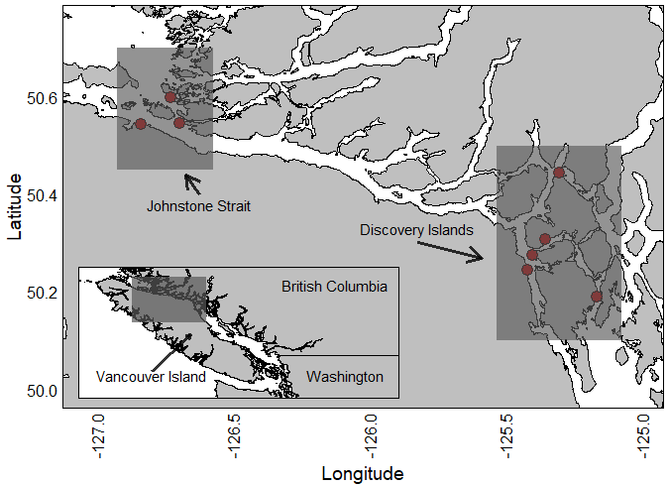

**Figure 1:** The study region, on the west coast of British Columbia, Canada. All sites lie in the sampling areas of Discovery Islands or Johnstone Strait, wedged between the western coast of the mainland, and the east coast of Vancouver Island. This is the region that is most heavily developed for fish farming.

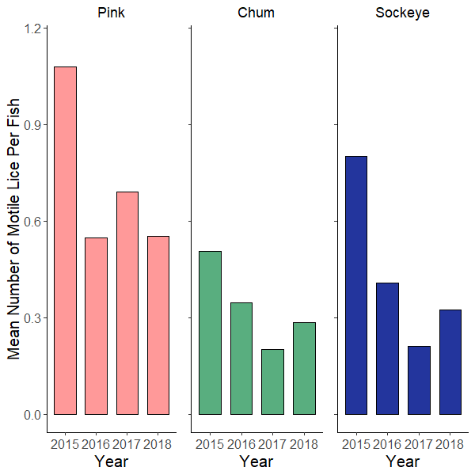

**Figure 2:**  Average number of lice per fish in each year, divided by Salmon species. Visually, Pink Salmon seem to have higher average numbers of lice overall*.*

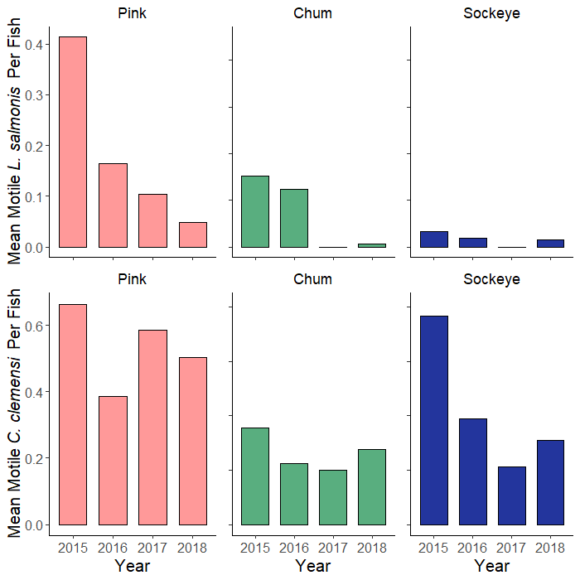

**Figure 3:**  Average number of lice per fish in each year, divided by louse species, and by fish species.. Visually, Pink Salmon seem to have higher average numbers of *L. Salmonis*, with Pink and Sockeye both having high loads of *C. clemensi.*

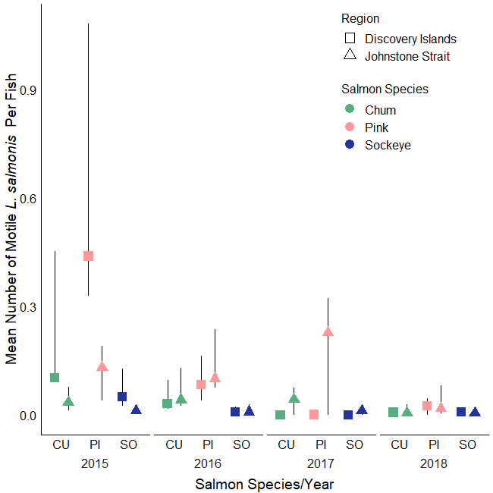

**Figure 4:** Estimated number of lice per fish for *L. Salmonis,* divided by sampling year, as well as by Salmon species, and grouped by sampling area. The points represent model-averaged estimates, and the confidence intervals were obtained by hierarchical bootstrapping of our model-averaged estimates.

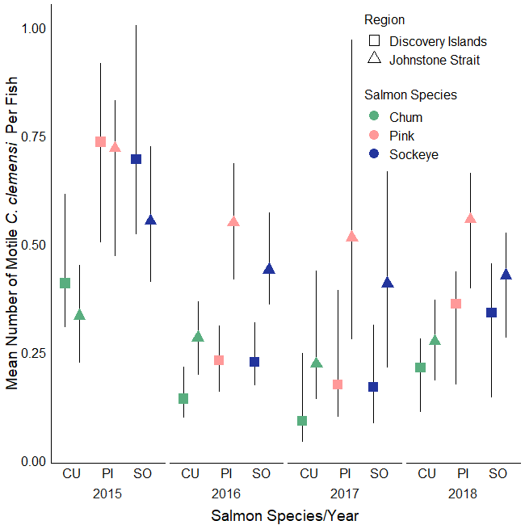

**Figure 5:** Estimated number of lice per fish for *L. Salmonis,* divided by sampling year, as well as by Salmon species, and grouped by sampling region. The points represent model-averaged estimates, and the confidence intervals were obtained by hierarchical bootstrapping of our model-averaged estimates.

**References:**

Anderson, D., and K. Burnham. 2004. Model selection and multi-model inference. Second. NY: Springer-Verlag 63.

Anderson, R. M., and R. M. May. 1979. Population biology of infectios diseases: Part I. Nature 280:361–367.

Barber, I., D. Hoare, and J. Krause. 2000. Effects of parasites on fish behaviour: a review and evolutionary perspective. Reviews in Fish Biology and Fisheries 10:131–165.

Beamish, R., J. Wade, W. Pennell, E. Gordon, S. Jones, C. Neville, K. Lange, and R. Sweeting. 2009. A large, natural infection of sea lice on juvenile Pacific salmon in the Gulf Islands area of British Columbia, Canada. Aquaculture 297:31–37.

Bricknell, I. R., S. J. Dalesman, B. O’Shea, C. C. Pert, and A. J. Mordue Luntz. 2006. Effect of environmental salinity on sea lice Lepeophtheirus salmonis settlement success. Diseases of Aquatic Organisms 71:201–212.

Brooks, M. E., K. Kristensen, K. J. van Benthem, A. Magnusson, C. W. Berg, A. Nielsen, H. J. Skaug, M. Mächler, and B. M. Bolker. 2017. glmmTMB balances speed and flexibility among packages for zero-inflated generalized linear mixed modeling. The R Journal 9:378–400.

de Castro, F., and B. Bolker. 2005. Mechanisms of disease-induced extinction. Ecology Letters 8:117–126.

Cleaveland, S., G. R. Hess, A. P. Dobson, M. K. Laurenson, H. I. McCallum, M. G. Roberts, and R. Woodroffe. 2002. The role of pathogens in biological conservation. Pages 139–150 The Ecology of Wildlife Diseases.

Cohen, B. I. 2012. Commission of Inquiry into the Decline of Sockeye Salmon in the Fraser River (Canada) The uncertain future of Fraser River sockeye Final Report – October 2012.

Connors, B. M., D. C. Braun, R. M. Peterman, A. B. Cooper, J. D. Reynolds, L. M. Dill, G. T. Ruggerone, and M. Krkošek. 2012. Migration links ocean-scale competition and local ocean conditions with exposure to farmed salmon to shape wild salmon dynamics. Conservation Letters 5:304–312.

Cooke, S. J., S. G. Hinch, A. P. Farrell, M. F. Lapointe, S. R. M. Jones, S. J. Macdonald, D. A. Patterson, M. C. Healey, and G. Van Der Kraak. 2004. Abnormal migration timing and high en route mortality of Sockeye Salmon in the Fraser river, British Columbia. Fisheries 29:23–32.

Costello, M. J. 1993. Review of methods to control sea lice (Caligidae: Crustacea) infestations on salmon (Salmo salar) farms.

Daszak, P., A. A. Cunningham, and A. D. Hyatt. 2001. Anthropogenic environmental change and the emergence of infectious diseases in wildlife. Acta Tropica 78:103–116.

DFO. 2019. Stock Assessment and Management Advice for BC Pacific Herring: 2018 Status and 2019 Forecast. Page 62. DFO Can. Sci. Advis. Sec. Sci. Resp.

Di Cicco, E., H. W. Ferguson, A. D. Schulze, K. H. Kaukinen, S. Li, R. Vanderstichel, Ø. Wessel, E. Rimstad, I. A. Gardner, K. L. Hammell, and K. M. Miller. 2017. Heart and skeletal muscle inflammation (HSMI) disease diagnosed on a British Columbia salmon farm through a longitudinal farm study. PLOS ONE 12:e0171471.

Eliason, E. J., T. D. Clark, M. J. Hague, L. M. Hanson, Z. S. Gallagher, K. M. Jeffries, M. K. Gale, D. A. Patterson, S. G. Hinch, and A. P. Farrell. 2011. Differences in Thermal Tolerance Among Sockeye Salmon Populations. Science 332:109–112.

FAO. 2015. FAO Global Capture Production database updated to 2013 - Summary information.

Godwin, S. C., L. M. Dill, J. D. Reynolds, and M. Krkošek. 2015. Sea lice, sockeye salmon, and foraging competition: lousy fish are lousy competitors. Canadian Journal of Fisheries and Aquatic Sciences 72:1113–1120.

Godwin, S. C., M. Krkošek, J. D. Reynolds, L. A. Rogers, and L. M. Dill. 2017. Heavy sea louse infection is associated with decreased stomach fullness in wild juvenile sockeye salmon. Canadian Journal of Fisheries and Aquatic Sciences 75:1587–1595.

Haydon, D. T., S. Cleaveland, L. H. Taylor, and M. K. Laurenson. 2002. Identifying reservoirs of infection: a conceptual and practical challenge. Emerging infectious diseases 8:1468–73.

Hedrick, R. P. 1998. Relationships of the Host, Pathogen, and Environment: Implications for Diseases of Cultured and Wild Fish Populations. Journal of Aquatic Animal Health 10:107–111.

Holt, R. D. 1977. Predation, Apparent Competition, and the Structure of Prey Communities. Theoretical Population Biology 12:197–229.

Holt, R. D., and J. H. Lawton. 1994. The Ecological Consequences of Shared Natural Enemies. Annual Review of Ecology and Systematics 25:495–520.

Hunt, B. P. V., B. T. Johnson, S. C. Godwin, M. Krkošek, E. A. Pakhomov, and L. A. Rogers. 2018. The Hakai Institute Juvenile Salmon Program : Early Life History Drivers of Marine Survival in Sockeye , Pink and Chum Salmon in British Columbia. Page 14.

Johnson, S. C., and L. J. Albright. 1991. Development, growth, and survival of lepeophtheirus salmonis (Copepoda: Caligidae) under laboratory conditions. Journal of the Marine Biological Association of the United Kingdom 71:425–436.

Kelly, D. W., R. A. Paterson, C. R. Townsend, R. Poulin, and D. M. Tompkins. 2009. Parasite spillback: A neglected concept in invasion ecology? Pages 2047–2056.

Krkošek, M., J. S. Ford, A. Morton, S. Lele, R. A. Myers, and M. A. Lewis. 2007. Declining Wild Salmon Populations in Relation to Parasites from Farm Salmon. Science 40:1772 – 1775.

Krkošek, M., M. A. Lewis, J. P. Volpe, and A. Morton. 2006. Fish Farms and Sea Lice Infestations of Wild Juvenile Salmon in the Broughton Archipelago—A Rebuttal to. Reviews in Fisheries Science 14:1–11.

Krkošek, M., Morton, J. P. Volpe, and M. A. Lewis. 2009. Sea lice and salmon population dynamics: effects of exposure time for migratory fish. Proceedings of the Royal Society B: Biological Sciences 276:2819–2828.

Krkosek, M., C. W. Revie, P. G. Gargan, O. T. Skilbrei, B. Finstad, and C. D. Todd. 2013. Impact of parasites on salmon recruitment in the Northeast Atlantic Ocean. Proceedings. Biological sciences 280:20122359.

Long, A., K. A. Garver, and S. R. M. Jones. 2019. Differential Effects of Adult Salmon Lice Lepeophtheirus salmonis on Physiological Responses of Sockeye Salmon and Atlantic Salmon. Journal of Aquatic Animal Health 31:75–87.

Longshaw, M., P. A. Frear, A. D. Nunn, I. G. Cowx, and S. W. Feist. 2010. The influence of parasitism on fish population success. Fisheries Management and Ecology 17:426–434.

Lüdecke, D. 2018. ggeffects: Tidy Data Frames of Marginal Effects from Regression Models. The Journal of Open Source Software 3.

Marty, G. D., S. M. Saksida, and T. J. Quinn. 2010. Relationship of farm salmon, sea lice, and wild salmon populations. Proceedings of the National Academy of Sciences 107:22599–22604.

Morton, A., R. Routledge, and M. Krkoš. 2008a. Sea Louse Infestation in Wild Juvenile Salmon and Pacific Herring Associated with Fish Farms off the East-Central Coast of Vancouver Island, British Columbia. North American Journal of Fisheries Management 28:523–532.

Morton, A., R. Routledge, and M. Krkosek. 2008b. Sea Louse Infestation in Wild Juvenile Salmon and Pacific Herring Associated with Fish Farms off the East-Central Coast of Vancouver Island, British Columbia. North American Journal of Fisheries Management 28:523–532.

Peterman, R. M., D. Marmorek, B. Beckman, and M. Bradford. 2010. Synthesis of evidence from a workshop on the decline of Fraser River sockeye. A Report to the Pacific Salmon Commission, Vancouver, B.C.:123pp.

Power, A. G., and C. E. Mitchell. 2004. Pathogen Spillover in Disease Epidemics. The American Naturalist 164:S79–S89.

Price, M. H. H., A. Morton, and J. D. Reynolds. 2010. Evidence of farm-induced parasite infestations on wild juvenile salmon in multiple regions of coastal British Columbia, Canada. Canadian Journal of Fisheries and Aquatic Sciences 67:1925–1932.

Price, M. H. H., S. L. Proboszcz, R. D. Routledge, A. S. Gottesfeld, C. Orr, and J. D. Reynolds. 2011. Sea louse infection of juvenile sockeye salmon in relation to marine salmon farms on Canada’s west coast. PLoS ONE 6:e16851.

Stien, A., P. A. Bjorn, P. A. Heuch, and D. A. Elston. 2005. Population dynamics of salmon lice Lepeophtheirus salmonis on Atlantic salmon and sea trout. Marine Ecology Progress Series 290:263–275.

Tucker, C. S., C. Sommerville, and R. Wootten. 2000. The effect of temperature and salinity on the settlement and survival of copepodids of Lepeophtheirus salmonis (Krøyer, 1837) on Atlantic salmon, Salmo salar L. Journal of Fish Diseases 23:309–320.

Williams, H. H. 1964. Some observations on the mass mortality of the freshwater fish Rutilus rutilus (L.)*. Parasitology 54:155–171.