**Differential Sea Lice Loads on Pacific Salmon Species**

What follows are some preliminary results, with the findings indicating that two species of sea lice (*C. clemensi* and *L. salmonis*) are present at different levels on three pacific juvenile salmon species (sockeye (*Oncorhynchus nerka*), pink (*Oncorhynchus gorbuscha*), and chum (*Oncorhynchus keta*)).

*Note:* A collection represents a unique sampling location/date combination, with >=5 individuals of each of the three salmon species.

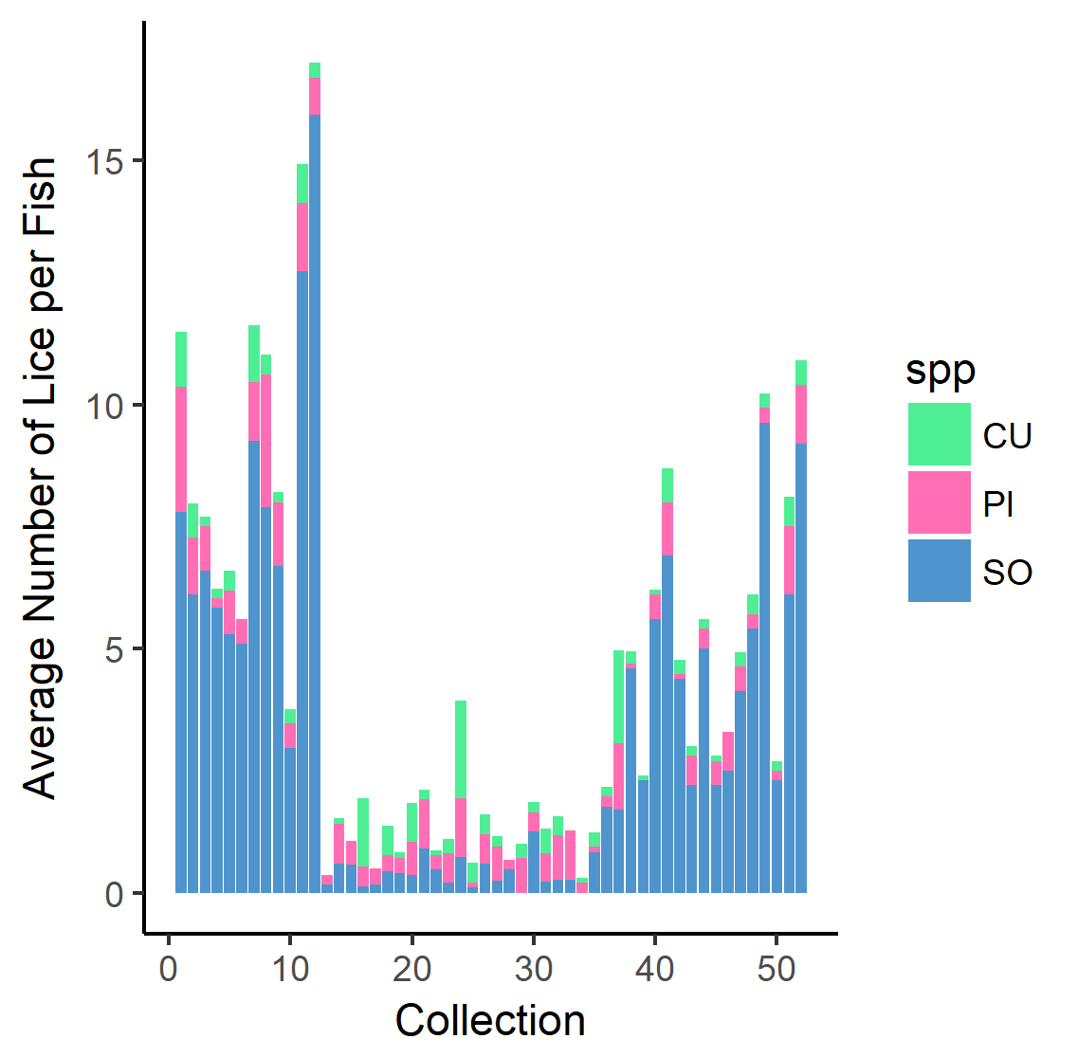

**Figure 1:** Here we see the average number of lice per fish (both lice species as well as individuals at unidentified stages combined), for each collection across the data. The colours in each collection represent the species of salmon. It is clear that generally, the sockeye salmon have the highest average number of lice per fish across the data.

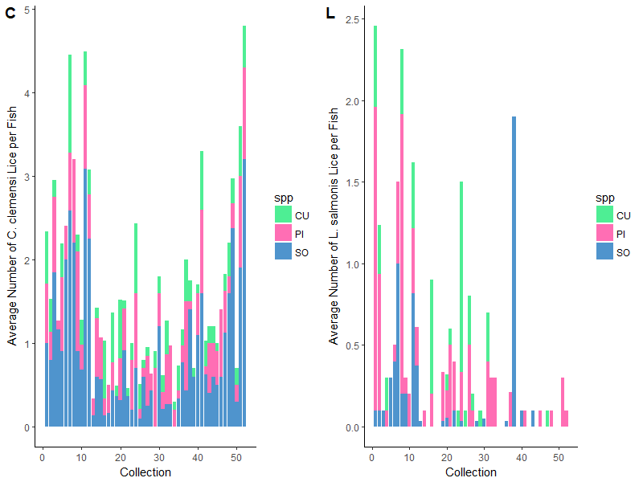

**Figure 2:** Here we see the average number of lice per fish in each collection, divided into two plots to separate by louse species, and divided by colour to separate by fish species. ‘C’ shows the average number of *C. clemensi*  per fish, with colour dividing per species. Visually it is clear that sockeye typically have higher average numbers of *C. clemensi.* ‘L’ shows the average number of *L. salmonis* per fish, with colour dividing per species. Visually, pink salmon seem to have higher average numbers of *L. salmonis*.

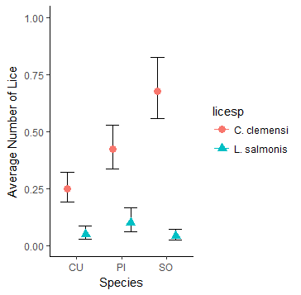

**Figure 3:** Here we show the estimated average number of lice per fish across all collections, separated by the louse species. This confirms the visual estimate from the above plots that *C. clemensi* can be found with the highest frequency on sockeye salmon, and that *L. salmonis* can be found with the highest frequency on pink salmon.

**Methods:**

In order to quantify statistically whether or not there is any real relationship between salmon (host) species and lice (parasite) species loads, we used generalized linear mixed effects models (GLMMs) in the glmmABMD package to draw our conclusions. The models employed a negative binomial error for the response distribution, as well as a log link function. The GLMMs were written such that the number of lice per fish was treated as the response variable, and species of salmon were fixed effects. In addition, the ‘collection’ (unique sampling location/date combination, with >=5 individuals of each of the three salmon species) number was treated as a random effect in these models. The results of the models were used to plot Figure 3, with the points representing the reverse transformed coefficients of the salmon species effects from our GLMMs, along with +/- 2 standard errors to form a 95% confidence interval, represented by the error bars. Four models were run, one alternate and one null model for each lice species.

**Table 1:** A summary of some important result values from our null and alternate models for both *C. clemensi* and *L. salmonis* lice.

|  |  |  |  |  |
| --- | --- | --- | --- | --- |
| **Model** | **Fixed Effect** | **Negative Log Likelihood** | **AIC value** | **Delta-AIC value** |
| ***C. clemensi* Null** | -- | -1783.72 | 3573.4 | 0.0 |
| ***C. clemensi* Alternate** | Salmon Species | -1737.68 | 3485.4 | 88.1 |
| ***L. salmonis* Null** | -- | -571.268 | 1148.5 | 0.0 |
| ***L. salmonis* Alternate** | Salmon Species | -562.663 | 1135.3 | 13.2 |

**Table 2:** A summary of the coefficients and standard errors from the two alternate models run for both *C. clemensi* and *L. salmonis* lice. The coefficient values here were reverse transformed, along with +/- two standard errors to plot the points and error bars for Fig. 3.

|  |  |  |  |  |  |  |
| --- | --- | --- | --- | --- | --- | --- |
| **Output** | **Chum Coefficient** | **Chum Standard Error** | **Pink Coefficient** | **Pink**  **Standard Error** | **Sockeye Coefficient** | **Sockeye Standard Error** |
| ***C. clemensi* Model** | -1.3939 | 0.1281 | -0.8659 | 0.1130 | -0.3894 | 0.0979 |
| ***L. salmonis* Model** | -3.049 | 0.285 | -2.311 | 0.252 | -3.182 | 0.260 |