Hakai-Lice-Models-Overview

# Initial Model Set

The first set of models from this past school year (region removed from initial model and fit by itself)

## Species Level Models

#models and dredge them  
lepmodspecies.full <- glmmTMB(all.leps ~ spp + year - 1 + (1|collection),   
 data = mainlice, family=nbinom2)  
calmodspecies.full <- glmmTMB(all.cal ~ spp + year - 1 + (1|collection),   
 data = mainlice, family=nbinom2)  
  
lepmodspecies.full_dredge = MuMIn::dredge(lepmodspecies.full)

calmodspecies.full_dredge = MuMIn::dredge(calmodspecies.full)

**lepmodspecies.full_dredge**

## Global model call: glmmTMB(formula = all.leps ~ spp + year - 1 + (1 | collection),   
## data = mainlice, family = nbinom2, ziformula = ~0, dispformula = ~1)  
## ---  
## Model selection table   
## dsp((Int)) cnd(spp) cnd(yer) df logLik AICc delta weight  
## 4 + + + 8 -418.419 852.9 0.00 0.998  
## 2 + + 5 -427.833 865.7 12.78 0.002  
## 3 + + 6 -452.366 916.8 63.86 0.000  
## Models ranked by AICc(x)   
## Random terms (all models):   
## 'cond(1 | collection)'

**calmodspecies.full_dredge**

## Global model call: glmmTMB(formula = all.cal ~ spp + year - 1 + (1 | collection),   
## data = mainlice, family = nbinom2, ziformula = ~0, dispformula = ~1)  
## ---  
## Model selection table   
## dsp((Int)) cnd(spp) cnd(yer) df logLik AICc delta weight  
## 4 + + + 8 -1490.784 2997.6 0.00 0.971  
## 2 + + 5 -1497.330 3004.7 7.04 0.029  
## 3 + + 6 -1502.828 3017.7 20.06 0.000  
## Models ranked by AICc(x)   
## Random terms (all models):   
## 'cond(1 | collection)'

## Species Level Effects Plots

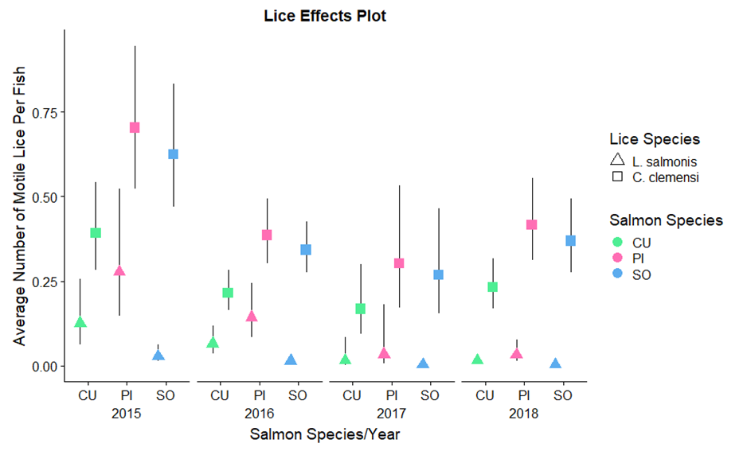

## Region-Level Models

#region-level models  
regionlice <- read.csv('Hakai_lice_data_all_fish_CB_edits.csv')  
  
chumrmod.calnb <- glmmTMB(all.cal ~ site.region + year - 1 + (1|week),   
 data = chum.region, family=nbinom2)  
chumrmod.lepsnb <- glmmTMB(all.leps ~ site.region + year - 1 + (1|week),   
 data = chum.region, family=nbinom2)  
pinkrmod.calnb <- glmmTMB(all.cal ~ site.region + year - 1 + (1|week),   
 data = pink.region, family=nbinom2)  
pinkrmod.lepsnb <- glmmTMB(all.leps ~ site.region + year - 1 + (1|week),   
 data = pink.region, family=nbinom2)  
sockrmod.calnb <- glmmTMB(all.cal ~ site.region + year - 1 + (1|week),   
 data = sock.region, family=nbinom2)  
sockrmod.lepsnbsr <- glmmTMB(all.leps ~ site.region - 1 + (1|week),   
 data = sock.region, family=nbinom2)Region Level

## Effects Plots

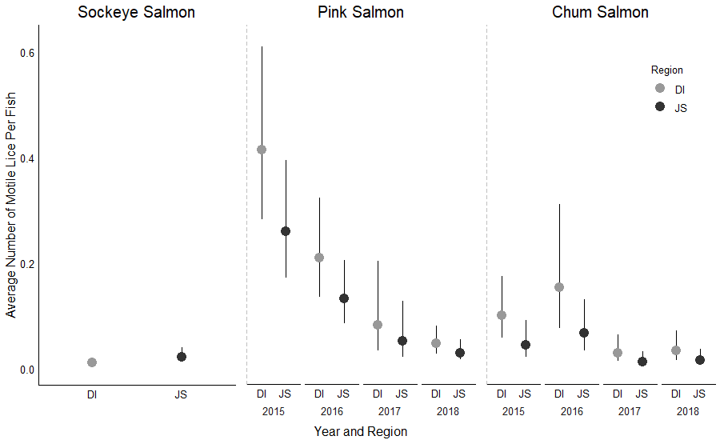

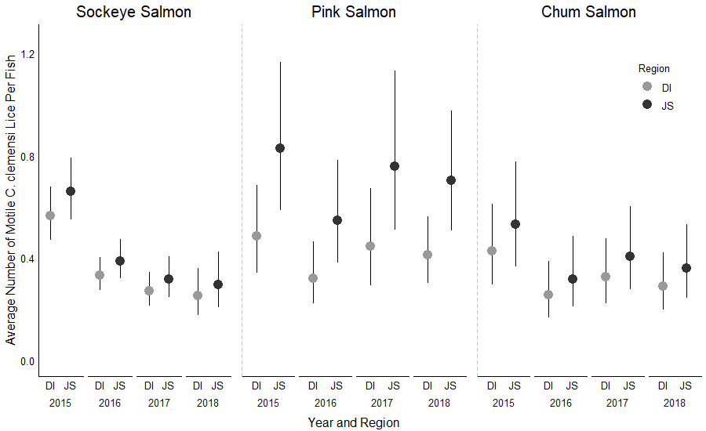

# New Set of Models

## Models (No Crossed Effects)

lepmod.yrsrsp <- glmmTMB(all.leps ~ spp + site.region +

year - 1 + (1|collection), data = mainlice, family=nbinom2)

calmod.yrsrsp <- glmmTMB(all.cal ~ spp + site.region +

year - 1 + (1|collection), data = mainlice, family=nbinom2)

## AIC tables

lepmod.yrsrsp_dredge = MuMIn::dredge(lepmod.yrsrsp)

calmod.yrsrsp_dredge = MuMIn::dredge(calmod.yrsrsp)

**lepmod.yrsrsp_dredge**

## Global model call: glmmTMB(formula = all.leps ~ spp + site.region + year - 1 + (1 |   
## collection), data = mainlice, family = nbinom2, ziformula = ~0,   
## dispformula = ~1)  
## ---  
## Model selection table   
## dsp((Int)) cnd(sit.rgn) cnd(spp) cnd(yer) df logLik AICc delta weight  
## 7 + + + 8 -418.419 852.9 0.00 0.706  
## 8 + + + + 9 -418.292 854.7 1.76 0.292  
## 3 + + 5 -427.833 865.7 12.78 0.001  
## 4 + + + 6 -427.751 867.5 14.63 0.000  
## 5 + + 6 -452.366 916.8 63.86 0.000  
## 6 + + + 7 -452.342 918.7 65.83 0.000  
## 2 + + 4 -461.316 930.7 77.74 0.000  
## Models ranked by AICc(x)   
## Random terms (all models):   
## 'cond(1 | collection)'

**calmod.yrsrsp_dredge**

## Global model call: glmmTMB(formula = all.cal ~ spp + site.region + year - 1 + (1 |   
## collection), data = mainlice, family = nbinom2, ziformula = ~0,   
## dispformula = ~1)  
## ---  
## Model selection table   
## dsp((Int)) cnd(sit.rgn) cnd(spp) cnd(yer) df logLik AICc delta  
## 8 + + + + 9 -1486.158 2990.4 0.00  
## 7 + + + 8 -1490.784 2997.6 7.23  
## 4 + + + 6 -1493.201 2998.4 8.03  
## 3 + + 5 -1497.330 3004.7 14.28  
## 6 + + + 7 -1498.198 3010.5 20.04  
## 5 + + 6 -1502.828 3017.7 27.29  
## 2 + + 4 -1505.653 3019.3 28.91  
## weight  
## 8 0.956  
## 7 0.026  
## 4 0.017  
## 3 0.001  
## 6 0.000  
## 5 0.000  
## 2 0.000  
## Models ranked by AICc(x)   
## Random terms (all models):   
## 'cond(1 | collection)'

## Effects Plots

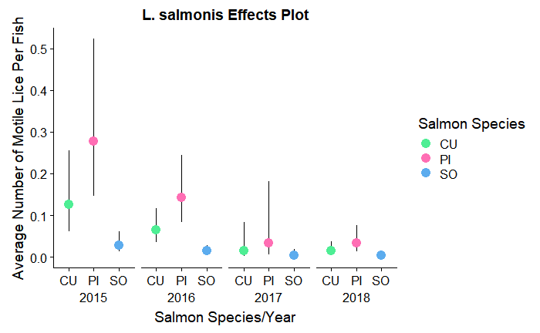

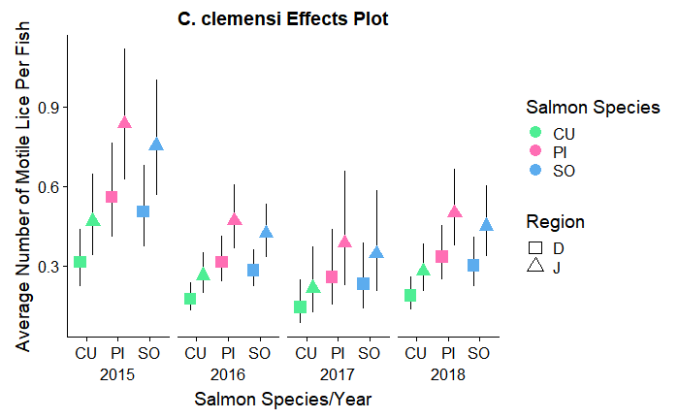

## Models (Crossed Effects)

lepmod.crossed <- glmmTMB(all.leps ~ spp * site.region + spp * year +   
 site.region * year + (1 | collection),   
 data = mainlice, family=nbinom2)  
calmod.crossed <- glmmTMB(all.cal ~ spp * site.region + spp * year +   
 site.region * year + (1 | collection),   
 data = mainlice, family=nbinom2)

## AIC Tables

lepmod.crossed_dredge = MuMIn::dredge(lepmod.crossed, subset = (`cond(site.region)` && `cond(year)`))

**lepmod.crossed_dredge**

## Global model call: glmmTMB(formula = all.leps ~ spp * site.region + spp * year +   
## site.region * year + (1 | collection), data = mainlice, family = nbinom2,   
## ziformula = ~0, dispformula = ~1)  
## ---  
## Model selection table   
## cnd((Int)) dsp((Int)) cnd(sit.rgn) cnd(spp) cnd(yer) cnd(sit.rgn:spp)  
## 24 -1.185 + + + +   
## 56 -1.469 + + + +   
## 32 -1.125 + + + + +  
## 64 -1.427 + + + + +  
## 8 -1.983 + + + +   
## 40 -2.244 + + + +   
## 16 -1.957 + + + + +  
## 48 -2.227 + + + + +  
## 22 -1.051 + + +   
## 6 -1.939 + + +   
## cnd(sit.rgn:yer) cnd(spp:yer) df logLik AICc delta weight  
## 24 + 12 -411.452 847.1 0.00 0.529  
## 56 + + 18 -406.204 848.8 1.71 0.225  
## 32 + 14 -410.656 849.5 2.47 0.154  
## 64 + + 20 -405.297 851.1 3.98 0.072  
## 8 9 -418.292 854.7 7.61 0.012  
## 40 + 15 -413.222 856.7 9.63 0.004  
## 16 11 -417.618 857.4 10.30 0.003  
## 48 + 17 -412.495 859.3 12.25 0.001  
## 22 + 10 -444.677 909.5 62.40 0.000  
## 6 7 -452.342 918.7 71.67 0.000  
## Models ranked by AICc(x)   
## Random terms (all models):   
## 'cond(1 | collection)'

calmod.crossed_dredge = MuMIn::dredge(calmod.crossed, subset = (`cond(site.region)` && `cond(year)`))

**calmod.crossed_dredge**

## Global model call: glmmTMB(formula = all.cal ~ spp * site.region + spp * year +   
## site.region * year + (1 | collection), data = mainlice, family = nbinom2,   
## ziformula = ~0, dispformula = ~1)  
## ---  
## Model selection table   
## cnd((Int)) dsp((Int)) cnd(sit.rgn) cnd(spp) cnd(yer) cnd(sit.rgn:spp)  
## 32 -0.7104 + + + + +  
## 24 -0.7910 + + + +   
## 64 -0.8636 + + + + +  
## 56 -0.9259 + + + +   
## 8 -1.1610 + + + +   
## 16 -1.0900 + + + + +  
## 40 -1.2760 + + + +   
## 48 -1.2170 + + + + +  
## 22 -0.3716 + + +   
## 6 -0.7379 + + +   
## cnd(sit.rgn:yer) cnd(spp:yer) df logLik AICc delta weight  
## 32 + 14 -1478.419 2985.1 0.00 0.410  
## 24 + 12 -1480.773 2985.7 0.65 0.297  
## 64 + + 20 -1473.480 2987.4 2.35 0.126  
## 56 + + 18 -1475.829 2988.0 2.97 0.093  
## 8 9 -1486.158 2990.4 5.35 0.028  
## 16 11 -1484.199 2990.5 5.47 0.027  
## 40 + 15 -1481.158 2992.6 7.51 0.010  
## 48 + 17 -1479.200 2992.7 7.67 0.009  
## 22 + 10 -1493.316 3006.8 21.68 0.000  
## 6 7 -1498.198 3010.5 25.39 0.000  
## Models ranked by AICc(x)   
## Random terms (all models):   
## 'cond(1 | collection)'

## Effects Plots

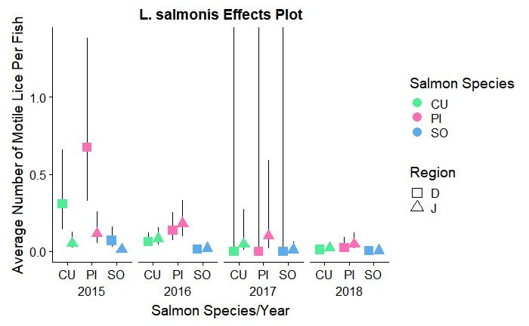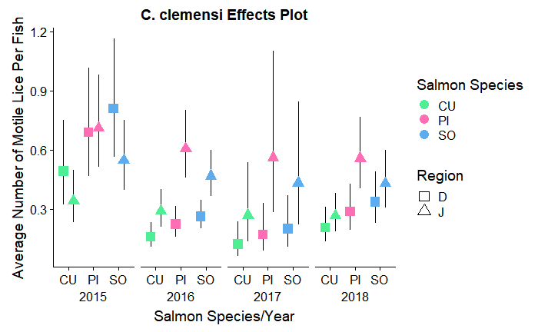

summary(chumrmod.calnb); summary(chumrmod.lepsnb); summary(pinkrmod.calnb); summary(pinkrmod.lepsnb); summary(sockrmod.calnb); summary(sockrmod.lepsnbsr)

## Family: nbinom2 ( log )  
## Formula: all.cal ~ site.region + year - 1 + (1 | week)  
## Data: chum.region  
##   
## AIC BIC logLik deviance df.resid   
## 2120.8 2157.3 -1053.4 2106.8 1358   
##   
## Random effects:  
##   
## Conditional model:  
## Groups Name Variance Std.Dev.  
## week (Intercept) 0.2548 0.5048   
## Number of obs: 1365, groups: week, 12  
##   
## Overdispersion parameter for nbinom2 family (): 2.12   
##   
## Conditional model:  
## Estimate Std. Error z value Pr(>|z|)   
## site.regionD -0.8537 0.1846 -4.624 3.76e-06 ***  
## site.regionJ -0.6314 0.1926 -3.279 0.00104 **   
## year2016 -0.5131 0.1637 -3.133 0.00173 **   
## year2017 -0.2677 0.1306 -2.051 0.04031 *   
## year2018 -0.3880 0.1352 -2.870 0.00410 **   
## ---  
## Signif. codes: 0 '***' 0.001 '**' 0.01 '*' 0.05 '.' 0.1 ' ' 1

## Family: nbinom2 ( log )  
## Formula: all.leps ~ site.region + year - 1 + (1 | week)  
## Data: chum.region  
##   
## AIC BIC logLik deviance df.resid   
## 510.6 547.1 -248.3 496.6 1358   
##   
## Random effects:  
##   
## Conditional model:  
## Groups Name Variance Std.Dev.  
## week (Intercept) 2.132e-08 0.000146  
## Number of obs: 1365, groups: week, 12  
##   
## Overdispersion parameter for nbinom2 family (): 0.0749   
##   
## Conditional model:  
## Estimate Std. Error z value Pr(>|z|)   
## site.regionD -2.3025 0.2821 -8.162 3.28e-16 ***  
## site.regionJ -3.1487 0.3838 -8.205 2.31e-16 ***  
## year2016 0.4227 0.4203 1.006 0.31464   
## year2017 -1.2784 0.4857 -2.632 0.00848 **   
## year2018 -1.1277 0.4742 -2.378 0.01740 *   
## ---  
## Signif. codes: 0 '***' 0.001 '**' 0.01 '*' 0.05 '.' 0.1 ' ' 1

## Family: nbinom2 ( log )  
## Formula: all.cal ~ site.region + year - 1 + (1 | week)  
## Data: pink.region  
##   
## AIC BIC logLik deviance df.resid   
## 1795.5 1829.5 -890.8 1781.5 932   
##   
## Random effects:  
##   
## Conditional model:  
## Groups Name Variance Std.Dev.  
## week (Intercept) 0.1967 0.4435   
## Number of obs: 939, groups: week, 12  
##   
## Overdispersion parameter for nbinom2 family (): 5.85   
##   
## Conditional model:  
## Estimate Std. Error z value Pr(>|z|)   
## site.regionD -0.72429 0.17729 -4.085 4.4e-05 ***  
## site.regionJ -0.18910 0.17509 -1.080 0.28014   
## year2016 -0.41514 0.15914 -2.609 0.00909 **   
## year2017 -0.08654 0.16465 -0.526 0.59916   
## year2018 -0.16441 0.12203 -1.347 0.17788   
## ---  
## Signif. codes: 0 '***' 0.001 '**' 0.01 '*' 0.05 '.' 0.1 ' ' 1

## Family: nbinom2 ( log )  
## Formula: all.leps ~ site.region + year - 1 + (1 | week)  
## Data: pink.region  
##   
## AIC BIC logLik deviance df.resid   
## 728.2 762.1 -357.1 714.2 932   
##   
## Random effects:  
##   
## Conditional model:  
## Groups Name Variance Std.Dev.  
## week (Intercept) 2.314e-09 4.81e-05  
## Number of obs: 939, groups: week, 12  
##   
## Overdispersion parameter for nbinom2 family (): 0.318   
##   
## Conditional model:  
## Estimate Std. Error z value Pr(>|z|)   
## site.regionD -0.8806 0.1975 -4.459 8.22e-06 ***  
## site.regionJ -1.3489 0.2128 -6.340 2.30e-10 ***  
## year2016 -0.6860 0.2576 -2.663 0.00775 **   
## year2017 -1.6262 0.4798 -3.389 0.00070 ***  
## year2018 -2.2009 0.3248 -6.777 1.23e-11 ***  
## ---  
## Signif. codes: 0 '***' 0.001 '**' 0.01 '*' 0.05 '.' 0.1 ' ' 1

## Family: nbinom2 ( log )  
## Formula: all.cal ~ site.region + year - 1 + (1 | week)  
## Data: sock.region  
##   
## AIC BIC logLik deviance df.resid   
## 6467.4 6510.9 -3226.7 6453.4 3687   
##   
## Random effects:  
##   
## Conditional model:  
## Groups Name Variance Std.Dev.  
## week (Intercept) 0.05698 0.2387   
## Number of obs: 3694, groups: week, 11  
##   
## Overdispersion parameter for nbinom2 family (): 0.974   
##   
## Conditional model:  
## Estimate Std. Error z value Pr(>|z|)   
## site.regionD -0.57222 0.09288 -6.161 7.25e-10 ***  
## site.regionJ -0.41522 0.09257 -4.486 7.27e-06 ***  
## year2016 -0.52957 0.07103 -7.456 8.92e-14 ***  
## year2017 -0.73482 0.10118 -7.262 3.81e-13 ***  
## year2018 -0.80543 0.16844 -4.782 1.74e-06 ***  
## ---  
## Signif. codes: 0 '***' 0.001 '**' 0.01 '*' 0.05 '.' 0.1 ' ' 1

## Family: nbinom2 ( log )  
## Formula: all.leps ~ site.region - 1 + (1 | week)  
## Data: sock.region  
##   
## AIC BIC logLik deviance df.resid   
## 783.8 808.7 -387.9 775.8 3690   
##   
## Random effects:  
##   
## Conditional model:  
## Groups Name Variance Std.Dev.  
## week (Intercept) 0.3741 0.6116   
## Number of obs: 3694, groups: week, 11  
##   
## Overdispersion parameter for nbinom2 family (): 0.142   
##   
## Conditional model:  
## Estimate Std. Error z value Pr(>|z|)   
## site.regionD -4.5724 0.3222 -14.19 <2e-16 ***  
## site.regionJ -3.8232 0.2959 -12.92 <2e-16 ***  
## ---  
## Signif. codes: 0 '***' 0.001 '**' 0.01 '*' 0.05 '.' 0.1 ' ' 1