Hakai-Lice-Models-Overview

Cole

August 20, 2019

# Preliminary Things

I thought this might be the easiest way to show you all the things without having to copy and paste everything into a word document, so here’s an RMD instead lol.

Necessary packages etc:

## Warning: package 'tidyverse' was built under R version 3.5.3

## -- Attaching packages ------------------------------------------------------------------ tidyverse 1.2.1 --

## v ggplot2 3.1.1 v purrr 0.3.2  
## v tibble 2.1.3 v dplyr 0.8.1  
## v tidyr 0.8.3 v stringr 1.4.0  
## v readr 1.3.1 v forcats 0.4.0

## Warning: package 'ggplot2' was built under R version 3.5.3

## Warning: package 'tibble' was built under R version 3.5.3

## Warning: package 'tidyr' was built under R version 3.5.3

## Warning: package 'readr' was built under R version 3.5.3

## Warning: package 'purrr' was built under R version 3.5.3

## Warning: package 'dplyr' was built under R version 3.5.3

## Warning: package 'stringr' was built under R version 3.5.3

## Warning: package 'forcats' was built under R version 3.5.3

## -- Conflicts --------------------------------------------------------------------- tidyverse_conflicts() --  
## x dplyr::filter() masks stats::filter()  
## x dplyr::lag() masks stats::lag()

## Warning: package 'glmmTMB' was built under R version 3.5.2

## Warning: package 'ggeffects' was built under R version 3.5.3

## Warning: package 'DHARMa' was built under R version 3.5.3

## Warning: package 'MuMIn' was built under R version 3.5.3

## Warning: package 'cowplot' was built under R version 3.5.3

##   
## Attaching package: 'cowplot'

## The following object is masked from 'package:ggplot2':  
##   
## ggsave

# Initial Model Set

The first set of models from this past school year (region removed from initial model and fit by itself)

## Species Level Models

#models and dredge them  
lepmodspecies.full <- glmmTMB(all.leps ~ spp + year - 1 + (1|collection),   
 data = mainlice, family=nbinom2)  
calmodspecies.full <- glmmTMB(all.cal ~ spp + year - 1 + (1|collection),   
 data = mainlice, family=nbinom2)  
  
lepmodspecies.full_dredge = MuMIn::dredge(lepmodspecies.full)

## Fixed term is "disp((Int))"

## Warning in glmmTMB(formula = all.leps ~ 0, data = mainlice, family =  
## nbinom2, : unused argument (`NA` = ~(1 | collection)) (model 0 skipped)

calmodspecies.full_dredge = MuMIn::dredge(calmodspecies.full)

## Fixed term is "disp((Int))"

## Warning in glmmTMB(formula = all.cal ~ 0, data = mainlice, family =  
## nbinom2, : unused argument (`NA` = ~(1 | collection)) (model 0 skipped)

lepmodspecies.full_dredge

## Global model call: glmmTMB(formula = all.leps ~ spp + year - 1 + (1 | collection),   
## data = mainlice, family = nbinom2, ziformula = ~0, dispformula = ~1)  
## ---  
## Model selection table   
## dsp((Int)) cnd(spp) cnd(yer) df logLik AICc delta weight  
## 4 + + + 8 -418.419 852.9 0.00 0.998  
## 2 + + 5 -427.833 865.7 12.78 0.002  
## 3 + + 6 -452.366 916.8 63.86 0.000  
## Models ranked by AICc(x)   
## Random terms (all models):   
## 'cond(1 | collection)'

calmodspecies.full_dredge

## Global model call: glmmTMB(formula = all.cal ~ spp + year - 1 + (1 | collection),   
## data = mainlice, family = nbinom2, ziformula = ~0, dispformula = ~1)  
## ---  
## Model selection table   
## dsp((Int)) cnd(spp) cnd(yer) df logLik AICc delta weight  
## 4 + + + 8 -1490.784 2997.6 0.00 0.971  
## 2 + + 5 -1497.330 3004.7 7.04 0.029  
## 3 + + 6 -1502.828 3017.7 20.06 0.000  
## Models ranked by AICc(x)   
## Random terms (all models):   
## 'cond(1 | collection)'

## Species Level Effects Plots

#effects and plot them  
  
calspecieseffects <- ggpredict(calmodspecies.full, terms = c('spp', 'year'))  
lepspecieseffects <- ggpredict(lepmodspecies.full, terms = c('spp', 'year'))  
  
lepspecieseffects = lepspecieseffects %>%   
 rename(sal = x, yr = group)  
  
lepspecieseffects$sal = factor(lepspecieseffects$sal, levels = c(1, 2, 3), labels = c('CU', 'PI', 'SO'))  
  
calspecieseffects = calspecieseffects %>%   
 rename(sal = x, yr = group)  
  
calspecieseffects$sal = factor(calspecieseffects$sal, levels = c(1, 2, 3), labels = c('CU', 'PI', 'SO'))  
  
leg_title <- 'Salmon Species'  
lepspeciesfullmodplot <- lepspecieseffects %>%   
 group_by(., yr,sal) %>%   
 ggplot(aes(x = sal, y = predicted, colour = sal)) +  
 geom_errorbar(aes(ymin=conf.low, ymax = conf.high,width = 0), colour = 'Black')+  
 geom_point(size = 4) +  
 facet_wrap(~yr,nrow=1,strip.position = "bottom")+  
 theme(strip.background = element_blank(), strip.placement = "outside") +   
 scale_color_manual(leg_title,values=c('seagreen2', 'hotpink1', 'steelblue2')) +  
 labs(title = "L. salmonis Effects Plot", x = 'Salmon Species/Year', y = 'Average Number of Motile Lice Per Fish')  
lepspeciesfullmodplot

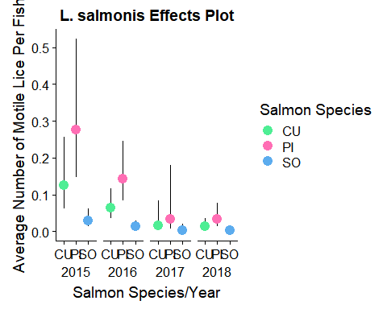

calspeciesfullmodplot <- calspecieseffects %>%   
 group_by(., yr,sal) %>%   
 ggplot(aes(x = sal, y = predicted, colour = sal)) +  
 geom_errorbar(aes(ymin=conf.low, ymax = conf.high,width = 0), colour = 'Black')+  
 geom_point(size = 4) +  
 facet_wrap(~yr,nrow=1,strip.position = "bottom")+  
 theme(strip.background = element_blank(), strip.placement = "outside") +   
 scale_color_manual(leg_title,values=c('seagreen2', 'hotpink1', 'steelblue2'))+  
 labs(title = "C. clemensi Effects Plot", x = 'Salmon Species/Year', y = 'Average Number of Motile Lice Per Fish')  
calspeciesfullmodplot

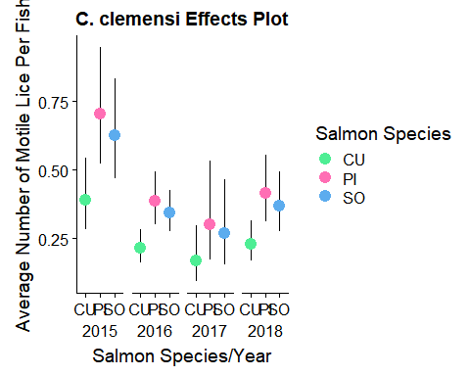

## Region-Level Models

#region-level models  
regionlice <- read.csv('Hakai_lice_data_all_fish_CB_edits.csv')  
  
#now lets do it between all three species, by making some sub-dfs first  
regionlice$week <- as.factor(regionlice$week); regionlice$year <- as.factor(regionlice$year)  
chum.region <- regionlice %>%   
 filter(spp == 'CU')  
pink.region <- regionlice %>%   
 filter(spp == 'PI')  
sock.region <- regionlice %>%   
 filter(spp == 'SO')  
  
chumrmod.calnb <- glmmTMB(all.cal ~ site.region + year - 1 + (1|week),   
 data = chum.region, family=nbinom2)  
chumrmod.lepsnb <- glmmTMB(all.leps ~ site.region + year - 1 + (1|week),   
 data = chum.region, family=nbinom2)  
pinkrmod.calnb <- glmmTMB(all.cal ~ site.region + year - 1 + (1|week),   
 data = pink.region, family=nbinom2)  
pinkrmod.lepsnb <- glmmTMB(all.leps ~ site.region + year - 1 + (1|week),   
 data = pink.region, family=nbinom2)  
sockrmod.calnb <- glmmTMB(all.cal ~ site.region + year - 1 + (1|week),   
 data = sock.region, family=nbinom2)  
sockrmod.lepsnbsr <- glmmTMB(all.leps ~ site.region - 1 + (1|week),   
 data = sock.region, family=nbinom2)  
summary(chumrmod.calnb); summary(chumrmod.lepsnb); summary(pinkrmod.calnb); summary(pinkrmod.lepsnb); summary(sockrmod.calnb); summary(sockrmod.lepsnbsr)

## Family: nbinom2 ( log )  
## Formula: all.cal ~ site.region + year - 1 + (1 | week)  
## Data: chum.region  
##   
## AIC BIC logLik deviance df.resid   
## 2120.8 2157.3 -1053.4 2106.8 1358   
##   
## Random effects:  
##   
## Conditional model:  
## Groups Name Variance Std.Dev.  
## week (Intercept) 0.2548 0.5048   
## Number of obs: 1365, groups: week, 12  
##   
## Overdispersion parameter for nbinom2 family (): 2.12   
##   
## Conditional model:  
## Estimate Std. Error z value Pr(>|z|)   
## site.regionD -0.8537 0.1846 -4.624 3.76e-06 ***  
## site.regionJ -0.6314 0.1926 -3.279 0.00104 **   
## year2016 -0.5131 0.1637 -3.133 0.00173 **   
## year2017 -0.2677 0.1306 -2.051 0.04031 *   
## year2018 -0.3880 0.1352 -2.870 0.00410 **   
## ---  
## Signif. codes: 0 '***' 0.001 '**' 0.01 '*' 0.05 '.' 0.1 ' ' 1

## Family: nbinom2 ( log )  
## Formula: all.leps ~ site.region + year - 1 + (1 | week)  
## Data: chum.region  
##   
## AIC BIC logLik deviance df.resid   
## 510.6 547.1 -248.3 496.6 1358   
##   
## Random effects:  
##   
## Conditional model:  
## Groups Name Variance Std.Dev.  
## week (Intercept) 2.132e-08 0.000146  
## Number of obs: 1365, groups: week, 12  
##   
## Overdispersion parameter for nbinom2 family (): 0.0749   
##   
## Conditional model:  
## Estimate Std. Error z value Pr(>|z|)   
## site.regionD -2.3025 0.2821 -8.162 3.28e-16 ***  
## site.regionJ -3.1487 0.3838 -8.205 2.31e-16 ***  
## year2016 0.4227 0.4203 1.006 0.31464   
## year2017 -1.2784 0.4857 -2.632 0.00848 **   
## year2018 -1.1277 0.4742 -2.378 0.01740 *   
## ---  
## Signif. codes: 0 '***' 0.001 '**' 0.01 '*' 0.05 '.' 0.1 ' ' 1

## Family: nbinom2 ( log )  
## Formula: all.cal ~ site.region + year - 1 + (1 | week)  
## Data: pink.region  
##   
## AIC BIC logLik deviance df.resid   
## 1795.5 1829.5 -890.8 1781.5 932   
##   
## Random effects:  
##   
## Conditional model:  
## Groups Name Variance Std.Dev.  
## week (Intercept) 0.1967 0.4435   
## Number of obs: 939, groups: week, 12  
##   
## Overdispersion parameter for nbinom2 family (): 5.85   
##   
## Conditional model:  
## Estimate Std. Error z value Pr(>|z|)   
## site.regionD -0.72429 0.17729 -4.085 4.4e-05 ***  
## site.regionJ -0.18910 0.17509 -1.080 0.28014   
## year2016 -0.41514 0.15914 -2.609 0.00909 **   
## year2017 -0.08654 0.16465 -0.526 0.59916   
## year2018 -0.16441 0.12203 -1.347 0.17788   
## ---  
## Signif. codes: 0 '***' 0.001 '**' 0.01 '*' 0.05 '.' 0.1 ' ' 1

## Family: nbinom2 ( log )  
## Formula: all.leps ~ site.region + year - 1 + (1 | week)  
## Data: pink.region  
##   
## AIC BIC logLik deviance df.resid   
## 728.2 762.1 -357.1 714.2 932   
##   
## Random effects:  
##   
## Conditional model:  
## Groups Name Variance Std.Dev.  
## week (Intercept) 2.314e-09 4.81e-05  
## Number of obs: 939, groups: week, 12  
##   
## Overdispersion parameter for nbinom2 family (): 0.318   
##   
## Conditional model:  
## Estimate Std. Error z value Pr(>|z|)   
## site.regionD -0.8806 0.1975 -4.459 8.22e-06 ***  
## site.regionJ -1.3489 0.2128 -6.340 2.30e-10 ***  
## year2016 -0.6860 0.2576 -2.663 0.00775 **   
## year2017 -1.6262 0.4798 -3.389 0.00070 ***  
## year2018 -2.2009 0.3248 -6.777 1.23e-11 ***  
## ---  
## Signif. codes: 0 '***' 0.001 '**' 0.01 '*' 0.05 '.' 0.1 ' ' 1

## Family: nbinom2 ( log )  
## Formula: all.cal ~ site.region + year - 1 + (1 | week)  
## Data: sock.region  
##   
## AIC BIC logLik deviance df.resid   
## 6467.4 6510.9 -3226.7 6453.4 3687   
##   
## Random effects:  
##   
## Conditional model:  
## Groups Name Variance Std.Dev.  
## week (Intercept) 0.05698 0.2387   
## Number of obs: 3694, groups: week, 11  
##   
## Overdispersion parameter for nbinom2 family (): 0.974   
##   
## Conditional model:  
## Estimate Std. Error z value Pr(>|z|)   
## site.regionD -0.57222 0.09288 -6.161 7.25e-10 ***  
## site.regionJ -0.41522 0.09257 -4.486 7.27e-06 ***  
## year2016 -0.52957 0.07103 -7.456 8.92e-14 ***  
## year2017 -0.73482 0.10118 -7.262 3.81e-13 ***  
## year2018 -0.80543 0.16844 -4.782 1.74e-06 ***  
## ---  
## Signif. codes: 0 '***' 0.001 '**' 0.01 '*' 0.05 '.' 0.1 ' ' 1

## Family: nbinom2 ( log )  
## Formula: all.leps ~ site.region - 1 + (1 | week)  
## Data: sock.region  
##   
## AIC BIC logLik deviance df.resid   
## 783.8 808.7 -387.9 775.8 3690   
##   
## Random effects:  
##   
## Conditional model:  
## Groups Name Variance Std.Dev.  
## week (Intercept) 0.3741 0.6116   
## Number of obs: 3694, groups: week, 11  
##   
## Overdispersion parameter for nbinom2 family (): 0.142   
##   
## Conditional model:  
## Estimate Std. Error z value Pr(>|z|)   
## site.regionD -4.5724 0.3222 -14.19 <2e-16 ***  
## site.regionJ -3.8232 0.2959 -12.92 <2e-16 ***  
## ---  
## Signif. codes: 0 '***' 0.001 '**' 0.01 '*' 0.05 '.' 0.1 ' ' 1

## AIC tables

chumcalspeffects <- ggpredict(chumrmod.calnb, terms = c('site.region', 'year'))  
chumcalspeffects = chumcalspeffects %>%  
 rename(site.region = x, yr = group) %>%  
 mutate(lice = 'cal')  
chumcalspeffects$site.region = factor(chumcalspeffects$site.region, levels = c(1, 2),  
 labels = c('D', 'J'))  
  
chumlepspeffects <- ggpredict(chumrmod.lepsnb,terms = c('site.region', 'year'))  
chumlepspeffects = chumlepspeffects %>%  
 rename(site.region = x, yr = group)%>%  
 mutate(lice = 'leps')  
chumlepspeffects$site.region = factor(chumlepspeffects$site.region, levels = c(1, 2),  
 labels = c('D', 'J'))  
  
pinkcalspeffects <- ggpredict(pinkrmod.calnb, terms = c('site.region', 'year'))  
pinkcalspeffects = pinkcalspeffects %>%  
 rename(site.region = x, yr = group)%>%  
 mutate(lice = 'cal')  
pinkcalspeffects$site.region = factor(pinkcalspeffects$site.region, levels = c(1, 2),  
 labels = c('D', 'J'))  
  
pinklepspeffects <- ggpredict(pinkrmod.lepsnb,terms = c('site.region', 'year'))  
pinklepspeffects = pinklepspeffects %>%  
 rename(site.region = x, yr = group)%>%  
 mutate(lice = 'leps')  
pinklepspeffects$site.region = factor(pinklepspeffects$site.region, levels = c(1, 2),  
 labels = c('D', 'J'))  
  
sockcalspeffects <- ggpredict(sockrmod.calnb, terms = c('site.region', 'year'))  
sockcalspeffects = sockcalspeffects %>%  
 rename(site.region = x, yr = group)%>%  
 mutate(lice = 'cal')  
sockcalspeffects$site.region = factor(sockcalspeffects$site.region, levels = c(1, 2),  
 labels = c('D', 'J'))  
  
socklepspeffects <- ggpredict(sockrmod.lepsnbsr,terms = 'site.region')  
socklepspeffects = socklepspeffects %>%  
 rename(site.region = x)%>%  
 mutate(lice = 'leps')  
socklepspeffects$site.region = factor(socklepspeffects$site.region, levels = c(1, 2),  
 labels = c('D', 'J'))  
  
chumeffects = rbind(chumcalspeffects, chumlepspeffects)  
pinkeffects = rbind(pinkcalspeffects, pinklepspeffects)

## Region Level Effects Plots

#make some themes so it all looks nice beside each other  
fte_themeSock <- function(){  
 color.background = 'white'  
 color.grid.major = 'black'  
 color.axis.text = 'black'  
 color.axis.title = 'black'  
 color.title = 'black'  
 theme_bw(base_size = 9) +  
 theme(panel.background = element_rect(fill=color.background,color = color.background)) +  
 theme(plot.background = element_rect(fill = color.background, color = color.background)) +  
 theme(panel.border = element_blank()) +  
 theme(panel.grid.major = element_blank()) +  
 theme(panel.grid.minor = element_blank()) +  
 theme(axis.ticks = element_blank()) +  
 theme(plot.title = element_text(color = color.title, size = 15, vjust = 1.25)) +  
 theme(axis.text.x = element_text(size = 10, color = color.axis.text)) +  
 theme(axis.text.y = element_text(size = 10, color = color.axis.text)) +  
 theme(axis.title.x = element_text(size = 12, color = color.axis.title, vjust = 0)) +  
 theme(axis.title.y = element_text(size = 12, color = color.axis.title, vjust = 1.25)) +  
 theme(plot.title = element_text(hjust = 0.5)) +  
 theme(axis.line.x = element_line(color="black", size = 0.15),  
 axis.line.y = element_line(color="black", size = 0.15)) +  
 theme(strip.background = element_blank(),  
 strip.placement = 'outside',  
 strip.text = element_text(size = 10))+  
 theme(legend.position = 'none')  
}  
fte_themeSock2 <- function(){  
 color.background = 'white'  
 color.grid.major = 'black'  
 color.axis.text = 'black'  
 color.axis.title = 'black'  
 color.title = 'black'  
 theme_bw(base_size = 9) +  
 theme(panel.background = element_rect(fill=color.background,color = color.background)) +  
 theme(plot.background = element_rect(fill = color.background, color = color.background)) +  
 theme(panel.border = element_blank()) +  
 theme(panel.grid.major = element_blank()) +  
 theme(panel.grid.minor = element_blank()) +  
 theme(axis.ticks = element_blank()) +  
 theme(plot.title = element_text(color = color.title, size = 15, vjust = 1.25)) +  
 theme(axis.text.x = element_text(size = 10, color = color.axis.text)) +  
 theme(axis.text.y = element_text(size = 10, color = color.axis.text)) +  
 theme(axis.title.x = element_text(size = 12, color = color.axis.title, vjust = 0)) +  
 theme(axis.title.y = element_text(size = 12, color = color.axis.title, vjust = 1.25)) +  
 theme(plot.title = element_text(hjust = 0.5)) +  
 theme(axis.line.x = element_line(color="black", size = 0.15),  
 axis.line.y = element_line(color="black", size = 0.15)) +  
 theme(strip.background = element_blank(),  
 strip.placement = 'outside',  
 strip.text = element_text(size = 10))+  
 theme(legend.position = c(0.9,0.82),  
 legend.text = element_text(size = 10),  
 legend.title = element_text(size = 10))  
}  
fte_themeSock3 <- function(){  
 color.background = 'white'  
 color.grid.major = 'black'  
 color.axis.text = 'black'  
 color.axis.title = 'black'  
 color.title = 'black'  
 theme_bw(base_size = 9) +  
 theme(panel.background = element_rect(fill=color.background,color = color.background)) +  
 theme(plot.background = element_rect(fill = color.background, color = color.background)) +  
 theme(panel.border = element_blank()) +  
 theme(panel.grid.major = element_blank()) +  
 theme(panel.grid.minor = element_blank()) +  
 theme(axis.ticks = element_blank()) +  
 theme(plot.title = element_text(color = color.title, size = 15, vjust = 1.25)) +  
 theme(axis.text.x = element_text(size = 10, color = color.axis.text)) +  
 theme(axis.text.y = element_text(size = 10, color = color.axis.text)) +  
 theme(axis.title.x = element_text(size = 12, color = color.axis.title,  
 margin= margin(t = 0.7, r = , b = 0, l = 0, unit = "cm"), vjust = 0)) +  
 theme(axis.title.y = element_text(size = 12, color = color.axis.title, vjust = 1.25)) +  
 theme(plot.title = element_text(hjust = 0.5)) +  
 theme(axis.line.x = element_line(color="black", size = 0.15),  
 axis.line.y = element_line(color="black", size = 0.15)) +  
 theme(strip.background = element_blank(),  
 strip.placement = 'outside',  
 strip.text = element_text(size = 10))+  
 theme(legend.position = 'none')  
}  
fte_themePink <- function(){  
 color.background = 'white'  
 color.grid.major = 'black'  
 color.axis.text = 'black'  
 color.axis.title = 'black'  
 color.title = 'black'  
 theme_bw(base_size = 9) +  
 theme(panel.background = element_rect(fill=color.background,color = color.background)) +  
 theme(plot.background = element_rect(fill = color.background, color = color.background)) +  
 theme(panel.border = element_blank()) +  
 theme(panel.grid.major = element_blank()) +  
 theme(panel.grid.minor = element_blank()) +  
 theme(axis.ticks = element_blank()) +  
 theme(plot.title = element_text(color = color.title, size = 15, vjust = 1.25)) +  
 theme(axis.text.x = element_text(size = 10, color = color.axis.text)) +  
 theme(axis.text.y = element_blank()) +  
 theme(axis.title.x = element_text(size = 12, color = color.axis.title, vjust = 0)) +  
 theme(axis.title.y = element_text(size = 12, color = color.axis.title, vjust = 1.25)) +  
 theme(plot.title = element_text(hjust = 0.5)) +  
 theme(axis.line.x = element_line(color="black", size = 0.15),  
 axis.line.y = element_line(linetype = 'dashed', color = 'grey75')) +  
 theme(strip.background = element_blank(),  
 strip.placement = 'outside',  
 strip.text = element_text(size = 10))+  
 theme(legend.position = 'none')  
}  
fte_themeChum <- function(){  
 color.background = 'white'  
 color.grid.major = 'black'  
 color.axis.text = 'black'  
 color.axis.title = 'black'  
 color.title = 'black'  
 theme_bw(base_size = 9) +  
 theme(panel.background = element_rect(fill=color.background,color = color.background)) +  
 theme(plot.background = element_rect(fill = color.background, color = color.background)) +  
 theme(panel.border = element_blank()) +  
 theme(panel.grid.major = element_blank()) +  
 theme(panel.grid.minor = element_blank()) +  
 theme(axis.ticks = element_blank()) +  
 theme(plot.title = element_text(color = color.title, size = 15, vjust = 1.25)) +  
 theme(axis.text.x = element_text(size = 10, color = color.axis.text)) +  
 theme(axis.text.y = element_blank()) +  
 theme(axis.title.x = element_text(size = 12, color = color.axis.title, vjust = 0)) +  
 theme(axis.title.y = element_text(size = 12, color = color.axis.title, vjust = 1.25)) +  
 theme(plot.title = element_text(hjust = 0.5)) +  
 theme(axis.line.x = element_line(color="black", size = 0.15),  
 axis.line.y = element_line(linetype = 'dashed', color = 'grey75')) +  
 theme(strip.background = element_blank(),  
 strip.placement = 'outside',  
 strip.text = element_text(size = 10))+  
 theme(legend.position = c(0.8,0.82),  
 legend.text = element_text(size = 10),  
 legend.title = element_text(size = 10))  
}  
  
#make the plots  
regionestbyspplotchumnb <- chumeffects %>%   
 group_by(.,lice,site.region,yr) %>%   
 ggplot(aes(x=site.region, y = predicted, colour = site.region, shape = lice)) +  
 scale_shape_manual(values = c(17,15),labels = c('C. clemensi','L. salmonis'))+  
 geom_errorbar(aes(ymin=conf.low, ymax = conf.high, width = 0), position = position_dodge(width = 0.8),colour = 'Black') +  
 geom_point(size = 4, position = position_dodge(width=0.8)) +  
 facet_wrap(~yr, nrow=1, strip.position = 'bottom')+  
 scale_color_manual(values=c('grey60', 'grey20'))+  
 labs(title = "Chum Salmon",x = '', y = NULL,shape = 'Lice Species', colour = 'Region')+  
 guides(shape = guide_legend(override.aes = list(shape = c(24,22)), type = 'b'))+  
 scale_y_continuous(limits = c(0,1.25)) +  
 fte_themeChum()  
regionestbyspplotchumnb

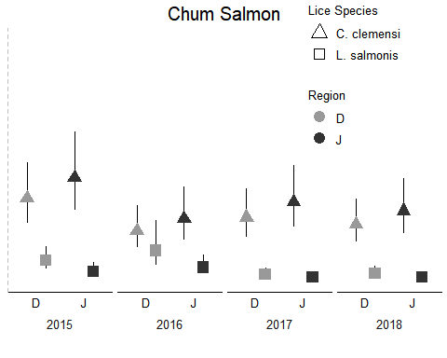

regionestbyspplotpinknb <- pinkeffects %>%   
 group_by(.,lice,site.region,yr) %>%   
 ggplot(aes(x=site.region, y = predicted, colour = site.region, shape = lice)) +  
 scale_shape_manual(values = c(17,15),labels = c('C. clemensi','L. salmonis'))+  
 geom_errorbar(aes(ymin=conf.low, ymax = conf.high, width = 0), position = position_dodge(width = 0.8),colour = 'Black') +  
 geom_point(size = 4, position = position_dodge(width=0.8)) +  
 facet_wrap(~yr, nrow=1, strip.position = 'bottom')+  
 theme(strip.background = element_blank(),strip.placement = 'outside') +  
 scale_color_manual(values=c('grey60', 'grey20'))+  
 labs(title = "Pink Salmon", x = 'Year & Region', y = NULL,shape = 'Lice Species')+  
 guides(shape = guide_legend(override.aes = list(shape = c(24,22)), type = 'b'))+  
 scale_y_continuous(limits = c(0,1.25)) +  
 fte_themePink()  
regionestbyspplotpinknb

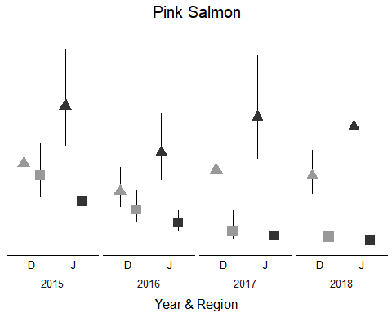

regionestbyspplotsockcal <- sockcalspeffects %>%   
 group_by(.,lice,site.region,yr) %>%   
 ggplot(aes(x=site.region, y = predicted, colour = site.region, shape = lice)) +  
 scale_shape_manual(values = c(17,15),labels = c('C. clemensi','L. salmonis'))+  
 geom_errorbar(aes(ymin=conf.low, ymax = conf.high, width = 0), position = position_dodge(width = 0.8),colour = 'Black') +  
 geom_point(size = 4, position = position_dodge(width=0.8)) +  
 facet_wrap(~yr, nrow=1, strip.position = 'bottom')+  
 theme(strip.background = element_blank(),strip.placement = 'outside') +  
 scale_color_manual(values=c('grey60', 'grey20'))+  
 labs(title = "Sockeye Salmon", x = '', y = 'Average Number of Motile Lice Per Fish',shape = 'Lice Species')+  
 guides(shape = guide_legend(override.aes = list(shape = c(24,22)), type = 'b'))+  
 scale_y_continuous(limits = c(0,1.25))+  
 fte_themeSock()  
regionestbyspplotsockcal

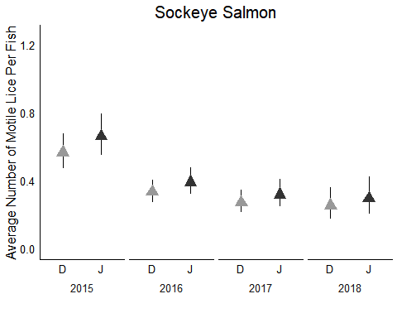

regionbothcalsock <- plot_grid(regionestbyspplotsockcal,regionestbyspplotpinknb,regionestbyspplotchumnb,  
 nrow = 1, labels = NULL, rel_widths = c(1,1,1))   
regionbothcalsock

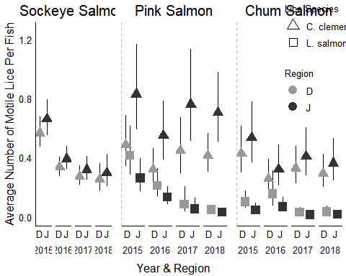

# New Set of Models

## Models (No Crossed Effects)

lepmod.yrsrsp <- glmmTMB(all.leps ~ spp + site.region + year - 1 + (1|collection),   
 data = mainlice, family=nbinom2)  
calmod.yrsrsp <- glmmTMB(all.cal ~ spp + site.region + year - 1 + (1|collection),   
 data = mainlice, family=nbinom2)

## AIC tables

lepmod.yrsrsp_dredge = MuMIn::dredge(lepmod.yrsrsp)

## Fixed term is "disp((Int))"

## Warning in glmmTMB(formula = all.leps ~ 0, data = mainlice, family =  
## nbinom2, : unused argument (`NA` = ~(1 | collection)) (model 0 skipped)

calmod.yrsrsp_dredge = MuMIn::dredge(calmod.yrsrsp)

## Fixed term is "disp((Int))"

## Warning in glmmTMB(formula = all.cal ~ 0, data = mainlice, family =  
## nbinom2, : unused argument (`NA` = ~(1 | collection)) (model 0 skipped)

lepmod.yrsrsp_dredge

## Global model call: glmmTMB(formula = all.leps ~ spp + site.region + year - 1 + (1 |   
## collection), data = mainlice, family = nbinom2, ziformula = ~0,   
## dispformula = ~1)  
## ---  
## Model selection table   
## dsp((Int)) cnd(sit.rgn) cnd(spp) cnd(yer) df logLik AICc delta weight  
## 7 + + + 8 -418.419 852.9 0.00 0.706  
## 8 + + + + 9 -418.292 854.7 1.76 0.292  
## 3 + + 5 -427.833 865.7 12.78 0.001  
## 4 + + + 6 -427.751 867.5 14.63 0.000  
## 5 + + 6 -452.366 916.8 63.86 0.000  
## 6 + + + 7 -452.342 918.7 65.83 0.000  
## 2 + + 4 -461.316 930.7 77.74 0.000  
## Models ranked by AICc(x)   
## Random terms (all models):   
## 'cond(1 | collection)'

calmod.yrsrsp_dredge

## Global model call: glmmTMB(formula = all.cal ~ spp + site.region + year - 1 + (1 |   
## collection), data = mainlice, family = nbinom2, ziformula = ~0,   
## dispformula = ~1)  
## ---  
## Model selection table   
## dsp((Int)) cnd(sit.rgn) cnd(spp) cnd(yer) df logLik AICc delta  
## 8 + + + + 9 -1486.158 2990.4 0.00  
## 7 + + + 8 -1490.784 2997.6 7.23  
## 4 + + + 6 -1493.201 2998.4 8.03  
## 3 + + 5 -1497.330 3004.7 14.28  
## 6 + + + 7 -1498.198 3010.5 20.04  
## 5 + + 6 -1502.828 3017.7 27.29  
## 2 + + 4 -1505.653 3019.3 28.91  
## weight  
## 8 0.956  
## 7 0.026  
## 4 0.017  
## 3 0.001  
## 6 0.000  
## 5 0.000  
## 2 0.000  
## Models ranked by AICc(x)   
## Random terms (all models):   
## 'cond(1 | collection)'

## Effects Plots

calspeffects <- ggpredict(calmod.yrsrsp, terms = c('spp', 'year', 'site.region'))  
lepspeffects <- ggpredict(lepmod.yrsrsp, terms = c('spp', 'year', 'site.region'))  
  
calspeffects = calspeffects %>%   
 rename(sal = x, reg = facet, yr = group)  
  
calspeffects$sal = factor(calspeffects$sal, levels = c(1, 2, 3), labels = c('CU', 'PI', 'SO'))  
  
lepspeffects = lepspeffects %>%   
 rename(sal = x, reg = facet, yr = group)  
  
lepspeffects$sal = factor(lepspeffects$sal, levels = c(1, 2, 3), labels = c('CU', 'PI', 'SO'))  
  
## Make the plots  
  
leg_title <- 'Salmon Species'  
leps3fullmodplot <- lepspeffects %>%   
 group_by(., yr,sal,reg) %>%   
 ggplot(aes(x = sal, y = predicted, colour = sal, shape = reg)) +  
 scale_shape_manual(values = c(15,17)) +  
 geom_errorbar(aes(ymin=conf.low, ymax = conf.high,width = 0), position = position_dodge(width = 0.8),colour = 'Black')+  
 geom_point(size = 4,position = position_dodge(width = 0.8)) +  
 facet_wrap(~yr,nrow=1,strip.position = "bottom")+  
 theme(strip.background = element_blank(), strip.placement = "outside") +   
 scale_color_manual(leg_title,values=c('seagreen2', 'hotpink1', 'steelblue2'))+  
 labs(title = "L. salmonis Effects Plot", x = 'Salmon Species/Year', y = 'Average Number of Motile Lice Per Fish') +  
 guides(shape = guide_legend(title = 'Region', override.aes = list(shape = c(0,2)), type = 'b'))  
leps3fullmodplot

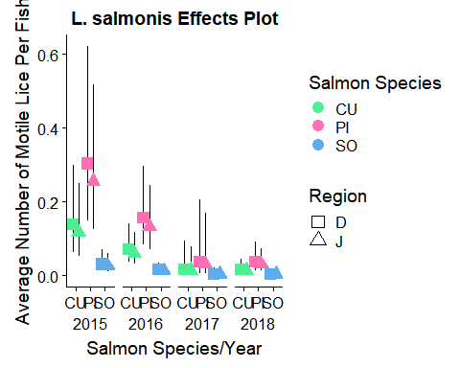

cal3fullmodplot <- calspeffects %>%   
 group_by(., yr,sal,reg) %>%   
 ggplot(aes(x = sal, y = predicted, colour = sal, shape = reg)) +  
 scale_shape_manual(values = c(15,17)) +  
 geom_errorbar(aes(ymin=conf.low, ymax = conf.high,width = 0), position = position_dodge(width = 0.8),colour = 'Black')+  
 geom_point(size = 4,position = position_dodge(width = 0.8)) +  
 facet_wrap(~yr,nrow=1,strip.position = "bottom")+  
 theme(strip.background = element_blank(), strip.placement = "outside") +   
 scale_color_manual(leg_title,values=c('seagreen2', 'hotpink1', 'steelblue2'))+  
 labs(title = "C. clemensi Effects Plot", x = 'Salmon Species/Year', y = 'Average Number of Motile Lice Per Fish') +  
 guides(shape = guide_legend(title = 'Region', override.aes = list(shape = c(0,2)), type = 'b'))  
cal3fullmodplot

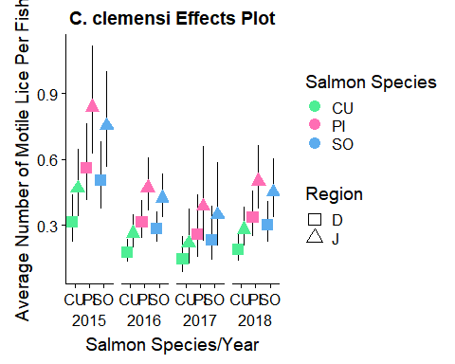

## Models (Crossed Effects)

lepmod.crossed <- glmmTMB(all.leps ~ spp * site.region + spp * year +   
 site.region * year + (1 | collection),   
 data = mainlice, family=nbinom2)  
calmod.crossed <- glmmTMB(all.cal ~ spp * site.region + spp * year +   
 site.region * year + (1 | collection),   
 data = mainlice, family=nbinom2)

## AIC Tables

lepmod.crossed_dredge = MuMIn::dredge(lepmod.crossed, subset = (`cond(site.region)` && `cond(year)`))

## Fixed terms are "cond((Int))" and "disp((Int))"

lepmod.crossed_dredge

## Global model call: glmmTMB(formula = all.leps ~ spp * site.region + spp * year +   
## site.region * year + (1 | collection), data = mainlice, family = nbinom2,   
## ziformula = ~0, dispformula = ~1)  
## ---  
## Model selection table   
## cnd((Int)) dsp((Int)) cnd(sit.rgn) cnd(spp) cnd(yer) cnd(sit.rgn:spp)  
## 24 -1.185 + + + +   
## 56 -1.469 + + + +   
## 32 -1.125 + + + + +  
## 64 -1.427 + + + + +  
## 8 -1.983 + + + +   
## 40 -2.244 + + + +   
## 16 -1.957 + + + + +  
## 48 -2.227 + + + + +  
## 22 -1.051 + + +   
## 6 -1.939 + + +   
## cnd(sit.rgn:yer) cnd(spp:yer) df logLik AICc delta weight  
## 24 + 12 -411.452 847.1 0.00 0.529  
## 56 + + 18 -406.204 848.8 1.71 0.225  
## 32 + 14 -410.656 849.5 2.47 0.154  
## 64 + + 20 -405.297 851.1 3.98 0.072  
## 8 9 -418.292 854.7 7.61 0.012  
## 40 + 15 -413.222 856.7 9.63 0.004  
## 16 11 -417.618 857.4 10.30 0.003  
## 48 + 17 -412.495 859.3 12.25 0.001  
## 22 + 10 -444.677 909.5 62.40 0.000  
## 6 7 -452.342 918.7 71.67 0.000  
## Models ranked by AICc(x)   
## Random terms (all models):   
## 'cond(1 | collection)'

calmod.crossed_dredge = MuMIn::dredge(calmod.crossed, subset = (`cond(site.region)` && `cond(year)`))

## Fixed terms are "cond((Int))" and "disp((Int))"

calmod.crossed_dredge

## Global model call: glmmTMB(formula = all.cal ~ spp * site.region + spp * year +   
## site.region * year + (1 | collection), data = mainlice, family = nbinom2,   
## ziformula = ~0, dispformula = ~1)  
## ---  
## Model selection table   
## cnd((Int)) dsp((Int)) cnd(sit.rgn) cnd(spp) cnd(yer) cnd(sit.rgn:spp)  
## 32 -0.7104 + + + + +  
## 24 -0.7910 + + + +   
## 64 -0.8636 + + + + +  
## 56 -0.9259 + + + +   
## 8 -1.1610 + + + +   
## 16 -1.0900 + + + + +  
## 40 -1.2760 + + + +   
## 48 -1.2170 + + + + +  
## 22 -0.3716 + + +   
## 6 -0.7379 + + +   
## cnd(sit.rgn:yer) cnd(spp:yer) df logLik AICc delta weight  
## 32 + 14 -1478.419 2985.1 0.00 0.410  
## 24 + 12 -1480.773 2985.7 0.65 0.297  
## 64 + + 20 -1473.480 2987.4 2.35 0.126  
## 56 + + 18 -1475.829 2988.0 2.97 0.093  
## 8 9 -1486.158 2990.4 5.35 0.028  
## 16 11 -1484.199 2990.5 5.47 0.027  
## 40 + 15 -1481.158 2992.6 7.51 0.010  
## 48 + 17 -1479.200 2992.7 7.67 0.009  
## 22 + 10 -1493.316 3006.8 21.68 0.000  
## 6 7 -1498.198 3010.5 25.39 0.000  
## Models ranked by AICc(x)   
## Random terms (all models):   
## 'cond(1 | collection)'

## Effects Plots

lepmod.crossed.top <- glmmTMB(all.leps ~ spp + site.region + year + site.region * year - 1 + (1 | collection),   
 data = mainlice, family=nbinom2)  
summary(lepmod.crossed.top)

## Family: nbinom2 ( log )  
## Formula:   
## all.leps ~ spp + site.region + year + site.region * year - 1 +   
## (1 | collection)  
## Data: mainlice  
##   
## AIC BIC logLik deviance df.resid   
## 846.9 913.1 -411.5 822.9 1823   
##   
## Random effects:  
##   
## Conditional model:  
## Groups Name Variance Std.Dev.  
## collection (Intercept) 0.3998 0.6323   
## Number of obs: 1835, groups: collection, 52  
##   
## Overdispersion parameter for nbinom2 family (): 0.426   
##   
## Conditional model:  
## Estimate Std. Error z value Pr(>|z|)   
## sppCU -1.1845 0.3925 -3.018 0.002543 **   
## sppPI -0.3956 0.3670 -1.078 0.281112   
## sppSO -2.6615 0.4323 -6.156 7.44e-10 ***  
## site.regionJ -1.7617 0.5415 -3.253 0.001141 **   
## year2016 -1.6059 0.4688 -3.425 0.000614 ***  
## year2017 -20.4291 5516.2593 -0.004 0.997045   
## year2018 -3.2990 0.7469 -4.417 1.00e-05 ***  
## site.regionJ:year2016 2.0520 0.6794 3.020 0.002524 **   
## site.regionJ:year2017 20.2818 5516.2594 0.004 0.997066   
## site.regionJ:year2018 2.3905 0.9687 2.468 0.013599 *   
## ---  
## Signif. codes: 0 '***' 0.001 '**' 0.01 '*' 0.05 '.' 0.1 ' ' 1

calmod.crossed.top <- glmmTMB(all.cal ~ year + site.region + spp + spp * site.region +   
 site.region * year + (1 | collection),   
 data = mainlice, family=nbinom2)  
summary(calmod.crossed.top)

## Family: nbinom2 ( log )  
## Formula:   
## all.cal ~ year + site.region + spp + spp * site.region + site.region *   
## year + (1 | collection)  
## Data: mainlice  
##   
## AIC BIC logLik deviance df.resid   
## 2984.8 3062.0 -1478.4 2956.8 1821   
##   
## Random effects:  
##   
## Conditional model:  
## Groups Name Variance Std.Dev.  
## collection (Intercept) 0.06448 0.2539   
## Number of obs: 1835, groups: collection, 52  
##   
## Overdispersion parameter for nbinom2 family (): 1.41   
##   
## Conditional model:  
## Estimate Std. Error z value Pr(>|z|)   
## (Intercept) -0.71037 0.21773 -3.263 0.001104 **   
## year2016 -1.13092 0.21375 -5.291 1.22e-07 ***  
## year2017 -1.40737 0.35949 -3.915 9.05e-05 ***  
## year2018 -0.88082 0.24456 -3.602 0.000316 ***  
## site.regionJ -0.37197 0.29207 -1.274 0.202823   
## sppPI 0.33813 0.19955 1.694 0.090184 .   
## sppSO 0.49964 0.17934 2.786 0.005335 **   
## site.regionJ:sppPI 0.40133 0.25662 1.564 0.117840   
## site.regionJ:sppSO -0.02155 0.23835 -0.090 0.927962   
## year2016:site.regionJ 0.97337 0.28481 3.418 0.000632 ***  
## year2017:site.regionJ 1.16990 0.51493 2.272 0.023088 *   
## year2018:site.regionJ 0.63727 0.32298 1.973 0.048486 *   
## ---  
## Signif. codes: 0 '***' 0.001 '**' 0.01 '*' 0.05 '.' 0.1 ' ' 1

lep_top_effects <- ggpredict(lepmod.crossed.top, terms = c('spp', 'year', 'site.region')) #not sure if I did this right  
cal_top_effects <- ggpredict(calmod.crossed.top, terms = c('spp', 'year', 'site.region'))  
  
lep_top_effects = lep_top_effects %>%   
 rename(sal = x, reg = facet, yr = group)  
cal_top_effects = cal_top_effects %>%   
 rename(sal = x, reg = facet, yr = group)  
  
lep_top_effects$sal = factor(lep_top_effects$sal, levels = c(1, 2, 3), labels = c('CU', 'PI', 'SO'))  
cal_top_effects$sal = factor(cal_top_effects$sal, levels = c(1, 2, 3), labels = c('CU', 'PI', 'SO'))  
  
## Make the plots  
  
leg_title <- 'Salmon Species'  
lepsfullmodplot_top <- lep_top_effects %>%   
 group_by(., yr,sal,reg) %>%   
 ggplot(aes(x = sal, y = predicted, colour = sal, shape = reg)) +  
 scale_shape_manual(values = c(15,17)) +  
 geom_errorbar(aes(ymin=conf.low, ymax = conf.high,width = 0), position = position_dodge(width = 0.8),colour = 'Black')+  
 geom_point(size = 4,position = position_dodge(width = 0.8)) +  
 facet_wrap(~yr,nrow=1,strip.position = "bottom")+  
 theme(strip.background = element_blank(), strip.placement = "outside") +   
 scale_color_manual(leg_title,values=c('seagreen2', 'hotpink1', 'steelblue2'))+  
 labs(title = "L. salmonis Effects Plot", x = 'Salmon Species/Year', y = 'Average Number of Motile Lice Per Fish') +  
 guides(shape = guide_legend(title = 'Region', override.aes = list(shape = c(0,2)), type = 'b'))  
lepsfullmodplot_top

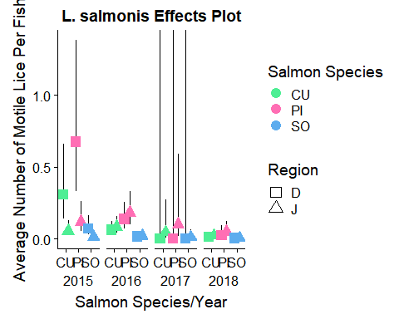

calfullmodplot_top <- cal_top_effects %>%   
 group_by(., yr,sal,reg) %>%   
 ggplot(aes(x = sal, y = predicted, colour = sal, shape = reg)) +  
 scale_shape_manual(values = c(15,17)) +  
 geom_errorbar(aes(ymin=conf.low, ymax = conf.high,width = 0), position = position_dodge(width = 0.8),colour = 'Black')+  
 geom_point(size = 4,position = position_dodge(width = 0.8)) +  
 facet_wrap(~yr,nrow=1,strip.position = "bottom")+  
 theme(strip.background = element_blank(), strip.placement = "outside") +   
 scale_color_manual(leg_title,values=c('seagreen2', 'hotpink1', 'steelblue2'))+  
 labs(title = "L. salmonis Effects Plot", x = 'Salmon Species/Year', y = 'Average Number of Motile Lice Per Fish') +  
 guides(shape = guide_legend(title = 'Region', override.aes = list(shape = c(0,2)), type = 'b'))  
calfullmodplot_top

