**Negative Binomial & Poisson Model Comparisons**

Below are the plots of the model results for the region-level models with sampling region and year as the fixed effects and week of the year as a random effect. Two versions of these plots were created, one using models with a Negative Binomial Distribution, and the other using a Poisson distribution.

Generally, the results are very similar, particularly for the *C. Clemensi* estimates, with a small amount of variation in a few of the *L. salmonis* estimates.

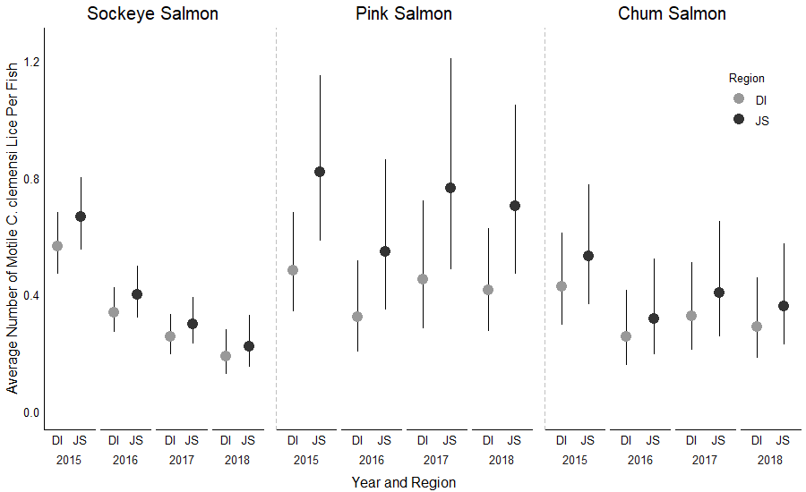

**Figure 1:** *C. clemensi* Lice with Poisson Model

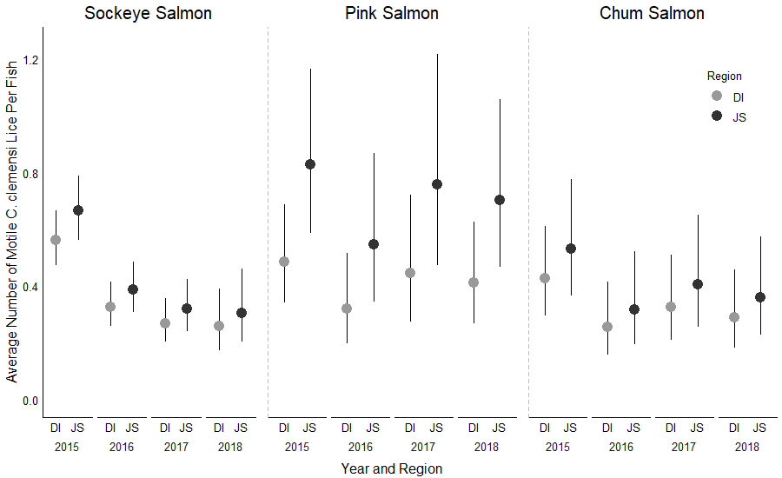

**Figure 2:** *C. clemensi* Lice with Negative Binomial Model

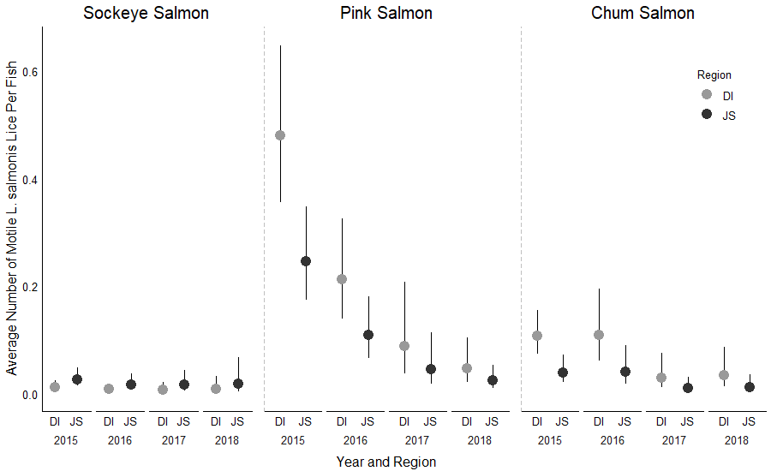

**Figure 3:** *L. salmonis* Lice with Poisson Model

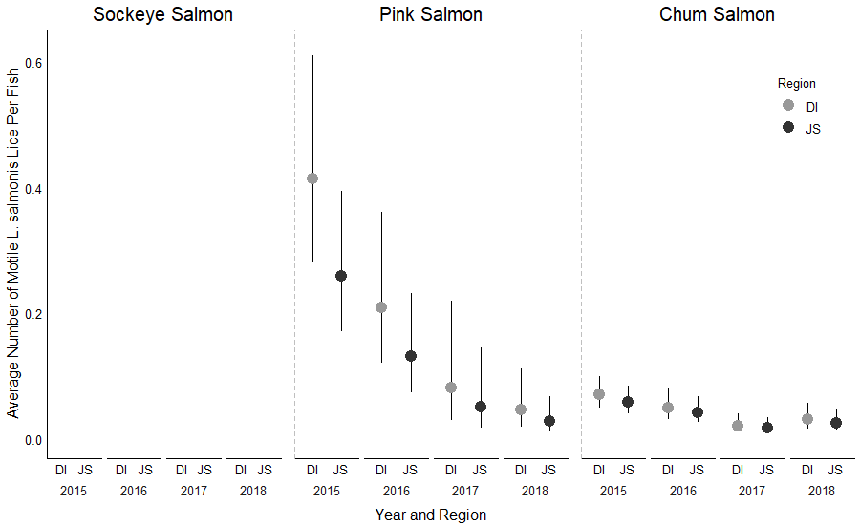

**Figure 4:** *L. salmonis* Lice with Negative Binomial Model – *Plot option 1 – see option 2 below*

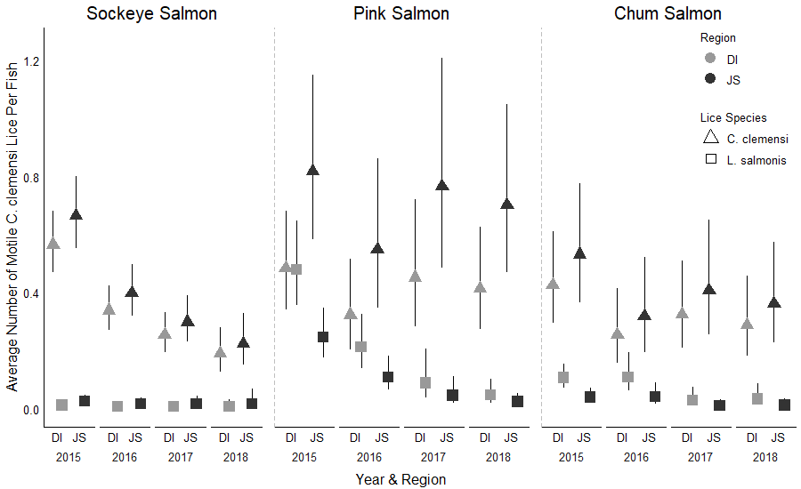

**Figure 5:** Both Lice with Poisson Model

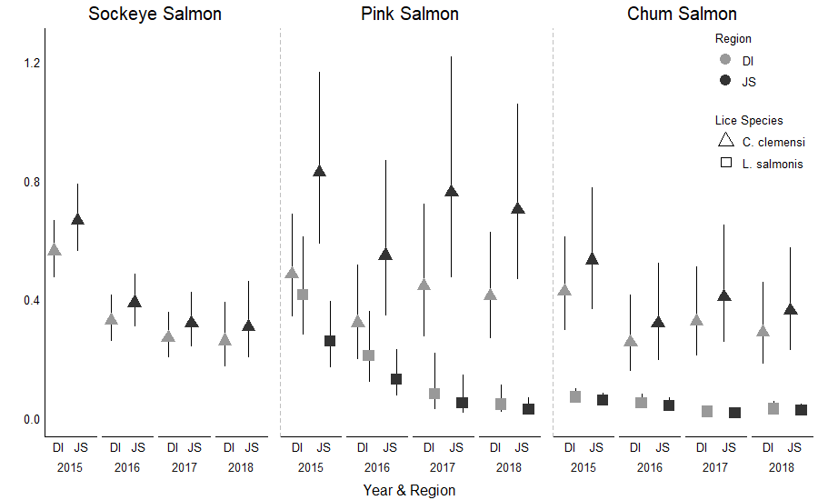

**Figure 6:** Both Lice with Negative Binomial Model

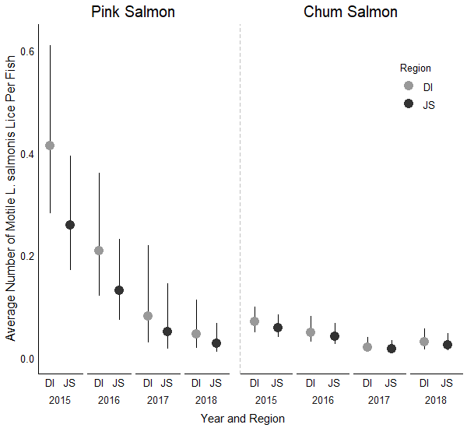

**Figure 7:** *L. salmonis* Lice with Negative Binomial Model – *Plot option 2*