Chris Cole

CS330 Comp Graphic and Visualization

Module Two Milestone

May 20, 2023

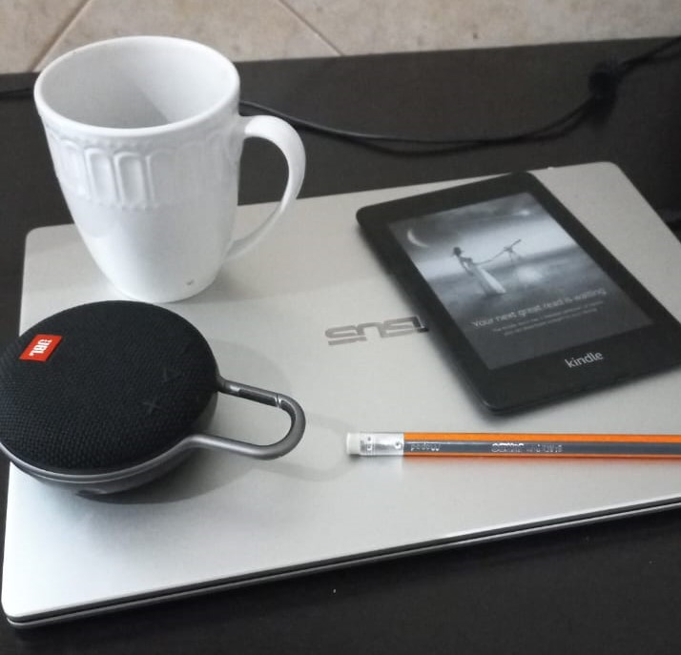

I have chosen to work with the photo above. The photo includes a laptop, a mug, a speaker, a pencil, and a Kindle. I will create each of these objects on the flat surface of a desk created using a plane. I will use a cylinder to create the pencil and possibly the edges of the Kindle and laptop. I will use cubes for the body of the rectangular objects. I will use spheres to represent parts of the speaker and mug. A torus may be useful for the handles of both the mug and speaker.

I think that the pencil, laptop, and Kindle will be relatively straight-forward to create with planes, cylinders, and cubes. The speaker and mug will be much more difficult, I plan to experiment with pyramids, spheres, and tori. I think all the objects are good choices because they are made from a range of different primitive shapes. They are all common objects that would appear in a 3D representation found in a game or other medium.