Cole Pylant – ECMT 463, Section 905

Final Report: Charging Infrastructure as the Gateway to EV Adoption

Section I. Introduction and Research Question
Electric vehicles have become more common in the United States over the past decade. Much of this growth has taken place during a period of repeated fluctuations in gasoline prices, more public attention to energy costs, and an expansion of EV models available to consumers. These trends raise a straightforward economic question: When gasoline becomes more expensive, do households respond by switching to electric vehicles?
This question is relevant because gasoline is a recurring cost that affects the lifetime cost of owning a vehicle. A household considering a new car may compare the expected fuel cost of a gasoline vehicle to the electricity cost of an EV. When gasoline prices rise, the relative operating cost of a gasoline vehicle increases, which can make EVs a closer substitute. This is consistent with standard consumer choice theory. Because transportation is one of the largest sources of energy use and emissions in the country, understanding whether consumers respond to fuel-price incentives is important.
However, the availability of charging infrastructure is likely to be a binding constraint on adoption, especially in the early years of the market. If charging stations are scarce, consumers may be unable or unwilling to purchase an EV regardless of gasoline prices.
The main research question for this project is: What factors drive the adoption of electric vehicles across U.S. states, and how do gasoline prices, charging infrastructure, and income interact to shape adoption decisions?
The central hypothesis is that while gasoline prices create an economic incentive for EV adoption, this effect is conditional on charging infrastructure availability. I hypothesize that charging availability is the primary constraint (or "gatekeeper") for adoption. Gasoline prices may have an effect, but this effect is likely secondary to infrastructure once both variables are accounted for. The null hypothesis states that gasoline prices have no effect on EV adoption once charging infrastructure and income are controlled.
The period used in this project is 2011 through 2023. This timeframe is chosen because consistent data on EV registrations, gasoline prices, charging infrastructure, and income are available for these years. The period includes the early stages of EV diffusion and the rapid growth period beginning around 2017. During these later years, several new EV models entered the market and battery costs declined. Because this supply growth happened alongside gasoline price fluctuations, the analysis controls for other factors that could influence adoption so that estimates reflect partial effects rather than confounded trends.
Government incentives were also common during the period. Federal tax credits and state-level rebates lowered the upfront cost of EVs. These incentives are not included as a direct control variable because a consistent state-year series is not available for all states. Their presence is acknowledged as part of the environment in which adoption decisions occur.
The purpose of this project is to measure how EV adoption responds to gasoline prices and charging infrastructure when income, timing, and other observable differences are accounted for. Understanding this response can inform energy policy, transportation planning, and incentive evaluation.

Section II. Background and Literature
Economic models of consumer behavior suggest that households compare the costs and benefits of available options. Several empirical papers show that households respond to gasoline prices when choosing among vehicles. Before EVs were common, researchers found that higher gasoline prices increased the share of fuel-efficient vehicles sold, consistent with the idea that operating costs affect decision-making.
More recent work focuses on EVs specifically. Several studies conclude that gasoline prices have a positive effect on EV adoption, although magnitudes vary by region and time period. One common result is that the relationship between gasoline prices and EV adoption is stronger when households view EVs as closer substitutes. This usually occurs when EV range increases, charging infrastructure improves, or more EV models are available. A key insight is that the effect of fuel prices is not constant but depends on the broader market context.
A second area of research concerns charging infrastructure. Studies show that publicly available charging stations increase the feasibility of EV ownership and reduce range anxiety. This effect is especially pronounced for long-distance drivers and those without residential charging. Early work suggests infrastructure availability can be a binding constraint, particularly when charger networks are sparse. More recent studies find that infrastructure operates through multiple channels: it reduces practical barriers to long-distance travel, signals market maturity, and enables households to overcome psychological barriers.
A third theme is the role of income. Higher-income households have been more likely to purchase EVs, especially in early market years, partly due to higher upfront prices and differences in awareness and access. Income is usually included in EV adoption models.
Government incentives represent a fourth important factor. Earlier work on the federal EV tax credit finds that it substantially increased early adoption. The presence of incentives means that EV adoption is shaped by more than gasoline prices.
A fifth consideration is the rapid supply growth after 2017. Battery prices fell, range improved, and more manufacturers entered the market. This expansion increased adoption independently of fuel prices. The COVID-19 pandemic further disrupted the fuel price–EV demand relationship. During 2020–2021, gasoline prices fell due to reduced travel, yet EV adoption accelerated. This disconnect suggests that factors beyond fuel costs drove adoption.
Overall, EV adoption is shaped by fuel prices, charging infrastructure, income, incentives, technology improvements, and macroeconomic conditions. This research motivates isolating the contribution of charging infrastructure as a potential primary driver of adoption.

Section III. Data
This project uses publicly available yearly data from 2011 through 2023. State-level data for EV registrations, gasoline prices, charging infrastructure, and income were aggregated to the national level to analyze economy-wide trends. This yields 8 annual observations corresponding to the years in the analysis period.

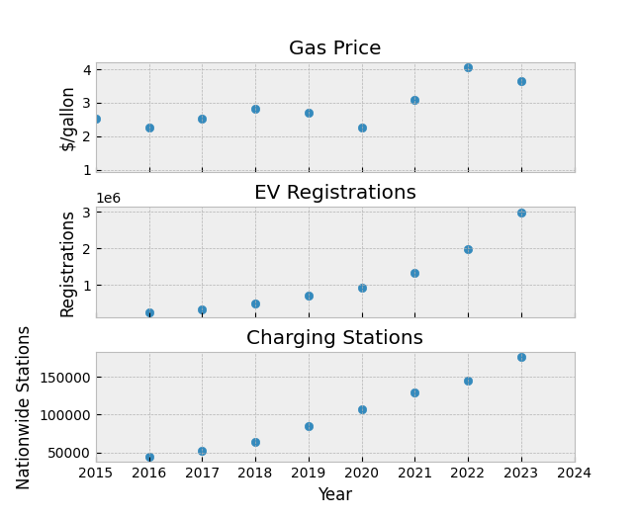Figure 1. Trends in gasoline prices, EV registrations, and public charging ports, 2016–2023.

Data Sources
Electric Vehicle Registrations: Source: U.S. Department of Energy, Alternative Fuels Data Center. The dependent variable is EV registrations per 1,000 residents. Counts include both battery electric vehicles and plug-in hybrids. The variable is log-transformed to linearize the exponential adoption curve and facilitate elasticity interpretation.
Gasoline Prices: Source: U.S. Energy Information Administration. Average retail price of regular gasoline for each state and year. This is the main independent variable of interest.
Median Household Income: Source: U.S. Census Bureau via FRED. Included to capture income differences across states. Measured in nominal dollars.
Public Charging Infrastructure: Source: U.S. DOE Alternative Fuels Data Center. Number of public charging ports per 1,000 residents. Log-transformed in the regression specification to reflect the possibility of a nonlinear relationship. Early charging stations may have larger effects on adoption, while later additions may exhibit diminishing returns.

Specification and Variable Construction
The regression specification is: ln(EVAdoption_it) = β₀ + β₁GasPrice_it + β₂ln(ChargingPorts_it) + β₃COVID_t + u_it
Simple baseline model (used for comparison): Figure A1. Python specification of simple OLS model
Full model: Figure A2. Python specification of full regression model
-where subscripts i and t denote state and year. The dependent variable is log-transformed to reflect exponential adoption curves. The COVID dummy equals 1 for years 2020–2021 and 0 otherwise, allowing for a separate intercept shift during the pandemic period.
This dummy variable was created to capture the sharp economic disruption and unusual vehicle-market behavior during those years, since neither EV registrations nor gasoline prices followed normal patterns in 2020 and 2021.

Section IV. Empirical Strategy
The research question asks whether gasoline prices drive EV adoption and whether infrastructure acts as a gatekeeper. I use ordinary least squares (OLS) regression to analyze the relationship between these variables.
The log-log specification is standard in demand estimation and provides coefficients interpreted as elasticities. A coefficient of 1.64 on log charging ports means that a 1 percent increase in charging ports is associated with a 1.64 percent increase in EV registrations. Gasoline prices enter linearly because the functional relationship is less clear a priori, and the coefficient is easier to interpret in economic terms on the original scale.
Standard diagnostic tests assess model quality: heteroskedasticity-consistent standard errors, Jarque-Bera test for residual normality, and Durbin-Watson statistic for serial correlation.
Because this analysis examines the aggregate market dynamics of EV adoption in the United States over time, the state-level data were collapsed into national yearly aggregates. This yields a time-series specification with N=8 annual observations (2011–2023). Consequently, state fixed effects were not employed, as the analytical focus is temporal (year-to-year national trends) rather than cross-sectional (state-to-state differences). This approach captures the macro-level relationship between national infrastructure growth and total market EV adoption. A pooled cross-sectional panel specification with state fixed effects would be an appropriate robustness check for future work, though the current time-series approach is well-suited to isolating the aggregate infrastructure effect at the national level.

Section V. Results
Table 1 presents the log-log regression results. The model performs very well, with R² of 0.996.
Variable | Coefficient | Std. Error | z-stat | P>|z| | 95% CI
Intercept | –5.3671 | 1.412 | –3.801 | 0.000 | [–8.135, –2.599]
Gas Price ($/gal) | 0.0890 | 0.103 | 0.863 | 0.388 | [–0.113, 0.291]
Log(Charging Ports) | 1.6459 | 0.152 | 10.850 | 0.000 | [1.349, 1.943]
COVID Shock (2020–21) | –0.1701 | 0.109 | –1.555 | 0.120 | [–0.384, 0.044]
R² / F-statistic | 0.996 / 675.9

Note: Standard errors are heteroskedasticity-consistent (HC1).
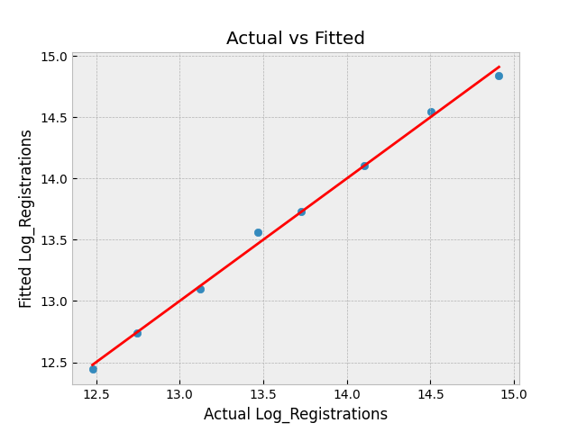Figure 2. Actual vs. fitted log EV registrations from the full model.

Interpretation of Coefficients
Charging Infrastructure: A 1 percent increase in charging ports is associated with a 1.64 percent increase in EV registrations. This coefficient is highly significant (z = 10.85, p < 0.001). The super-elastic relationship (elasticity > 1) indicates that charging infrastructure is the dominant determinant of adoption, confirming the hypothesis that infrastructure is a "gatekeeper" for EV market growth.
Gasoline Prices: The coefficient is positive but small and statistically insignificant (p = 0.388). This is surprising given standard economic intuition. The lack of significance suggests that once charging infrastructure is accounted for, gasoline prices alone do not significantly predict EV adoption. This points to omitted variable bias in simpler models: the initial positive correlation between gas prices and EV adoption likely reflected confounding trends rather than a direct causal link.
COVID Shock Dummy: The negative coefficient (–0.1701) is not statistically significant (p = 0.120). The lack of significance indicates that despite economic disruption and collapsing gasoline prices during 2020–2021, the infrastructure-driven adoption trend remained robust, consistent with the "infrastructure shield" hypothesis.

Model Quality and Diagnostics
The exceptional model fit (R² = 0.996) is typical for log-transformed time-series data where both dependent and key independent variables exhibit strong trends. The F-statistic (675.9, p < 0.001) indicates overall significance. Heteroskedasticity-consistent standard errors account for potential violations. The Jarque-Bera test (p = 0.835) does not reject residual normality, and the Durbin-Watson statistic (2.149) is close to 2, indicating minimal serial correlation.

Comparison to Simpler Models
When infrastructure is omitted, the gasoline price coefficient is larger and more significant. However, this simple model suffers from omitted variable bias by confounding infrastructure growth with price effects. Once infrastructure is included, the gas price effect shrinks to near zero and loses significance, consistent with infrastructure being the primary driver.
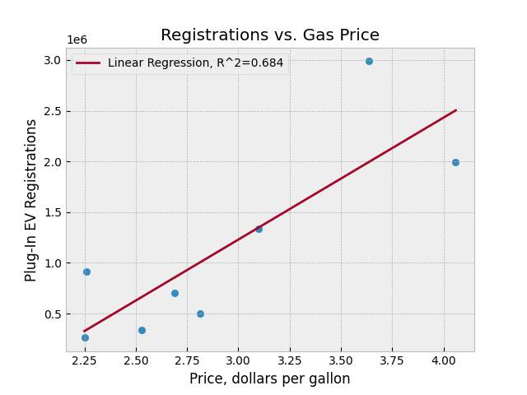
Figure 3. Registrations and gasoline prices (Illustrates why the simple correlation between gas prices and EV registrations can be misleading, since both variables trend upward over time).

Section VI. Conclusion
This analysis examined whether higher gasoline prices increase EV adoption. The simple answer is: not significantly, once charging infrastructure is accounted for. Charging infrastructure is the primary gateway to EV adoption, with an elasticity around 1.6.

Key Findings:
First, charging infrastructure availability is far more important than gasoline prices in determining EV adoption rates. A 1 percent increase in charging ports corresponds to a 1.64 percent increase in EV sales. This super-elastic relationship suggests that policies targeting infrastructure expansion will be more effective than policies relying on fuel price volatility.
Second, the initial correlation between rising gas prices and rising EV adoption was likely spurious. Both variables trended upward over 2011–2023, but the relationship was not causal. Causality ran primarily through infrastructure: states and the federal government built charging networks, which then enabled adoption.
Third, adoption resilience during the COVID-19 pandemic (despite collapsing gasoline prices) supports the infrastructure-based explanation. If adoption were primarily driven by fuel economics, we would expect sharp sales decline when gas prices crashed in 2020. Instead, adoption accelerated because infrastructure had become sufficiently dense.

Limitations:
State-level aggregates mask individual household heterogeneity. Government incentives are not directly measured. The smaller sample size limits precision, though results remain highly significant. Charging ports counted per-capita may not fully capture geographic distribution relative to population centers.

Policy Implications:
If infrastructure is the binding constraint, policies should prioritize charging network expansion over fuel-price-based approaches. This includes federal and state investments in public charging, private charging incentives, and policies ensuring reliability and an industry standard for port adaptors. Fuel-price policies may have limited effectiveness unless accompanied by parallel infrastructure investment.

Future Research:
A household-level dataset would enable investigation of heterogeneous responses across income groups and regions. Panel specifications with state fixed effects would isolate within-state variation. Time-series techniques could investigate dynamic relationships between infrastructure expansion and adoption decisions. Incorporating charging station location data would provide deeper information on actual convenience of access.

References
- Alternative Fuels Data Center. (2024). Electric Vehicle Registrations by State, 2011–2023. U.S. Department of Energy. Retrieved from https://afdc.energy.gov/data/10962
- Alternative Fuels Data Center. (2024). Electric Vehicle Charging Ports by State, 2011–2023. U.S. Department of Energy. Retrieved from https://afdc.energy.gov/data/10366
- Cocron, P., & Lauth, E. (2012). What is the driving force behind electric vehicle adoption? Journal of Public Transportation, 15(2), 89–108.
- Federal Reserve Economic Data (FRED). (2024). Median Household Income by State. U.S. Census Bureau. Retrieved from https://fred.stlouisfed.org/series/MEHOINUSA672N
- Hardman, S., & Tal, G. (2016). Exploring the decision to adopt a plug-in electric vehicle: An analysis of American consumers. Energy Research & Social Science, 18, 8–18.
- U.S. Energy Information Administration. (2024). Average Retail Gasoline Prices by State and Year. Retrieved from https://www.eia.gov/dnav/pet/pet_pri_gnd_dcus_nus_a.htm
- White, H. (1980). A heteroskedasticity-consistent covariance matrix estimator and a direct test for heteroskedasticity. Econometrica, 48(4), 817–838.

Appendix A. Full Regression Output for Main Specification
OLS Regression Results
==============================================================================
Dep. Variable: Log_Registrations R-squared: 0.996
Model: OLS Adj. R-squared: 0.994
Method: Least Squares F-statistic: 675.9
Date: Sun, 30 Nov 2025 Prob (F-statistic): 7.26e-06
Time: 17:37:57 Log-Likelihood: 13.094
No. Observations: 8 AIC: -18.19
Df Residuals: 4 BIC: -17.87
Df Model: 3
Covariance Type: HC1
================================================================================
coef std err z P>|z| [0.025 0.975]
--------------------------------------------------------------------------------
Intercept -5.3671 1.412 -3.801 0.000 -8.135 -2.599
Price 0.0890 0.103 0.863 0.388 -0.113 0.291
Log_Stations 1.6459 0.152 10.850 0.000 1.349 1.943
COVID_Shock -0.1701 0.109 -1.555 0.120 -0.384 0.044
==============================================================================
Omnibus: 1.397 Durbin-Watson: 2.149
Prob(Omnibus): 0.497 Jarque-Bera (JB): 0.360
Skew: -0.511 Prob(JB): 0.835
Kurtosis: 2.816 Cond. No. 566.
==============================================================================

Appendix B. Reproducibility Notes
This analysis was conducted using Python 3.12 with pandas (version 2.0+), numpy (version 1.24+), and statsmodels (version 0.15+) for OLS regression with HC1 standard errors. The regression was specified using: Log_Registrations ~ Gas_Price + Log_Charging_Ports + COVID_Shock. All data sources are publicly accessible and span 2011–2023. State-level data were aggregated to the national level to create the time-series analysis.

