MIS S381N Project
Kalani Dissanayake, Manas Ayyalaraju, Cole Pylant, Sarvesh Miskin

Introduction
Although every marriage is unique, large datasets can reveal common patterns that are associated with whether relationships endure or end in divorce. For this project, we are analyzing the Marriage Longevity: What Makes Relationships Last dataset from Kaggle. The dataset contains 45,000 marriage records and 24 variables describing demographic, financial, lifestyle, and relationship characteristics. These variables include age at marriage, age difference between partners, education level, household income, employment status, number of children, financial stress, religious attendance, premarital counseling, conflict frequency, shared activities, and communication behaviors such as criticism, contempt, defensiveness, and stonewalling. The dataset also includes positive relationship measures, such as repair-attempt success and the ratio of positive to negative interactions, along with whether each marriage ended in divorce.
The main question guiding this project is: What demographic, financial, and relationship factors are associated with divorce? To answer this question, we compare divorced and non-divorced couples and examine patterns across financial stress, education, marriage history, premarital counseling, communication behaviors, conflict patterns, and positive relationship characteristics.
This problem is important because divorce can have significant personal, social, and economic consequences. It may affect household finances, emotional well-being, family stability, and the experiences of children and other family members. Understanding the characteristics associated with divorce may therefore be useful to couples, relationship counselors, researchers, educators, and others interested in relationship stability. This dataset is especially valuable because it includes a large number of observations and examines several dimensions of marriage rather than focusing on only one factor.

Graph 1: Overall Divorce Rate
To establish a baseline for the analysis, we first examined the overall distribution of marriage outcomes by comparing the number of divorced and non-divorced couples. Approximately 46% of the marriages ended in divorce, while 54% remained intact. The relatively balanced distribution between the two groups provides a strong foundation for meaningful comparisons throughout the remainder of the analysis.

Graph 2: Financial Stress by Divorce Status
To examine whether financial factors are associated with divorce, we compared the average financial stress reported by divorced and non-divorced couples. Divorced couples reported noticeably higher levels of financial stress than couples who remained married. This pattern suggests that greater financial strain is associated with divorce and may contribute to differences in long-term relationship outcomes.

Graph 3: Negative Relationship Behaviors
To analyze whether negative communication patterns differ by marriage outcome, we compared criticism, contempt, defensiveness, and stonewalling between divorced and non-divorced couples. Divorced couples had higher average scores for all four behaviors. The largest difference appears in contempt, while defensiveness had the highest average score overall. This suggests that more frequent negative communication behaviors are associated with divorce.

Graph 4: Positive Relationship Behaviors
To examine the role of positive relationship patterns, we compared repair-attempt success, positive-to-negative interactions, and shared activities between divorced and non-divorced couples. Non-divorced couples had higher average scores for all three measures. Clear differences appear in both repair-attempt success and the positive-to-negative interaction ratio. This suggests that positive communication and spending time together are associated with marriages that remain intact.

Graph 5: Divorce Rate by Education Level
The graph shows a clear decrease in divorce rates as education level increases. Individuals with less than a high school education have the highest divorce rate at approximately 63%, while graduates have the lowest rate at about 30%. This suggests that higher education levels are associated with lower divorce rates in this dataset.

Graph 6: Divorce Rate by Marriage Number
The graph shows that divorce rates increase with the number of marriages. The divorce rate rises from approximately 42% for first marriages to 54% for second marriages and 73% for third marriages. This indicates that later marriages are associated with a greater likelihood of divorce in this dataset.

Graph 7: Divorce Rate by Premarital Counseling
To examine whether premarital preparation is associated with divorce, we compared divorce rates between couples who attended premarital counseling and those who did not. Couples who did not attend counseling had a noticeably higher divorce rate (48.9%) than couples who did (37.2%), an 11.7 percentage-point gap. This pattern suggests that premarital counseling is associated with lower divorce risk, and unlike most other factors in this dataset, it is something couples can actively choose to do.

Graph 8: Correlations with Divorce
To identify which variables are most strongly associated with divorce, we calculated the Pearson correlation between each numeric variable and the divorce outcome. Contempt shows the strongest positive correlation (r = 0.33), followed by criticism, stonewalling, and defensiveness, indicating that negative relationship behaviors are the factors most closely tied to divorce. On the other end, repair-attempt success and the positive-to-negative interaction ratio show the strongest negative correlations, meaning couples who handle conflict well and maintain more positive interactions are less likely to divorce. Variables such as cohabitation, employment status, and number of children sit near zero, indicating little to no association with divorce in this dataset.

Classification Analysis
After identifying patterns through exploratory analysis, we evaluated whether these variables could also be used to predict divorce. Divorce status was modeled as a binary classification problem using two machine learning models: Logistic Regression and Random Forest. The variables marriage_id, years_married, and years_to_divorce were excluded because they either provide no predictive value or are directly tied to the outcome being predicted. The remaining demographic, financial, and relationship variables were used to train the models.
Both models performed substantially better than the baseline prediction of always choosing the majority class. Logistic Regression achieved an accuracy of 75.7% with an AUC of 0.837, while the Random Forest achieved 73.5% accuracy with an AUC of 0.812. These results indicate that the variables in the dataset contain meaningful predictive information about divorce and support the patterns observed in the exploratory analysis.
To better understand which variables contributed most to the predictions, we examined the Random Forest feature importance. Contempt ranked as the most important predictor, followed by the positive-to-negative interaction ratio, repair-attempt success, and criticism. This closely matches the findings from the exploratory analysis, where relationship behaviors consistently showed stronger associations with divorce than demographic characteristics.

Model | Accuracy | AUC
Baseline | 54.0% | –
Logistic Regression | 75.7% | 0.837
Random Forest | 73.5% | 0.812
Table 1: Classification Model Performance

Conclusion
Across both the exploratory analysis and the classification models, relationship behavior emerged as the strongest signal associated with divorce. Divorced couples showed consistently higher criticism, contempt, defensiveness, stonewalling, conflict frequency, and financial stress, while couples who stayed married showed stronger repair-attempt success, a healthier positive-to-negative interaction ratio, and more shared activities. Contempt had the strongest correlation with divorce and also ranked as the most important feature in the Random Forest model. Repair-attempt success and the positive-to-negative ratio had the strongest protective correlations.
Demographic and background factors mattered too, but less dramatically: divorce rates fell as education rose, climbed with each subsequent marriage, and were lower among couples who attended premarital counseling. Cohabitation, employment status, and number of children showed little to no association.
The practical takeaway is that day-to-day communication quality, repairing conflict effectively, maintaining more positive than negative interactions, spending time together, and attending premarital counseling are more closely associated with marital stability than most demographic traits. In addition, the classification models achieved accuracies above 73%, indicating that these variables contain meaningful predictive information about divorce. However, these findings describe associations rather than causal relationships and should not be interpreted as proof that any single factor causes or prevents divorce.

Figures

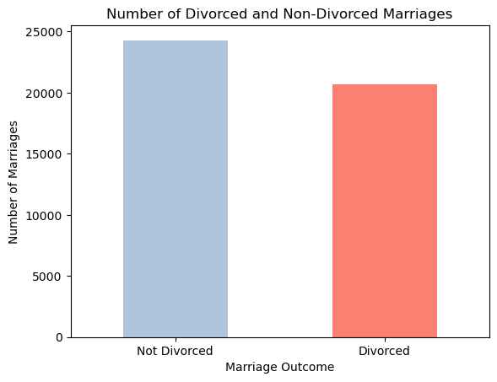
Graph 1: Number of Divorced and Non-Divorced Marriages

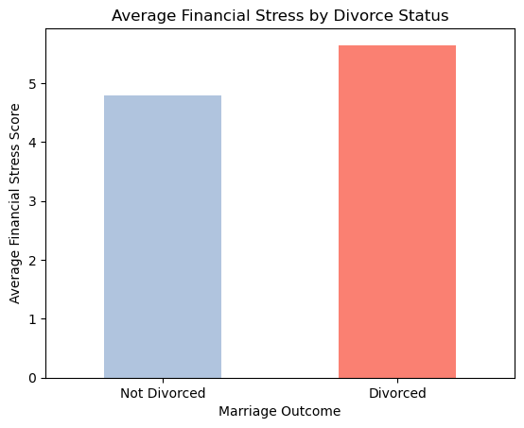
Graph 2: Average Financial Stress by Divorce Status

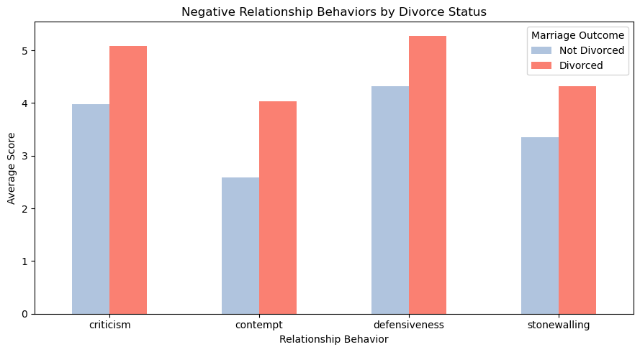
Graph 3: Negative Relationship Behaviors by Divorce Status

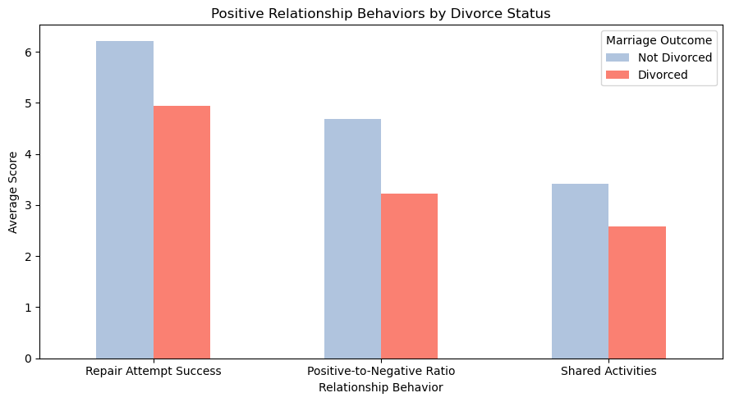
Graph 4: Positive Relationship Behaviors by Divorce Status

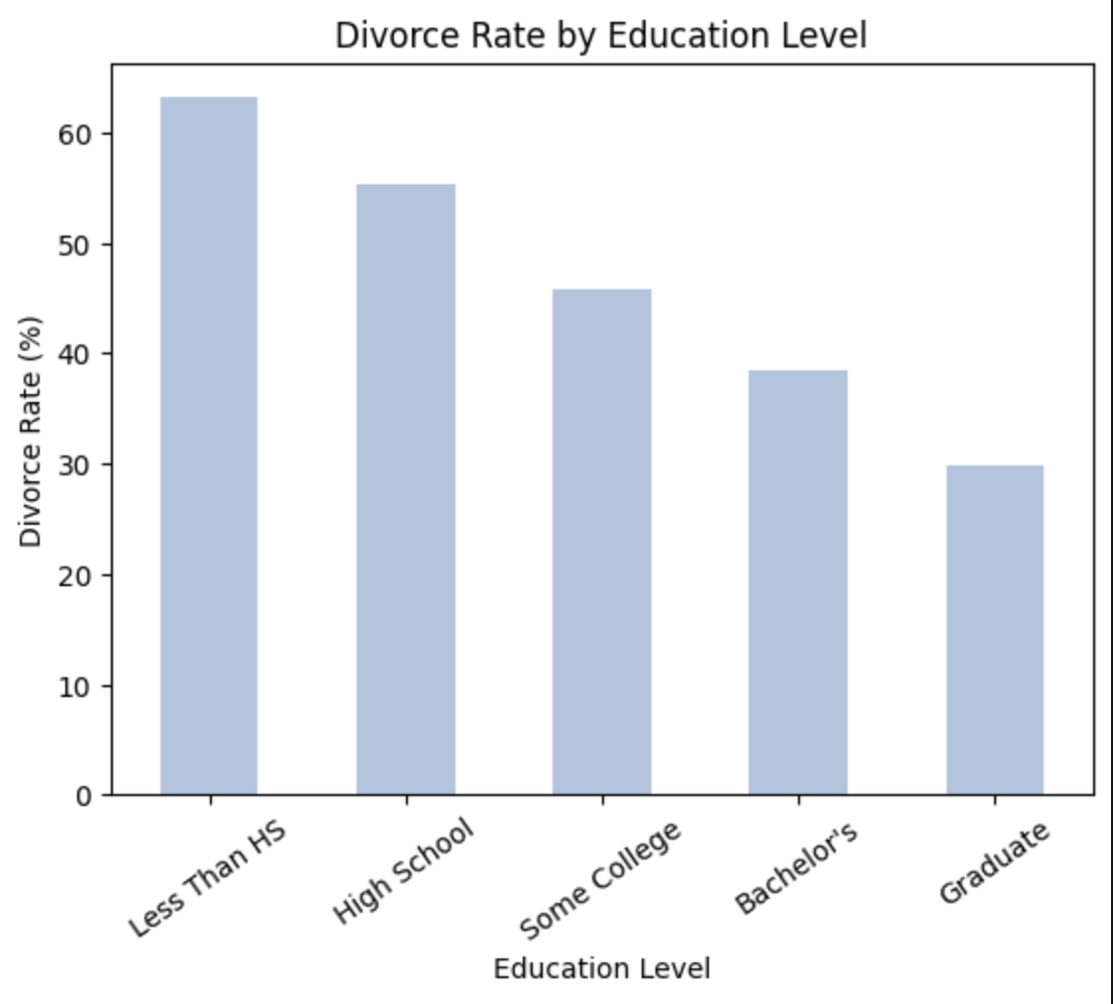
Graph 5:Divorce rate by education level

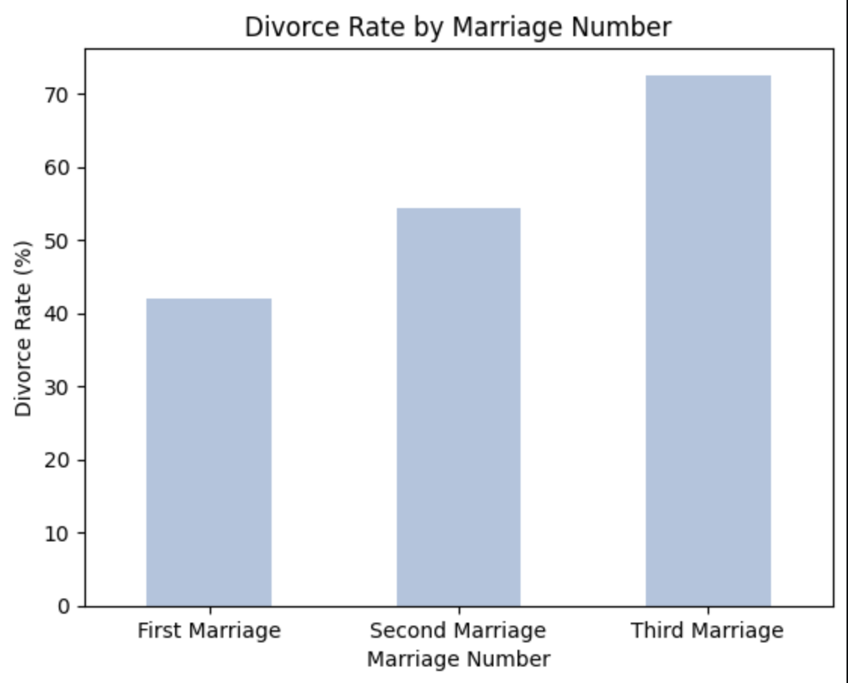
Graph 6: Divorce rate by marriage number

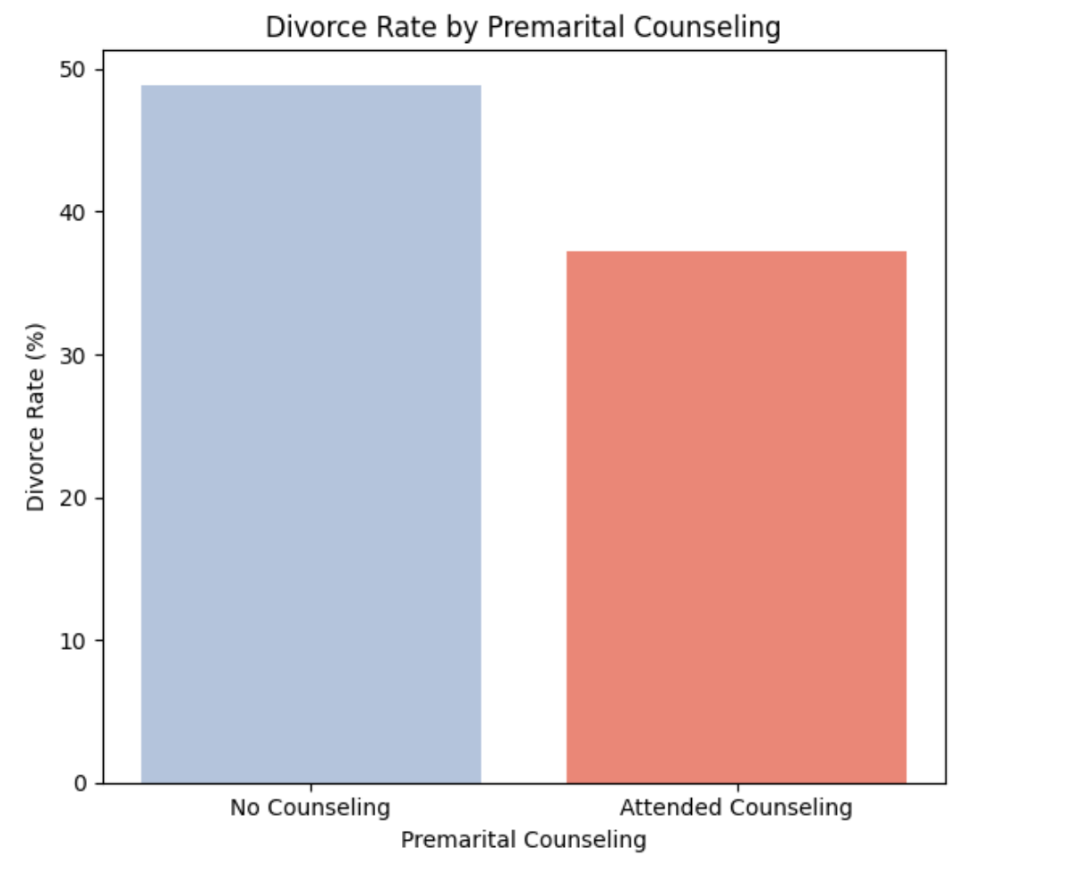
Graph 7: Divorce Rate by Premarital Counseling

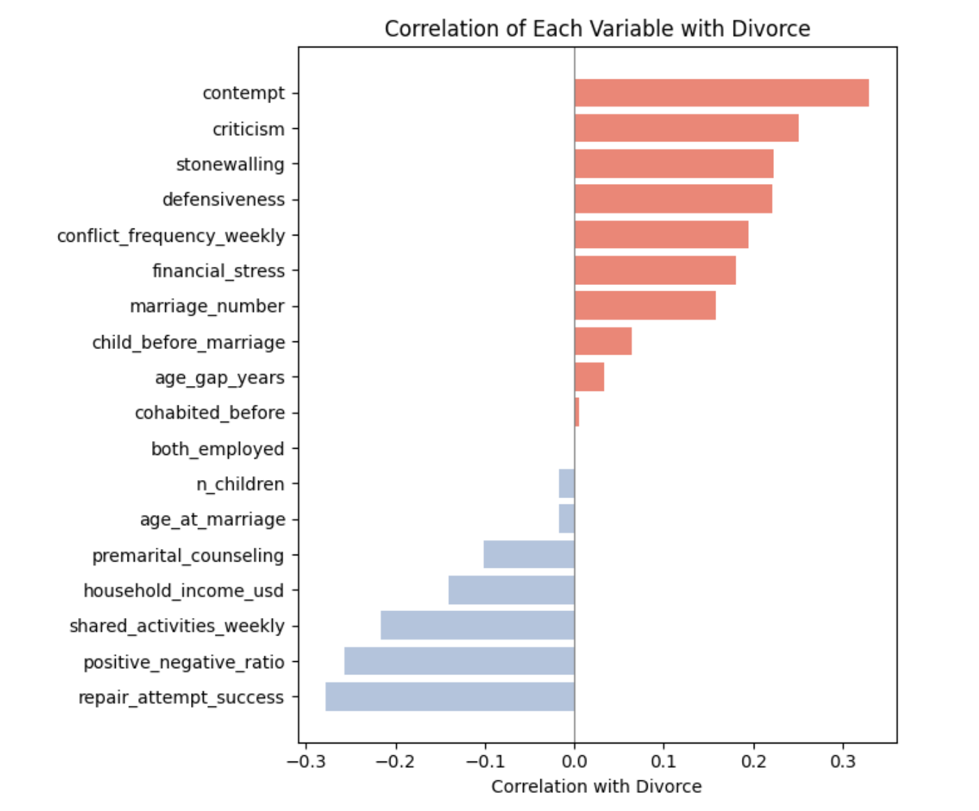
Graph 8: Correlation of Each Variable with Divorce

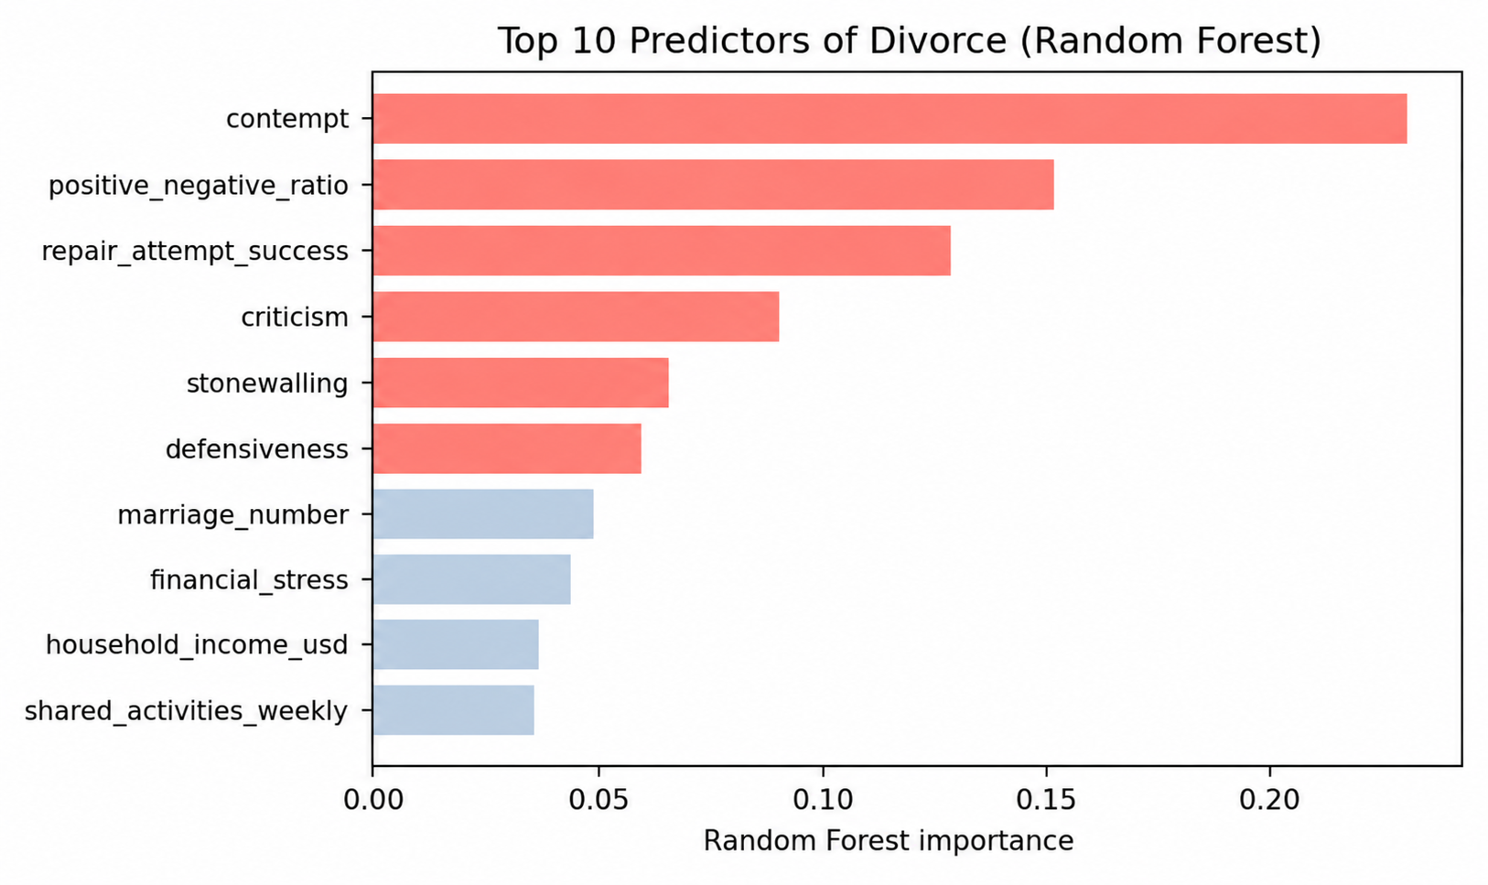
Graph 9: Random Forest Feature Importance

