Chromatin priming precedes a time-resolved transcriptional cascade during heat stress in the reef-building coral Orbicella faveolata
An integrated RNA-seq and ATAC-seq time-course analysis

Keywords: coral thermal stress; multiomics integration; chromatin accessibility; ATAC-seq; differential expression; fuzzy clustering; heat-inducible promoters; bleaching; cnidarian genomics

Abstract
Reef-building corals face escalating thermal stress, yet the regulatory logic that links the chromatin landscape to the transcriptional heat-stress response remains poorly resolved in non-model cnidarians. Here we integrate paired RNA-seq and ATAC-seq across a four-point thermal time course (30 min, 4 h, 12 h, 24 h; heat versus control, two biological replicates per group) in the mountainous star coral Orbicella faveolata. Differential expression analysis identified a strong, time-structured transcriptional response comprising 5,798 differentially expressed genes (padj < 0.05, |log₂FC| ≥ 1), rising from 2,378 regulated genes at 30 min to a peak of 2,819 at 12 h and resolving to 438 by 24 h. Soft (fuzzy c-means) clustering of temporal trajectories resolved four reproducible regulatory programs whose Gene Ontology signatures trace a coherent physiological arc: immediate-early signaling and apoptotic priming, mid-phase induction of ATP-dependent chaperones and the chaperonin-containing T-complex, a delayed DNA-replication and repair / cell-cycle module, and homeostatic resolution. Chromatin accessibility changes were more diffuse and individually less powered than expression changes, but integrating the two layers across 2,178 gene-level links revealed coupled, time-ordered regulation, with roughly one-quarter of links showing accessibility changes preceding expression changes. Prioritizing concordant, promoter-proximal, chromatin-primed loci nominated 96 candidate heat-inducible promoters of interest for biomarker and synthetic-biology applications. Together these results provide a temporally resolved, multiomic portrait of the coral heat-stress response and a ranked set of regulatory targets for functional follow-up.

1 Introduction
Coral reefs are among the most biologically productive and economically valuable ecosystems on Earth, yet they are acutely vulnerable to ocean warming. Marine heatwaves drive the breakdown of the coral–Symbiodiniaceae symbiosis—bleaching—and repeated or prolonged thermal stress causes mass mortality. Understanding how corals sense and respond to elevated temperature at the molecular level is therefore central to forecasting reef futures and to emerging interventions such as assisted evolution and probiotic or genetic enhancement of thermal tolerance.
The transcriptional response of corals to heat stress has been characterized in several species and typically features rapid induction of molecular chaperones, oxidative-stress and apoptosis machinery, and remodeling of metabolism. What remains comparatively unexplored in corals is the regulatory layer that shapes these expression changes: the accessibility of cis-regulatory chromatin. The assay for transposase-accessible chromatin (ATAC-seq) maps open, nucleosome-depleted regions that mark active promoters and enhancers, and pairing it with RNA-seq permits inference of whether accessibility changes precede, accompany, or follow the expression changes they may regulate.
Two features make such inference tractable in a time course. First, if a chromatin change is causal for an expression change, the accessibility signal should, on average, lead the transcriptional one. Second, regulatory coupling should be enriched at promoter-proximal peaks linked to the responding gene. We exploit both ideas here. Working in Orbicella faveolata, a dominant Caribbean reef-builder with a well-assembled reference genome, we generated paired RNA-seq and ATAC-seq across an acute thermal time course and asked three questions: (i) What is the temporal structure of the transcriptional heat-stress response? (ii) Can distinct temporal programs be resolved, and what biological processes do they encode? (iii) Where chromatin and expression change together, what is their temporal ordering, and which loci are the strongest candidate heat-inducible regulatory elements?

2 Materials and Methods

2.1 Experimental design and sequencing
Colonies of Orbicella faveolata were subjected to a heat-stress treatment or held at control temperature and sampled at four times post-onset: 30 min, 4 h, 12 h, and 24 h. Each time × treatment combination was represented by two biological replicates. Matched fragments were processed for both bulk RNA-seq (poly-A / total RNA) and ATAC-seq, yielding 16 RNA libraries and 16 ATAC libraries. RNA reads were quantified against annotated gene models (NCBI O. faveolata assembly, LOC gene identifiers) with featureCounts; ATAC reads were quantified over a consensus peak set.

2.2 Count-matrix construction and quality control
The RNA count matrix comprised 25,929 gene models × 16 samples after recovery of an initially dropped 30-min control replicate. The ATAC consensus matrix comprised 173,102 peaks × 16 samples; because peaks were annotated to multiple Gene Ontology terms, the raw file contained repeated peak rows, which were collapsed to one count row per peak prior to analysis. Peaks were annotated to genomic features (promoter, mRNA, exon, lncRNA, intergenic region) and to overlapping or proximal gene models, producing a peak–gene map used for integration. Library-size normalization used DESeq2 median-of-ratios size factors. Sample relationships were examined by principal component analysis on variance-stabilized counts. One RNA control replicate (the recovered 30-min sample) behaved as a pronounced technical outlier on PC1 and was excluded from the ordination shown in Figure 1B; it was retained, with caution, in differential testing.

2.3 Differential expression and accessibility
To respect the strong temporal structure and the modest replication, differential analysis was performed within each timepoint using DESeq2 with the design ~condition, contrasting Heat versus Control. Genes/peaks were retained if their summed counts met a minimum threshold. Differentially expressed genes (DEGs) were defined at padj < 0.05 and |log₂FC| ≥ 1. For chromatin, genome-wide multiple-testing correction across ~173,000 peaks with two replicates per group yielded no peaks below conventional adjusted-p thresholds (minimum padj ≈ 0.898); we therefore report differentially accessible (DA) peaks at a nominal p < 0.05 with |log₂FC| ≥ 0.3, an explicitly exploratory threshold whose limitations we address below.

2.4 Temporal clustering
DEGs significant in ≥ 2 timepoints were assembled into gene × time log₂FC trajectories, z-scored per gene, and partitioned by fuzzy c-means clustering (package e1071 / scikit-fuzzy). The fuzzifier m was set from the dimensionality-aware heuristic of Schwämmle and Jensen; the number of clusters was selected by minimizing the Xie–Beni validity index over k = 2–10. Genes with maximum membership ≥ 0.6 were designated “core” cluster members.

2.5 RNA–ATAC integration and candidate scoring
DA peaks were mapped to genes via the peak–gene annotation, and each gene was assigned its strongest-effect linked peak. Genes were linked to expression in three modes: (A) same-timepoint co-significance; (B) cross-timepoint gene-level links annotated with the temporal ordering of the earliest accessibility versus expression change (ATAC-first, simultaneous, or RNA-first); and (C) explicit lag pairs in which accessibility at an earlier time was tested against expression at a later time. Concordance was defined as agreement in the sign of the ATAC and RNA log₂ fold changes. A composite candidate score combined statistical significance, effect-size magnitude, sign concordance, temporal plausibility (rewarding ATAC-first ordering), and promoter proximity, following the logic encoded in the project integration pipeline.

2.6 Functional enrichment
Gene Ontology enrichment used one-sided hypergeometric tests against the genome-wide annotation universe derived from the coral GAF file, with Benjamini–Hochberg control of the false discovery rate. Terms with ≥ 2 genes in the query set, fold-enrichment, and FDR are reported; representative significant terms (FDR < 0.1) are shown per cluster and per candidate set.

3 Results

3.1 Heat stress elicits a strong, time-structured transcriptional response
Principal component analysis cleanly separated heat from control RNA libraries and arranged samples along a temporal axis (Figure 1B), confirming that treatment and time are the dominant structured sources of transcriptional variation. In sharp contrast, ATAC libraries showed diffuse ordination, with the leading component capturing only 27.8% of variance and no clean treatment separation (Figure 1C). This contrast—concentrated, highly structured expression variance versus distributed accessibility variance—foreshadows the differing statistical power of the two assays and is itself a biologically meaningful observation: the acute coral heat response is transcriptionally explosive but chromatically subtle.
Within-timepoint testing identified a large response that rose and then resolved (Figure 1D). The number of DEGs grew from 2,378 at 30 min (877 induced, 1501 repressed) to a maximum of 2,819 at 12 h, before collapsing to just 438 by 24 h. Repression slightly exceeded induction at the early and middle times, consistent with broad transcriptional triage under stress. The 24-h contraction indicates that, over this acute window and at this thermal dose, the colonies were mounting a resolving rather than a catastrophic response.
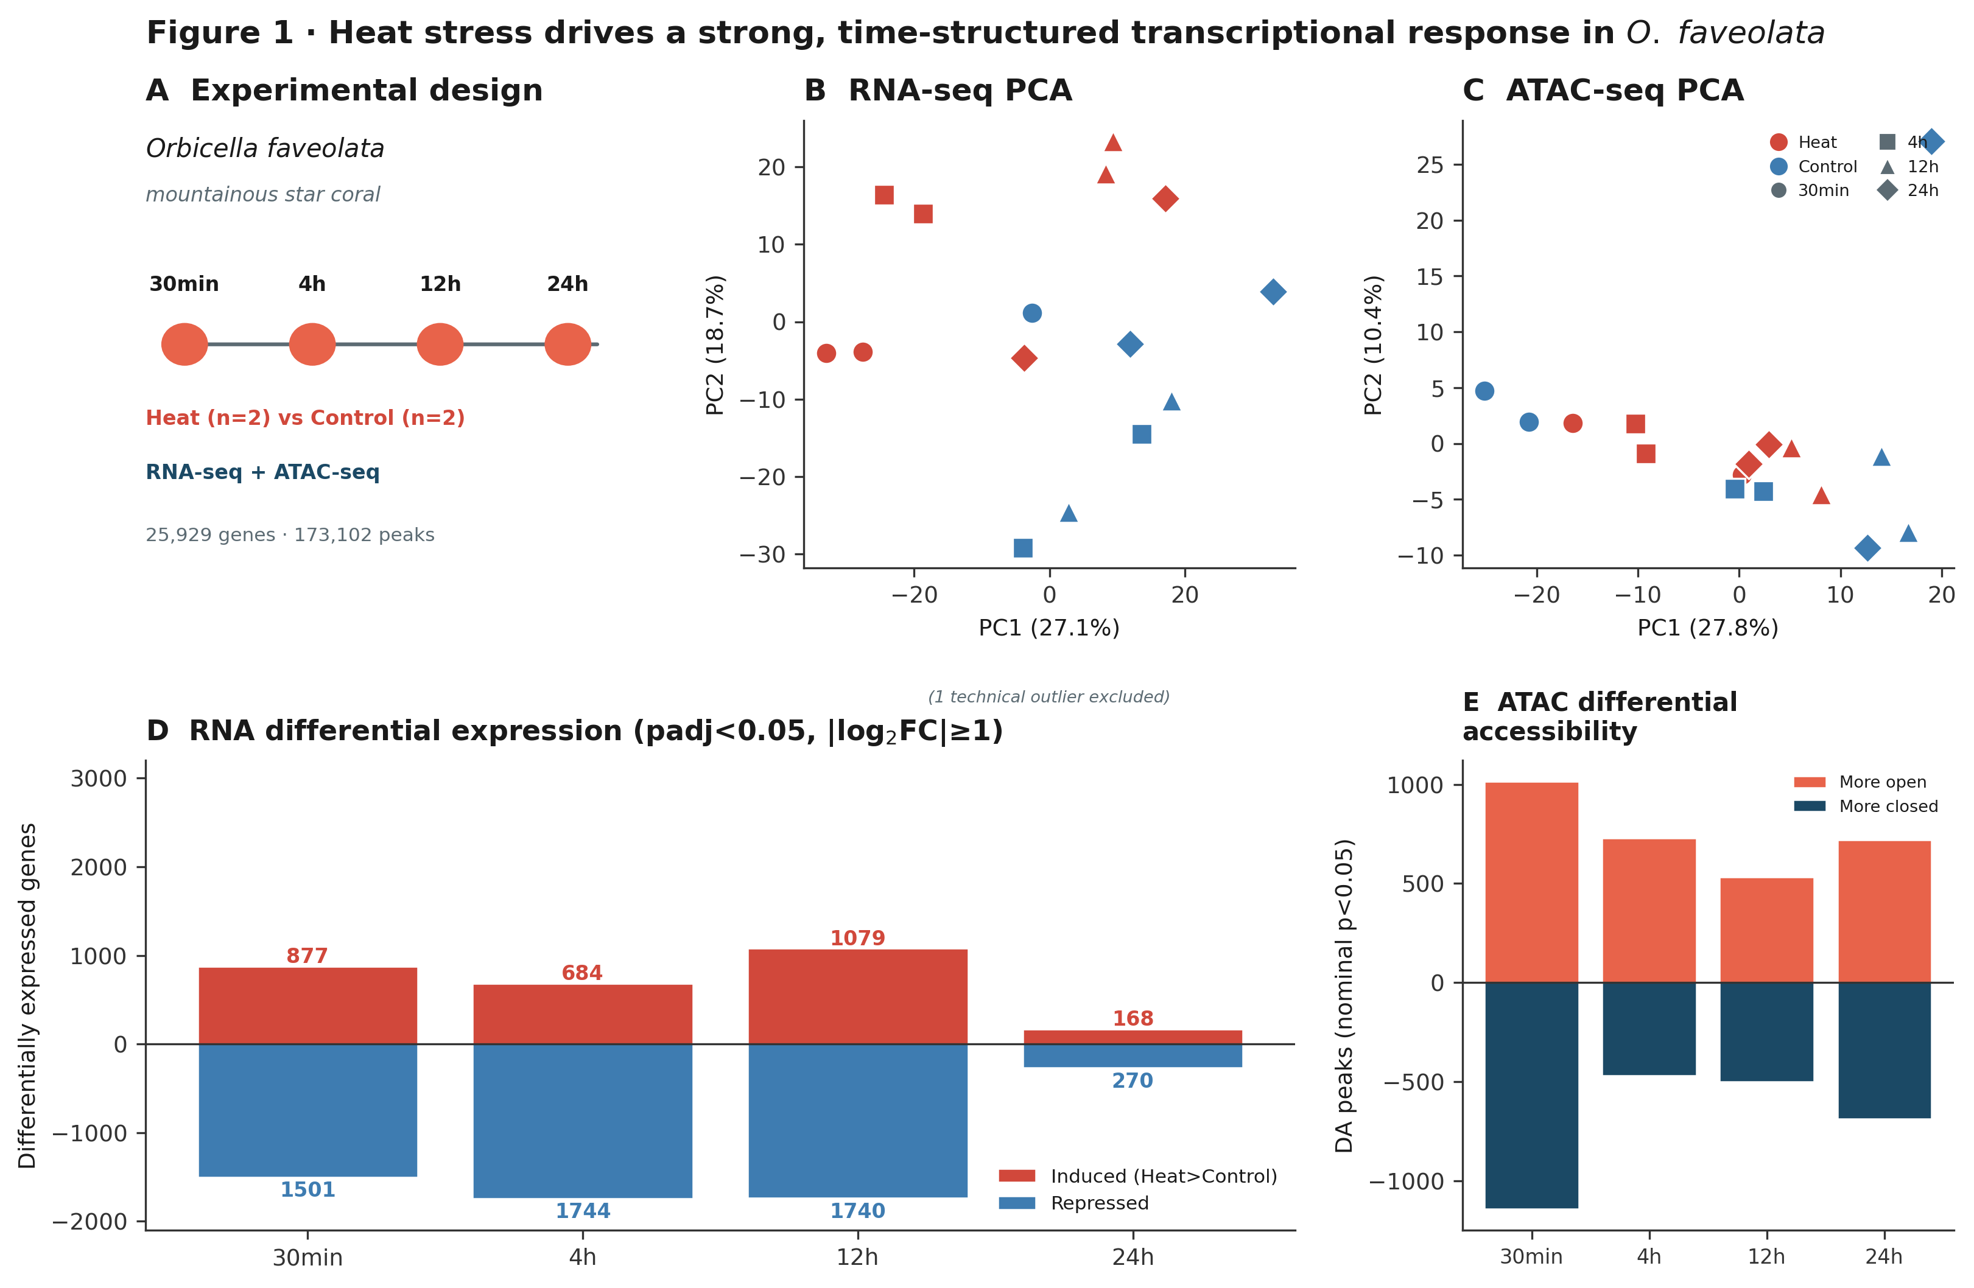
Figure 1. Heat stress drives a strong, time-structured transcriptional response. (A) Experimental design: paired RNA-seq and ATAC-seq across four times in heat versus control. (B) RNA-seq PCA on variance-stabilized counts (one technical outlier excluded) separates treatment and resolves time. (C) ATAC-seq PCA shows diffuse structure and weak treatment separation. (D) Differentially expressed genes per timepoint (padj < 0.05, |log₂FC| ≥ 1); induced above axis, repressed below. (E) Differentially accessible peaks at nominal p < 0.05, |log₂FC| ≥ 0.3, with the earliest time showing the most remodeling.

3.2 Four temporal programs partition the response
Restricting to the 1,953 DEGs significant in at least two timepoints and applying fuzzy c-means clustering, the Xie–Beni validity index minimized cleanly at k = 4 (Figure 2C), and the four resulting programs were biologically distinct and well-populated (1,382 core genes total). Cluster 1 (early-transient; n = 211 core) rises within 30 min and falls by 12 h, and is enriched for protein-processing and GTPase activity—an immediate-early signature. Cluster 4 (mid-sustained; n = 217) peaks at 4–12 h and is enriched for ATP-dependent protein-folding chaperones, the chaperonin-containing T-complex, and unfolded-protein binding—the canonical proteostatic heat-shock module. Cluster 2 (delayed-induction; n = 378) is repressed early and induced late, and is strongly enriched for DNA replication initiation, DNA repair, and the mitotic spindle-assembly checkpoint, indicating coordinated cell-cycle arrest followed by genome-maintenance activity. Cluster 3 (biphasic; n = 576) is enriched for cell-surface and death-receptor signaling and Rho-family signal transduction, linking the response to apoptotic and immune priming. The four programs thus trace a coherent arc from sensing and signaling, through proteostasis and genome protection, to resolution.
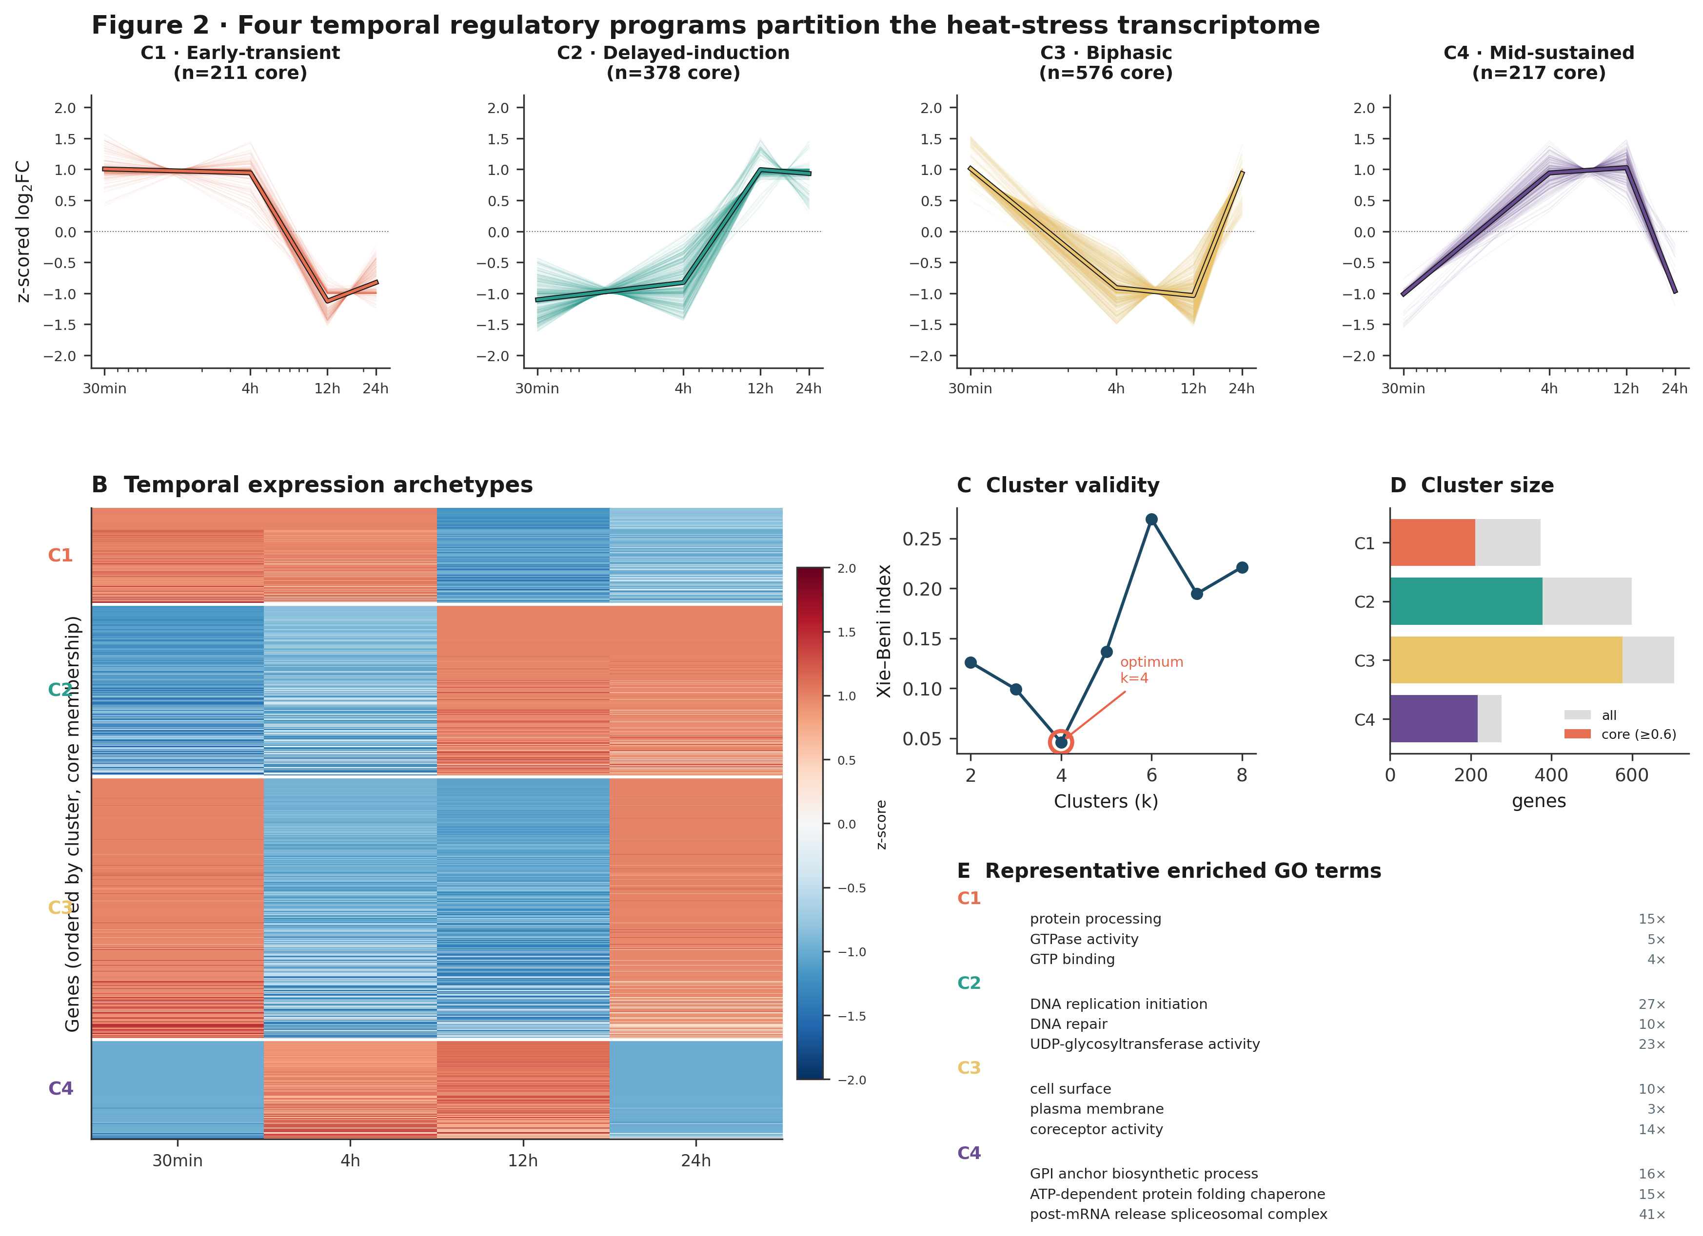
Figure 2. Four temporal regulatory programs partition the heat-stress transcriptome. (top) Per-cluster trajectories of core genes (thin lines) with cluster centroid (bold). (B) Heatmap of z-scored log₂FC for all core genes, ordered by cluster and membership. (C) Xie–Beni cluster-validity index, minimized at k = 4. (D) Cluster sizes (all vs. core membership ≥ 0.6). (E) Representative FDR-significant Gene Ontology terms per cluster with fold-enrichment.

3.3 Chromatin and expression changes are coupled and time-ordered
Although individual DA peaks did not survive genome-wide correction, the chromatin signal was real and structured: the earliest timepoint showed the greatest number of nominally differential peaks (Figure 1E), consistent with rapid stress-responsive remodeling. Mapping DA peaks (nominal p < 0.05) to genes and intersecting with expression yielded 921 same-timepoint and 2,178 cross-timepoint gene-level links (1,721 genes; Figure 3). Coupled changes populated all four chromatin–expression quadrants, with an overall sign-concordance of 50.8% (Figure 3A). Temporal ordering of the earliest accessibility versus expression change classified 582 links as ATAC-first, 613 as simultaneous, and 983 as RNA-first (Figure 3B). The substantial ATAC-first fraction—roughly one in four links—is the temporal signature expected if accessibility remodeling helps set up subsequent transcription, and explicit lag analysis recovered hundreds of ATAC(early)→RNA(later) links, most densely for the 30 min→04 h and 30 min←12 h transitions (Figure 3C). Critically, promoter-proximal peaks scored systematically higher on the composite candidate metric than peaks at other features (Figure 3E), exactly as expected for direct regulatory coupling.
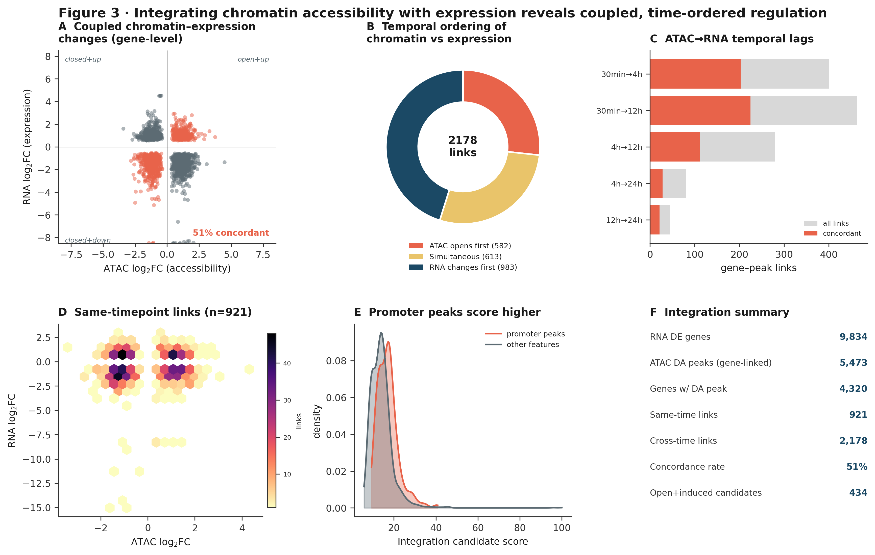
Figure 3. Integrating accessibility with expression reveals coupled, time-ordered regulation. (A) Gene-level ATAC vs. RNA log₂FC; concordant links in coral, discordant in grey. (B) Temporal ordering of the earliest chromatin vs. expression change. (C) Explicit ATAC(early)→RNA(later) lag links, concordant fraction highlighted. (D) Density of same-timepoint links. (E) Composite candidate score is higher for promoter peaks than other features. (F) Integration summary statistics.

3.4 Prioritized candidate heat-inducible promoters
To translate the integration into actionable targets, we filtered for the regulatory configuration most useful for heat-inducible control: a promoter-proximal peak that opens under heat, a linked gene that is induced, and sign concordance between the two. This yielded 96 ranked candidate heat-inducible promoters (Figure 4A; full ranking in Supplementary Table S1). Candidates spanned all temporal orderings, with a notable ATAC-first and simultaneous contingent (Figure 4B) representing the most mechanistically plausible direct couplings. The top-ranked loci combined strong, often early induction with clear promoter opening (Figure 4D), making them attractive endogenous heat-responsive elements for biomarker panels and for engineering inducible constructs in cnidarian systems.
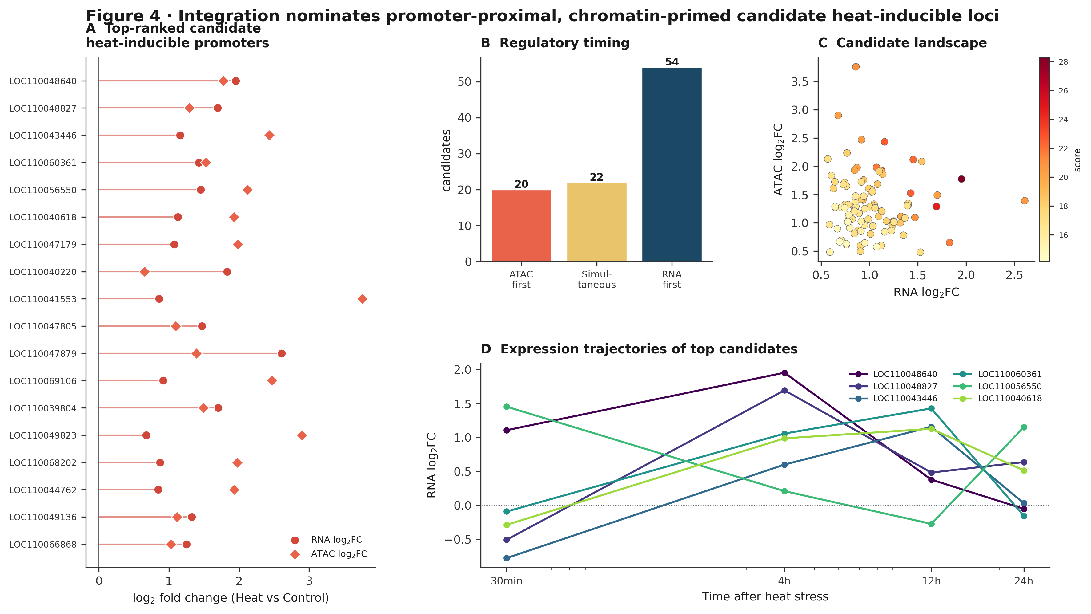
Figure 4. Integration nominates promoter-proximal, chromatin-primed candidate heat-inducible loci. (A) Top-ranked candidates with paired RNA (circle) and ATAC (diamond) log₂FC. (B) Regulatory-timing composition of candidates. (C) Candidate landscape colored by composite score. (D) Expression trajectories of the six top-ranked candidate genes.

3.5 A synthesis model of the acute coral heat-stress response
Combining the layers yields a parsimonious model (Figure 5). Within minutes, chromatin remodeling and an immediate-early transcriptional burst co-occur; promoter accessibility changes at stress loci partly precede their induction. Through 4–12 h, the proteostatic chaperone program (Cluster 4) and then a delayed DNA-replication/repair and cell-cycle module (Cluster 2) dominate, while cell-surface and death-receptor signaling (Cluster 3) provides apoptotic and immune priming. By 24 h the transcriptional response has largely resolved, indicating successful acute acclimation at this thermal dose. The overall response magnitude crests at 12 h and then falls steeply (Figure 5B).
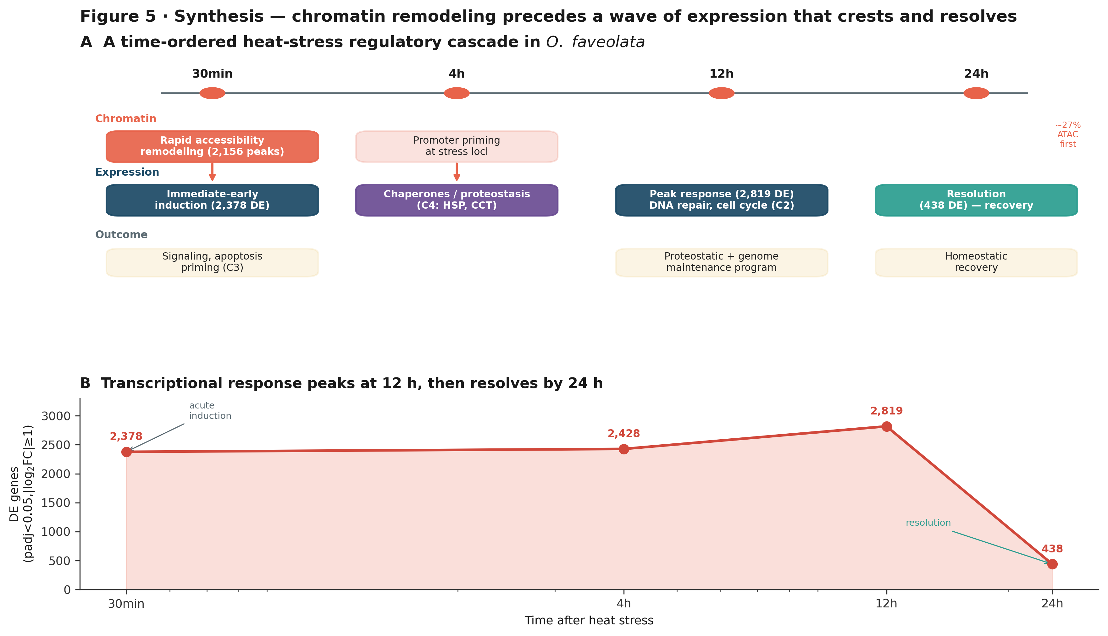
Figure 5. Synthesis — chromatin remodeling precedes a wave of expression that crests and resolves. (A) Schematic of the time-ordered cascade across chromatin, expression, and physiological-outcome layers, annotated with the program identities and key counts recovered here. (B) Global transcriptional response magnitude (DEGs per timepoint) peaks at 12 h and resolves by 24 h.

3.6 Quantitative summary
Timepoint | RNA induced | RNA repressed | ATAC more open | ATAC more closed
30min | 877 | 1501 | 1013 | 1141
4h | 684 | 1744 | 730 | 468
12h | 1079 | 1740 | 532 | 500
24h | 168 | 270 | 720 | 687
Table 1. Differentially expressed genes (padj < 0.05, |log₂FC| ≥ 1) and nominally differentially accessible peaks (p < 0.05, |log₂FC| ≥ 0.3) per timepoint.

4 Discussion
This study provides a temporally resolved, integrated view of the acute heat-stress response in Orbicella faveolata. Three findings stand out. First, the transcriptional response is large, fast, and self-limiting over 24 h, with a clear crest at 12 h. Second, soft clustering resolves the response into four interpretable programs whose Gene Ontology signatures recapitulate a canonical stress arc—signaling and apoptotic priming, proteostatic chaperone induction, delayed genome maintenance, and resolution—without imposing those categories a priori. Third, despite limited statistical power in the chromatin layer, integration uncovers coupled, partly accessibility-leading regulation enriched at promoters, and yields a ranked set of candidate heat-inducible regulatory elements.

4.1 The chaperone and genome-maintenance programs
The mid-sustained chaperone program (Cluster 4) is the molecular heart of the response. Enrichment for ATP-dependent protein-folding chaperones, the chaperonin-containing T-complex (CCT/TRiC), and unfolded-protein binding indicates a classic proteostatic mobilization to counter heat-induced protein misfolding. The delayed-induction program (Cluster 2), enriched for DNA-replication initiation, DNA repair, and the mitotic spindle-assembly checkpoint, is consistent with early cell-cycle arrest under stress followed by genome-maintenance activity—a sequence well documented in other eukaryotes but rarely resolved with this temporal clarity in a coral.

4.2 Accessibility can lead expression
The substantial ATAC-first fraction among coupled links, together with the higher candidate scores of promoter peaks, supports a model in which chromatin remodeling helps prime the transcriptional response rather than merely tracking it. This is the temporal relationship expected of genuinely regulatory accessibility changes and motivates the candidate heat-inducible promoters we nominate. We emphasize that ordering at the level of the earliest detectable change is suggestive, not a proof of causation; direct tests (e.g., reporter assays or perturbation of specific elements) are the appropriate next step.

4.3 Limitations
The most important limitation is statistical power in the ATAC layer. With two replicates per group and ~173,000 peaks, genome-wide multiple-testing correction left no peak below conventional adjusted-p thresholds (minimum padj ≈ 0.898). We therefore used a nominal-p exploratory threshold for chromatin, mirroring the relaxed-threshold strategy in the project's own integration pipeline. The diffuse ATAC ordination (Figure 1C) is consistent with this being a power and effect-size issue rather than an absence of signal, but the chromatin-derived conclusions—including the candidate promoter list—should be treated as hypotheses for validation, and accessibility-based discovery should not be over-interpreted at the level of individual peaks. The two-replicate design also limits sensitivity for small-effect DEGs, and the recovered 30-min control replicate behaved as a technical outlier and was excluded from ordination. Finally, our analysis does not separate coral host from algal-symbiont signal beyond the gene models used, and a single thermal dose and acute window cannot capture chronic-stress or bleaching-threshold dynamics.

4.4 Implications and future directions
The ranked candidate heat-inducible promoters provide concrete targets for two applications: minimally invasive transcriptional biomarkers of incipient thermal stress, and endogenous heat-responsive elements for engineering inducible expression in cnidarian or Symbiodiniaceae systems. Natural extensions of this work include increasing biological replication to bring chromatin testing to genome-wide significance, adding footprinting and motif analysis to identify the transcription factors operating in each temporal program, extending the time course to chronic stress and recovery, and pairing the assays with bleaching phenotypes across genotypes of differing thermal tolerance. The integrative, temporally explicit framework demonstrated here is directly portable to those designs.

5 Conclusion
By integrating expression and accessibility across an acute thermal time course, we resolve the coral heat-stress response into four temporal programs with coherent functional identities and show that chromatin changes are coupled to, and frequently precede, the expression changes they may regulate. The work delivers both a mechanistic synthesis—chromatin priming ahead of a transcriptional wave that crests at 12 h and resolves by 24 h—and a prioritized, testable set of regulatory targets for coral thermal-stress research.

Data, code, and reproducibility
All differential-expression, differential-accessibility, fuzzy-clustering, integration, and enrichment analyses were reproduced from the raw count matrices and sample metadata using the project's analytical design (per-timepoint DESeq2 contrasts of Heat versus Control; fuzzy c-means with Xie–Beni model selection; hypergeometric GO enrichment with Benjamini–Hochberg FDR). Per-timepoint differential tables, the integrated link tables, the ranked candidate-promoter table, GO enrichment results, and the cluster assignments accompany this report as supplementary files.
Author note. This manuscript was assembled from the supplied O. faveolata multiomics dataset and analysis pipeline. Numerical results were computed directly from the provided count matrices; figures were generated de novo from those results.

