Database Management Systems

Homework 1

|  |  |
| --- | --- |
| COURSE | Database Management Systems |
| SECTION | 001 |
| SEMESTER | Fall 2015 |
| INSTRUCTOR | Dr. Le Gruenwald |
| GROUP PROJECT NUMBER | 4 |
| GROUP MEMBERS | David Findley, Coleman Jackson, Swati Nemade, Stephen Smart |
| SCORE |  |

1.

1. ATTACHED
2. ER-Diagrams are a design tool dealing with the logical side of the database. Storing the articles on CDs is a physical aspect of the database that does not affect the ER-diagram.
3. ATTACHED, in an instance of “consult”, an analyst may choose to “visit” any number of websites. This is an example of aggregation. Add this diagram back in place of the “consult” relation from our original ER diagram.

ATTACHED, the relationship from our original diagram does not represent an instance of a substitution. Instead it outlines who will substitute in the event of an absence. By aggregating, we can connect the “substitute” relation to an instance of an absence, as a weak entity set. (It would be strong if we could give it a date!)

Problem 1 a:

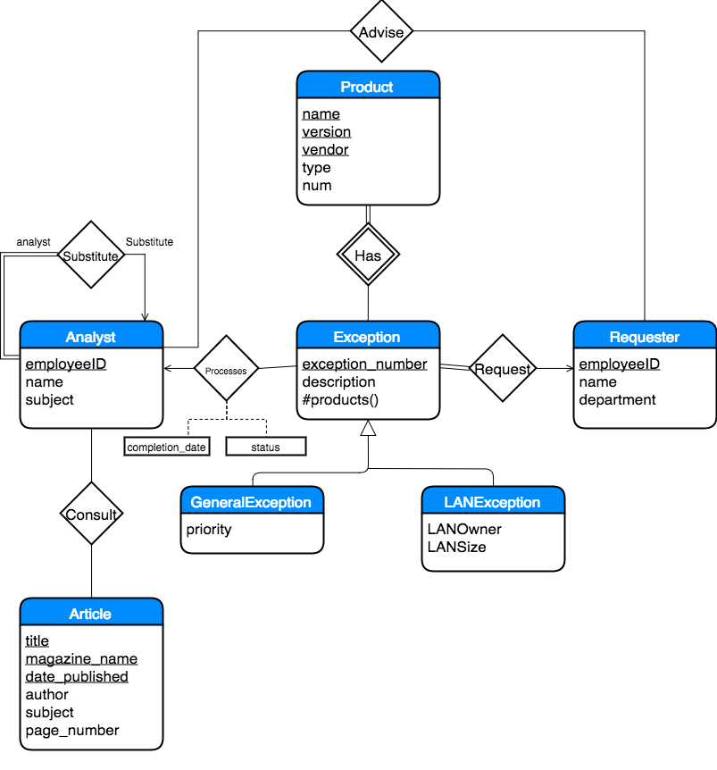

Problem 1 c and d:

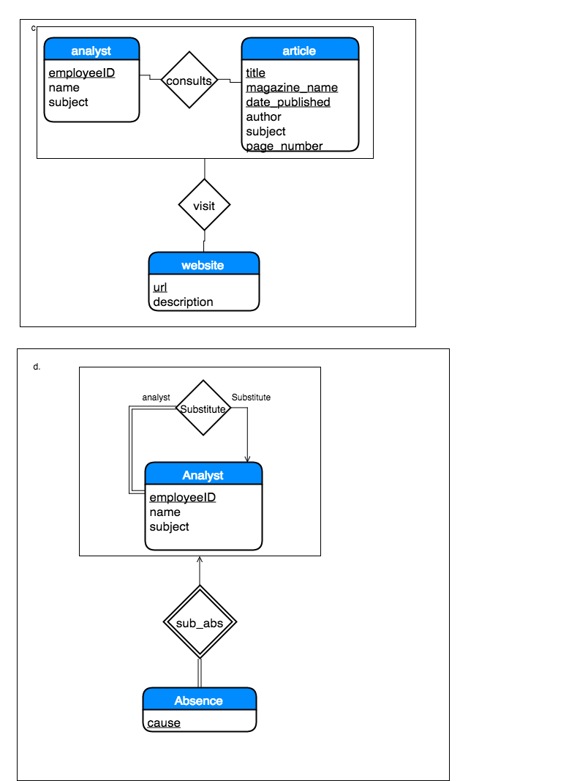

2. Language Learning Center Database Design (ER ATTACHED)

The Language Learning Center at OU needs a database to track inventory of learning materials and tutoring hours.

* Members of the Department of Modern Languages (MLLL) have a unique ID number as well as a name, and languages that they specialize in. They can be either students or faculty members.
* Each student in the database has a major as well as a classification. Students can engage in tutoring with other students. In tutoring sessions, which have a date, one student acts as the tutor and the other is tutored.
* Faculty members have a section (the language they teach) as well as an office.
* The Lab maintains an inventory of educational materials, all of which have a unique ID number and condition. Inventory can be equipment (laptops, ipads, etc) or foreign language DVDs. Equipment has a type, while DVDs have a title, year, and language.
* There is an inventory of foreign language DVDs used as educational materials that can be rented out by students or faculty. These DVDs have a unique call number as well as titles, year, and language.
* Laboratory staff have a unique staff_ID number as well as a name.
* Lab staff must maintain at least one piece of equipment and all equipment must be maintained by at least one staff member. Both relationships may be many-to-one.
* Faculty members must check out certain inventory items to ensure the utilization of learning resources. Each inventory can only be checked by one faculty member.
* Students may use equipment with faculty permission. One piece of equipment can only be used by one student (or group of students) at a time. Any faculty member may give permission for each student using a piece of equipment.
* Students may also rent DVDs. One DVD can only be rented by one student at a time.
* If a student fails to return a DVD before the rental due date, a fine will be issued to the student renting the DVD. The fine will contain the days overdue and will be able to calculate the amount the student needs to pay.

Homework Problem 2 E-R Diagram

