Cole Bodine

Project: Weather Data Analysis System

Design Document

CSE-222-101

This project is a program that allows a user to log in and access a data analysis system. The data analysis system extracts data from a data library file and allows the user to select a data set and time period to be plotted.

**Project Milestone #1 – Main GUI, Account Creation, and Password Handling**

When the program is initially started, the user will be taken to the screen shown in Figure 1. The screen contains user login, account creation, and exit buttons.

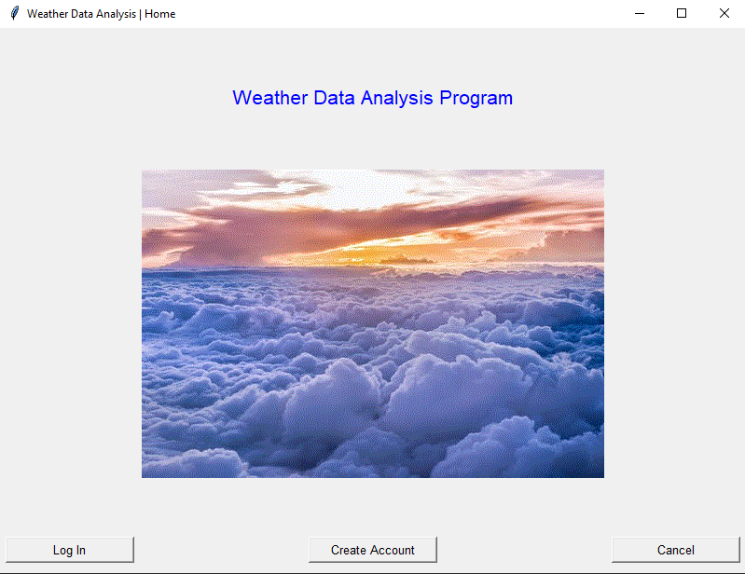

*Figure 1: Home GUI*

If the user does not have an account, they can create one by clicking the “Create Account” button shown in Figure 1. Upon clicking the button, they will be taken to a new window, where they can enter their username and password, as shown in Figure 2.

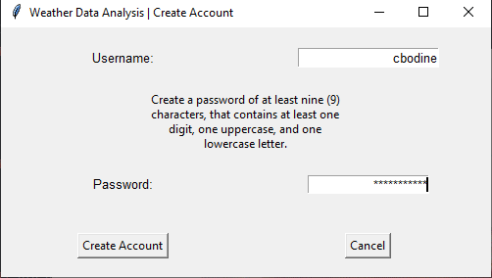

*Figure 2: Account Creation Window*

If the user enters a username that has already been taken, they will receive an error telling them that the username has been taken (Figure 3). Likewise, if they enter an invalid password, they will receive a prompt informing them that the password is not valid (Figure 4). Finally, if the user enters a valid username and password, their account will be created and stored in a file (Figure 5).

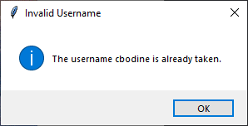

*Figure 3: Invalid Username*

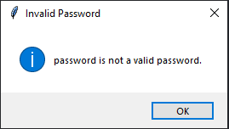

*Figure 4: Invalid Password*

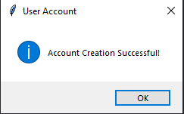

*Figure 5: Successful Account Creation*

When an account is successfully created, it is appended to a list of dictionaries in a file called “accounts.json” (Figure 6) that resides in the same location as the Python program. Before being stored, the password is passed through a hashing function provided by the hashlib library, which encrypts the password.



*Figure 6: Username and Password as stored in the file.*

After the user’s account is created, the account creation button is disabled, and the login button is re-enabled. If they could not already, the user may now log in by cligking the “Log In” button from Figure 1. This will take them to the screen shown below, in Figure 7.

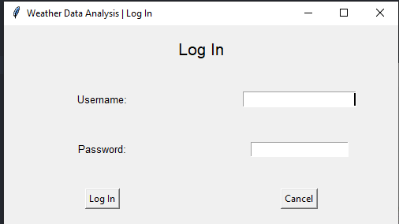

*Figure 7: Login Window*

Like with the account creation window, activating the login window deactivates the “Log In” and “Create Account” buttons from the main window. Here, the user will be prompted to enter a valid username and password. The program determines which username and password is valid by opening the “accounts.json” file and parsing through the user_accounts list. If the program finds a dictionary that contains a username and password matching what the user entered, that user will be logged in to the system (Figure 8). This doesn’t do anything besides display a message right now.

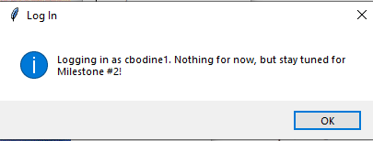

*Figure 8: Successful Login*

If they provide an invalid username (Figure 9) or password (Figure 10), they will receive a prompt informing them.

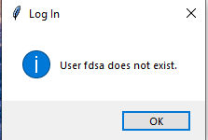

*Figure 9: Invalid User*

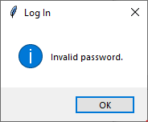

*Figure 10: Invalid Password*

**Project Milestone #2**

The program now has complete login functionality and a main GUI that will allow the user to select which data they would like to view. The message box from Figure 8 has been removed and logging in will now take the user to the main GUI, as shown in Figure 11.

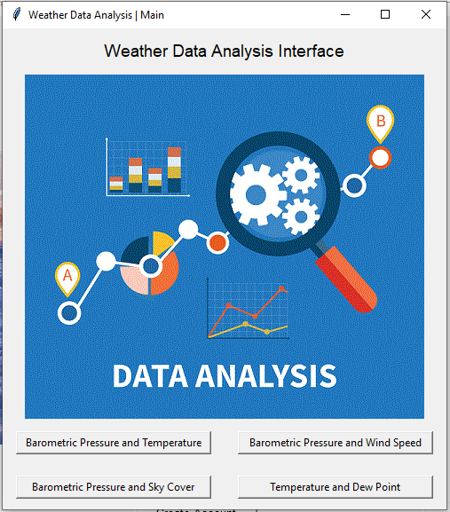

*Figure 11: Main GUI.*

Most of the other work done to the project is simple maintenance and changing the code around, as I accidentally went too far in Milestone #1 by completing the login process that was meant to be saved for Milestone #2. For example, I renamed the original main.py to home.py and changed any code with the word main to have the word home, to make it more easily differentiable from the new main.py. I opted for creating an entirely new window rather than morphing the original because I want the user to still have access to the home window in case they want to log out of the program and let someone else use it without having to close the entire program. Now, all they will have to do is close the main window and they can start the program anew by logging in as someone else (Figure 12).

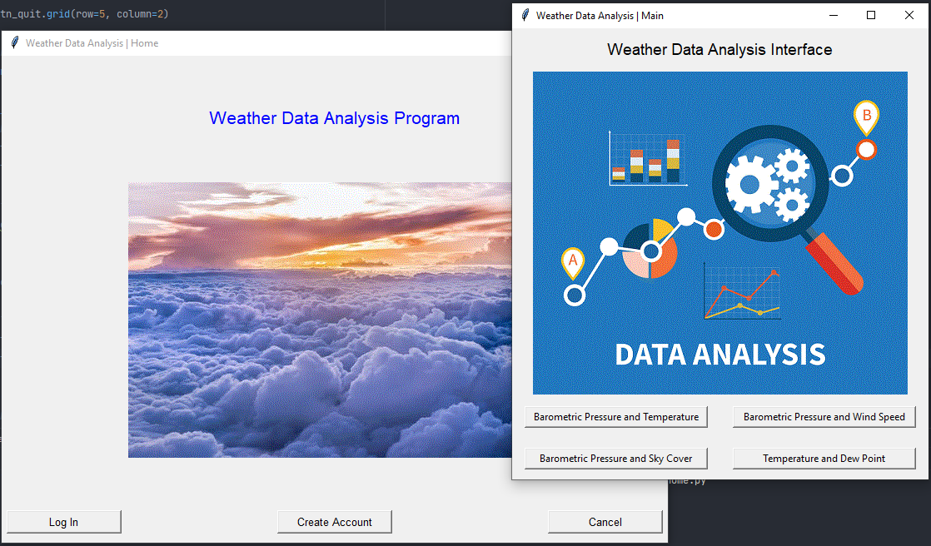

*Figure 12: Allow the user to log in as someone else after closing main interface.*

**Project Milestone #3**

**Current State of Code**

# home.py

# This file stores the home window for the weather data analysis project.

from tkinter import *

import tkinter as tk

import create

import login

import main

# home window

class HomeGUI:

"""A class holding the home window."""

def __init__(self):

"""Initialize the home window."""

# Create the home window.

self.win_home = tk.Tk()

self.win_home.title("Weather Data Analysis | Home")

self.win_home.minsize(width=450, height=300)

# Configure columns

self.win_home.columnconfigure(0, minsize=150)

self.win_home.columnconfigure(1, minsize=150)

self.win_home.columnconfigure(2, minsize=150)

# Configure Rows

self.win_home.rowconfigure(0, minsize=50)

self.win_home.rowconfigure(1, minsize=50)

self.win_home.rowconfigure(2, minsize=50)

self.win_home.rowconfigure(3, minsize=50)

self.win_home.rowconfigure(4, minsize=50)

self.win_home.rowconfigure(5, minsize=50)

# Create label widget.

self.lbl_header = tk.Label(text="Weather Data Analysis Program",

font=("Helvetica", 16),

fg="blue")

self.lbl_header.grid(row=1, column=0, columnspan=3)

# Create the picture widget.

photo = PhotoImage(file="weather.gif")

self.labelGIF = tk.Label(image=photo)

self.labelGIF.image = photo

self.labelGIF.grid(row=3, column=1)

# Create the button widgets.

self.btn_login = tk.Button(text="Log In",

font=("Helvetica", 10),

width=16,

command=self.log_in)

self.btn_create_acct = tk.Button(text="Create Account",

font=("Helvetica", 10),

width=16,

command=self.create_account)

self.btn_quit = tk.Button(text="Cancel",

font=("Helvetica", 10),

width=16,

command=self.win_home.destroy)

self.btn_login.grid(row=5, column=0)

self.btn_create_acct.grid(row=5, column=1)

self.btn_quit.grid(row=5, column=2)

# Enter home tkinter loop

tk.mainloop()

def create_account(self):

# Disable the buttons

self.btn_create_acct.config(state=DISABLED)

self.btn_login.config(state=DISABLED)

# Create an account creation GUI

self.acct_GUI = create.CreateGUI()

# Wait for the window to be destroyed.

self.acct_GUI.win_create.wait_window()

# Enable login button again.

self.btn_login.config(state=NORMAL)

self.btn_create_acct.config(state=NORMAL)

def log_in(self):

# Disable the buttons

self.btn_create_acct.config(state=DISABLED)

self.btn_login.config(state=DISABLED)

# Create an account creation GUI

self.login_GUI = login.LoginGUI()

# Wait for the windows to be destroyed.

self.login_GUI.win_login.wait_window()

# Enable login and create buttons again.

self.btn_login.config(state=NORMAL)

self.btn_create_acct.config(state=NORMAL)

dataProgram = HomeGUI()

################################################################################

# create.py

# This file holds the account creation window and logic.

from tkinter import *

from tkinter import messagebox

import tkinter as tk

import json

import os

import hashlib

class CreateGUI:

"""A class containing the create account GUI"""

def __init__(self):

"""Initialize the AccountGUI class."""

# Create window

self.win_create = tk.Tk()

self.win_create.title("Weather Data Analysis | Create Account")

self.win_create.minsize(width=500, height=250)

# Configure columns

self.win_create.columnconfigure(0, minsize=250)

self.win_create.columnconfigure(1, minsize=250)

# Configure Rows

self.win_create.rowconfigure(0, minsize=62.5)

self.win_create.rowconfigure(1, minsize=62.5)

self.win_create.rowconfigure(2, minsize=62.5)

self.win_create.rowconfigure(3, minsize=62.5)

# Create username widgets.

self.win_create.lbl_username = tk.Label(self.win_create,

text="Username:",

font=("Helvetica", 10))

self.win_create.lbl_username.grid(row=0, column=0)

self.win_create.entry_username = tk.Entry(self.win_create,

justify="right",

font=("Helvetica", 10))

self.win_create.entry_username.grid(row=0, column=1)

self.win_create.entry_username.focus_force()

# Create the password widgets.

self.win_create.lbl_password_guide = tk.Label(self.win_create,

text="Create a password "

"of at least nine "

"(9) characters, "

"that contains at "

"least one digit, "

"one uppercase, "

"and one lowercase "

"letter.",

wraplength=200)

self.win_create.lbl_password_guide.grid(row=1, column=0, columnspan=2)

self.win_create.lbl_password = tk.Label(self.win_create,

text="Password:",

font=("Helvetica", 10))

self.win_create.lbl_password.grid(row=2, column=0)

self.win_create.entry_password = tk.Entry(self.win_create,

width=20,

justify="right",

show="*")

self.win_create.entry_password.grid(row=2, column=1)

self.win_create.btn_create = tk.Button(self.win_create,

text="Create Account",

command=self.create_account)

self.win_create.btn_create.grid(row=3, column=0)

self.win_create.btn_cancel = tk.Button(self.win_create,

text="Cancel",

command=self.win_create.destroy)

self.win_create.btn_cancel.grid(row=3, column=1)

# Lift to top

self.win_create.lift()

def create_account(self):

"""Create a user account."""

password = self.win_create.entry_password.get()

username = self.win_create.entry_username.get()

# If a file does not exist for user accounts, create one with

# placeholder data.

if not os.path.isfile("accounts.json"):

acct_file = open("accounts.json", "w")

json.dump([{"username": "demo", "password": "Password123"}],

acct_file)

acct_file.close()

try:

acct_file = open("accounts.json", "r")

user_accounts = json.load(acct_file)

except FileNotFoundError:

print(f"File {acct_file} does not exist.")

def validate_username(username):

"""Check to see if the username is taken."""

if not any(user['username'] == username.lower() for

user in user_accounts):

return True

else:

tk.messagebox.showinfo("Invalid Username",

f"The username {username} is already "

f"taken.")

def validate_password(password):

"""Validate user's password."""

long_enough = False

has_lower = False

has_upper = False

has_digit = False

if len(password) >= 9:

long_enough = True

for ch in password:

if ch.islower():

has_lower = True

if ch.isupper():

has_upper = True

if ch.isdigit():

has_digit = True

if long_enough and has_lower and has_upper and has_digit:

return True

else:

tk.messagebox.showinfo("Invalid Password", f"{password} is "

f"not a valid "

f"password.")

if validate_username(username) and validate_password(password):

hashed_password = hashlib.sha256(str.encode(password)).hexdigest()

user_accounts.append({'username': username.lower(),

'password': hashed_password})

tk.messagebox.showinfo("User Account", "Account Creation "

"Successful!")

acct_file.close()

acct_file = open("accounts.json", 'w')

json.dump(user_accounts, acct_file)

acct_file.close()

self.win_create.entry_username.delete(0, END)

self.win_create.entry_password.delete(0, END)

self.win_create.destroy()

else:

print("Couldn't create account. Please try again.")

self.win_create.entry_username.delete(0, END)

self.win_create.entry_password.delete(0, END)

################################################################################

# login.py

# This login window and logic.

from tkinter import *

import tkinter as tk

from tkinter import messagebox

import json

import hashlib

import main

class LoginGUI:

"""A class holding the login GUI."""

def __init__(self):

"""Initialize the login GUI."""

# Create window

self.win_login = tk.Tk()

self.win_login.title("Weather Data Analysis | Log In")

self.win_login.minsize(width=500, height=250)

# Configure columns

self.win_login.columnconfigure(0, minsize=250)

self.win_login.columnconfigure(1, minsize=250)

# Configure Rows

self.win_login.rowconfigure(0, minsize=62.5)

self.win_login.rowconfigure(1, minsize=62.5)

self.win_login.rowconfigure(2, minsize=62.5)

self.win_login.rowconfigure(3, minsize=62.5)

# Create Login Label

self.win_login.lbl_title = tk.Label(self.win_login,

text="Log In",

font=("Arial", 16))

self.win_login.lbl_title.grid(row=0, column=0, columnspan=2)

# Create username widgets.

self.win_login.lbl_username = tk.Label(self.win_login,

text="Username:",

font=("Helvetica", 10))

self.win_login.lbl_username.grid(row=1, column=0)

self.win_login.entry_username = tk.Entry(self.win_login,

justify="right",

font=("Helvetica", 10))

self.win_login.entry_username.grid(row=1, column=1)

self.win_login.entry_username.focus_force()

# Create the password widgets.

self.win_login.lbl_password = tk.Label(self.win_login,

text="Password:",

font=("Helvetica", 10))

self.win_login.lbl_password.grid(row=2, column=0)

self.win_login.entry_password = tk.Entry(self.win_login,

width=20,

justify="right",

show="*")

self.win_login.entry_password.grid(row=2, column=1)

self.win_login.btn_create = tk.Button(self.win_login,

text="Log In",

command=self.log_in)

self.win_login.btn_create.grid(row=3, column=0)

self.win_login.btn_cancel = tk.Button(self.win_login,

text="Cancel",

command=self.win_login.destroy)

self.win_login.btn_cancel.grid(row=3, column=1)

# Lift to top

self.win_login.lift()

def log_in(self):

"""Log the user in."""

username = self.win_login.entry_username.get()

password = self.win_login.entry_password.get()

hashed_password = hashlib.sha256(str.encode(password)).hexdigest()

# Try to open the file

try:

acct_file = open("accounts.json", "r")

user_accounts = json.load(acct_file)

except IOError:

tk.messagebox.showinfo("FILE ERROR", f"File {acct_file} does not "

f"exist.")

if any(user['username'] == username.lower() and

user['password'] == hashed_password for user in user_accounts):

self.main_GUI = main.MainGUI()

self.win_login.destroy()

if not any(user['username'] == username.lower() for

user in user_accounts):

tk.messagebox.showinfo("Log In", f"User {username} does not exist.")

self.win_login.entry_username.delete(0, END)

self.win_login.entry_password.delete(0, END)

elif any(user['username'] == username.lower() and

not user['password'] == hashed_password for

user in user_accounts):

tk.messagebox.showinfo("Log In", "Invalid password.")

self.win_login.entry_username.delete(0, END)

self.win_login.entry_password.delete(0, END)

################################################################################

# home.py

# This file holds the Main GUI that accesses the weather station data.

from tkinter import *

import tkinter as tk

class MainGUI:

"""A class holding the login GUI."""

def __init__(self):

"""Initialize the login GUI."""

# Create window

self.win_main = tk.Toplevel()

self.win_main.title("Weather Data Analysis | Main")

self.win_main.minsize(width=500, height=250)

# Configure columns

self.win_main.columnconfigure(0, minsize=250)

self.win_main.columnconfigure(1, minsize=250)

# Configure rows

self.win_main.rowconfigure(0, minsize=50)

self.win_main.rowconfigure(1, minsize=50)

self.win_main.rowconfigure(2, minsize=50)

self.win_main.rowconfigure(3, minsize=50)

# Create Main Label

self.win_main.lbl_main = tk.Label(self.win_main,

text="Weather Data Analysis "

"Interface",

font=("Helvetica", 14))

self.win_main.lbl_main.grid(row=0, column=0, columnspan=2)

# Create picture widget

photo = PhotoImage(file="data_analysis.gif")

self.labelGIF = tk.Label(self.win_main, image=photo)

self.labelGIF.image = photo # Retain a reference

self.labelGIF.grid(row=1, column=0, columnspan=2)

# Create Buttons

self.win_main.btn_1 = tk.Button(self.win_main,

text="Barometric Pressure and "

"Temperature",

width=30)

self.win_main.btn_1.grid(row=2, column=0)

self.win_main.btn_2 = tk.Button(self.win_main,

text="Barometric Pressure and Wind "

"Speed",

width=30)

self.win_main.btn_2.grid(row=2, column=1)

self.win_main.btn_3 = tk.Button(self.win_main,

text="Barometric Pressure and Sky "

"Cover",

width=30)

self.win_main.btn_3.grid(row=3, column=0)

self.win_main.btn_4 = tk.Button(self.win_main,

text="Temperature and Dew Point",

width=30)

self.win_main.btn_4.grid(row=3, column=1)