Symbols

♭ ♯ ♮

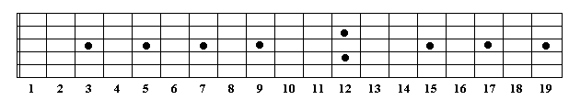

Major

R (w) 2 (w) 3 (h) 4 (w) 5 (w) 6 (w) 7 (h) 8

Minor (Natural)

R (w) 2 (h) 3♭ (w) 4 (w) 5 (h) 6♭ (w) 7♭ (w) 8

Minor (Harmonic)

R (w) 2 (h) 3♭ (w) 4 (w) 5 (h) 6♭ (wh) 7 (h) 8

Major Key Chord Sequence

Maj min min Maj Maj min dim

Major – 1, 3, 5

Minor – 1, 3♭, 5

Dominant 7th – 1, 3, 5, 7♭

Major 7th – 1, 3, 5, 7

Diminished – 1, 3♭, 5♭

Augmented – 1, 3, 5♯

Sus2 – 1, 2, 5

Sus4 – 1, 4, 5

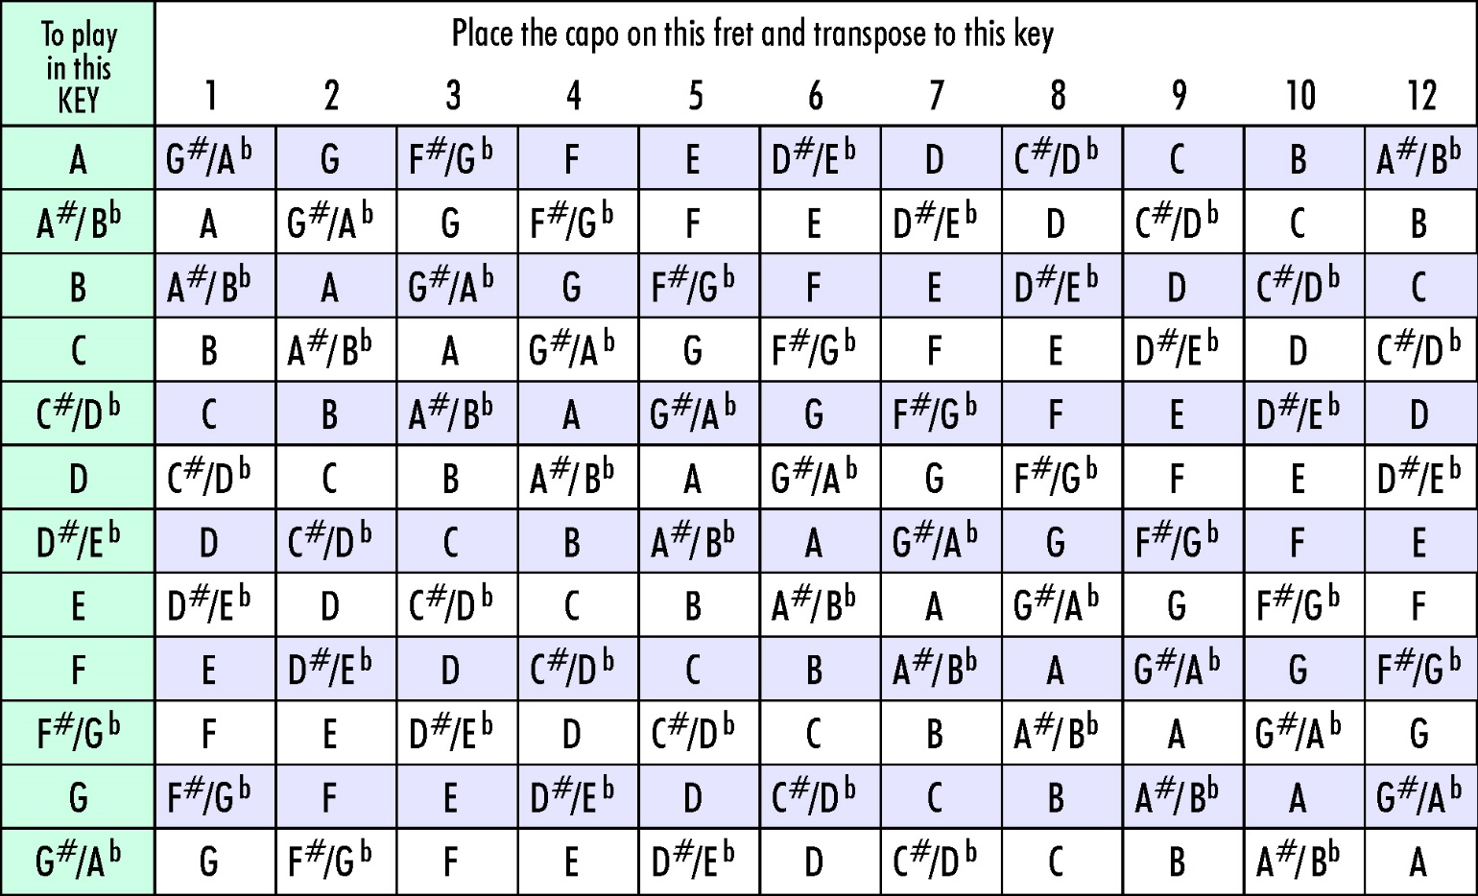

# Keys (Major)

|  |  |  |  |  |  |  |  |  |
| --- | --- | --- | --- | --- | --- | --- | --- | --- |
|  | I (1) | ii (2) | iii (3) | IV (4) | V (5) | vi (6) | VII (7) | VIII (8) |
| C | C | Dm | Em | F | G | Am | Bdim | C |
| C♯ | C♯ | D♯m | E♯m | F♯ | G♯ | A♯m | B♯dim | C♯ |
| D | D | Em | F♯m | G | A | Bm | C♯dim | D |
| D♯ |  |  |  |  |  |  |  |  |
| E♭ |  |  |  |  |  |  |  |  |
| E | E | F♯m | G♯m | A | B | C♯m | D♯dim | E |
| F | F | Gm | Am | B♭ | C | Dm | Edim | F |
| F♯ |  |  |  |  |  |  |  |  |
| G | G | Am | Bm | C | D | Em | F♯dim | G |
| G♯ |  |  |  |  |  |  |  |  |
| A♭ |  |  |  |  |  |  |  |  |
| A | A | Bm | C♯m | D | E | F♯m | G♯dim | A |
| A♯ |  |  |  |  |  |  |  |  |
| B♭ | B♭ | Cm | Dm | E♭ | F | Gm | Adim | B♭ |
| B | B | C♯m | D♯m | E | F♯ | G♯m | A♯dim | B |

# Chords

|  |  |  |  |  |  |  |  |  |  |
| --- | --- | --- | --- | --- | --- | --- | --- | --- | --- |
|  | Major | Minor | Dom 7th | Major 7th | Dim | Aug | 2, Sus2 | 4, Sus | m7 |
|  | 1, 3, 5 | 1, 3♭, 5 | 1, 3, 5, 7♭ | 1, 3, 5, 7 | 1, 3♭, 5♭ | 1, 3, 5♯ | 1, 2, 5 | 1, 4, 5 | 1, 3♭, 5, 7♭ |
| C | C E G | C E♭ G | C E G B♭ | C E G B | C E♭ G♭ | C E G♯ | C D G | C F G | C E♭ G B♭ |
| C♯ | C♯ E♯ G♯ | C♯ E G♯ | C♯ E♯ G♯ B | C♯ E♯ G♯ B♯ | C♯ E G | C♯ E♯ G♯♯ | C♯ D♯ G♯ | C♯ F♯ G♯ | C♯ E G♯ B |
| D♭ |  |  |  |  |  |  |  |  |  |
| D | D F♯ A | D F A | D F♯ A C | D F♯ A C♯ | D F A♭ | D F♯ A♯ | D E A | D G A | D F A C |
| D♯ |  |  |  |  |  |  |  |  |  |
| E♭ |  |  |  |  |  |  |  |  |  |
| E | E G♯ B | E G B | E G♯ B D | E G♯ B D♯ | E G B♭ | E G♯ B♯ | E F♯ B | E A B | E G B D |
| E♯ |  |  |  |  |  |  |  |  |  |
| F♭ |  |  |  |  |  |  |  |  |  |
| F | F A C | F A♭ C | F A C E♭ | F A C E | F A♭ C♭ | F A C♯ | F G C | F B♭ C | F A♭ C E♭ |
| F♯ |  |  |  |  |  |  |  |  |  |
| G♭ |  |  |  |  |  |  |  |  |  |
| G | G B D | G B♭ D | G B D F | G B D F♯ | G B♭ D♭ | G B D♯ | G A D | G C D | G B♭ D F |
| G♯ |  |  |  |  |  |  |  |  |  |
| A♭ |  |  |  |  |  |  |  |  |  |
| A | A C♯ E | A C E | A C♯ E G | A C♯ E G♯ | A C E♭ | A C♯ E# | A B E | A D E | A C E G |
| A♯ |  |  |  |  |  |  |  |  |  |
| B♭ |  |  |  |  |  |  |  |  |  |
| B | B D♯ F♯ | B D F♯ | B D♯ F♯ A | B D♯ F♯ A♯ | B D F | B D♯ F♯♯ | B C♯ F♯ | B E F♯ | B D F♯ A |
| B♯ |  |  |  |  |  |  |  |  |  |

# C

|  |  |  |  |  |  |  |  |  |
| --- | --- | --- | --- | --- | --- | --- | --- | --- |
|  | I (1) | II (2) | III (3) | IV (4) | V (5) | VI (6) | VII (7) | VIII (8) |
| Major | C | D | E | F | G | A | B | C |
| Minor (Natural) | C | D | E♭ | F | G | A♭ | B♭ | C |
| Minor (Harmonic) | C | D | E♭ | F | G | A♭ | B | C |
| Major Key | C | Dm | Em | F | G | Am | Bdim | C |
| Major 7th | CMaj7 | Dmin7 | Emin7 | FMaj7 | G7 | AMaj7 |  | CMaj7 |

Chords

Major – C, C Maj,

1 – C, 3 – E, 5 – G

Minor – Cm, C Min

1 – C, 3♭ – E♭, 5 – G

Dominant 7th – C7

1 – C, 3 – E, 5 – G, 7♭ - B♭

Major 7th – CMaj7

1 – C, 3 – E, 5 – G, 7 - B

Diminished – Cdim

1 – C, 3♭ - E♭, 5♭ - G♭

Suspended 2nd – C2, Csus2

1 – C, 2 – D, 5 – G

Suspended 4th – C4, Csus, Csus4

1 – C, 4 – F, 5 - G

# C♯

|  |  |  |  |  |  |  |  |  |
| --- | --- | --- | --- | --- | --- | --- | --- | --- |
|  | I (1) | II (2) | III (3) | IV (4) | V (5) | VI (6) | VII (7) | VIII (8) |
| Major | C♯ | D♯ | E♯ (F) | F♯ | G♯ | A♯ | B♯ (C) | C♯ |
| Minor (Natural) | C♯ | D♯ | E | F♯ | G♯ | A | B | C♯ |
| Minor (Harmonic) | C♯ | D♯ | E | F♯ | G♯ | A | B♯ | C♯ |
| Major Key | C♯ | D♯m | E♯m (Fm) | F♯ | G♯ | A♯m | B♯dim | C♯ |
| Major 7th | C♯Maj7 | D♯m7 | E♯m7 (Fm7) | F♯Maj7 | G♯7 | A♯Maj7 |  | C♯Maj7 |

Chords

Major – C♯, C♯ Maj,

1 – C♯, 3 – E♯, 5 – G♯

Minor – C♯m, C♯ Min

1 – C♯, 3♭ – E, 5 – G♯

Dominant 7th – C♯7

1 – C♯, 3 – E♯, 5 – G♯, 7♭ - B

Major 7th – C♯Maj7

1 – C♯, 3 – E♯, 5 – G♯, 7 - B♯

Diminished – C♯dim

1 – C♯, 3♭ - E, 5♭ - G

Suspended 2nd – C♯2, C♯sus2

1 – C♯, 2 – D♯, 5 – G♯

Suspended 4th – C♯4, C♯sus, C♯sus4

1 – C♯, 4 – F♯, 5 - G♯

# D

|  |  |  |  |  |  |  |  |  |
| --- | --- | --- | --- | --- | --- | --- | --- | --- |
|  | I (1) | II (2) | III (3) | IV (4) | V (5) | VI (6) | VII (7) | VIII (8) |
| Major | D | E | F♯ | G | A | B | C♯ | D |
| Minor (Natural) | D | E | F | G | A | B♭ | C | D |
| Minor (Harmonic) | D | E | F | G | A | B♭ | C♯ | D |
| Major Key | D | Em | F♯m | G | A | Bm | C♯dim | D |
| Major 7th | DMaj7 | Em7 | Fm7 | GMaj7 | A7 | Bm7 |  | DMaj7 |

Chords

Major – D, D Maj

1 – D, 3 – F♯, 5 – A

Minor – Dm, D Min

1 – D, 3♭ – F, 5 – A

Dominant 7th – D7

1 – D, 3 – F♯, 5 – A, 7♭ - C

Major 7th – DMaj7

1 – D, 3 – F♯, 5 – A, 7 - C♯

Diminished – Ddim

1 – D, 3♭ - F, 5♭ - G♯

Suspended 2nd – D2, Dsus2

1 – D, 2 – E, 5 – A

Suspended 4th – D4, Dsus, Dsus4

1 – D, 4 – G, 5 - A

# D♯

|  |  |  |  |  |  |  |  |  |
| --- | --- | --- | --- | --- | --- | --- | --- | --- |
|  | I (1) | II (2) | III (3) | IV (4) | V (5) | VI (6) | VII (7) | VIII (8) |
| Major | D♯ | F | G | G♯ | A♯ | C | D | D♯ |
| Minor (Natural) | D♯ | F | F♯ | G♯ | A♯ | B | C♯ | D♯ |
| Minor (Harmonic) | D♯ | F | F♯ | G♯ | A♯ | B | D | D♯ |
| Major Key | D♯ | Fm | Gm | G♯ | A♯ | Cm | Ddim | D♯ |
| Major 7th | DMaj7 | Em7 | Fm7 | GMaj7 | A7 | Bm7 |  | DMaj7 |

Chords

Major – D, D Maj

1 – D, 3 – F♯, 5 – A

Minor – Dm, D Min

1 – D, 3♭ – F, 5 – A

Dominant 7th – D7

1 – D, 3 – F♯, 5 – A, 7♭ - C

Major 7th – DMaj7

1 – D, 3 – F♯, 5 – A, 7 - C♯

Diminished – Ddim

1 – D, 3♭ - F, 5♭ - G♯

Suspended 2nd – D2, Dsus2

1 – D, 2 – E, 5 – A

Suspended 4th – D4, Dsus, Dsus4

1 – D, 4 – G, 5 - A

# E

|  |  |  |  |  |  |  |  |  |
| --- | --- | --- | --- | --- | --- | --- | --- | --- |
|  | I (1) | II (2) | III (3) | IV (4) | V (5) | VI (6) | VII (7) | VIII (8) |
| Major | E | F♯ | G♯ | A | B | C♯ | D♯ | E |
| Minor (Natural) | E | F♯ | G | A | B | C | D | E |
| Minor (Harmonic) | E | F♯ | G | A | B | C | D | E |
| Major Key | E | F♯m | G♯m | A | B | C♯m | D♯dim | E |
| Major 7th | EMaj7 | F#m7 | G♯m7 | AMaj7 | B7 | C♯m7 |  | EMaj7 |

Chords

Major – E, E Maj

1 – E, 3 – G♯, 5 – B

Minor – Em, E Min

1 – E, 3♭ – G, 5 – B

Dominant 7th – E7

1 – E, 3 – G♯, 5 – B, 7♭ - D

Major 7th – EMaj7

1 – E, 3 – G♯, 5 – B, 7 - D♯

Diminished – Edim

1 – E, 3♭ - G, 5♭ - A♯

Suspended 2nd – E2, Esus2

1 – E, 2 – F♯, 5 – B

Suspended 4th – E4, Esus, Esus4

1 – E, 4 – A, 5 – B

# F

|  |  |  |  |  |  |  |  |  |
| --- | --- | --- | --- | --- | --- | --- | --- | --- |
|  | I (1) | II (2) | III (3) | IV (4) | V (5) | VI (6) | VII (7) | VIII (8) |
| Major | F | G | A | B♭ | C | D | E | F |
| Minor (Natural) | F | G | A♭ | B♭ | C | D♭ | E♭ | F |
| Minor (Harmonic) | F | G | A♭ | B♭ | C | D♭ | E | F |
| Major Key | F | Gm | Am | B♭ | C | Dm | Edim | F |
| Major 7th | FMaj7 | Gm7 | Am7 | B♭Maj7 | C7 | Dm7 |  | FMaj7 |

Minor (Natural)

R (w) 2 (h) 3♭ (w) 4 (w) 5 (h) 6♭ (w) 7♭ (w) 8

Minor (Harmonic)

R (w) 2 (h) 3♭ (w) 4 (w) 5 (h) 6♭ (wh) 7 (w) 8

Chords

Major – F, F Maj

1 – F, 3 – A, 5 – C

Minor – Fm, F Min

1 – F, 3♭ – A♭, 5 – C

Dominant 7th – F7

1 – F, 3 – A, 5 – C, 7♭ - E♭

Major 7th – FMaj7

1 – F, 3 – A, 5 – C, 7 - E

Diminished – Fdim

1 – F, 3♭ - A♭, 5♭ - C♭ (B)

Suspended 2nd – F2, Fsus2

1 – F, 2 – G, 5 – C

Suspended 4th – F4, Fsus, Fsus4

1 – F, 4 – B♭, 5 – C

# G

|  |  |  |  |  |  |  |  |  |
| --- | --- | --- | --- | --- | --- | --- | --- | --- |
|  | I (1) | II (2) | III (3) | IV (4) | V (5) | VI (6) | VII (7) | VIII (8) |
| Major | G | A | B | C | D | E | F♯ | G |
| Minor (Natural) | G | A | B♭ | C | D | E♭ | F | G |
| Minor (Harmonic) | G | A | B♭ | C | D | E♭ | F♯ | G |
| Major Key | G | Am | Bm | C | D | Em | F♯dim | G |

Chords

Major – G, G Maj,

1 – G, 3 – B, 5 – D

Minor – Gm, G Min

1 – G, 3♭ – B♭, 5 – D

Dominant 7th – G7

1 – G, 3 – B♭, 5 – D, 7♭ – F

Major 7th – GMaj7

1 – G, 3 – B, 5 – G, 7 - F♯

Diminished – Gdim

1 – G, 3♭ - B♭, 5 - D♭

Suspended 2nd – G2, Gsus2

1 – G, 2 – A, 5 – D

Suspended 4th – G4, Gsus, Gsus4

1 – G, 4 – C, 5 – D

# A

|  |  |  |  |  |  |  |  |  |
| --- | --- | --- | --- | --- | --- | --- | --- | --- |
|  | I (1) | II (2) | III (3) | IV (4) | V (5) | VI (6) | VII (7) | VIII (8) |
| Major | A | B | C♯ | D | E | F♯ | G♯ | A |
| Minor (Natural) | A | B | C | D | E | F | G | A |
| Minor (Harmonic) | A | B | C | D | E | F | G♯ | A |
| Major Key | A | Bm | C♯m | D | E | F♯m | G♯dim | A |

Chords

Major – A, A Maj,

1 – A, 3 – C♯, 5 – E

Minor – Am, A Min

1 – A, 3♭ – C, 5 – E

Dominant 7th – A7

1 – A, 3 – C♯, 5 – E, 7♭ – G

Major 7th – AMaj7

1 – A, 3 – C♯, 5 – E, 7 - G♯

Diminished – Adim

1 – A, 3♭ - C, 5♭ - E♭

Suspended 2nd – A2, Asus2

1 – A, 2 – B, 5 – E

Suspended 4th – A4, Asus, Asus4

1 – A, 4 – D, 5 - E

# B

|  |  |  |  |  |  |  |  |  |
| --- | --- | --- | --- | --- | --- | --- | --- | --- |
|  | I (1) | II (2) | III (3) | IV (4) | V (5) | VI (6) | VII (7) | VIII (8) |
| Major | B | C♯ | D♯ | E | F♯ | G# | A♯ | B |
| Minor (Natural) | B | C♯ | D | E | F♯ | G | A | B |
| Minor (Harmonic) | B | C♯ | D | E | F♯ | G | A♯ | B |
| Major Key | B | C♯m | D♯m | E | F♯ | G♯m | A♯dim | B |

Chords

Major – B, B Maj,

1 – B, 3 – D♯, 5 – F♯

Minor – Bm, B Min

1 – B, 3♭ – D, 5 – F♯

Dominant 7th – B7

1 – B, 3 – D♯, 5 – F♯, 7♭ – A

Major 7th – BMaj7

1 – B, 3 – D♯, 5 – F♯, 7 - A♯

Diminished – Bdim

1 – B, 3♭ - D, 5♭ - F

Suspended 2nd – B2, Bsus2

1 – B, 2 – C♯, 5 – F♯

Suspended 4th – B4, Bsus, Bsus4

1 – B, 4 – E, 5 - F♯