Final Project Report

Foodies

[Video Demo](https://www.youtube.com/watch?v=B52c6Vd7ndE)

[GitHub Repository](https://github.com/ianebeckett/foodies)

Ian Beckett

Cole McAnelly

Margaret Zhuang

Thuc Tran

# Changes

We didn’t change much during the implementation process. We realized while constructing the database that there were several attribute names that were reserved keywords, so we changed those names, but semantically they serve the same purpose. We also realized that we forgot to represent an event “end time”, so that was added to the “meal_event” entity, but this did not introduce any strange dependencies. Overall, the changes we made to the database were very minor and had no impact on the structure or functionality of the database, and required no additional normalization following our changes.

## ERD before

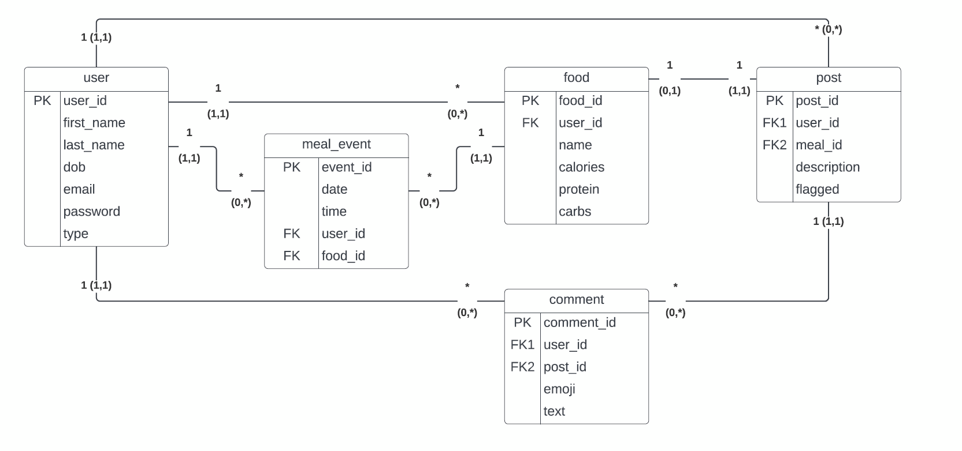

## ERD after

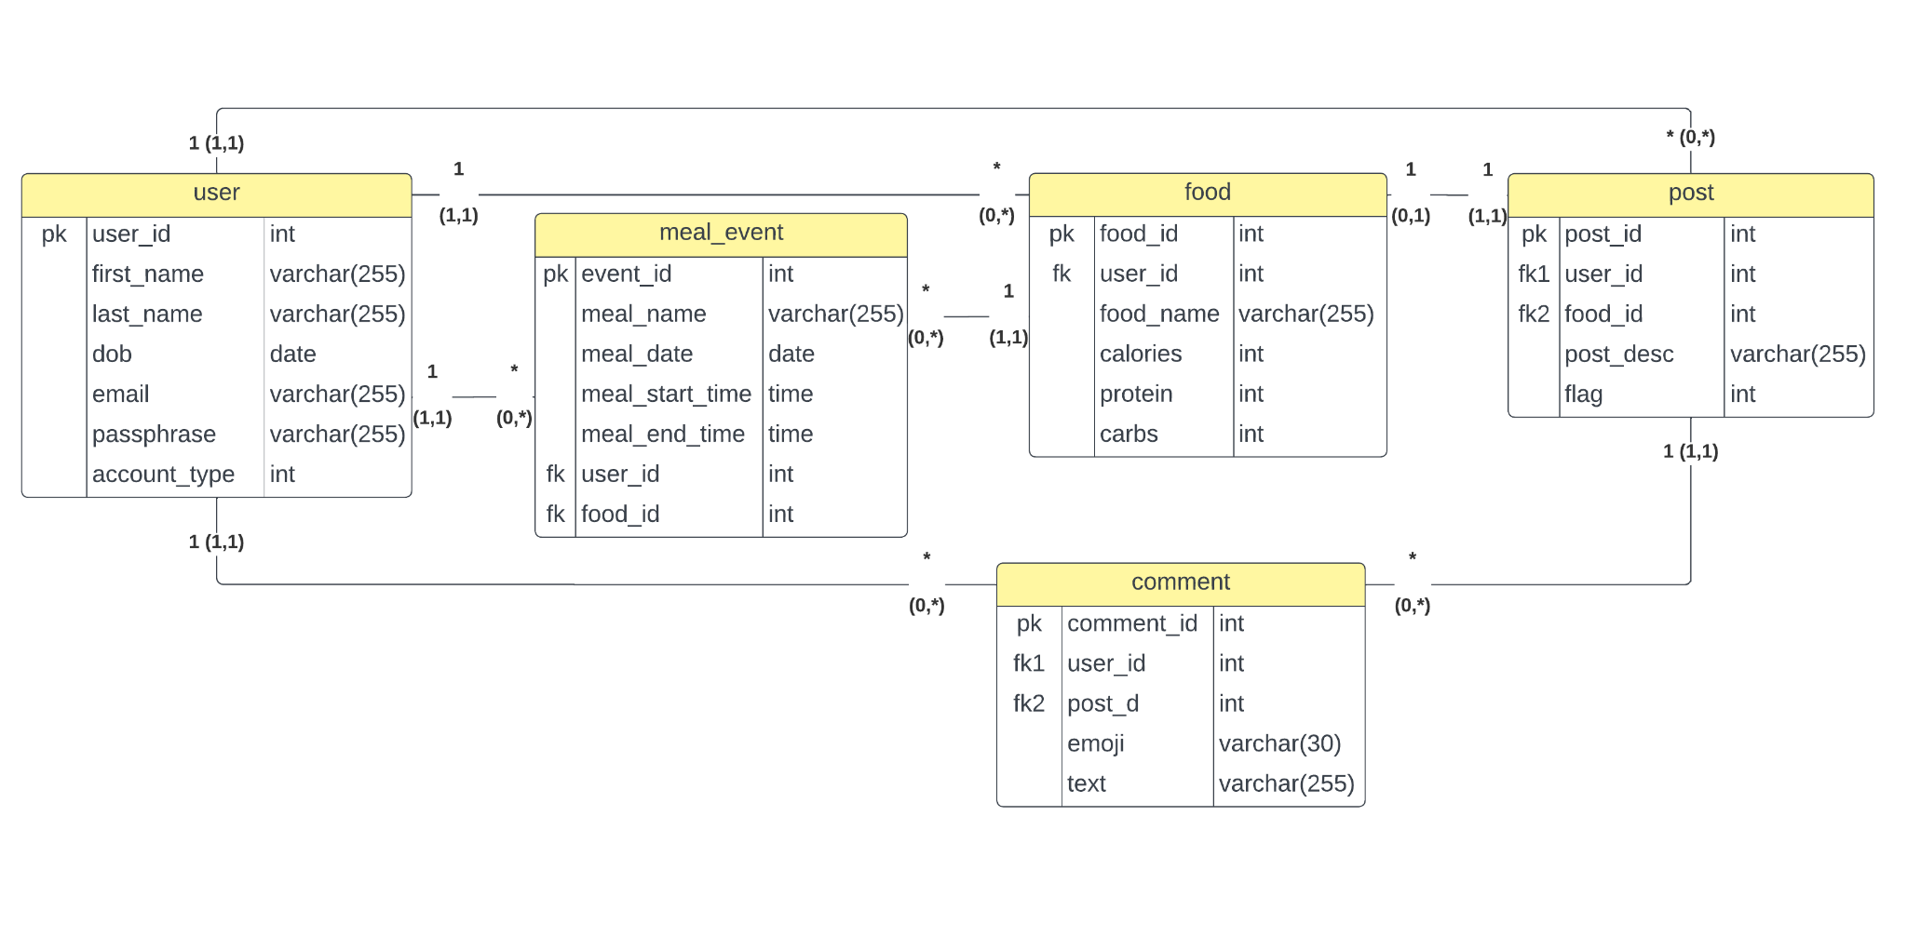

# Files

Below is a file tree of the repository for this project, where each file is annotated with which team member made those changes. This does not include all files in the repository, but just the files that were created by team members.

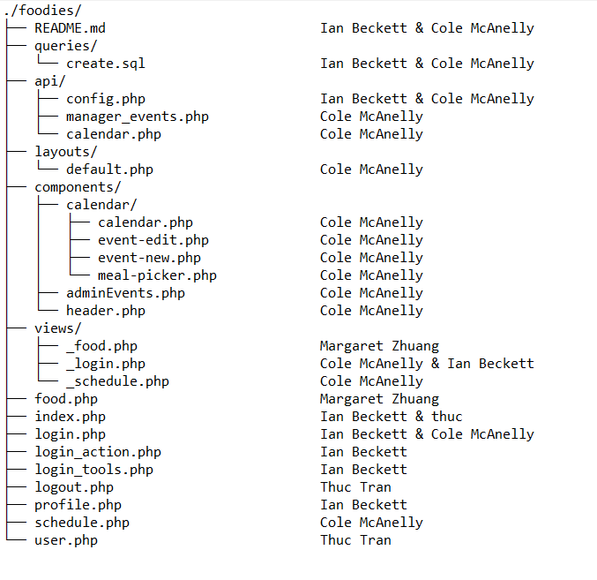

# Functionalities completed

|  |  |  |  |
| --- | --- | --- | --- |
| **Ian Beckett**   * Register * Login * Profile * New post * New comment | **Cole McAnelly**  User - Event Functionality:   * Create new events * Read existing events * Update events * Delete events   Admin - Event functionality   * Read ALL events | **Margaret Zhuang**  The food tab:   * Publish new foods * Look up food id by name * Look up foods by calories desired * Delete foods | **Thuc Tran**   * Logout * Admin view (delete posts and users) * User delete food/post |