# Model Derivation

We wish to derive an expression for the probability of a fusion between a sex chromosome and an autosome assuming that any chromosome is equally likely to be involved in the fusion with the exception of fusions between homologous chromosomes, and fusions between an X and a Y (because these would lead to unbalanced gametes during meiosis and would presumably be nonviable). Directly calculating the probability of a sex autosome fusion proves to be challenging and can be avoided by taking advantage of the compliment rule:

$P\left(SA\right)=1-P(AA)-P\left(SS\right)$ (A1)

Note that given a fusion occurs, the only three possibilities are that it is between two sex chromosome, two autosomes, or between a sex chromosome and an autosome. It is quite possible that the sexes may make unequal contributions to the fusions entering a species (Pennell et al. 2015). Because of this, we must account for the differing probabilities in males and females. We have added the term $μ_{d}$, representing the proportion of fusions that occur in females, and partitioned $P(AA)$ and $P\left(SS\right)$ into their sex specific components to account for this possibility. We use a subscript $s$ and $d$ for sire and dam when referring to sex specific values to avoid any confusion stemming from using subscript $m$ and $f$.

$P\left(SS\right)=μ_{d}P\left({SS}_{d}\right)+(1-μ_{d})P({SS}_{s})$ (A2)

$P\left(AA\right)=P\left({AA}_{d}\right)+(1-μ_{d})P({AA}_{s})$ (A3)

We will find an expression for each of the probabilities. Each term is calculated using a counting argument. These are the classic “marbles in an urn” probability arguments. The probability of choosing a red marble is the proportion of red marbles in the urn, just as the probability of ‘choosing’ an autosome is the number of autosomes available over the total number of chromosomes available to be ‘chosen’. A graphical description of each counting problem is given in figure A1, in the case of a XXYYY sex chromosome system with 6 autosomes, but the generalization follows easily.

$P\left({SS}_{d}\right)=P\left(X\right)P\left(X | X\right)=\frac{2X_{s}(2X_{s}-2)}{D_{d}(D_{d}-2)}$ (A4)

(fig A1, yellow square)

$P\left({SS}_{s}\right)=P\left(X\right)P\left(X | X\right)+P\left(Y\right)P(Y|Y)=\frac{X_{s}(X_{s}-1)}{D_{s}(D_{a}+X_{a}-1)}+\frac{Y(Y-1)}{D_{s}(D_{a}+Y-1)}$ (A5)

(fig A1, purple and green squares)

$P\left({AA}_{d}\right)=P\left(A\right)P\left(A | A\right)=\frac{D_{a}(D_{a}-2)}{D_{d}(D_{d}-2)}$ (A6)

(fig A1, red square)

$P\left({AA}_{s}\right)=P\left(A\right)P\left(A | A\right)=\frac{D_{a}(D_{a}-2)}{D_{s}(D_{s}-2)}$ (A7)

(fig A1, blue square)

Equations [A4]-[A7] can then be substituted into equations [A2] and [A3] yielding the following expressions for the proportion of SS and AA fusions:

$P(SS)=μ_{d}\frac{4X_{s}(X_{s}-1)}{D_{d}(D_{d}-2)}+(1-μ_{d})\left[\frac{X_{s}(X_{s}-1)}{D_{s}(D_{s}+X_{s}-1)}+\frac{Y(Y-1)}{D_{s}(D_{s}+Y-1)}\right]$ (A8)

$P(AA)=μ_{d}\frac{D_{a}(D_{a}-2)}{D_{d}(D_{d}-2)}+(1-μ_{d})\frac{D_{a}(D_{a}-2)}{D_{s}(D_{s}-2)}$ (A9)

Substituting equations [A8] and [A9] into equation [A1] gives us our result:

(A10)

**Figure S1 Graphical representation of the counting argument** used to derive each fraction in the case of an XXYYY system with a diploid autosome count of six. Circles are found on the chromosome we are ‘choosing’, and X’s are placed on chromosomes which are unavailable to be ‘chosen’ due to a previously ‘chosen’ chromosome. The diagrams represent the fraction surrounded by the box of matching color. For instance, the fraction in the red box represents P(A)P(A|A) in females (equation [A6]), the probability of an autosome is first ‘chosen’ to fuse, and a second autosome is ‘chosen’ to fuse with it and is represented by the diagram in the box of the same color. Inside the box, the diagram above the dotted line shows the probability of choosing one of the six autosomes out of all of the chromosomes. The diagram below the line shows the probability of choosing one of the four autosomes remaining available to be chosen after the first autosome had been chosen. The other fractions follow similarly.

# Drosophila analysis

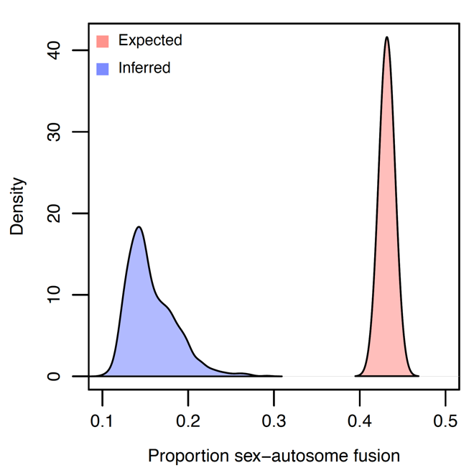

**Figure S2 Observed and expected proportions of fusions joining a sex chromosome and an autosome.** Our results indicate a scarcity of fusions joining sex chromosomes and autosomes. Of the 1000 stochastic mappings evaluated, none of the possible evolutionary histories sampled suggested a proportion of sex chromosome autosome fusions that would be expected under the null model. This is strong evidence that sex autosome fusions are either more deleterious than autosome autosome fusions or that de novo fusions joining a sex chromosome and an autosome occur more infrequently than do fusions joining autosomes.