density

20

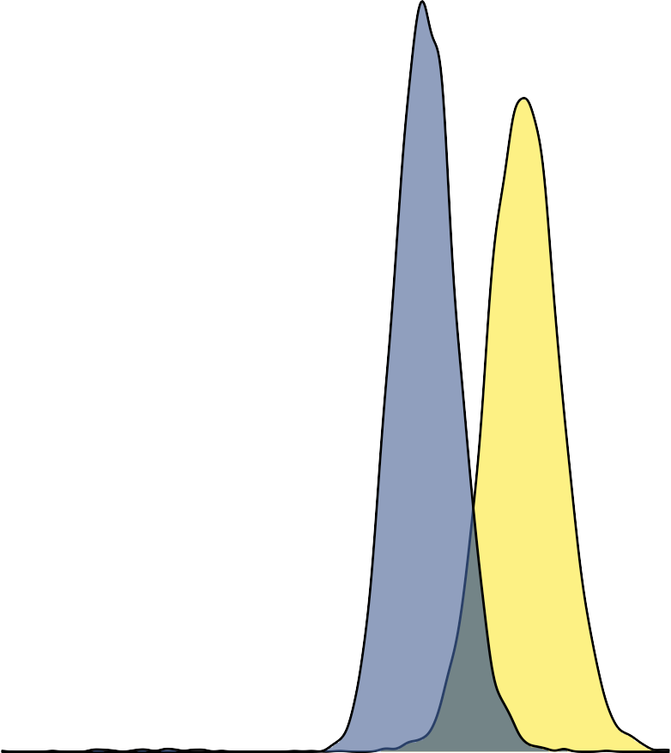

15

parameter

10

fission fusion

5

0

−0.1 0.0 0.1 0.2

rate difference (per MY) small − large range size