|  |  |  |
| --- | --- | --- |
|  | Taxa |  |
| Laemophloeidae | 6 |
| Phalacridae | 1 |
| Erotylidae | 1 |
| Nitidulidae | 2 |
| Chrysomelidae | 922 |
| Cerambycidae | 166 |
| Curculionoidea | 896 |
| Silvanidae | 3 |
| Melyridae | 5 |
| Cleridae | 11 |
| Trogossitidae | 2 |
| Coccinellidae | 196 |
| Anthicidae | 3 |
| Meloidae | 28 |
| Ciidae | 4 |
| Tenebrionoidea | 258 |
| Lycidae | 6 |
| Lampyridae | 26 |
| Cantharidae | 33 |
| Elateridae | 100 |
| Byrrhidae | 2 |
| Buprestidae | 100 |
| Dermestidae | 25 |
| Bostrichidae | 4 |
| Anobiidae | 9 |
| Helophoridae | 13 |
| Hydrophilidae | 18 |
| Silphidae | 8 |
| Staphylinidae | 16 |
| Trogidae | 11 |
| Passalidae | 60 |
| Geotrupidae | 24 |
| Lucanidae | 15 |
| Scarabaeidae | 448 |
| Glaphyridae | 1 |
| Hybosoridae | 1 |
| Glaresidae | 1 |
| Leiodidae | 18 |
| Histeridae | 2 |
| Carabidae | 1088 |
| Trachypachidae | 2 |
| Gyrinidae | 7 |
| Dytiscidae | 131 |
| Hygrobiidae | 1 |
| Haliplidae | 15 |
| Noteridae | 6 |
| Myxophaga | 1 |
| Archostemata | 2 |

Macintosh HD:Users:hlb7922:Desktop:Dropbox:papers:chrom.num:data and analysis:figures:tree:Rplot04.eps

Polyphaga

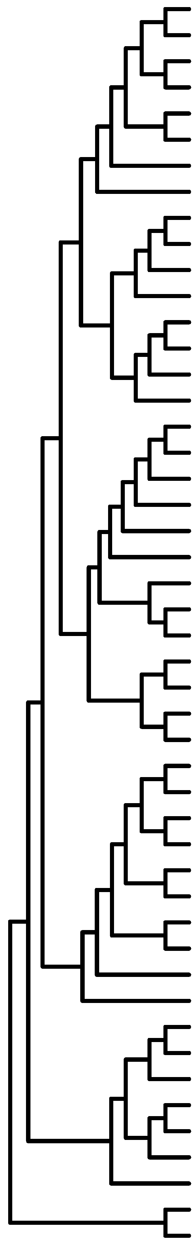

Adephaga

Figure 1. Cladogram illustrating the distribution of chromosome numbers in Coleoptera. Each block in the graph represents the number of taxa with that number of chromosome. Data and references are available at www.uta.edu/karyodb.