Name _______________________________________

Worksheet 5 Discrete Variables

You are interested in determining whether the first COVID-19 vaccines had an impact on severe COVID-19 outcomes. You create a questionnaire that you post to Twitter, Facebook, Truth Social, and Telegram. The questionnaire asks respondents if they have had 0, 1, or 2 doses of the COVID-19 vaccine and whether they have ever been hospitalized for COVID-19 symptoms. This is the result of your survey:

|  |  |  |
| --- | --- | --- |
|  | Hospitalized for Covid | Not hospitalized for Covid |
| No Vaccine | 34 | 5132 |
| 1 Dose | 24 | 1468 |
| 2 Doses | 15 | 3491 |

What test might you use to analyze this data, and what can you learn from this test?

What issues do you see with the design of this questionnaire?

You are interested in finding out if males and females have different probabilities of being left or right-handed, you collect the following data:

|  |  |  |
| --- | --- | --- |
|  | Left-Handed | Right-Handed |
| Female | 488 | 4512 |
| Male | 702 | 4298 |

You analyze this data with a Chi-Square test and get this result:

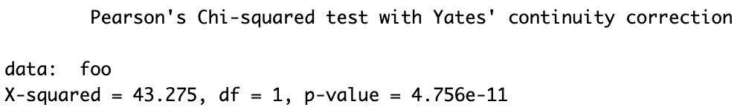

Describe what you can infer from this result: