Name _______________________________________

Worksheet 9

1) Describe the key difference between a Monte Carlo and a permutation test.

2) How do you determine how much of an MCMC to throw away as burn-in.

3) What is the name for the post-burnin portion of the MCMC

4) In Bayes Theorem, what does the highlighted term represent

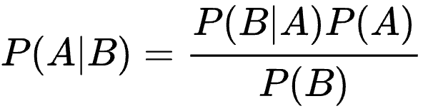

5) What is the hasting’s ratio

6) What are some major advantages of Bayesian approaches when compared to frequentist approaches? What are some major disadvantages of Bayesian approaches?