1. Create an R script to complete the following tasks.
2. Load the iris dataset included with base R.
3. Recreate this graph:

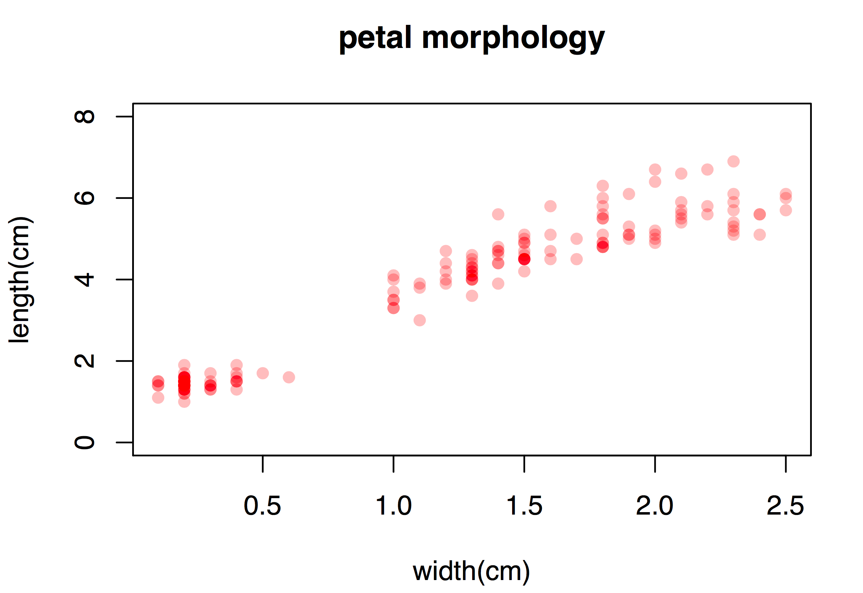

1. Plot a histogram of the petal length for the species setosa:

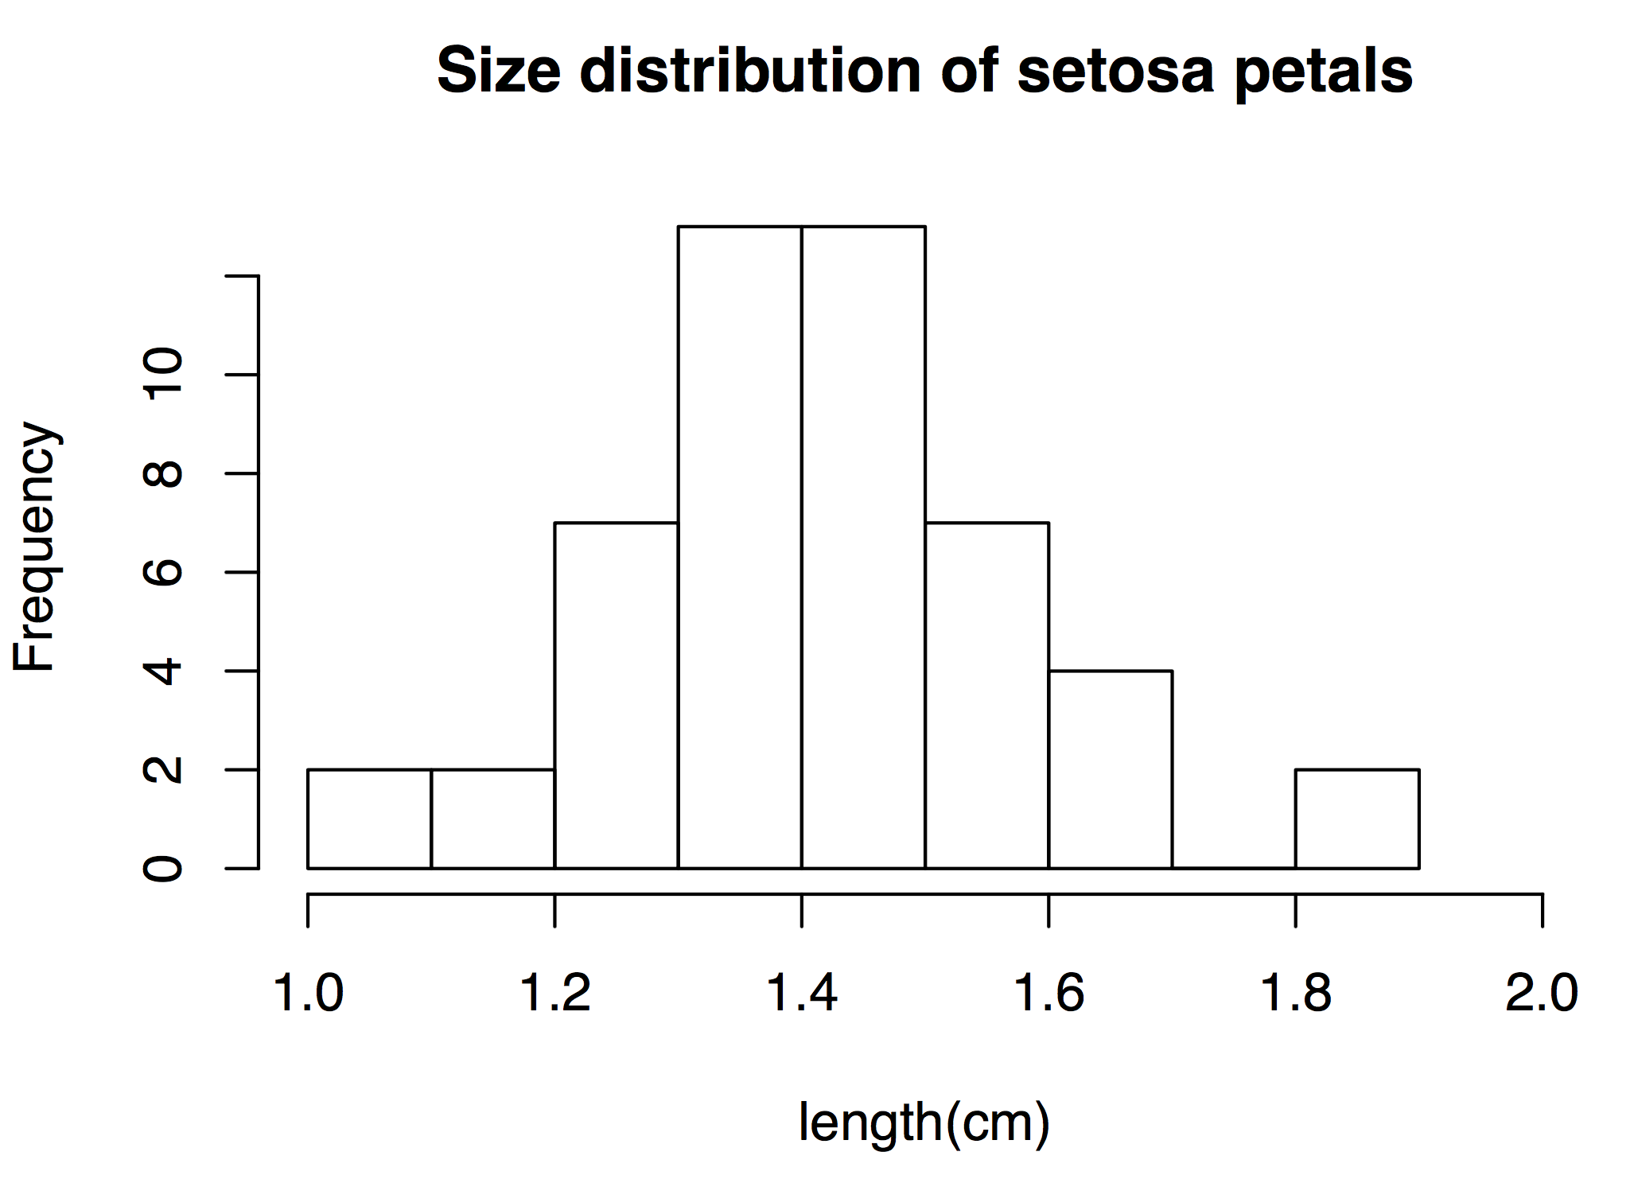

1. Use the **pnorm** function to calculate the probability of sampling a value of 37 or greater from a normal distribution with a mean of 36 and a standard deviation of 0.5.
2. Use the **rnorm** function to calculate this probability empirically.