**The fate of sexually antagonistic variation in finite populations with operational sex ratio bias**

Amy Shum, Robert David Gafford-Gaby, and Heath Blackmon

# **Abstract**

Although sexually antagonistic variation and operational sex biases in reproducing populations are common, the way these two factors interact in a finite population remains unexplored. Sexual antagonistic variation (where an allele is beneficial in one sex but deleterious in the other) has been well documented both in the lab and in empirical field studies. Likewise, strong biases in the ratio of breeding males and females are also common. To understand how sexual antagonism and sex ratio bias interact, we have used forward-time population genetic simulations to explore the fate of these types of mutations under a range of biologically realistic populations. In our study, we first examined populations with equal numbers of males and females. We next reduced the number of one sex so that there were just 80, 60, 40, 20, 10, or 5 percent as many of one sex. This process was repeated for both sexes and for base populations that ranged from 50 to 1000 individuals of the common sex. In our study, we also evaluated the role of varying dominance, genomic location, genetic architecture and the strength of selection. Our results illustrate that the dynamics of sexually antagonistic mutations are highly context dependent. We found that type of bias (rare males vs. rare females), dominance, effective population size, and genomic location all interact to determine the ultimate fate of sexually antagonistic mutations and the degree of either feminization or masculinization that should be expected.

# **Introduction**

Sexual antagonism, where an allele benefits one sex but is detrimental to the other has been well documented in many organisms, and plays a prominent role in much of theoretical population genetics (Mank 2017). Operational sex ratio (OSR), the ratio between the number of females and males that participate in reproduction varies greatly across the tree of life (Székely *et al.* 2014). However, the impact of strongly biased OSR on sexually antagonistic variation remains unexplored. On the one hand when very few individuals of one sex are able to reproduce, the mean fitness of the few individuals who reproduce will be greatly increased, but simultaneously, the potential for drift in allele frequency passed on by the rare sex should be greater. We address this gap in our understanding and illustrate the impact of OSR on sexually antagonistic variation using a forward time population genetic model that recapitulates a wide range of biologically realistic parameter space. Broadly, we find that the results are highly context dependent, with genetic architecture, genomic location, and degree of OSR all having important impacts on the fate of sexually antagonistic variation.

The evolution of anisogamy often leads to a cascading effect where the adaptive landscape of males and females is strikingly different. These differences in the adaptive landscape experienced by males and females may lead to fundamental differences in the benefits and costs associated with mutations. Mutations can have a fitness effect that ranges from deleterious to beneficial. However, the fitness effect of a single mutation may also vary among males and females (Sharp and Agrawal 2013). A classic example is the case where an allele benefits one sex but harms the other, this pattern is known as sexually antagonistic selection. More broadly, mutations may be conditionally expressed such that regardless of their fitness effect they will only impact a single sex. Empirical studies have identified several examples of loci that have differential fitness effects in males and females. In 12 species of African cichlid in the genera *Labeotropheus*, *Matriaclima* and *Tropheops* the OB locus has an allele that causes the orange-blotch color pattern and provides crypsis for females but disrupts the male color cues used for mate recognition. This sexually antagonistic variation has been largely resolved by the tight linkage of the OB locus to a dominant female sex determining allele (Roberts *et al.* 2009). Similarly, among sympatric populations of sticklebacks in Japan, it appears that sexually antagonistic variation has driven a fusion between an autosome and sex chromosome, and may have contributed to a speciation event (Kitano *et al.* 2009). More broadly, work in Drosophila has shown that some haplotypes provide strikingly different fitness depending on the sex in which they are carried (Innocenti and Morrow 2010). Even in the human genome, evidence has been found for the footprint of sexual antagonism. At birth, allele frequencies should be equal between males and females. However, some genes show a divergence in allele frequency among adults. This divergence is strongest in genes that are slightly sex-biased (Cheng and Kirkpatrick 2016).  However, modeling studies of this effect suggest that the strength of selection required to produce significant divergence in a single generation may be improbably high (Kasimatis *et al.* 2019).

Sexual antagonism is also central to our understanding of the origin and evolution of sex chromosomes (Charlesworth 1991). The canonical model of sex chromosome evolution posits that it is sexual antagonism that leads to selection to increase linkage between the sex-determining region and linked sexually antagonistic variation (Clark 1988; Charlesworth *et al.* 2005; Otto *et al.* 2011; Bachtrog 2013; Blackmon and Demuth 2015). Thus, selection to reduce recombination leads to the ultimate divergence of the X and Y chromosome and often to the decay of the Y chromosome. The same patterns are expected and observed in ZW sex-determination systems (Rice 1994; Bachtrog *et al.* 2011). In fact, sexual antagonistic variation in the pairing region of the sex chromosomes can drive reduction in recombination even if these reductions in pairing lead to high rates of failure during spermatogenesis (Blackmon and Brandvain 2017). Since the dawn of evolutionary biology sexual antagonism has been a challenge to understand because fundamentally the differences that we see in what makes a fit female and a fit male must be produced by a genome that is largely shared between the sexes.

Strong bias in OSR has been well documented in insects, birds, fish, and mammals (Elmberg 1990; Gwynne 1990; Mitani *et al.* 1996; Jirotkul 1999). These imbalances in the number of males and females that are able to reproduce can originate from either a skewed ratio of males and females at birth or may develop due to differences among sexes in survival to reproductive maturity. Sex bias in individuals at birth is especially common in species with haplodiploid and environmental sex determination systems. In bark beetles, which are haplodiploid, females often lay clutches of eggs where almost all eggs are fertilized producing daughters and only a small percent of unfertilized eggs are laid producing sons (Kirkendall 1993).

Sex bias is present in species that undergo temperature-dependent sex determination as well. In various species of sea turtles, hatchling sex ratios of between 60 to 98% (where females are the common sex) are observed consistently across their natural range, this ratio tracks temperature increases, and while extreme sex ratios may drive a species to extinction, increasing the number of female hatchlings in a clutch is therefore thought to be a strategy whereby increased female gamete production may help offset the observed increase in hatchling mortality up to a point (Hays *et al.* 2017).

Species with XY or ZW sex-determination systems can produce extreme biases in the number of males and females at birth.  For instance, in the grain pest *Gnatocerus cornutus* poor media conditions lead to the production of offspring that have a mean of 65 percent females and as high as 95 percent females (Cruickshank and Wade 2012). A metanalysis of offspring ratio in birds found that 17 percent of 114 species studied have a sex ratio significantly different from 50 percent (Donald 2007). Even in species where the number of males and females are equal at birth a biased OSR may develop due to differential mortality of the sexes. As mentioned above a metanalysis of bird populations indicated only 17 percent had a sex ratio bias at birth but this increased to 65 percent showing an OSR significantly different than 50% with the mean being 30-35% more males than females as a result of higher mortality rates in females. Likewise, in the fish *Poecilia mexicana*, greater predation occurs in male species due to its larger size and greater activity during mate acquisition (Reichard *et al.* 2014)., In the killifish *Nothobranchius guentheri*, bright color patterns of males are associated with greater bird predation (Haas 1976).

Finally, in those cases where relatively similar numbers of males and females survive to reproductive maturity mating systems may create a biased OSR. For instance, in fur seals and sea lions, it is estimated that one male is able to reproduce with between sixteen and one hundred females, while remaining males in the population often do not mate (Le Boeuf 1991). This pattern of a minority of males capturing the majority of mating opportunities has been documented in many mammals, including *Mirounga angustirostris*, *Mirounga leonina*, *Halichoerus grypus*, and *Cavia magna* (Le Boeuf 1991; Kraus *et al.* 2003).

Outside of natural populations there are many instances either in the lab or in agricultural settings where breeding designs are such that much of the genome flows through only a handful of a single sex. In racehorses a single stallion that has had a successful racing career can breed with as many as 125 mares per year, the average female produces 2.05 to 3.76 offspring over their lifetime (Hager and Jones 2009; Guzman 2017). A similar pattern is even recommended in cattle where optimum pregnancy rates are achieved with a male to female ratio of 1:25 (Unknown 2019).

To understand the impact of biased OSR, we have utilized a forward time population genetic simulation approach with diploid genomes, non-overlapping generations, and a variety of genetic architectures. We use this simulation approach to show under what condition strongly biased OSR is expected to lead to either masculinization or feminization of the genome. Broadly we find that biased OSR can be a strong force in shaping the amount and type of sexually antagonistic mutation that a species can maintain in the genome.

# **Methods**

## Model Description

We developed a forward time diploid two-locus biallelic model with non-overlapping generations and viability selection. The first locus is the sex determining region which is represented by an X and Y allele. Individuals homozygous for the X allele are females while heterozygous individuals are males. The second locus is Sexually Antagonistic (Brathwaite *et al.*) and has two alleles one is beneficial to females (A1) and one is beneficial to males (A2). Because females are homozygous at the sex determining locus we can ignore recombination in females. In males, recombination between the sex-determining locus and the SA locus occur as a function of the genetic distance (*rd*). When *rd* is less than 0.5 a SA locus in the recombining region of the sex chromosomes is simulated while and *rd* value of 0.5 leads to a simulation where the SA locus is on an autosome. The fitness of an individual is a function of its sex and the genotype at the SA locus (**table 1**).

Simulations were started with a selected number of males and females and an equal frequency of the two alleles at the SA locus. Alleles at the SA locus were assigned equally to X and Y chromosomes so that at the start of the simulation there is no linkage disequilibrium and allele frequency in males and females was equal. In each cycle of the simulation fitness was assessed for all individuals. Based on their fitness females were drawn to contribute eggs to the gamete pool. In females since recombination can be ignored, haplotypes for eggs were drawn at random from each selected female. In males, sperm haplotypes were drawn accounting for recombination between the sex-determining locus and the SA locus (double recombination events were not allowed in the model.) To reconstitute the next generation (including any bias in the number of males and females present) eggs were drawn at random and paired with randomly drawn sperm that contained either an X or Y allele at the sex-determining locus as appropriate for the number of offspring needed for each sex. This process was repeated until a specified number of generations was reached or until one of the alleles at the SA locus fixed in the population.

Haplodiploidy requires some modifications to this model. In this case we used a single locus biallelic model, where one of the alleles was male-beneficial, and the other was female-beneficial. Our simulations started with a given population with diploid genotypes for females and haploid genotypes for males. We then run a generation using our starting population with a selection coefficient of 0.5 and a dominance factor of 0.5. Each generation that is simulated goes through selection based on a fitness function, gamete production based on relative fitness, and fertilization of the next generation recapitulating the approach described above for a total of 500 generations and 1000 replications for each variation of the conditions we looked at.

## Simulation Scenarios

In our simulation, we evaluated 56 different pairings of numbers of males and females. In each simulation the population was made up of 50, 100, 500, or 1000 individuals of the common sex. For the second sex the number of individuals was the same as in the common sex or reduced by a factor of 0.8, 0.6, 0.4, 0.2, 0.1, or 0.05. Simulations with 50 of the common sex and an OSR of 0.05 would result in 2.5 individuals of the rare sex. For simulations with this pairing of parameters we used 3 individuals of the rare sex. These pairings were repeated with both males and females as the rarer sex. For each of these scenarios, we varied three other factors: recombination distance *rd* (0.1, 0.2, and 0.5), selection strength *s* (0.1, 0.2, 0.5, and 0.9), and dominance *h* (0.0, 0.5, 1.0). We also evaluated the case for sex specific dominance in which an allele that benefits a sex is dominant in that sex. This condition requires a different fitness function rather than simply a different *h* value (**Table 1**). Under each simulation scenario 1000 replicates were performed. This simulation design yielded a total of 2016 scenarios and over two million individual simulations.

|  |  |  |  |  |  |
| --- | --- | --- | --- | --- | --- |
|  | Additive  dominance  recessive | |  | Sex-specific  dominance | |
|  | Male | Female |  | Male | Female |
| A1A1 |  |  |  |  | 1 |
| A1A2 |  |  |  |  |  |
| A2A2 | 1 | 1 |  | 1 |  |

**Table 1:** Fitness function. The first column represents all the possible genotypes at the SA locus where A1 is male beneficial and A2 is female beneficial. The columns are divided between genetic architecture: additive, dominance, recessive and sex specific dominance in males versus females. The selection coefficient is represented by s and the dominance factor of the male benefit allele is indicated with an h.

In our haplodiploid simulation we followed the same conditions we used above for the number of the common sex and the factor by which the rare sex was reduced, applying the same procedure to both males and females. The selection coefficients considered were also the same as above as were the dominance factors. However, since we were considering a single locus recombination distance did not need to be factored into these scenarios. A total of 672,000 simulations were carried out encompassing all of the relevant scenarios.

|  |  |  |  |  |
| --- | --- | --- | --- | --- |
|  | **female** |  |  | **male** |
| A1A1 |  |  | A1 |  |
| A1A2 |  |  |  |  |
| A2A2 |  |  | A2 |  |

**Table 2:** Fitness function for haplodiploid simulations. The first column contains all the genotypes females can exhibit. The third column has the male genotypes. The selection coefficient is denoted by *s* and the dominance factor by *h*.

# **Results**

**Autosomal Loci** are present in males and females with equal frequency and because we use a symmetric fitness function, when there are equal numbers of males and females, we expect to see allele frequency of additive SA alleles maintained without a sex bias. Our results confirm this expectation. In simulations regardless of total population size or the strength of selection, allele frequency ranged from 47% to 53% (**FIGURE 1-4**). In populations with 1000 individuals of each sex, no simulations fixed a single allele regardless of selection strength. Despite this mean, the number of simulations that fixed one allele increased as population size or selection coefficient decreased. However, there was no consistent difference in whether it was the male or female benefit allele that fixed. For populations with 500 of each sex fixation of a single allele was rare, but became common with populations made up of just 100 or 50 of each sex.

Under a symmetric fitness function with a model where one allele is dominant, fitness should be maximized when the recessive allele is at a higher frequency than the dominant allele. This is the pattern that we observed. In populations with 1000 of each sex, the mean allele frequency for the dominant allele was 26, 27, 29, and 37% for selection coefficients of 0.9, 0.5, 0.2, and 0.1 respectively (**FIGURE 1-4**). As population sizes were reduced, this pattern was repeated but became noisy as the impact of drift became stronger. Likewise, the frequency that one of the alleles fixes is higher in simulations where one allele is dominant and is biased towards fixation of the recessive allele. For instance, in simulation with 100 individuals of each sex, we find that when selection is strong (s=0.9), 18% of simulations fix the recessive allele but no simulations fix the dominant allele. This bias is observed to varying degrees across selection coefficients and population sizes.

Under a sex specific dominance model, the mean allele frequency across replicate simulations ranged from 47% to 51%. Similar to simulations under an additive model, fixation of either allele is rare until the number of each sex is below 500 and no bias towards the allele that benefits one sex was observed regardless of population size. Our simulation results also show that the variance in allele frequency under a sex specific dominance model is lower than under an additive model. This is particularly true for small populations of either 50 or 100 of each sex. For simulations with 500 or 1000 of each sex, variance in allele frequency across simulations is still higher for additive models than it is for sex specific dominance models, but this difference becomes trivial **(FIGURE 1-4)**.

Once we begin to reduce the number of individuals of one sex that are able to reproduce, the dynamics of sexually antagonistic variation on autosomes changes in a consistent fashion. First, we find only very small biases in allele frequency towards those that benefit the common sex occur when simulations have 1000 individuals of the common sex even when OSR is extreme. For instance, the mean allele frequency for simulations with an additive genetic architecture and a selection coefficient of 0.5 range from 0.48 to 0.58 with the largest bias towards the common sex in simulations that have an OSR of 0.05. However, when the common sex is represented by 500, 100 or 50 individuals the and the OSR is 0.05 we find allele frequency biases towards the allele benefitting the common sex of 0.65, 0.64, and 0.60 respectively **(FIGURE 1-4).**

**X chromosome loci** even when the number of males and females are equal, X chromosomes are present in females two thirds of the time leading to the expectation that allele frequency for alleles benefitting females will under most circumstances be elevated in comparison autosomal loci. For X chromosome loci that are tightly linked (recombination distance of 0.1) simulations with an additive genetic architecture and a selection coefficient of 0.5 and equal numbers of males and females led to allele frequencies of 0.68, 0.68, 0.67, and 0.59 for populations with 1000, 500, 100, and 50 of each sex respectively. The pattern for sex specific dominance is quantitatively different but qualitatively the same (**FIGURE 5-8**). For X chromosome loci that are loosely linked (recombination distance of 0.2) simulations with an additive genetic architecture and a selection coefficient of 0.5 and equal numbers of males and females led to allele frequencies of 0.59, 0.58, 0.56, and 0.57 for populations with 1000, 500, 100, and 50 of each sex respectively. The pattern for sex specific dominance is quantitatively different but qualitatively the same for loosely linked loci as well (**FIGURE 5-8**). Similar to the pattern observed in autosomes recessive alleles will reach a higher frequency than dominant alleles. For simulations with a recessive allele benefiting females and a selection coefficient of 0.5 and equal numbers of males and females we observed mean allele frequency of 0.87, 0.87, 0.86, 0.85 for populations with 1000, 500, 100, and 50 of each sex. For the case of loosely linked loci we see the same pattern but with less extreme bias towards the female benefit recessive allele.

As we begin to reduce the number of males in a population we find that allele frequency becomes more strongly biased towards the alleles benefitting females. This pattern is strongest with intermediate populations sizes and extreme OSRs. The maximum bias towards alleles benefitting females when the genetic architecture was either additive or recessive was found when the population consisted of 100 females and just 20 males. In these cases the allele frequency of the female beneficial allele was 0.93 for the recessive case and 0.85 for the additive case. In the case of sex specific dominance the most extreme result was achieved with the same number of females but just 10 males and the allele frequency in this case was 0.85.

X chromosomes can also become masculinized when the number females is small and the number males is large. We find that populations consisting of just 50 or 100 males and with OSRs of either 0.1 or 0.05 exhibit strong biases towards fixing alleles that benefit males and are either additive, dominant or exhibit sex specific dominance (**FIGURE 9**). As an example, with 100 males and an OSR of 0.05 we find mean allele frequencies of .99, 1.0, 1.0 for additive, dominant and sex specific dominant alleles. Notably if the allele benefiting males is recessive we do not observe as extreme masculinization of the X chromosome loci with a mean allele frequency of only 0.69. These results are for a locus that is tightly linked with a recombination distance of 0.1. Results from a loosely linked locus are similar but usually less extreme.

**Y chromosome loci** are unique in that they are present in males more often than in females. Therefore, even without a bias in the number of males and females we expect them to exhibit masculinization under most conditions. For Y chromosome loci that are tightly linked (recombination distance of 0.1) simulations with an additive genetic architecture and a selection coefficient of 0.5 and equal numbers of males and females led to allele frequencies of 0.71, 0.71, 0.69, and 0.56 for populations with 1000, 500, 100, and 50 of each sex respectively. The results for sex specific dominance, regardless of population size, is similar to the result for an additive architecture with 1000 individuals of each sex (**FIGURE 10**). For Y chromosome loci that are loosely linked (recombination distance of 0.2) simulations with an additive genetic architecture and a selection coefficient of 0.5 and equal numbers of males and females led to allele frequencies similar to those for a tightly linked locus. Similar to the pattern observed in autosomes recessive alleles will reach a higher frequency than dominant alleles. For simulations with a recessive allele benefiting males and a selection coefficient of 0.5 and equal numbers of males and females we observed mean allele frequency of 0.87, 0.87, 0.86, and 0.73 for populations with 1000, 500, 100, and 50 of each sex. For the case of loosely linked loci we see the same pattern but with less extreme bias towards the male benefit recessive allele.

As we begin to reduce the number of females in a population we find that allele frequency becomes more strongly biased towards the alleles benefitting males. This pattern is strongest with small populations sizes and extreme OSRs. The maximum bias towards alleles benefitting males when the genetic architecture was either additive, male benefit dominant, or exhibiting sex specific dominance was found when the population consisted of 100 males and just 5 females. In these cases, the allele frequency of the male beneficial allele was .99 for the additive case, 1.0 for the dominant case, and 1.0 for sex specific dominance. In the case of a recessive allele benefitting males the most extreme result was achieved with 500 males but just 25 females and the allele frequency in this case was 0.93.

**Haplodiploidy.**

We observed instances where alleles fixed at all population sizes, and all selection coefficients. However, the number of simulations where the allele benefiting the males fixes is seen in populations where there are as little as 25 females to every 500 males, with only strong selection maintaining the female-beneficial alleles at a 0.5 frequency in fewer than approximately 250 simulations. Fixation of male-beneficial alleles becomes more frequent when the number of males is 100 or less, and the number of females in the population is lower than 40% of the male population. Nevertheless, drift appears to have a strong impact as these alleles are just as likely to be lost under the same conditions at which they become fixed (**FIGURE 11**).

In the case where there is a strong female bias in the OSR, the simulations paint a similar picture but both the number of instances where the female-beneficial allele will fix is lower than the case where females are rare, and the OSR at which male beneficial alleles are lost occurs between scenarios where there is one male for every 100 females, or 5 males (or fewer) to every 50 females (**FIGURE 12**).

# Discussion

The frequency of operational sex ratio bias and sexually antagonistic variation combined with our results has important implications for genome evolution in natural populations, agricultural settings, model organism maintenance, and captive breeding programs. Intuition would suggest that when there are very few individuals of one sex but many of the other, the selection coefficient when a genotype is expressed in the common sex may dominate the fate of alleles. Our simulations bear out this intuitive view. In particular, we found that for the case of autosomal loci, we should expect either a net feminization or masculinization of the genome when strong OSRs are maintained over many generations. This finding is consistent across genetic architectures, selection coefficients, and many combinations of numbers of males and females. The most extreme biases in genome evolution should be expected for loci that have a recessive allele that benefits the common sex. In these cases, the equilibrium allele frequency that is already closer to fixation and stochastic changes in allele frequency are more likely to lead to a complete loss of the rarer allele.

Because autosomal loci are selected both in males and females, this region of the genome experiences the lowest levels of masculinization or feminization. However, even in this portion of the genome under certain breeding systems where the common sex is present in relatively low numbers 100-500 and the rare sex is represented by 5-25 individuals, 65-76 percent of loci will fix for the allele benefiting the common sex. This pattern becomes stronger as the strength of selection increases. This suggests that species whose natural breeding system is similar to this may overtime see a decline in the absolute fitness of the rarer sex. This may be a partial explanation for the relatively degenerate nature of the rare sex in some species that are characterized by extreme OSRs. A classic example of this is found in the bark and ambrosia beetles where males are often only a fraction of the size of females, lack wings, and have reduced eyes. These characteristics have been explained in the past as evidence of selection for reduction of the expression of costly traits in males that function primarily to fertilize their sisters. However, we suggest this also may be compounded by the impact of OSR on the fate of alleles that are required for proper development in males but not necessary in females.

One important consideration of our results is their application to agricultural and sport breeding. The ability of a single male to fertilize 1000s of females allows breeders with prized males to earn enormous incomes through stud fees. Perhaps the best example of this is in horse breeding. We should consider though that effectively bottle-necking a breed through only a handful of males will over the long-term lead to a feminization of the genome. Currently male horses win about 4 percent more races than would be expected if the sexes performed equally. However, our results suggest that existing breeding practices should lead to a feminization of genome racehorse breeds and this should inevitably lead to an average reduction of male fitness and possibly a reduction in their slight edge in racing.

In lab settings the ratio of males and females that reproduce can be easily manipulated and our results illustrate that this could be a highly effective approach to discover the genes that have differential fitness in males and females. Some past studies have forced an autosome to segregate as a pseudo sex chromosome in Drosophila to investigate the fate of new sex chromosomes. Because Drosophila males lack recombination, these studies have focused on the fate of male specific portions of Y chromosomes. However, our results illustrate that performing a similar experiment in a species with recombination in males could allow these pseudo sex chromosomes to preferentially fix those alleles important to a single sex while recombination would allow researchers to avoid fixation of the many mildly deleterious alleles expected to accumulate on a non-recombining portion of the genome. Taken together, our results indicate that the fate of sexually antagonistic variation can be heavily influenced by breeding systems and that this should lead to predictable increase in the absolute fitness of the common sex and a concordant decrease in the absolute fitness of individuals of the rarer sex.

Bachtrog, D., 2013 Y-chromosome evolution: emerging insights into processes of Y-chromosome degeneration. Nat Rev Genet 14**:** 113-124.

Bachtrog, D., M. Kirkpatrick, J. E. Mank, S. F. McDaniel, J. C. Pires *et al.*, 2011 Are all sex chromosomes created equal? TRENDS in Genetics 27**:** 350-357.

Blackmon, H., and Y. Brandvain, 2017 Long-term fragility of Y chromosomes is dominated by short-term resolution of sexual antagonism. Genetics 207**:** genetics. 300382.302017.

Blackmon, H., and J. P. Demuth, 2015 Genomic origins of insect sex chromosomes. Current Opinion in Insect Science 7**:** 45-50.

Brathwaite, S., M. M. Yearsley, T. Bekaii-Saab, L. Wei, C. R. Schmidt *et al.*, 2016 Appendiceal Mixed Adeno-Neuroendocrine Carcinoma: A Population-Based Study of the Surveillance, Epidemiology, and End Results Registry. Front Oncol 6**:** 148.

Charlesworth, B., 1991 The evolution of sex chromosomes. Science 251**:** 1030.

Charlesworth, D., B. Charlesworth and G. Marais, 2005 Steps in the evolution of heteromorphic sex chromosomes. Heredity 95**:** 118-128.

Cheng, C., and M. Kirkpatrick, 2016 Sex-specific selection and sex-biased gene expression in humans and flies. PLoS genetics 12**:** e1006170.

Clark, A., 1988 The evolution of the Y chromosome with XY recombination. Genetics 119**:** 711-720.

Cruickshank, T., and M. J. Wade, 2012 Maternal adjustment of the sex ratio in broods of the broad-horned flour beetle, Gnathocerus cornutus. Integrative and Comparative Biology 52**:** 100-107.

Donald, P. F., 2007 Adult sex ratios in wild bird populations. Ibis 149**:** 671-692.

Elmberg, J., 1990 Long-term survival, length of breeding season, and operational sex ratio in a boreal population of common frogs, Rana temporaria L. Canadian Journal of Zoology 68**:** 121-127.

Guzman, Z., 2017 How ‘America’s most valuable stallion’ makes over $35 million a year without setting hoof on the track, pp. CNBC.

Gwynne, D. T., 1990 Testing parental investment and the control of sexual selection in katydids: the operational sex ratio. The American Naturalist 136**:** 474-484.

Haas, R., 1976 Sexual selection in Nothobranchius guentheri (Pisces: cyprinodontidae). Evolution**:** 614-622.

Hager, R., and C. B. Jones, 2009 *Reproductive skew in vertebrates: proximate and ultimate causes*. Cambridge University Press.

Hays, G. C., A. D. Mazaris, G. Schofield and J. O. Laloe, 2017 Population viability at extreme sex-ratio skews produced by temperature-dependent sex determination. Proc Biol Sci 284.

Innocenti, P., and E. H. Morrow, 2010 The sexually antagonistic genes of Drosophila melanogaster. PLoS biology 8**:** e1000335.

Jirotkul, M., 1999 Operational sex ratio influences female preference and male–male competition in guppies. Animal Behaviour 58**:** 287-294.

Kasimatis, K. R., P. L. Ralph and P. C. Phillips, 2019 Limits to Genomic Divergence Under Sexually Antagonistic Selection. bioRxiv**:** 591610.

Kirkendall, L. R., 1993 Ecology and Evolution of Biased Sex Ratios in Bark and Ambrosia Beetles, pp. 235-345 in *Evolution and diversity of sex ratio in insects and mites*, edited by D. L. Wrensch and M. A. Ebbert. Chapman and Hall, London.

Kitano, J., J. A. Ross, S. Mori, M. Kume, F. C. Jones *et al.*, 2009 A role for a neo-sex chromosome in stickleback speciation. Nature 461**:** 1079-1083.

Kraus, C., J. Künkele and F. Trillmich, 2003 Spacing behaviour and its implications for the mating system of a precocial small mammal: an almost asocial cavyCavia magna? Animal Behaviour 66**:** 225-238.

Le Boeuf, B. J., 1991 Pinniped mating systems on land, ice and in the water: emphasis on the Phocidae, pp. 45-65 in *The behaviour of pinnipeds*. Springer.

Mank, J. E., 2017 Population genetics of sexual conflict in the genomic era. Nature Reviews Genetics 18**:** 721.

Mitani, J. C., J. Gros-Louis and A. F. Richards, 1996 Sexual dimorphism, the operational sex ratio, and the intensity of male competition in polygynous primates. The American Naturalist 147**:** 966-980.

Otto, S. P., J. R. Pannell, C. L. Peichel, T.-L. Ashman, D. Charlesworth *et al.*, 2011 About PAR: the distinct evolutionary dynamics of the pseudoautosomal region. Trends in Genetics 27**:** 358-367.

Reichard, M., M. Polačik, R. Blažek and M. Vrtílek, 2014 Female bias in the adult sex ratio of African annual fishes: interspecific differences, seasonal trends and environmental predictors. Evolutionary Ecology 28**:** 1105-1120.

Rice, W. R., 1994 Degeneration of a nonrecombining chromosome. Science 263**:** 230-232.

Roberts, R. B., J. R. Ser and T. D. Kocher, 2009 Sexual conflict resolved by invasion of a novel sex determiner in Lake Malawi cichlid fishes. Science 326**:** 998-1001.

Sharp, N. P., and A. F. Agrawal, 2013 Male‐biased fitness effects of spontaneous mutations in Drosophila melanogaster. Evolution: International Journal of Organic Evolution 67**:** 1189-1195.

Székely, T., F. J. Weissing and J. Komdeur, 2014 Adult sex ratio variation: implications for breeding system evolution. Journal of evolutionary biology 27**:** 1500-1512.

Unknown, 2019 Pregnant cows, timing of pregnancy, open cows, pregnancy rate, pp. FAQ on cattle breeding in *Institute of Agriculture and Natural Resources*. Univeristy of Nebraska.

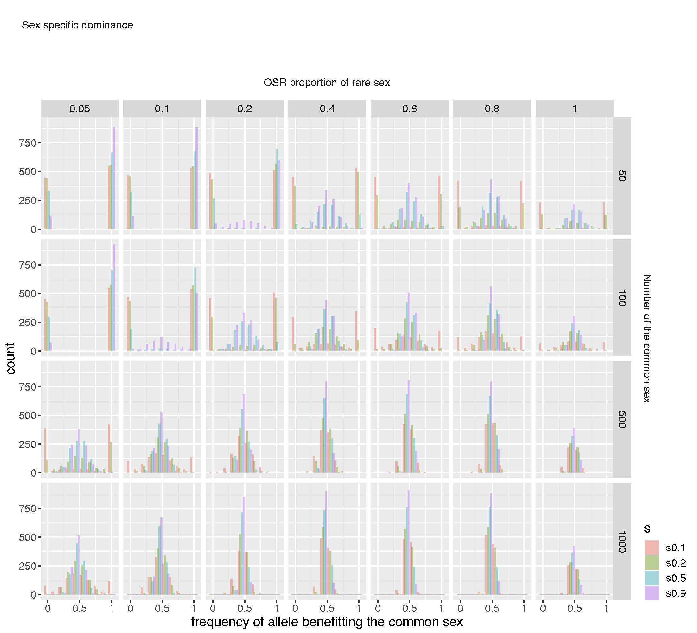

Figure 1 fate of autosomal antagonistic loci with sex specific dominance

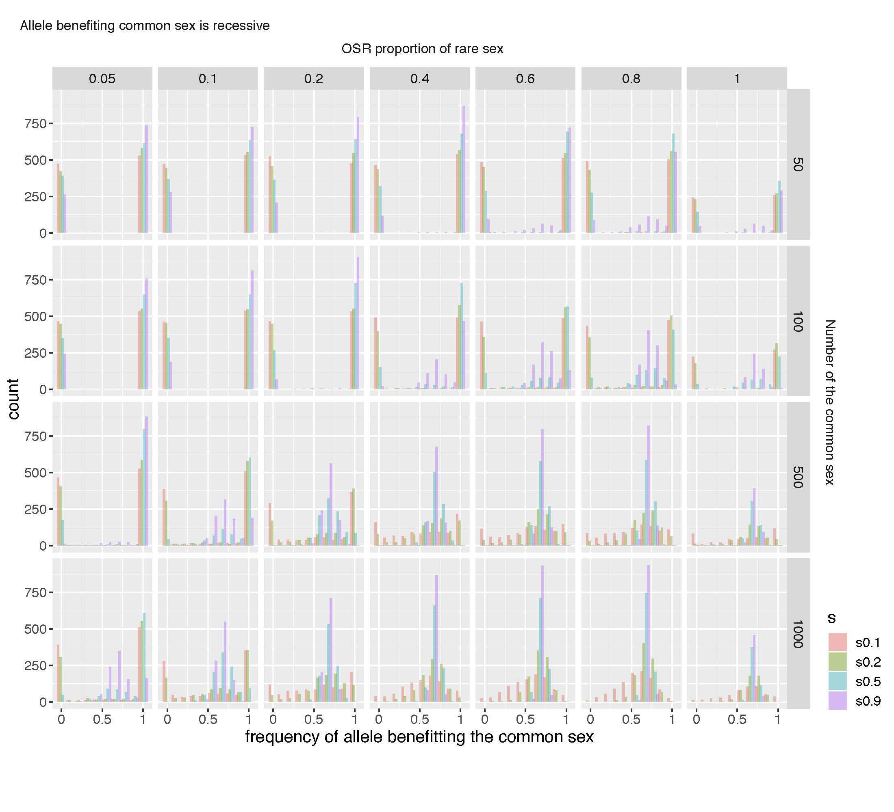

Figure 2 fate of autosomal antagonistic loci with allele beneficial to common sex recessive

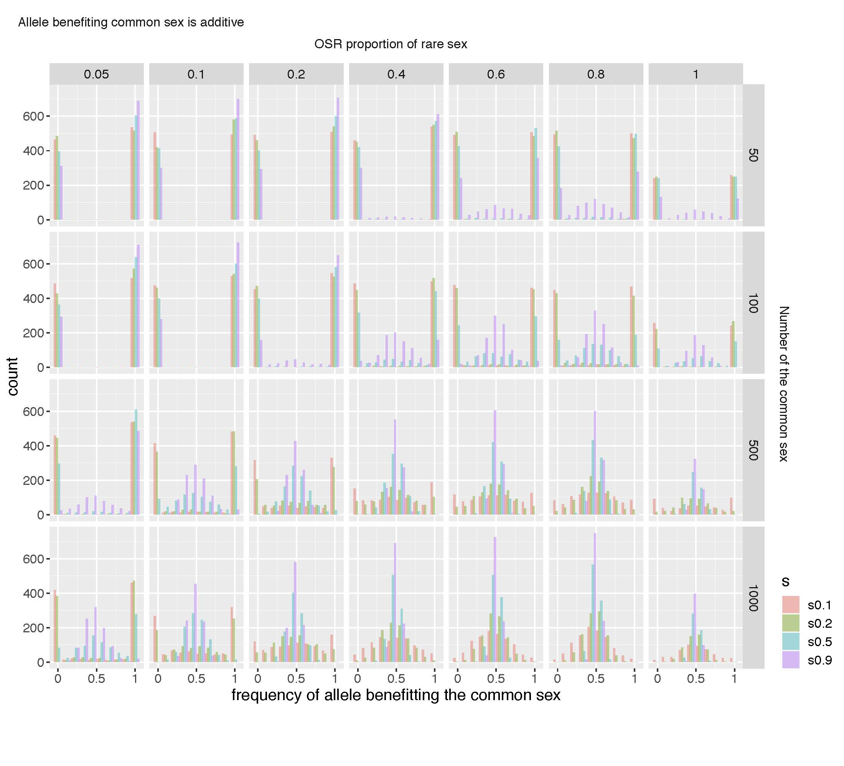

Figure 3 fate of autosomal antagonistic loci with additive gene action

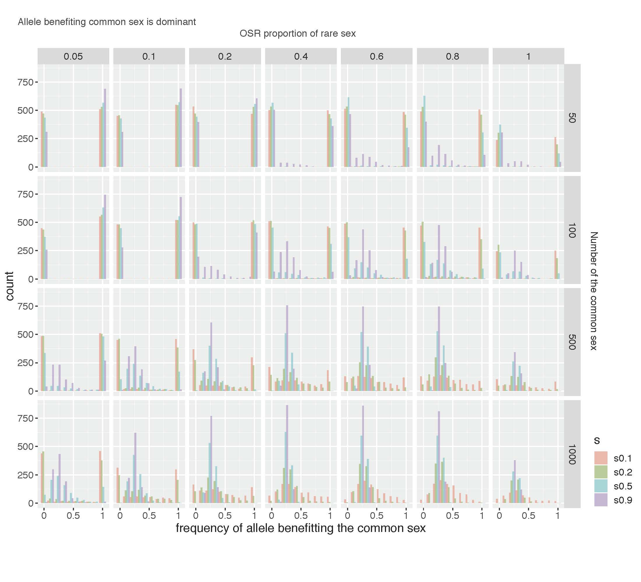

Figure 4 fate of autosomal antagonistic loci with allele beneficial to the common sex dominant

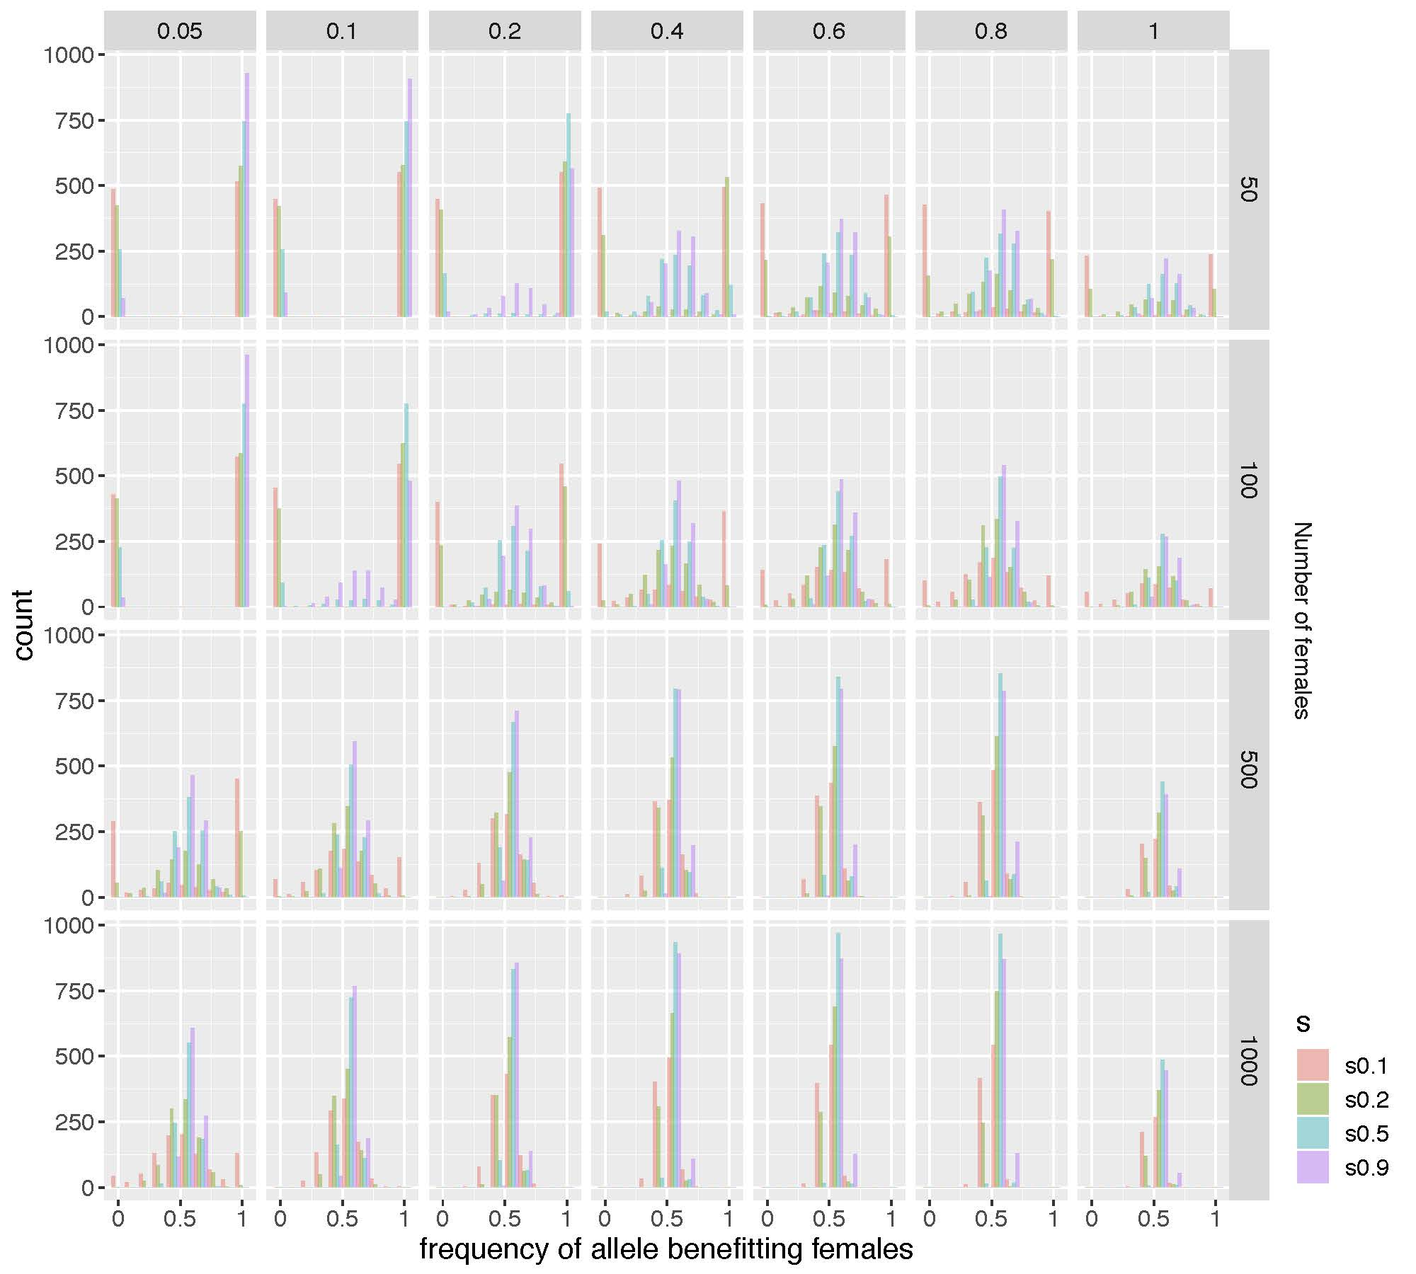

Figure 5 fate of X chromosome antagonistic loci with sex specific dominance

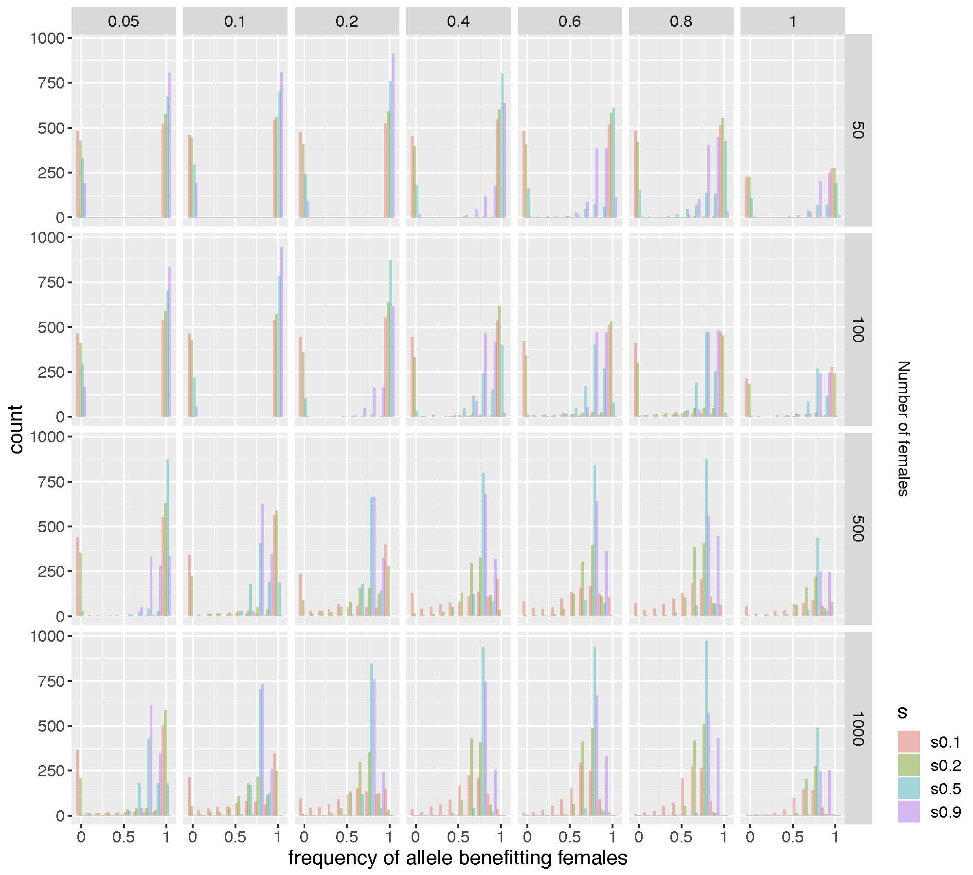

Figure 6 fate of X chromosome antagonistic loci with allele beneficial to females recessive

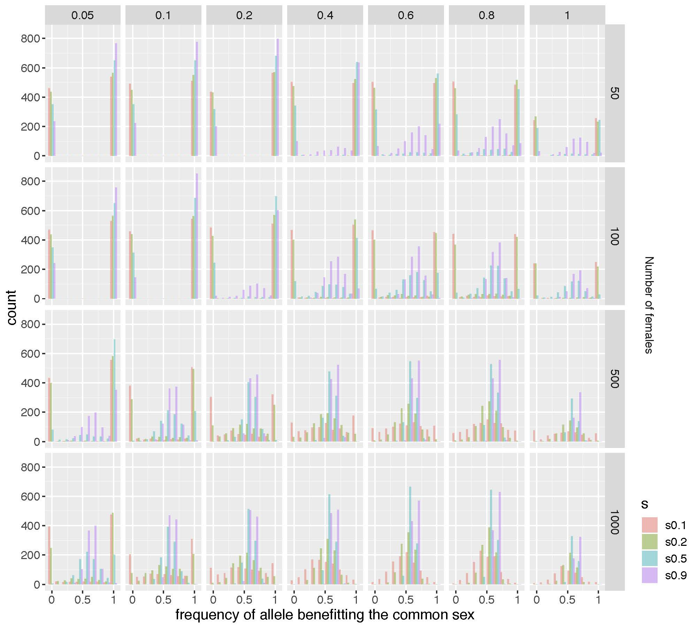

Figure 7 fate of X chromosome antagonistic loci with additive gene action

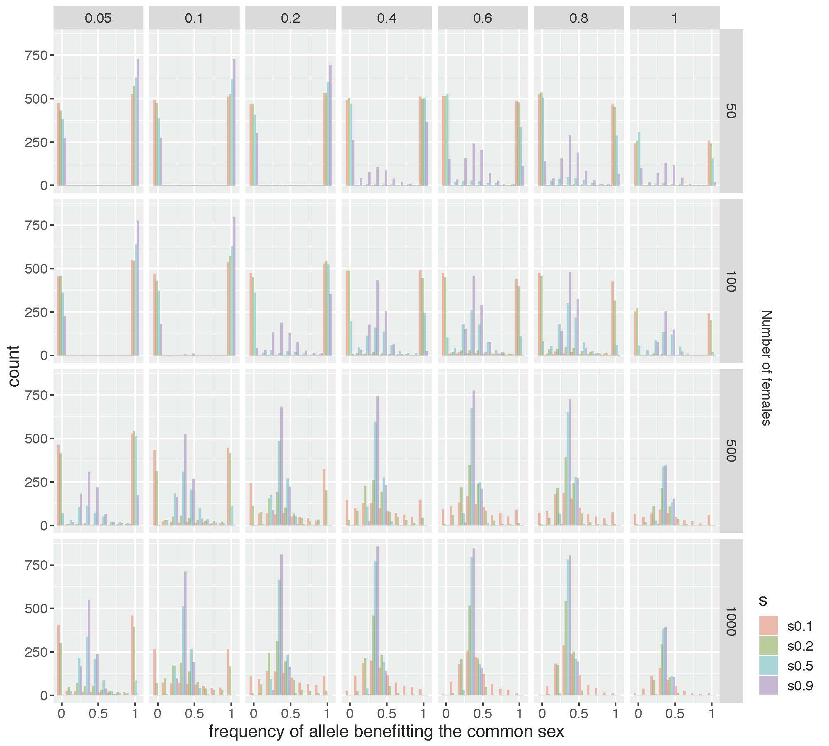

Figure 8 fate of X chromosome antagonistic loci with allele beneficial to the females dominant



Figure 9 fate of X chromosome antagonistic loci with selection coefficient of 0.5 and allele beneficial to males recessive



Figure 10 Frequency allele on the Y chromosome that is additive antagonistic with a selection coefficient of 0.5.



Figure 11. Frequency of the allele benefiting males. (must add label on y-axis for common sex and x-axis for OSR-proportion of the rare sex)



Figure 12. Frequency of the allele benefiting females. (must add label on y-axis for common sex and x-axis for OSR-proportion of the rare sex)