Title: The fitness of a the rare sex is destined to decline

**Authors:** R.D. Gafford-Gaby1†, A. Shum1†, and H. Blackmon1*.

**Affiliations:**

1Department of Biology, Texas A&M University, Texas USA 77804.

*Correspondence to: blackmon@tamu.edu.

† equal contributions.

**Abstract:**

In both captive and natural conditions, many species face not only small population sizes, but also an imbalance between the number of males and females reproducing. How do these characteristics impact the fitness of each sex and the species in question? These characteristics ultimately determine the strength of selection and genetic drift in the species and within each sex. This balance between selection and drift can impact the fate of alleles that have different selection pressures in males and females. Using simulations, we show that under certain conditions species will fix alleles that benefit the common sex and harm the rarer sex. Our results provide insights into the range of population sizes and sex ratios that lead to a fitness collapse.

**One Sentence Summary**:

If population size is small and the ratio of males to females is unequal, the rarer sex is destined to become unfit.

The population size of a species determines the balance of natural selection and genetic drift, which jointly dictates the fate of genetic variation. When population sizes are large, natural selection will drive change in allele frequency, such that beneficial mutations are more likely to increase in frequency, and deleterious mutations are more likely to decrease in frequency. However, if population sizes are small, genetic drift will be the dominant force in allele frequency change such that beneficial and deleterious mutations can have similar probabilities of increasing or decreasing in frequency. While many species are naturally rare and likely characterized by small population sizes (Qiao et al. 2010), climate change and habitat loss are leading to the fragmentation and isolation of ranges of once common species (Proctor et al. 2005; Dixo et al. 2009). Thus, as a result of drift, species with small population sizes are at a greater risk of accumulating more deleterious alleles and being unable to fix new adaptive mutations. This balance between selection and drift has been well explored in both empirical and theoretical frameworks (Lande 1976; Lynch 2007).

This balance between selection and drift is not determined by the census population size but by the effective population size. Many characteristics can reduce the effective population size far below the census size of the population. One such characteristic is the balance between males and females. The degree of imbalance between males and females that participate in reproduction is termed the operational sex ratio (OSR). OSR is the ratio of the number of the rarer sex to the more common sex that participate in reproduction. The impact of differing numbers of males and females on effective population size can be calculated as where is the number of males and is the number of females. Strong biases in OSR has been well documented in insects, birds, fish, and mammals (Elmberg 1990; Gwynne 1990; Mitani et al. 1996; Jirotkul 1999). These imbalances in the number of males and females that are able to reproduce can originate from a skewed ratio of males and females at birth, may develop due to differences among sexes in survival to reproductive maturity, or may be a product of the ability of a few individuals of one sex to dominate all mating opportunities. It is unclear how strong OSR bias will impact the balance of selection and drift. Can the fate of mutations be dominated by drift in one sex but by selection in the other?

If the balance between selection and drift extends to sexes within a species, it could have a striking impact on the fate of within species genetic variation, particularly in regards to alleles with different selection coefficients in males and females. The evolution of separate sexes often leads to a cascading effect where the adaptive landscape of males and females is strikingly different. These sex-specific differences in selection pressure can lead to fundamental differences in the selection coefficients when a genotype is expressed in a male versus a female. The classic example of this, known as sexually antagonistic selection, is which an allele benefits one sex but harms the other. Several examples of loci with differential fitness effects in males and females have been identified in empirical studies. In 12 species of African cichlid in the genera Labeotropheus, Matriaclima and Tropheops, the allele which causes the orange-blotch color pattern and provides crypsis for females disrupts the male color cues used in mate recognition (Roberts et al. 2009). Similarly, among sympatric populations of sticklebacks in Japan, sexually antagonistic variation is proposed to have driven a fusion between an autosome and sex chromosome, likely contributing to a speciation event (Kitano et al. 2009). More broadly, work in *Drosophila* has shown that some haplotypes provide strikingly different levels of fitness depending on the sex in which they are carried (Innocenti and Morrow 2010). Even in the human genome, evidence has been found for the footprint of sexual antagonism. At birth, allele frequencies should be equal between males and females. However, some genes show a divergence in allele frequency among adults suggesting differential viability selection among the sexes in a single generation. (Cheng and Kirkpatrick 2016; but see Kasimatis et al. 2019).

Even in cases where a mutation is either beneficial or deleterious in both sexes the selection coefficient that is measured in the sexes may be strikingly different (Sharp and Agrawal 2013). A more extreme example of this disparity in selection coefficients are those genes that have sex-specific expression. The lack of expression in the one sex will relax the constraint of selection, possibly protecting the gene from purifying selection in the non-expressing sex (Van Dyken and Wade 2010; Connallon and Jordan 2016). Some work, both theoretical and empirical, has shown a two to four-fold increase in variation in maternal-effect genes when compared to zygotically expressed genes (Whitlock and Wade 1995; Barker et al. 2005; Demuth and Wade 2007; Cruickshank and Wade 2008; Van Dyken and Wade 2010). This increase in variation has not only been shown in maternal-effect genes, but also male-specific genes. In an extreme example, Brisson and Nuzhdin (2008) found that male-specific genes in the pea aphid, which undergoes facultative parthenogenesis, more diverged relative to the neutral and female-specific genes, with significantly higher levels of nonsynonymous changes. This species undergoes facultative parthenogenesis, which dramatically reduces the amount of time the male-biased genes are exposed to selective pressure. The relaxed selection in cases of sex-limited expression, and increased probability of genetic drift in low effective population sizes, increases the likelihood of fixing deleterious mutations in populations.

We used forward time population genetic simulations to explore the impact of OSR on genetic variation. We demonstrate that OSR can have profound impacts on the fate of sexually antagonistic alleles. We describe a range of population characteristics that can lead to a collapse of fitness in the rarer sex in a population. These results are key to making informed decisions in captive breeding programs, animal production, and maintenance of laboratory colonies of model organisms.

**Results and Discussion**

**Model**

We used diploid, biallelic, two-locus forward-time population genetic simulations to investigate the fate of mutations with different selection coefficients in males and females. The first locus is a sex-determining locus, with alleles X and Y. Individuals that are homozygous for the X allele are females, while heterozygous individuals are males. The second locus (the sexually antagonistic locus) has alleles A1 and A2. For the case of a sexually antagonistic locus the A1 allele is male beneficial and allele A2 is female beneficial. The two loci were separated by a recombination distance of either 20 or 50 centimorgans to represent either a site linked to the sex-determining locus or an autosomal site with no linkage to the sex-determining locus. Population size was defined by the number of the common sex (four levels varying from 50 to 1000 individuals) and the OSR bias (eight levels varying from 0.05 to 1.0), which determines the number of the rare sex. For example, if the common sex is represented by 500 individuals and OSR is 0.6 then the rare sex would be represented by 300 individuals, for a total census population size of 800. For the analysis of a sexually antagonistic locus three dominance factors (0.0, 0.5, 1.0) describing the male benefitting allele were analyzed. We repeated each simulation using four selection coefficients (varying from 0.1 to 0.9). These combinations lead to 768 model scenarios of which 1000 simulations where run for each. For each of these scenarios, the model was initialized with an A1 allele frequency of 0.5 in both males and females and were run until a single allele fixed or 1000 generations had elapsed.

We also explored the fate of conditionally deleterious alleles by making the A1 allele neutral and the A2 allele deleterious in one of the sexes. For these simulations we assumed an additive genetic architecture. In each simulation the population began fixed for the A1 allele and mutations to the deleterious allele A2 occurred at a rate of 10-4. Simulations were run for 1000 generations. These simulations were repeated with the A2 allele impacting the common sex or the rare sex. To evaluate the results of simulations with an imbalance in the numbers of males and females, we calculated the effective population size of each scenario and repeated it with a population with the same effective population size but equal numbers of males and females.

The primary results discussed are for a locus that exhibits symmetric sexual antagonism, where the benefit to one sex is the same as the cost to the other sex. Results for a model of sex-limited selection, linkage to a sex determining locus, and a complete description of methods are available in the supplementary file 1.

**Figure 1 Impact of variation in operational sex ratio on genetic variation.** Columns represents models with 50, 100, 500, or 1000 individuals of the common sex. Rows represents models with dominance factors of 0.0, 0.5, or 1.0. The horizontal axis indicates the operational sex ratio–number of the rare sex divided by the number of the common sex. The vertical axis indicates the mean frequency of the allele benefitting the common sex in yellow or the proportion of simulations where this allele fixed in purple.

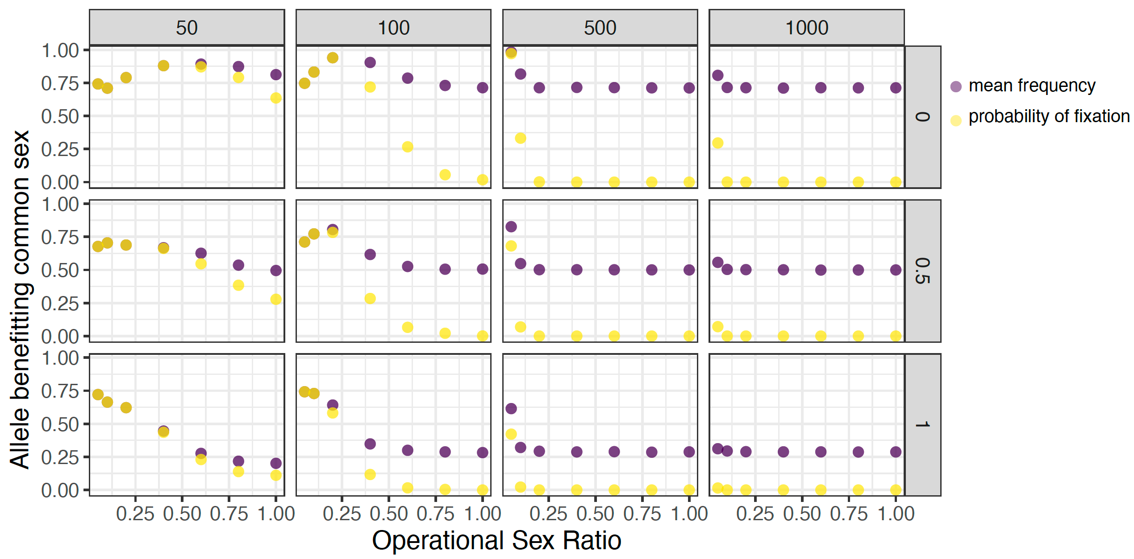

Our results reveal distinct “danger zones” where the effectiveness of selection in the common sex leads to fixation of alleles beneficial to that sex and the collapse of fitness in the rare sex. In each set of scenarios, genetic architecture, more specifically whether the locus is recessive, additive, or dominant leads to variation in fixation rates. Fixation rates are highest when the allele beneficial to the common sex is recessive and lowest when the allele beneficial to the common sex is dominant. In scenarios with 1000 individuals of the common sex and an OSR of 0.05, the allele beneficial to the common sex will fix in 2-26% of simulations (Fig. 1). When the sex ratio approaches equality (OSR = 1) both alleles are maintained in almost all simulations (100% for scenarios with a common sex number of 100 or greater). In scenarios with 500 individuals of the common sex and an OSR of 0.10 or 0.05, the allele beneficial to the common sex will fix in approximately 2-27% and 40-98% of simulations, respectively (Fig. 1A). Scenarios with 100 individuals of the common sex provide the most striking examples of fitness collapse in the rare sex. In these scenarios, we find many genetic architectures and OSR values will lead to high fixation rates of alleles benefitting the common sex. The most compelling of these is when OSR is either 0.10 or 0.20. In these cases, the fixation rates for alleles beneficial to the common sex often approach 100% (Fig. 1A). In scenarios with 50 individuals of the common sex, drift is a much more powerful force than selection. The combination of equilibrium frequencies and drift lead to high fixation rates even with equal sex ratio. When sex ratio is equal and the genetic architecture is additive, 25% of simulations will fix one of the alleles. In the scenario where the allele benefitting the common sex is recessive, it will fix in approximately 60% of simulations, and likewise, in the case where the allele benefitting the rare sex is recessive, it will fix in 60% of simulations. In fact, this is the one scenario (recessive allele benefitting the rare sex and common sex number of 50 individuals) that we see a consistent pattern of higher fitness in the rare sex (Fig. S1). However, it should be noted that this would be expected to be balanced by an equal number of mutations with the opposite genetic architecture leading to no net gain in fitness in the rare sex. Even under these conditions of strong drift with a common number of just 50, if the OSR is reduced below 1.0, we begin to see a bias towards favoring alleles benefitting the common sex.

There is no *a priori* reason to believe that mutations benefitting one sex should be biased towards a particular genetic architecture, and as such, we can marginalize across architectures and evaluate the mean difference in fitness of the common sex and the rare sex. In figure 2 we see that when the common sex is represented by either 50 or 100 individuals, any OSR less than 1.0 will lead to a decrease in fitness of the rare sex relative to the common sex. This fitness collapse is most extreme for OSR levels of 0.2. In contrast, with larger populations, the level of OSR required to force a collapse of fitness in the rarer sex is higher (0.05-0.10). However, we note this is also the scenario where this effect is most extreme, and the rarer sex's fitness collapses most dramatically.

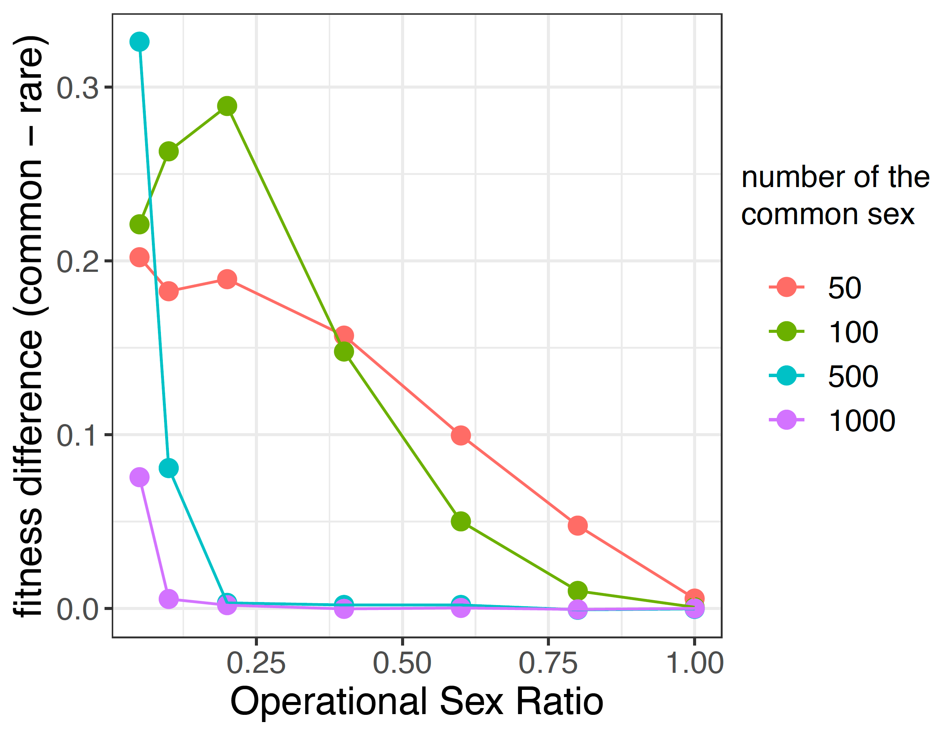

The results presented here are for an autosomal locus in a system with an XY sex-determination system. However, these results would apply equally to any autosomal locus in a ZW sex-determination system and to all loci in a system with environmental sex-determination. The application of these results to species with environmental sex determination could be particularly concerning in light of rising temperatures which could lead to a consistent strong bias in sex ratio and the potential collapse of fitness in the rarer sex.

Together these results demonstrate that the balance between drift and selection does extend below the species level and that strong OSR can lead to a concentration of drift in one sex and selection in the other. Captive breeding programs are becoming an essential tool in the conservation of species in danger of extinction. Having more females in captive breeding programs maximizes the number of offspring that can be produced. However, our findings suggest that any captive propagation should make every attempt to maintain relatively equal numbers of males and females in captivity. This route may extend the time course for recovery, but the population that emerges will retain more alleles important to the fitness of both sexes.

References and Notes:

1. There is only one reference list including all references in the text, Figure and Table captions, and Supplementary Material. Do not include a second reference list in the Supplementary Material. References only cited in the Supplementary Material are not counted toward length guidelines.
2. Each reference should be on a separate line ending in a period. For a style guide, see [http://www.sciencemag.org/authors/instructions-preparing-initial-manuscript](http://www.sciencemag.org/authors/instructions-preparing-initial-manuscript%20).
3. You should include titles in references and full page ranges. Titles will not be included in the print version of the paper, but will be shown in the online version.
4. Please include the above heading, “References and Notes:”.
5. You can use a numbered list in Word.
6. Each reference should have a separate number.
7. Please do not mix in references with explanatory notes.

**Acknowledgments:** We thank members of the Blackmon lab and J.N. Dulin for feedback as this project progressed **Funding:** Texas A&M University HB startup funds; **Author contributions:** All authors contributed to analysis, HB designed the study, RDG and AS wrote the initial draft of the manuscript; **Competing interests:** Authors declare no competing interests. **Data and materials availability:** Code necessary for running all simulations and producing all figures is available via the GitHub repository: XXXXXXX.

Supplementary Materials:

Materials and Methods

Figures S1-S#

Tables S1-S#

Movies S1-S#

Audio Files S1-S#

External Databases S1-S#

References (*##-##*)

**Fig. 1.** The figure caption should begin with a short descriptive statement of the entire figure followed by additional text. Captions should be immediately after each figure. Figure parts are indicated with capital letters (A). If you prefer, you can place both figures and captions logically throughout the text near where they are cited rather than at the end of the file (but not both). If a paragraph in the main text begins with the name of a figure, write out “Figure” in full (e.g., <para>“Figure 1 shows….”)

**Fig. 2.** You can place graphics in-line above each caption. Please do not use text boxes to arrange figures. All images should be JPEG, PNG, TIFF, or similar standard format. High resolution (preferably editable PDF or Adobe Illustrator format) figures will be requested following review.

**Table 1.** Start this caption with a short description of your table. Format tables using the Word Table commands and structures. Do not create tables using spaces or tab characters.

(Please delete before submission) Supplementary materials should be included in a separate supplementary materials file. A template for this file can be found at: <http://www.sciencemag.org/sites/default/files/Science_Supplementary_Materials_Word_template.docx>.

**COVER LETTER INFO**

* + The Article type you are submitting (see [**a description of manuscript types**](https://www.sciencemag.org/authors/science-information-authors#categories-manuscripts).)
  + The title of your manuscript (96 character maximum for Research Articles and Reports)
  + Short title (40 character maximum)
  + Field codes (select one or two fields/disciplines that describe your manuscript)
  + A cover letter which should include
    - Reference to any pre-submission discussions with editors.
    - The title of the paper and a statement of its main point.
    - Any information needed to ensure a fair review process, including related manuscripts submitted to other journals.
    - Names of colleagues who have reviewed the paper.
    - A statement that none of the material has been published or is under consideration for publication elsewhere.
    - For investigations on humans, a statement indicating that informed consent was obtained after the nature and possible consequences of the studies were explained.
    - For authors using laboratory animals, a statement that the animals' care was in accordance with institutional guidelines.
    - Specification of where all data underlying the study are available, or will be deposited, and whether there are any restrictions on data availability such as an MTA.
    - Information on any reference material or additional data files uploaded to the Auxiliary files section (see below).
    - Please also upload a .docx version of your cover letter – see below.
  + You will have the opportunity to request a specific editor, but this is not required and editor assignment also depends on availability, relative loads and other factors.
  + We require you to list all funding sources. This can be done through a dropdown if your funder is included in FundRef’s controlled vocabulary list.

1. **Reviewers:** Names, affiliations, and e-mail addresses of up to five potential reviewers and up to five excluded reviewers.

Barker, M. S., J. P. Demuth, and M. J. Wade. 2005. Maternal expression relaxes constraint on innovation of the anterior determinant, bicoid. PLoS genetics 1.

Brisson, J. A. and S. V. Nuzhdin. 2008. Rarity of males in pea aphids results in mutational decay. Science 319:58-58.

Cheng, C. and M. Kirkpatrick. 2016. Sex-specific selection and sex-biased gene expression in humans and flies. PLoS genetics 12:e1006170.

Connallon, T. and C. Y. Jordan. 2016. Accumulation of deleterious mutations near sexually antagonistic genes. G3: Genes, Genomes, Genetics 6:2273-2284.

Cruickshank, T. and M. J. Wade. 2008. Microevolutionary support for a developmental hourglass: gene expression patterns shape sequence variation and divergence in Drosophila. Evolution & development 10:583-590.

Demuth, J. P. and M. J. Wade. 2007. Maternal expression increases the rate of bicoid evolution by relaxing selective constraint. Genetica 129:37-43.

Dixo, M., J. P. Metzger, J. S. Morgante, and K. R. Zamudio. 2009. Habitat fragmentation reduces genetic diversity and connectivity among toad populations in the Brazilian Atlantic Coastal Forest. Biological Conservation 142:1560-1569.

Elmberg, J. 1990. Long-term survival, length of breeding season, and operational sex ratio in a boreal population of common frogs, Rana temporaria L. Canadian Journal of Zoology 68:121-127.

Gwynne, D. T. 1990. Testing parental investment and the control of sexual selection in katydids: the operational sex ratio. The American Naturalist 136:474-484.

Innocenti, P. and E. H. Morrow. 2010. The sexually antagonistic genes of Drosophila melanogaster. PLoS biology 8:e1000335.

Jirotkul, M. 1999. Operational sex ratio influences female preference and male–male competition in guppies. Animal Behaviour 58:287-294.

Kasimatis, K. R., P. L. Ralph, and P. C. Phillips. 2019. Limits to Genomic Divergence Under Sexually Antagonistic Selection. bioRxiv:591610.

Kitano, J., J. A. Ross, S. Mori, M. Kume, F. C. Jones, Y. F. Chan, D. M. Absher, J. Grimwood, J. Schmutz, and R. M. Myers. 2009. A role for a neo-sex chromosome in stickleback speciation. Nature 461:1079-1083.

Lande, R. 1976. Natural selection and random genetic drift in phenotypic evolution. Evolution 30:314-334.

Lynch, M. 2007. The origins of genome architecture. Sinauer Associates Sunderland, MA.

Mitani, J. C., J. Gros-Louis, and A. F. Richards. 1996. Sexual dimorphism, the operational sex ratio, and the intensity of male competition in polygynous primates. The American Naturalist 147:966-980.

Proctor, M. F., B. N. McLellan, C. Strobeck, and R. M. Barclay. 2005. Genetic analysis reveals demographic fragmentation of grizzly bears yielding vulnerably small populations. Proceedings of the Royal Society B: Biological Sciences 272:2409-2416.

Qiao, Q., C. Q. Zhang, and R. I. Milne. 2010. Population genetics and breeding system of Tupistra pingbianensis (Liliaceae), a naturally rare plant endemic to SW China. Journal of Systematics and Evolution 48:47-57.

Roberts, R. B., J. R. Ser, and T. D. Kocher. 2009. Sexual conflict resolved by invasion of a novel sex determiner in Lake Malawi cichlid fishes. Science 326:998-1001.

Sharp, N. P. and A. F. Agrawal. 2013. Male‐biased fitness effects of spontaneous mutations in Drosophila melanogaster. Evolution: International Journal of Organic Evolution 67:1189-1195.

Van Dyken, J. D. and M. J. Wade. 2010. The genetic signature of conditional expression. Genetics 184:557-570.

Whitlock, M. C. and M. J. Wade. 1995. Speciation: founder events and their effects on X-linked and autosomal genes. The American Naturalist 145:676-685.