Web Versions:

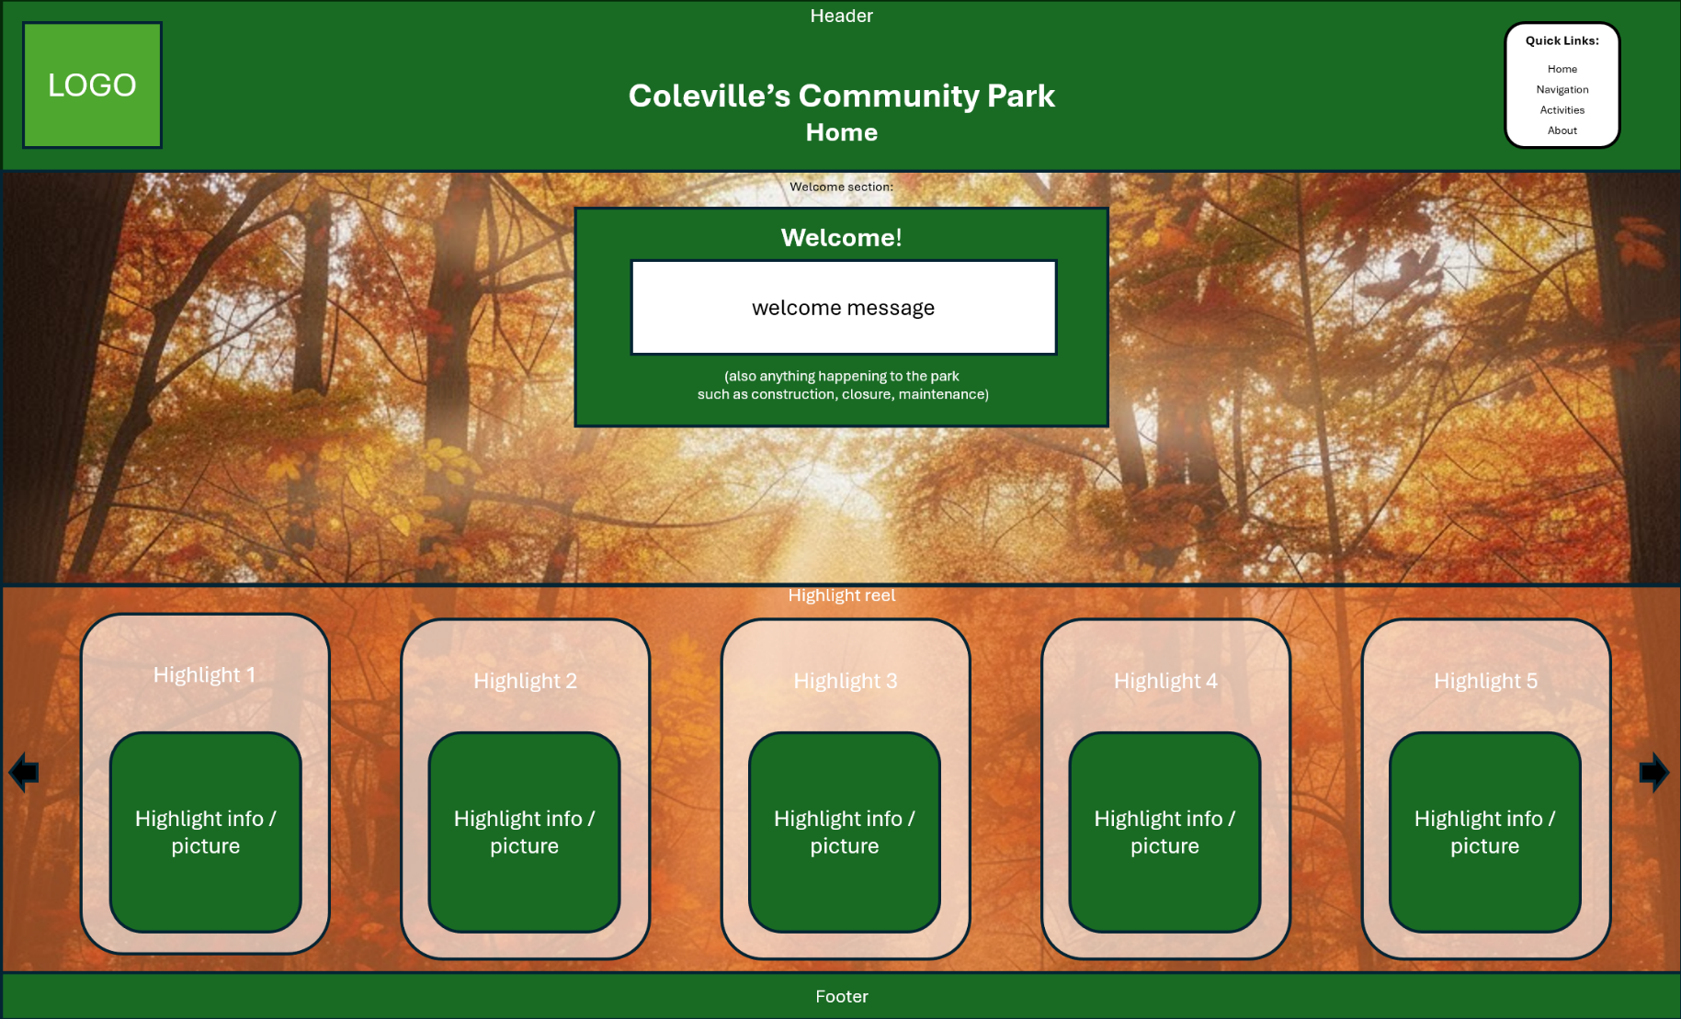
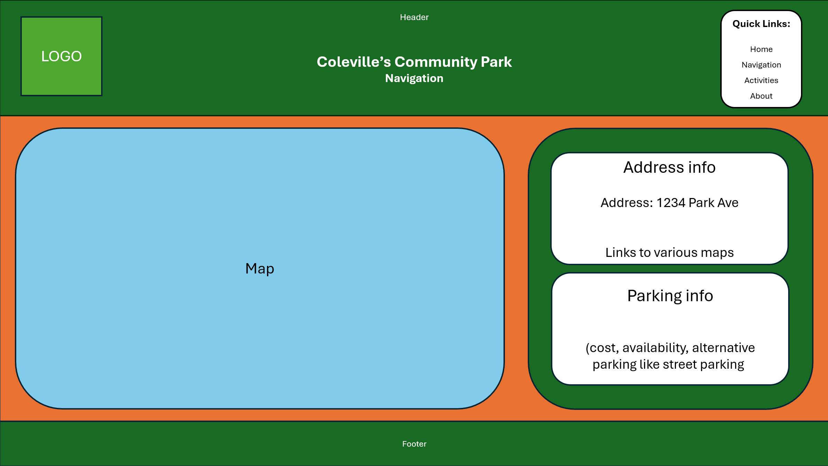

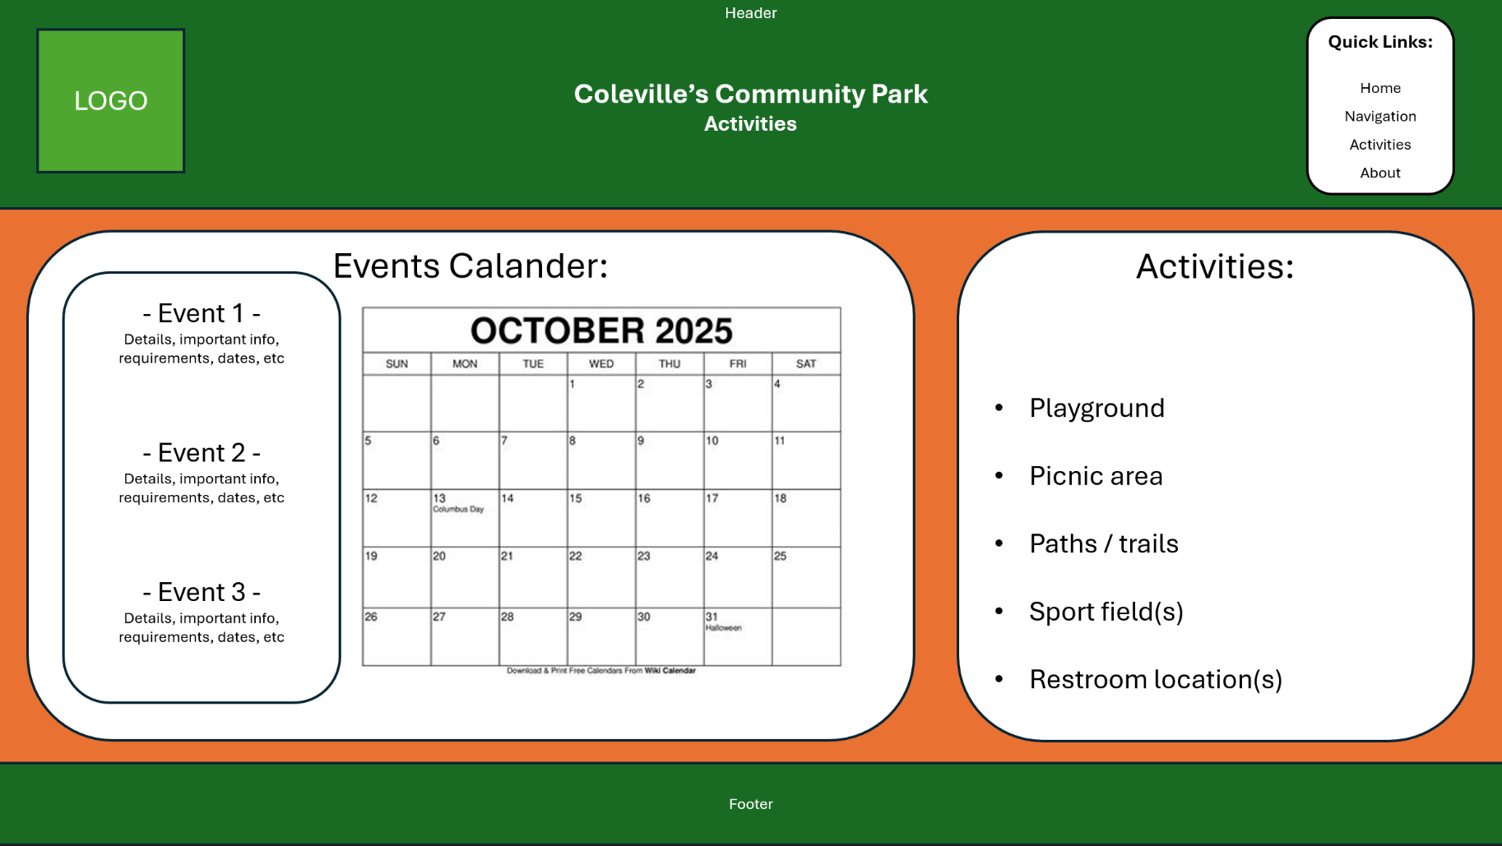

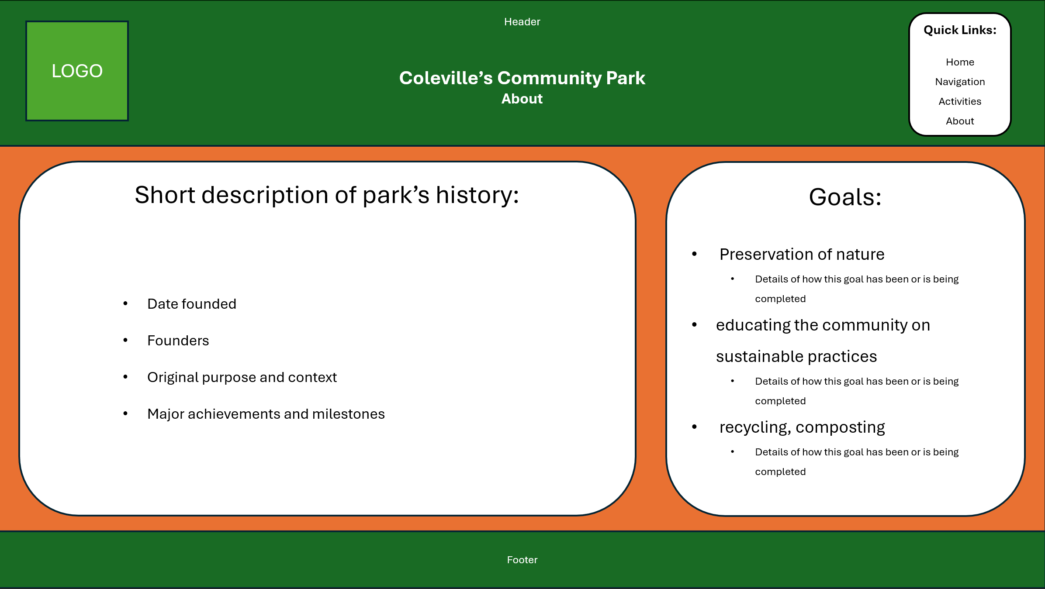

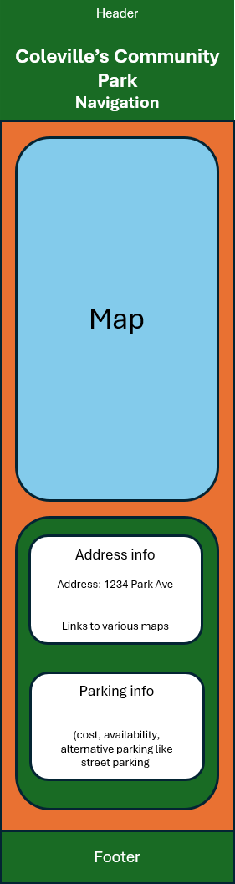
Mobile Versions

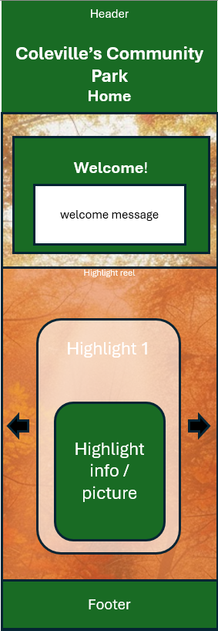

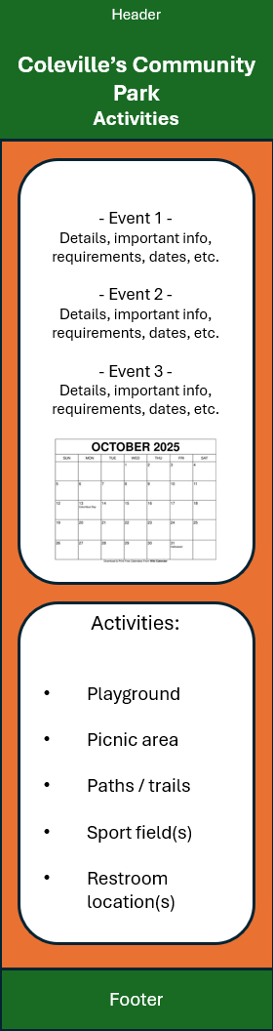
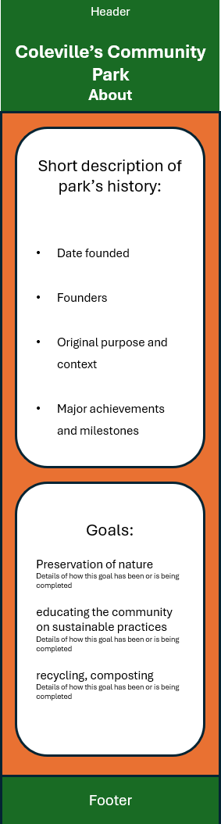

The orange background of each page will be replaced with an ai generated picture that has an orange filter, like the home page shows.

Color Palette:
- Green - rgba(25, 107, 36)

- Orange – rgba(233, 113, 50, 0.55)

Font Choice:
- Aptos(body)

