WIBT Website Documentation

# Logging In

* Click into Admin Portal



* Enter email and password and press login

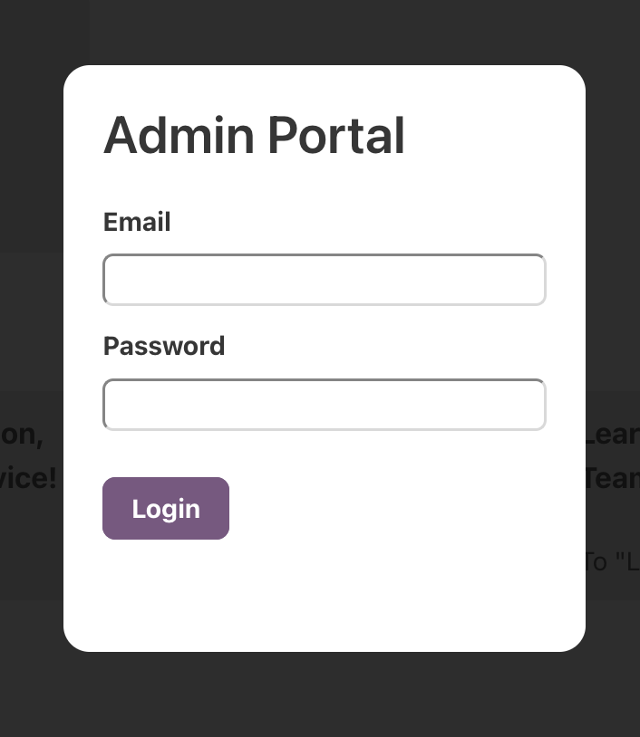

# Adding a New Admin User

* Once logged in, click on your username in the footer



* Click on the Add User button in the pop-up

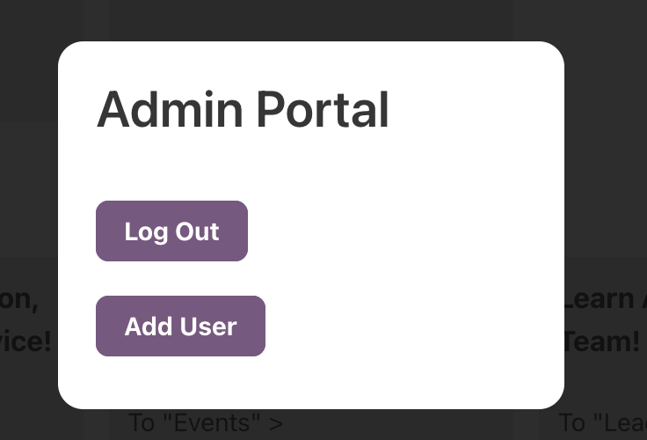

* Enter new user email and password and click add user to create

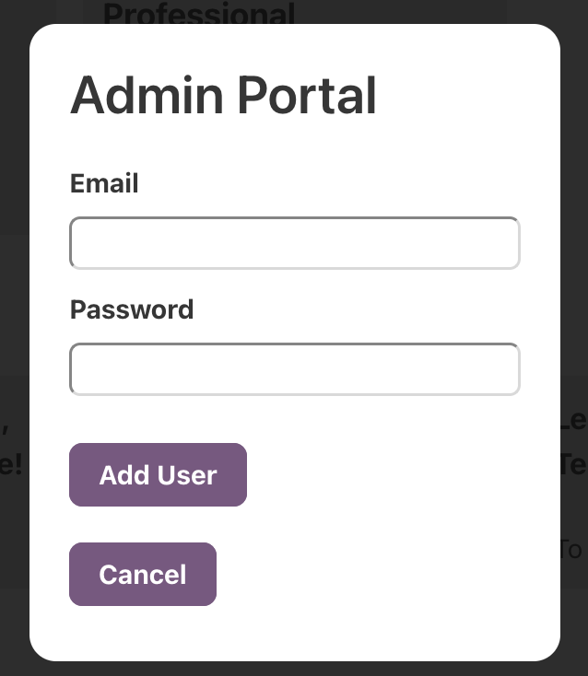

*Note: You will be immediately logged in as the new user. This is due to restrictions around google firebase and is unfortunately not something we have been able to change. To return to the original account, you will need to logout and log back in with your credentials.*

# Logging Out

* Once logged in, click on your username in the footer



* Click on the Log Out button in the pop-up



# Adding an Event

* On either the home page or the events & speakers page, click on the add event box

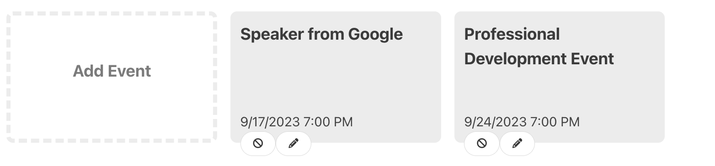

* Fill out all field on the pop-up and click add

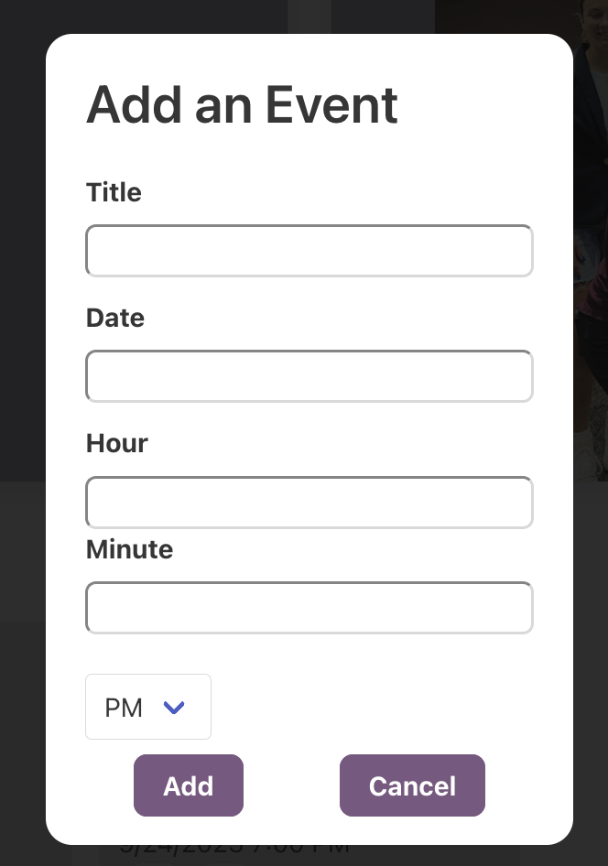

# Editing an Event

* On either the home page or the events & speakers page, click on the pencil icon of the desired event

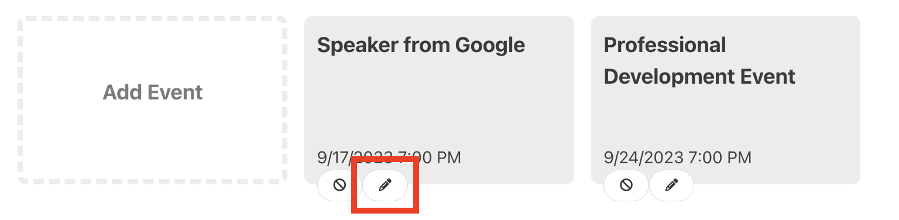

* Update event fields as desired and press submit changes to save

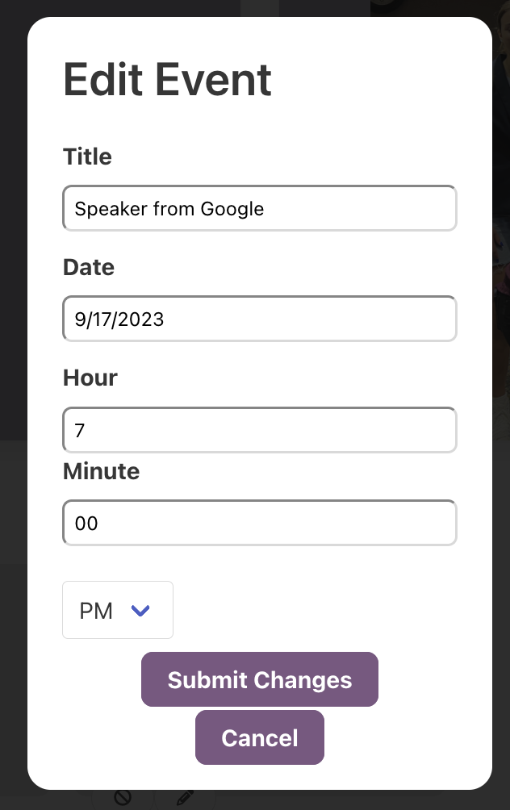

# Deleting an Event

* On either the home page or the events & speakers page, click on the delete icon of the desired event

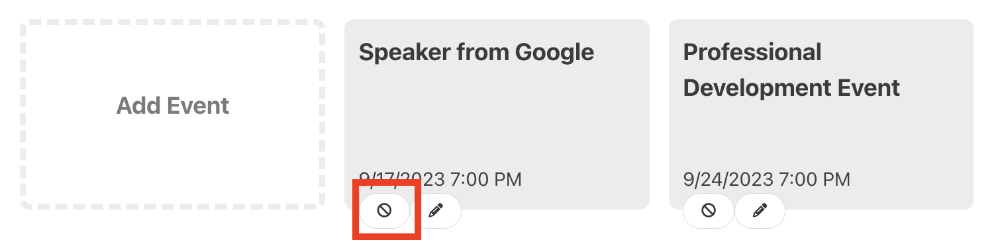

* Click the delete button to delete the event

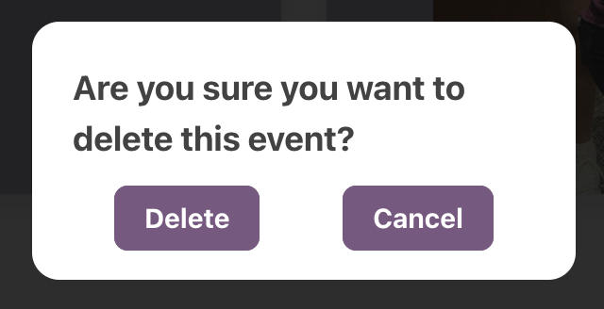

# Adding to ‘Previous Speakers’ Section

* Locate the following section of code in events.html, looking for “Insert Future Semesters Here”

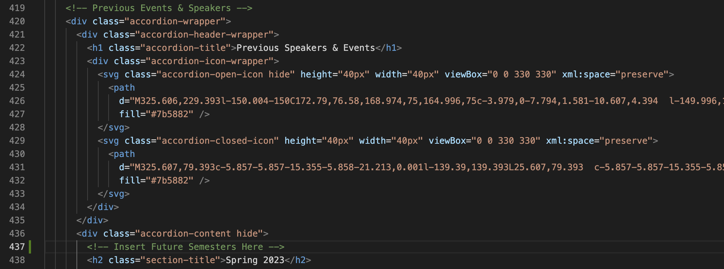

* To add a new semester, replace New Semester Name below with “Spring/Fall Year” and copy & paste right below “Insert Future Semesters Here”

<h2 class="section-title">New Semester Name</h2>

<div class="row">

</div>

* To add a previous speaker to a semester, first add the headshot of the speaker to the pastspeakerImages folder in the project repository. Replace IMAGEFILENAME, SPEAKERNAME, SPEAKERTITLE and SPEAKERCOMPANY then paste the code into the row made in the step above.

<div class="speaker-card">

<img class="speaker-image" src="images/pastspeakerImages/IMAGEFILENAME" alt="Headshot">

<div class="speaker-name">SPEAKERNAME</div>

<div class="speaker-position">SPEAKERTITLE</div>

<div class="speaker-company">SPEAKERCOMPANY</div>

</div>

* For the site to update, you will need to redeploy the site. First you will need to install the firebase command line tools: <https://firebase.google.com/docs/cli#install_the_firebase_cli>, then you will need to deploy the site (only step 3 applies) <https://firebase.google.com/docs/hosting/quickstart>

# Adding Images to Slideshows

### For “How to Join Page”

* Locate slideshow section on join.html

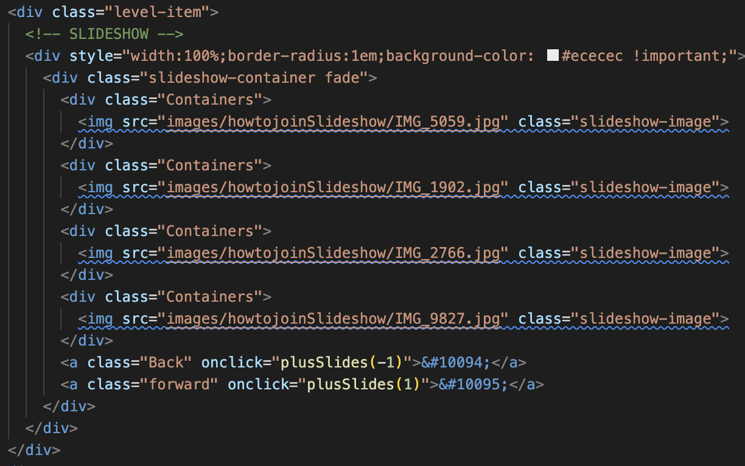

* Add image to “images/howtojoinSlideshow”
* Replace IMAGENAME with the filename that was added to “images/howtojoinSlideshow”

<div class="Containers">

<img src="images/howtojoinSlideshow/IMAGENAME" class="slideshow-image">

</div>

* Paste the updated code below the last image and above the back and forward buttons

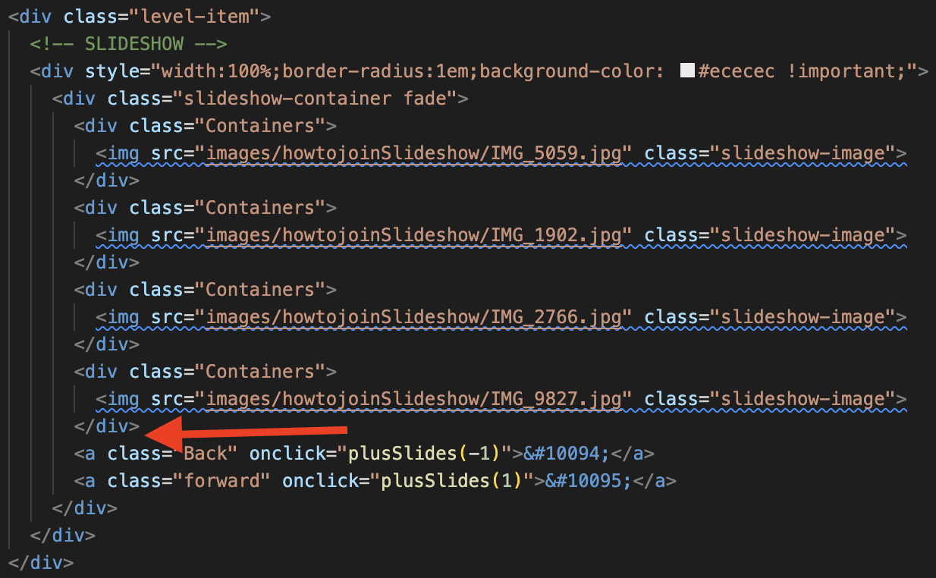

* For the site to update, you will need to redeploy the site. First you will need to install the firebase command line tools: <https://firebase.google.com/docs/cli#install_the_firebase_cli>, then you will need to deploy the site (only step 3 applies) <https://firebase.google.com/docs/hosting/quickstart>

# Updating ‘Leadership’ Page

### Replace an Existing Executive Board Member

* Add the new members photo to “images/execboardImages”
* Go to “leadership.html”, find the infoCard of the member you want to update and update the underlined sections

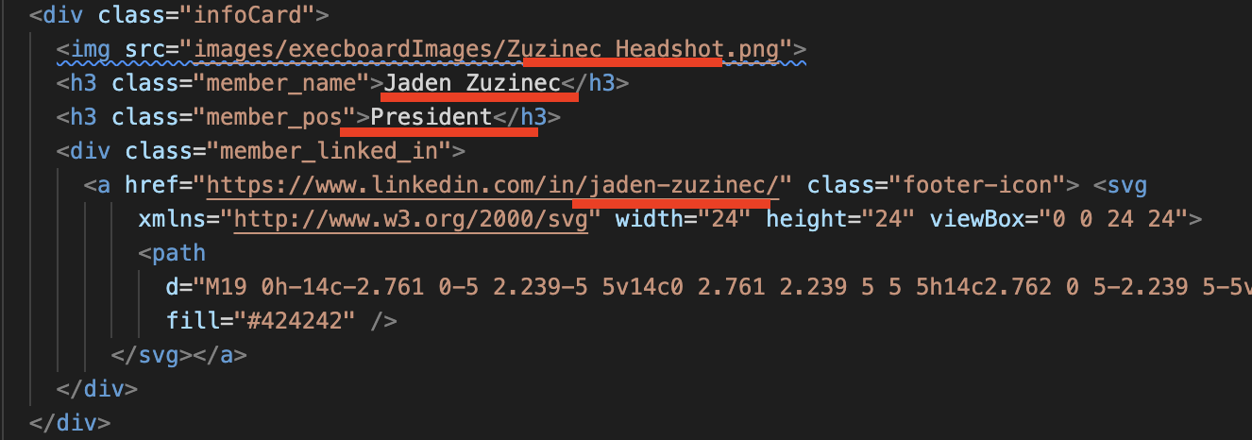

* For the site to update, you will need to redeploy the site. First you will need to install the firebase command line tools: <https://firebase.google.com/docs/cli#install_the_firebase_cli>, then you will need to deploy the site (only step 3 applies) <https://firebase.google.com/docs/hosting/quickstart>

### Remove an Existing Executive Board Member

* Locate infoCard for exec member on “leadership.html”

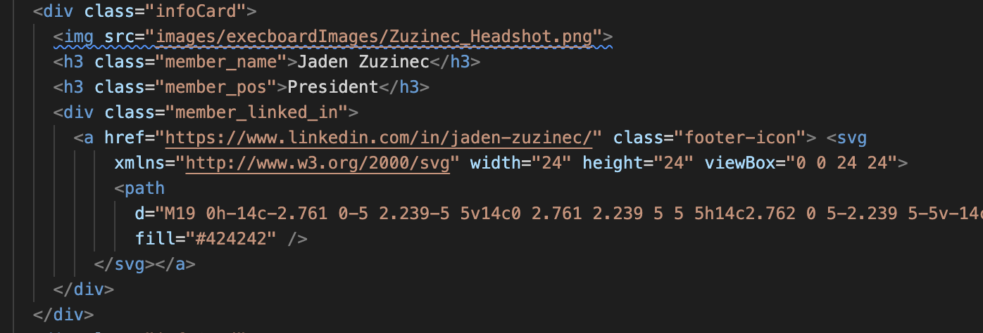

* Delete the entire <div class=”infoCard”> element
* Move other infoCards up from other rows to fill the rows. Page layout dictates 5 members per row. Rows 1 & 2 should each have 5 members, row 3 will have less and that is OK.
* For the site to update, you will need to redeploy the site. First you will need to install the firebase command line tools: <https://firebase.google.com/docs/cli#install_the_firebase_cli>, then you will need to deploy the site (only step 3 applies) <https://firebase.google.com/docs/hosting/quickstart>

### Adding a New Executive Board Member

* Add the new members photo to “images/execboardImages”
* Go to “leadership.html”, locate a row with space (most likely leadershipRowThree)

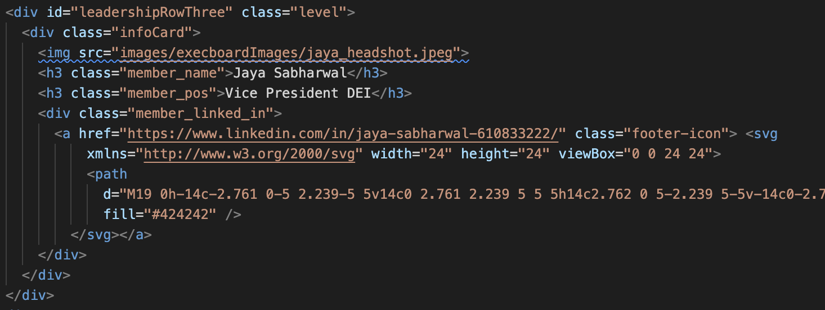

* Replace MEMBERNAME, MEMBERPOSITION, IMAGENAME and LINKEDIN in the code below

<div class="infoCard">

<img src="images/execboardImages/IMAGENAME">

<h3 class="member_name">MEMBERNAME</h3>

<h3 class="member_pos">MEMBERPOSITION</h3>

<div class="member_linked_in">

<a href="LINKEDIN" class="footer-icon"> <svg

xmlns="http://www.w3.org/2000/svg" width="24" height="24" viewBox="0 0 24 24">

<path

d="M19 0h-14c-2.761 0-5 2.239-5 5v14c0 2.761 2.239 5 5 5h14c2.762 0 5-2.239 5-5v-14c0-2.761-2.238-5-5-5zm-11 19h-3v-11h3v11zm-1.5-12.268c-.966 0-1.75-.79-1.75-1.764s.784-1.764 1.75-1.764 1.75.79 1.75 1.764-.783 1.764-1.75 1.764zm13.5 12.268h-3v-5.604c0-3.368-4-3.113-4 0v5.604h-3v-11h3v1.765c1.396-2.586 7-2.777 7 2.476v6.759z"

fill="#424242" />

</svg></a>

</div>

</div>

* Insert new code where arrow is or in another desired row

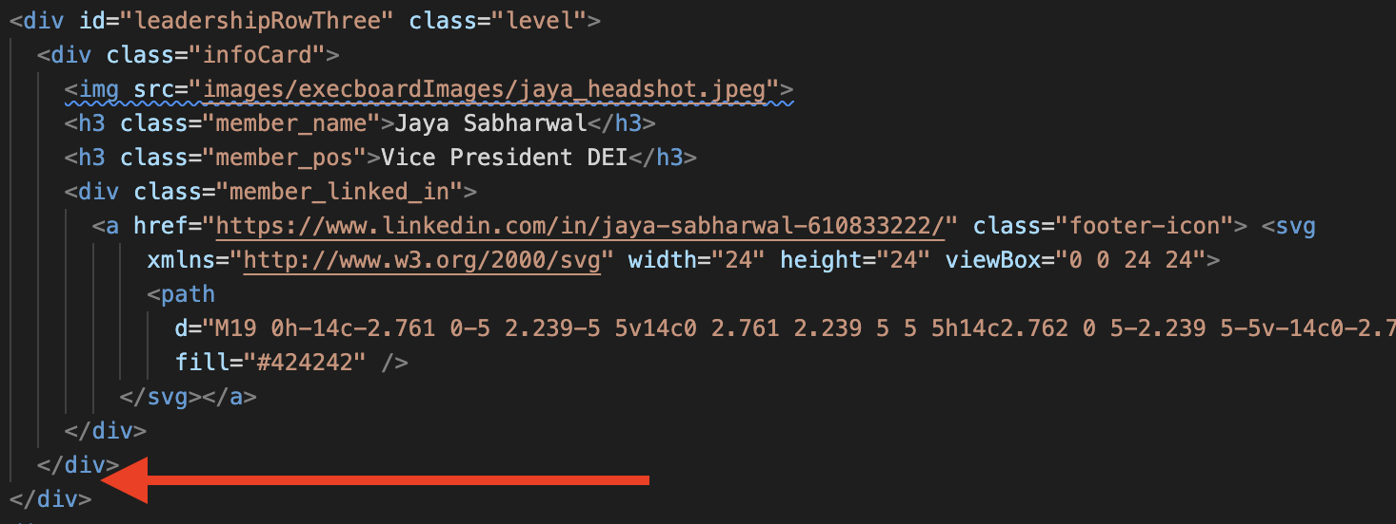

* For the site to update, you will need to redeploy the site. First you will need to install the firebase command line tools: <https://firebase.google.com/docs/cli#install_the_firebase_cli>, then you will need to deploy the site (only step 3 applies) <https://firebase.google.com/docs/hosting/quickstart>