Collaborative White Board
Catalin Dumitru, Melinte Iustina
Introduction
Collaborative White Board is a Web application designed specifically for tablets which enables its users to create, modify and share a White Board on which they can use the various tools provided to share information. Any changes that are applied to a White Board are automatically and immediately synced between all members who are connected to this application.
The White Board application provides various tools such as: primitive shapes (rectangle, triangle, and circle), n-sided polygons, text, images and brushes. All of these tools have associated a series of options which enables a high degree of customizability.
Considerations for Tablet environment
Due to the constraints of the Tablet environment, some design elements created especially for this application, were applied.
Firstly, due to the limited screen availability of a tablet device, some elements which are not needed frequently were hidden to the user, until he desires to use them. The first element, the user list, which has rights to view and modify the White Board, has a slide toggle associated with it, becoming visible only when the user desires. The second element, the options bar associated with one tool, is only visible when the tool is selected and the cursor hovers over the tool icon in the tool bar or it is explicitly touched / clicked.
The second most important limitation of tablet devices which was considered for thus application is the lack of general performance relative to desktop computers. This is why performance intensive tasks are redirected towards the server; the client only displays the result. This method was used for Boolean operations for Polygon primitives. The source and clip polygons are serialized into JSON objects, sent to the server alongside the operation desired, and the server then returns the resulted Polygons into a new JSON object. This entire task is done asynchronous.
Another consideration is the limited bandwidth available to mobile devices. This is why the data needed for serialization / deserialization needs to be at a minimum. One example where this principle is used is the serialization of brushes. The brush is converted to an image on the client side, which enabled faster drawing, but it is serialized to a list of points, which has a far smaller footprint that raw pixel data.
More information on these specific design elements can be found in the “General architecture” section.

General Architecture
In this section we describe the unique design elements used when creating this application. The class structure was chosen and created to ensure the minimum amount of abstractness with no extra overhead.

  - Class Structure
The base class for the client side Application is the App class which controls widget / layer serialization and syncing, initial board deserialization, event delegation, binding the user interface events which can occur in the HTML page to various classes which might use them and fetching / applying changes to the White Board. The App class interrogates the server for changes which have occurred to the current active board, and if changes are present, they are applied.
The main sub-object of the App class is and White Board object. This object controls the state of the White Board, alongside the layers contained in it.
To be as intuitive as possible to the user, the entire application has been divided into Layers and Widgets. A layer is a container for Widgets and dictates the order in which a group of widgets can be drawn on the canvas. A widget is an entity which can draw on the canvas, containing a set of options and a method of serialization / deserialization.
As previously stated, a widget is an abstract entity which can draw something on the canvas. The two events defined in a layer: EWidgetAdd and EWidgetRemove are called when a widget is added or removed. This is especially useful for the App class which control various elements of the user interface which need to be updated once a layer / widget has changed. The event EInvalidate is called when the widget needs to be redrawn. This in turn calls the EInvalidate event of the parent layer because the entire layer needs to be redrawn once one of its components has changed. The last event which can be bound is ESync. This event is triggered when an object should be synchronized with the server. Not all changes should be pushed to a server, or at least not as frequently as for the EInvalidate event. Some changes need to be redrawn in real time to allow the user to visualize the modifications performed on a widget / layer, while others only need to be synchronized with the server only when the entire operation has finished and the widget has entered a stable state.
Five types of widgets were defined for this application, while others can be easily added due to the abstract nature of the entity. The widget types are: Polygon (which supports unlimited vertices), Circle (specialized version of the Polygon widget), brush, image and text. Each widget has its own custom defined methods for serialization / deserialization. These methods create and use custom container objects in which a widget can store information needed to recreate it.
The prototypes for various tools and the objects which use them play a significant role in assuring that the tools used to create widgets remain abstract and modular.
The base prototype for all tools is the Tool prototype. All derived prototypes can define custom Icons which will appear in the application Tool bar, an option list and custom behavior for canvas events such as mouse click / drag, key pressing. A tool will receive events from the canvas only when the tool is active.
A tool can have various options defined which dictate the resulting widget created by this tool. These options also have an abstract base prototype called Option. All derived prototypes can define custom HTML elements which will appear in an option box and which values will be passed back to a parent Tool.
All of the above discussed options and tools are managed by a Tool Box object.
Other auxiliary prototypes where defined which are used by the general application or by specific layers and widgets. One such prototype is the widget and layer factory which can create widgets depending on the type of the desired widget or an empty layer. Both of these creation processes have in common the unique id generation process. These unique ids are vital to the synchronization of different version of the White Board held by all connected clients. The seed used by the factory to generate unique Ids is held by the server. Whenever a factory needs to create new objects, it can reserve a number of Ids from the server which can be used in the generation process.
Other small prototypes include: Polygon (used to manage a polygon with varying number of points and to provide point inclusion detection) and the widget manipulation object (used to transform an active widget by altering its polygon bounds rotation or pivot).
  - Information flow
As previously stated, Events play a key role in managing the flow of data between members which need it. They dictate when a layer / widget need to be redrawn and when information needs to be synchronized with the server and other clients. The object which changes a widgets property is responsible for calling the Invalidate or Sync functions to synchronize the changes with either the server to with the active White Board or to tell the container White Board that it needs to redraw a certain widget or layer. The changes are not automatically updated.
For widgets, the EInvalidate event first gets past to the parent layer, which acts as a proxy. The parent layer in turn triggers its own EInvalidate event (because a change to a single widget means the entire layer needs to be redrawn) which in turn gets passed to the parent White Board. This is the point where the drawing process actually begins, redrawing the layer and all contained widgets.
Conversely, ESync event fired by a widget does not pass through the parent layer; it is, in turn, redirected directly towards the App object which handles the synchronization process. The same is valid for the ESync event contained inside a layer. It is passed directly towards the App object which synchronizes the changes with the server. This event has three different meanings, selected according to the value of the “operation” member of the event. These types are: “add” (for when a widget or layer is added to the White Board), “remove” (for when a layer or widget is removed) and “change” (the default value – should be used when the properties of a widget or layer have been changed).
The fallowing diagram shows the different components involved in the process of communication, alongside the flow of different events.
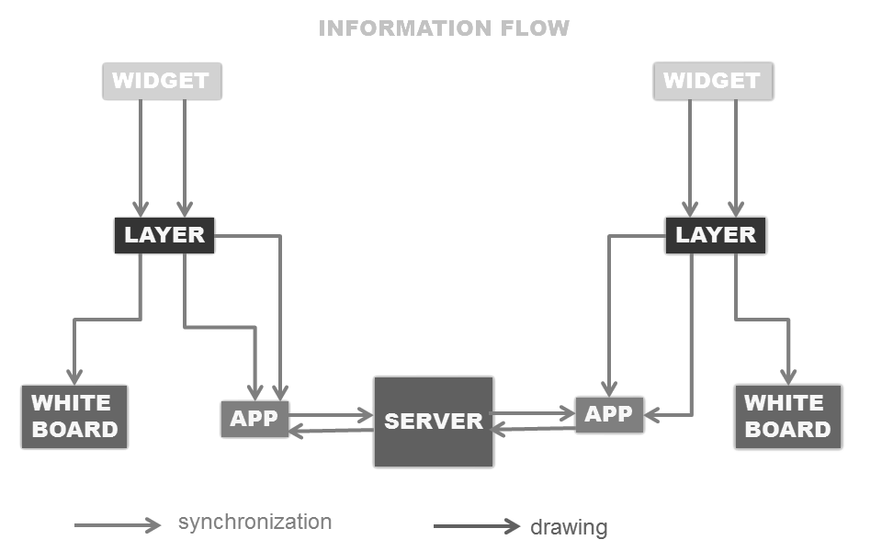
  - Serialization / Deserialization
A key principle of this application is the ability to transform widgets and layers into small packets of data, which don’t need a lot of bandwidth, and that provide enough information to recreate widgets or layers when desired. The serialization process is used when storing (and sending) data on the server side of the application, and when sending information to other connected clients, to ensure that the White Board is synchronized amongst them.
Typically, widgets and layers create object in which they store the minimum amount of data needed to recreate them. This in turn is serialized into JSON objects and strings, which can be easily sent to the server and other clients. The two common properties amongst all widgets that get added to the serialization object are the widgets name and type. The latter defines which empty widget needs to be recreated in the deserialization process, as this process requires an already build and empty widget (the empty widget will update its properties from the serialization object). On the backend side, these JSON objects will get deserialized into native objects, and stored inside a database.
The following is a diagram which shows the flow of data between the client and the server.
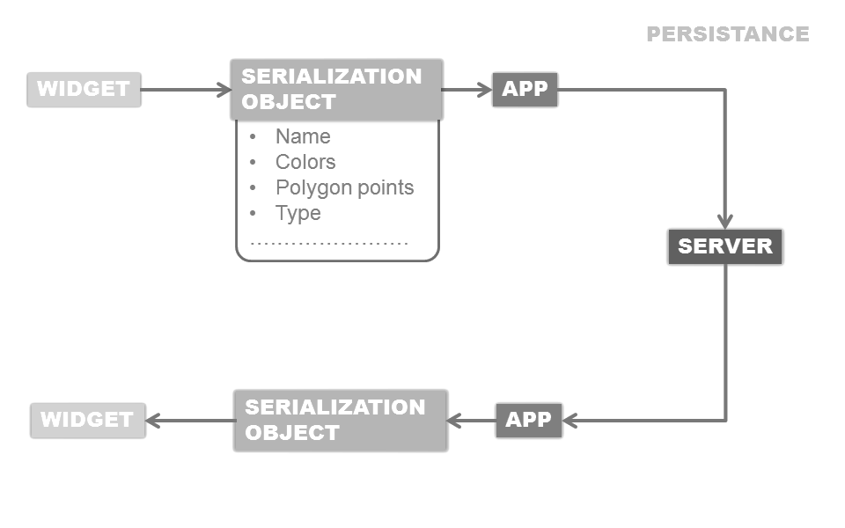
  - Assuring synchronization
The ability to synchronize a single White Board amongst multiple clients is a key feature of this application. This is achieved in part with the serialization process described above and the information flow between the clients and server described in this section.
As was previously stated, when a widget or layer gets changed, added or removed an ESync event is triggered. This in turn directs the App object to send the changes to the server. Firstly it creates an object containing the Board Id from where the event was originated, the Id of the widget or layer which was changed, the type of object (widget or layer), the operation performed (add, remove or change) and the Change String which is the JSON serialization object returned by the Serialize method of a widget, converted into a single string. This object is then sent to the server.
On the server side, each White Board contains a list of users connected to the active White Board. The user in turn contains a list of changes which have occurred since the last synchronization between a client and the server.
Each client calls a synchronization method periodically (once every 500ms) which fetches the changes from the server. Once this process has completed, the changes list on the server gets reset to empty. Every object from the changes list, which has been sent to the client, gets processed, and depending on the operation type, changes are applied to the White Board.
This entire process ensures that the White Board remains synchronized across all connected clients.
Optimizations
As mentioned in the introduction, a series of optimizations designed specifically for the Tablet Environment have been used. These optimizations include: Brush Compression, Server-Side Boolean operations and minimizing the serialization data. The latter has been discussed in the “Assuring synchronization” section and will not be covered here.
  - Brush Compression
The first of the techniques involves finding a solution to the problem of creating brush data than doesn’t need an excessive quantity of data to be (de)serialized and which can be easily and rapidly rendered on the client side.
Our solution was to separate the data that is serialized and the data that is rendered, while adding a short conversion period between the two.
The data that is sent to the server and to other clients consists of a list of points. The points list defines a list of lines, which in turn defines the geometry of a brush (as the result of the painting action using a brush is nothing but a linear path comprised of consecutive lines). The volume of data needed to store these lines is much less than for the technique which involves memorizing and sending the entire array of pixels from the end results.
However, pixel data (or image data) is much faster to render than recreating the entire path and rendering it. Because on the client side there is more memory available, we can cache the path into a finished and rendered state (an image). The process which converts the point list into a pixel array (ergo an image) starts with creating an empty and hidden canvas. The dimensions of the canvas are set such that it occupies the minimum area used by the brush, assuring that no space is wasted, and that no excessive memory is used. Then the path is rendered inside this hidden canvas. When the process is complete, a final image is extracted from the canvas which will be used to draw the brush. The entire process of converting the point list into pixel data will occur only once, when the Brush Widget is first drawn.
  - Boolean Operations
The process of finding polygons as a result of different Boolean operations applied to two polygons is another complex and time consuming process. This is why a special technique was employed to resolve this problem.
Our solution was to forward the process of computing Boolean Operations to the server. This method does not only reduce the computation time, but the entire process can be done asynchronously freeing the application to do other important tasks. Boolean Operations are only available to select widgets which can support it (currently only polygon widgets).
The entire process starts by getting the polygon bounds of the two widgets on which we will apply a Boolean Operation, the Source and the Clip. The two polygons are then serialized and sent to the server alongside the desired operation (currently the only three supported operations are: difference, intersection and union). The server then computes the resulting polygons which are serialized and sent back to the client. When the results arrive, the client deletes the two base polygons and creates new ones based on the result received from the server. After which the changes are synchronized with the server and other clients.
Conclusion
In this short paper, we covered the unique design elements and their implementation which were needed to achieve the end goal, that to provide a synchronized White Board amongst all the connected clients.

