**Push code to Git:**

1. On VS code navigate to source control section
   1. 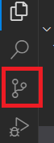
2. Write the commit message and click on commit.
   1. 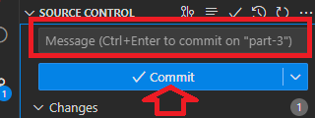
3. Sync the changes
   1. 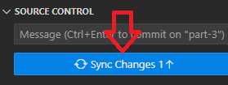

**Publish your code:**

1. Go to gitup.come and navigate to the repository
2. Go to Setting tab
   1. 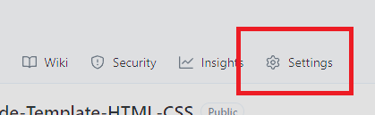
3. Navigate to Page
   1. 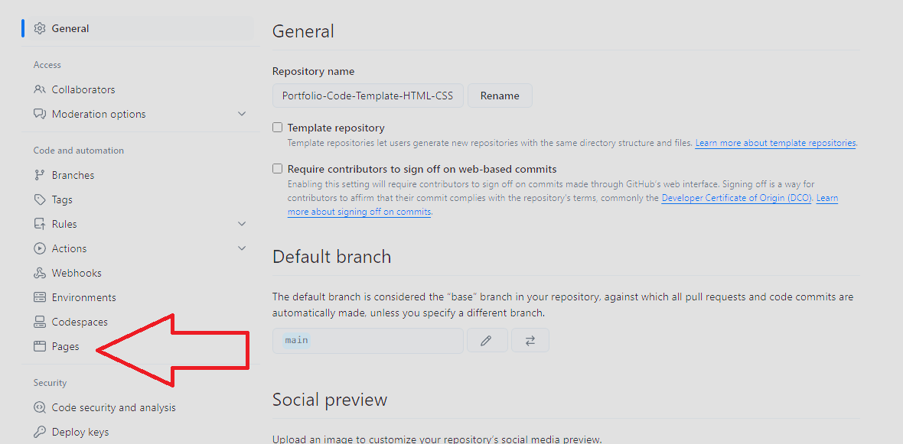
4. On Branches area Select “main” and save
   1. 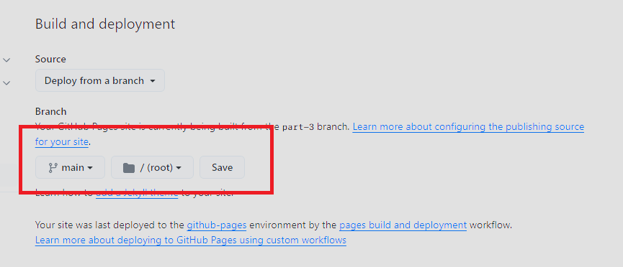
5. Refresh the page after 3~5min on top you will see a link to your live site
   1. 