**Figma design:**

[**https://www.figma.com/file/uu3aRgn6uIvVMCCJbmLJ4y/Portfolio-(Copy)-(Copy)?type=design&node-id=21-95&mode=design&t=KxzC0emKHZ84T1W3-0**](https://www.figma.com/file/uu3aRgn6uIvVMCCJbmLJ4y/Portfolio-(Copy)-(Copy)?type=design&node-id=21-95&mode=design&t=KxzC0emKHZ84T1W3-0)

**Solved**

[**https://github.com/hooman-faily/Portfolio-Code-Template-HTML-CSS/tree/part-1-solved**](https://github.com/hooman-faily/Portfolio-Code-Template-HTML-CSS/tree/part-1-solved)

**Folder structure:**

1. Add new folder “css”
   1. Add new file “style.css”
   2. Add new file “variables.css”
2. Add new folder “img”
3. Add new file in the main folder “index.html”

**images:**

download and copy the images from provided link into img folder

<https://github.com/hooman-faily/Portfolio-Code-Template-HTML-CSS/tree/part-1-solved/img>

**Publishing the Repository:**

1. navigate to source control
2. click on Publish to Git
   1. 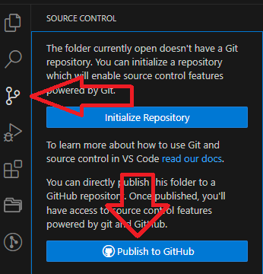
3. Provide name of the repository
4. select pu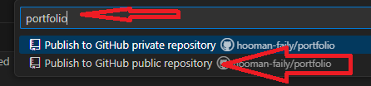blish to Git public

**Setting Variables:**

Open variables.css

1. Type :root{}
   1. Graphical user interface, application

      Description automatically generated
2. Start adding the color variables in the format below:
   1. –variableName: value
   2. Text

      Description automatically generated
3. Add font size variables:
   1. A screen shot of a computer program

      Description automatically generated

**Adding fonts:**

1. Go to <https://fonts.google.com/>
2. Search for Roboto
   1. 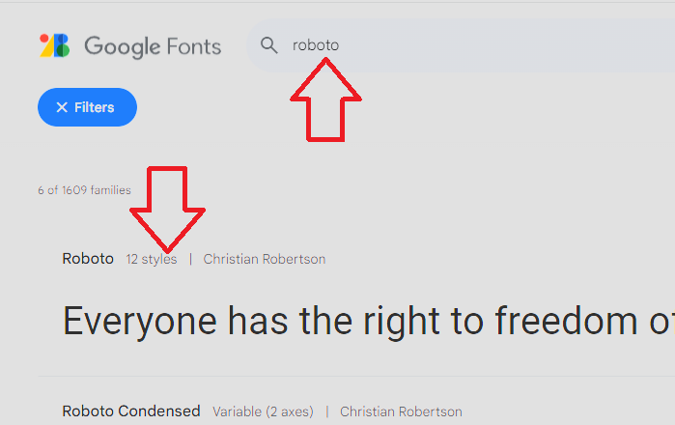
3. Click on the result
4. Click on Get Font
   1. 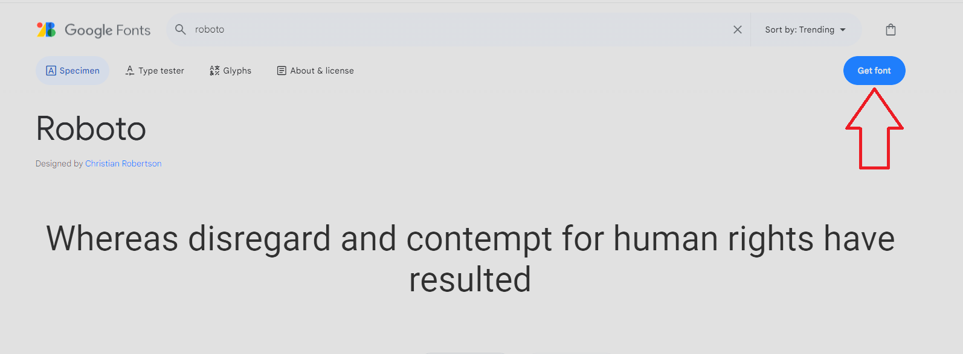
5. Click on Get embed code.
   1. 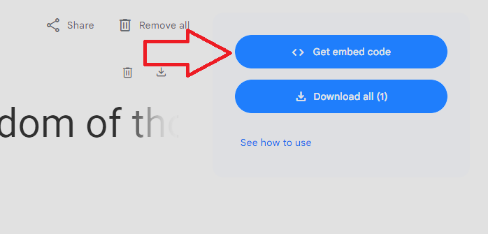
6. Select @import
   1. 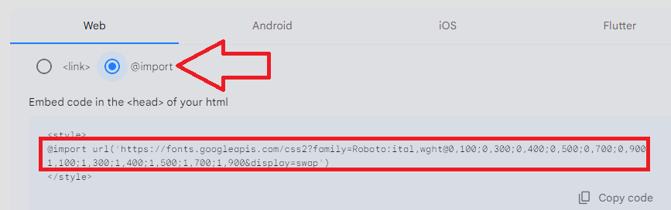
7. Copy the text between <style> tag.
   1. A computer screen shot of a blue and white screen

      Description automatically generated
8. Go to variables.css, and past the code at the top
   1. A screenshot of a computer

      Description automatically generated
9. Go to style.css and assign the font to body
   1. A screenshot of a computer

      Description automatically generated
   2. font-family: "Roboto", sans-serif;
   3. A computer screen shot of a black background

      Description automatically generated

**Index.html:**

1. Start typing **html.** 
   1. VS code will show you multiple options.
   2. Select html:5
   3. A blue line on a black background

      Description automatically generated
2. You should see the full HTML 5 structure.
   1. A screen shot of a computer

      Description automatically generated
3. **Link css files to index.html**
   1. Go to line 6 (before <title> tag) and add a new line by hitting **enter** key
      1. A screenshot of a computer program

         Description automatically generated
   2. Go back to line 6 and:
      1. Type **link** then hit **tab** key
         1. A screenshot of a computer screen

            Description automatically generated
      2. Add location of **variables.css** in **href** attribute:
         1. ./css/variables.css
         2. A black screen with white text

            Description automatically generated
   3. Add another line (line 7) (before <title> tag):
      1. Type **link** then hit **tab** key
         1. A screenshot of a computer screen

            Description automatically generated
      2. Add location of **style.css** in **href** attribute:
         1. ./css/style.css
         2. A black screen with white text

            Description automatically generated
4. Change title value on line 8 to **Home**
   1. A screen shot of a computer code

      Description automatically generated

**Add Navigation:**

1. Go to line 11 (between body tag)
   1. A screenshot of a computer

      Description automatically generated
2. Type nav.topNav then hit tab key
   1. A screen shot of a computer program

      Description automatically generated
   2. This will create a tag names **nav** with class **topNav**
3. In line 12 type **div.navContainer** then hit tab
   1. A screen shot of a computer program

      Description automatically generated
4. In line 13 type a.logo then hit tab
   1. A screen shot of a computer program

      Description automatically generated
   2. Add value to **href** between **“ ”**
      1. ./index.html
      2. A screen shot of a computer

         Description automatically generated
      3. When user clicks on logo, it will take them to homepage which is index.html
   3. Go to line 14 and type img then tab key
      1. A screen shot of a computer

         Description automatically generated
      2. Add image source (./img/logo.png)
         1. A screen shot of a computer

            Description automatically generated
   4. Go to line 16 and a new line between **div** tag.
      1. A screen shot of a computer program

         Description automatically generated
   5. Type ul.nav then tab key
      1. A screen shot of a computer program

         Description automatically generated
      2. **Ul** is unordered list.
      3. **.nav** will add class names **nav** to the tag.
   6. Go to line 17 between the **ul** tag and add list items(menu items).
      1. Type li*4>a.navItem then tab
         1. This will create 4 **li** tags and add **a** tag in each of them.
         2. A screen shot of a computer program

            Description automatically generated
         3. A screen shot of a computer

            Description automatically generated
      2. Add text to the a tags
         1. A black background with white text

            Description automatically generated
      3. Add value to hrefs
         1. ./index.html for home
         2. # for the rest as a placeholder
         3. A screen shot of a computer code

            Description automatically generated
5. Save the code and open in browser by clicking on “Go live”.
   1. 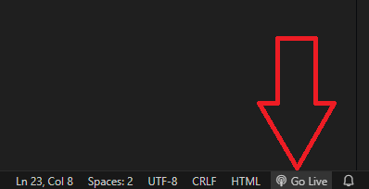
6. You should see this in your browser:
   1. A screenshot of a web page

      Description automatically generated

**Styling the top navigation**

1. Open style.css
2. Body:
   1. A black background with white text

      Description automatically generated
3. .topNav:
   1. A black background with white text

      Description automatically generated
4. .navContainer:
   1. A screen shot of a computer

      Description automatically generated
5. Ul.nav
   1. A screen shot of a computer program

      Description automatically generated
6. .navItem
   1. A screen shot of a computer program

      Description automatically generated
7. Add hover state on navItem
   1. A black background with white text

      Description automatically generated
8. Add selected class to the current page
   1. Go to index.html and add selected class to the 1st navItem (home page)
      1. 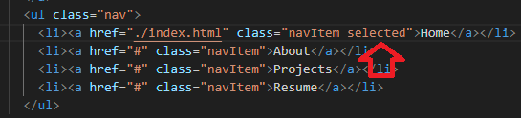
9. Go to style.css and add the class
   1. A black screen with white text

      Description automatically generated
10. Save and check the page:



**Adding the hero section:**

1. Locate **nav** tag’s closing line then add a new line by hitting enter key (line23)
   1. A screenshot of a computer screen

      Description automatically generated
2. add **section** with class hero**.** (Shortcut: **section.hero** then **tab** key)
   1. A black screen with white text

      Description automatically generated
3. add **div** with class **heroContainer**. (shortcut: **div.heroContainer** then **tab** key)
   1. A black screen with white text

      Description automatically generated
4. add an image inside:
   1. **img.heroImage** with src **./img/profile.png**
   2. A screen shot of a computer

      Description automatically generated
5. Add a divafter the image tag **div.heroContent**
   1. **A screen shot of a computer

      Description automatically generated**
6. **Line28:** add h1 tag with class heroTitle (h1.heroTitle then tab key)
   1. **A screen shot of a computer program

      Description automatically generated**
   2. Add content
      1. A screen shot of a computer program

         Description automatically generated
7. Find h1 closing tag and add a new tag
   1. P tag with class heroText (p.heroText)
      1. A screen shot of a computer program

         Description automatically generated
   2. Add some text inside the tag
      1. A screenshot of a computer

         Description automatically generated
8. Save the HTML
9. You should see the image below on your browser.

**Styling the hero section**

Open style.css

1. Add background to the section, by targeting **section.hero**
   * A black background with white text

     Description automatically generated
2. Style the hero container
   * A screen shot of a computer

     Description automatically generated
3. heroImage
   * A screen shot of a computer

     Description automatically generated
4. heroContent
   * A screen shot of a computer

     Description automatically generated
5. heroTitle
   * A screen shot of a computer program

     Description automatically generated
6. heroText
   * A screen shot of a computer

     Description automatically generated
7. Save

**Adding the project section**

1. Go to hero section’s closing and add a new line
   1. A black screen with white text

      Description automatically generated
2. Add: section with class projects (section.projects tab)
   1. A black screen with white text

      Description automatically generated
3. add: section title (h2.sectionTitle) with text Projects
   1. A screen shot of a computer program

      Description automatically generated
4. div.projectContainer
   1. A screen shot of a computer program

      Description automatically generated
5. div.projectCard
   1. A screen shot of a computer

      Description automatically generated
6. img.cardImage
   1. A computer screen with text and symbols

      Description automatically generated
7. Div.cardContent
   1. A screen shot of a computer program

      Description automatically generated
8. h3.cardTitle
   1. A screen shot of a computer program

      Description automatically generated
9. p.cardText
   1. A screen shot of a computer program

      Description automatically generated
10. a.btnPrimary
    1. A screen shot of a computer code

       Description automatically generated
11. Copy and paste 3 more cards inside the projectContainer
    1. 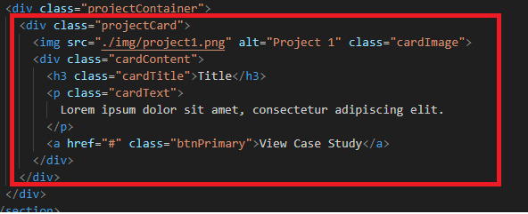
    2. 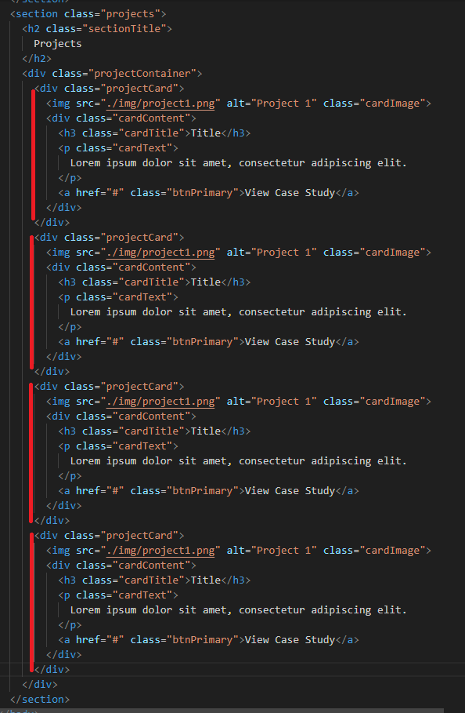
12. Save the file

**Styling the projects section**

Open style.css

1. Projects
   1. A screen shot of a computer code

      Description automatically generated
2. sectionTitle
   1. A screen shot of a computer program

      Description automatically generated
3. projectContainer
   1. A screen shot of a computer program

      Description automatically generated
4. projectCard
   1. A computer code on a black background

      Description automatically generated
5. cardImage
   1. A screen shot of a computer

      Description automatically generated
6. cardContent
   1. A screen shot of a computer code

      Description automatically generated
7. cardTitle
   1. A screen shot of a computer code

      Description automatically generated
8. cardText
   1. A black screen with white text

      Description automatically generated
9. btnPrimary
   1. A screen shot of a computer program

      Description automatically generated

**Adding Footer:**

1. Locate projects section closing tag and add footer tag
   1. 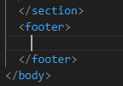
2. Div.footerContent
   1. A black screen with white text

      Description automatically generated
3. Add h5 with footerTitle class then content name.
   1. A computer screen with white text

      Description automatically generated
4. Add p tag with class footerText
   1. Et aut eum quis fuga eos sunt ipsa nihil.
   2. A screenshot of a computer program

      Description automatically generated
5. Add p.footerCopy
   1. © Copyright Name. All Rights Reserved
   2. <br>
   3. Designed by Your Name
   4. A screen shot of a computer program

      Description automatically generated
6. Save

**Style the Footer**

