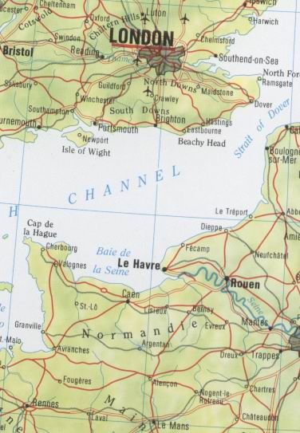
Goring
Belleme



Brittany

ferries

