Databases Project – Spring 2017
Prof. Anastasia Ailamaki
Team No: 15
Names: Colin Branca, Jules Courtois, Yoan Martin
Contents
Deliverable 1 2
Assumptions 2
Entity Relationship Schema 2
Schema 2
Description 2
Relational Schema 3
ER schema to Relational schema 3
DDL 4
General Comments 6

Deliverable 1

Assumptions
When we create the tables, we assume that each CHAR has a max size. No longer elements will be added later.

Entity Relationship Schema

Schema
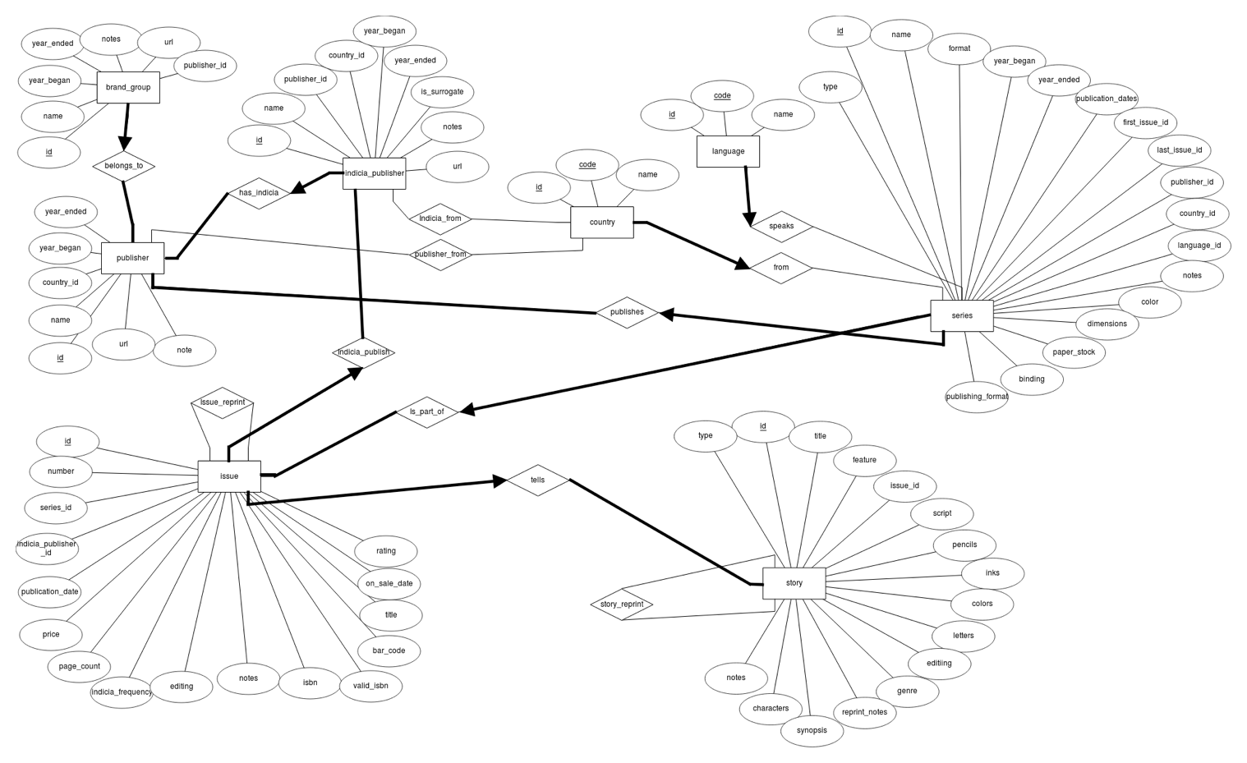

Description
There are two main parts in the schema: Books with Story, Issue and Series and Company with Publisher, Indicia Publisher and Brand Group. Let’s first describe each part before explaining the connections between them.
Books: This part is describing a book in the more general sense. The physical book is an issue. It tells a story and it is part of a series. For example, Harry Potter is a famous series. Harry Potter and the Philosopher’s Stone is a story from this series. Finally, the book with ISBN X is a physical book telling this story. Since these three components are highly connected. There are a lot of constraints between them.
- An issue tells at least a story.
- A story must be told by exactly one issue.
- Each series has at least one issue.
- An issue is part of exactly one series.

Company: This part is describing the company which publish some books. The main company is the publisher. It has smallest companies, the indicia publishers and it holds some brand group. For example, Marvel is the general company. It holds a brand group called Thor and the physical books are published by an indicia publisher, Thor Entertaining Group, which is part of Marvel. As for the book part, the company part has also a lot of constraints.
- Each publisher has at least one brand group.
- Each brand group belongs to exactly one publisher.
- Each publisher has at least one indicia publisher.
- Each indicia publisher is part of exactly one publisher.

Then, there are some connections between these two parts. The publisher publishes a series. It means that the publisher creates a series but the issues are printed by the indicia publisher. Here are the constraints related to these connections.
- A publisher publishes at least one series.
- A series is published by exactly one publisher.
- An indicia publisher publishes at least one issue.
- An issue is published by exactly one indicia publisher.

Finally, there are some smallest relationships. Firstly, the publisher, the indicia publisher and the series come from a country and the series have a language. Secondly, there is a reprint relationship between two stories or two issues. We consider only two constraints.
- A publisher, indicia publisher or series comes from exactly one country.
- A series has exactly one language.

N.B. We do not create a story_type and series_publication_type entity since these data contain only one attribute if we exclude the id. To simplify the schema, we add an attribute type containing the name of the type in the Story/Series entity.

Relational Schema

ER schema to Relational schema
To create the table, we simply took each entity or each relationship and we translate them into a table. We took care to respect the constraints using NOT NULL or PRIMARY KEY to state the “at least” constraint and we permit each “at most” relation to appear in only one column in the connected table.

DDL

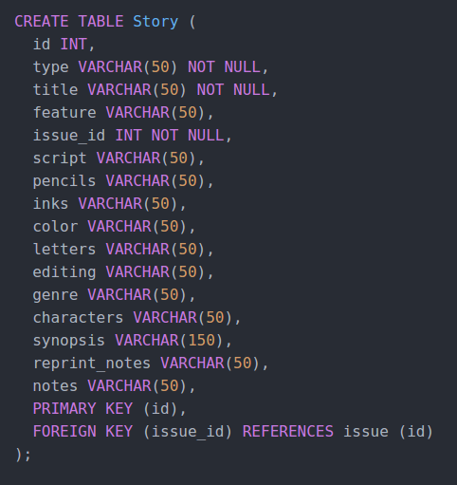
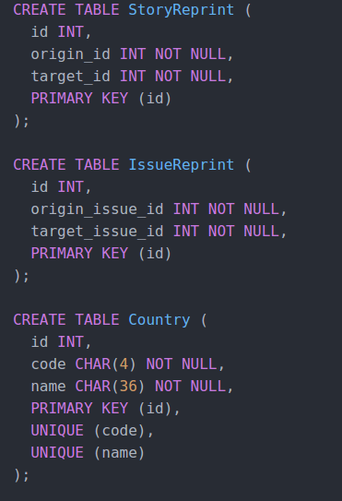

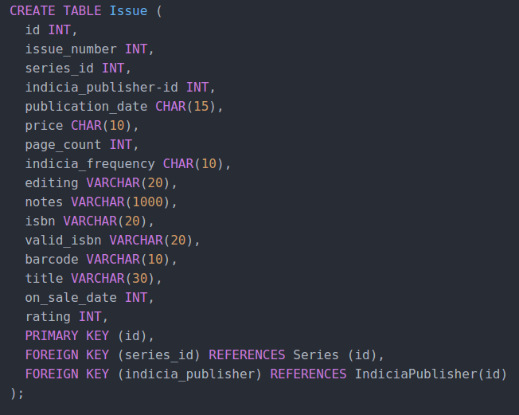
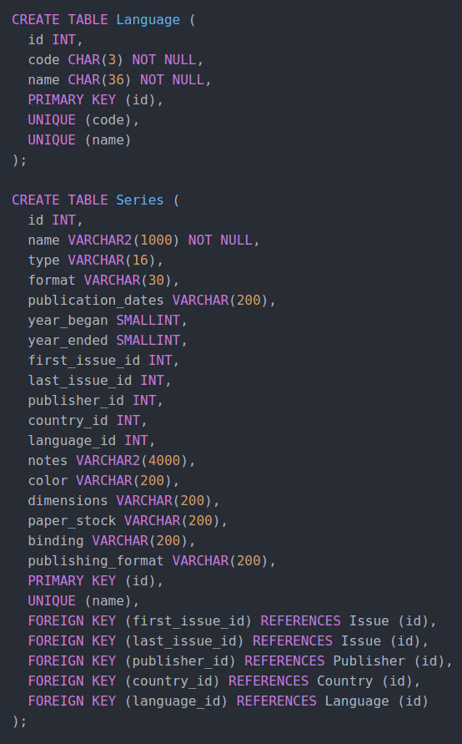
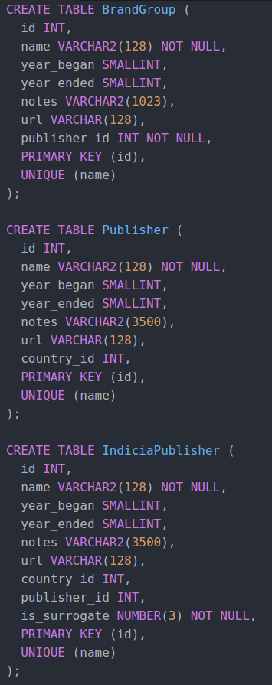

General Comments
For this deliverable, we design the schema together. Then we split the work individually. Colin Branca and Jules Courtois wrote the SQL commands to create the tables and Yoan Martin wrote this pdf document.

Deliverable 2

Schema

Description and Changes :

First of all, we had made a few mistakes in the direction and nature of the constraints which we have corrected, for example with the “Country” entity. Each Indica_Publisher or Series originates from exactly one country, whereas a country does not require to produce even one of either.

The other big change is around the “Story” entity : we have created numerous new entities and relations which represent some of the attributes in the original database like the people who worked on each story based on their role, the genre of the story, or the characters featured in it. At first, we divided the people into artists, authors, editors and typesetters, for which we created the corresponding N-to-N relations as seen on the diagram. But after some reflexion and looking more into the data, we've realized that some authors are also artists or editors, and some artists are also typesetters which creates a duplication of the data. We are looking into changing this for the next version of the project, maybe by creating a “People” table and using ISA relationships.

To parse the original data and create the new tables, we had to write extra scripts in Python which automatically turned the story table into multiple smaller tables, and removed duplicates.

Data Loading

Query Implementation

/*a) Print the brand group names with the highest number of Belgian indicia publishers */
Select BG.name
From BrandGroup BG, (
Select COUNT(distinct *)
From Publisher P, (
Select *
From IndiciaPublisher IP, Country C
Where IP.country_id = C.id and C.name = 'Belgium')
Where P.id = IP.publisher_id)
Where BG.publisher_id = P.id and P.ROWNUM = 1

/*b) Print the ids and names of publishers of Danish book series*/
SELECT P.id, P.name
FROM Publisher P, Series S, Country C
WHERE S.country_id = C.id and C.name = 'Denmark' and S.publisher_id = P.id

/*c) Print the names of all Swiss series that have been published in magazines */
SELECT S.name
FROM Series S, Country C, Serie_type T, Has_Serie_Type H
WHERE H.serie_id = H.type_id and Serie_type.name = 'magazine' and S.country_id = C.id and C.name = 'Switzerland'

/*d) Starting from 1990, print the number of issues published each year*/
Select *
From Issue I
Group By I.publication_date
Where I.publication_date >= 1990

/*e) Print the number of series of each indicia publisher whose names resembles 'DC comics'*/
Select Count(distinct *)
From Issue I, Series S
Where (I.id = S.first_issue_id or I.id = S.last_issue_id) and I.Indiciapublisher_id IN(
Select IP.id
From IndiciaPublisher IP
Where IP.name LIKE '%DC comics%')

/*f) Print the titles of the 10 most reprinted stories */
Select title
From (
Select S.title AS title, COUNT(DISTINCT SR.origin_id) AS count_reprint
From Story S, StoryReprint SR
Where S.id = SR.origin_id
Group By S.id, S.title
Order By count_reprint DESC)
Where ROWNUM <= 10

/*g) Print the artists that have scripted, drawn, and colored at least one of the stories they where involved in */
Select A
From Artists A, Story S, Inks I, Colors C, Pencils P
Where A.id = I.artist_id and S.id = I.story_id and A.id = C.artist_id and S.id = C.story_id and A.id = C.artist_id and S.id = C.story_id

/*h) Print all non-reprinted stories involving Batman as a non-featured character */
Select S
From Characters C, Has_charaters HC (
Select S
From Story S, StoryReprint SR
Where not exists (select * from StoryReprint SR where SR.origin_id = S.id)
)
Where C.name != 'Batman' and C.id = HC.character_id and S.id = HC.story_id

Interface

Design logic Description
<Describe the general logic of your design as well as the technology you decided to use>

Screenshots
<Provide some initial screen shots of your interface>

General Comments
We have met some difficulties due to the data format, for example in dates and how to compare them, or inconsistencies in the names of the authors or even the actual initial database. This will require some work before having a fully functional import.

Concerning the work attribution, Yoan Martin did the Interface, Jules Courtois coded some scripts to clean the dataset and Colin Branca corrected the work done for the last milestone and wrote the SQL queries.

