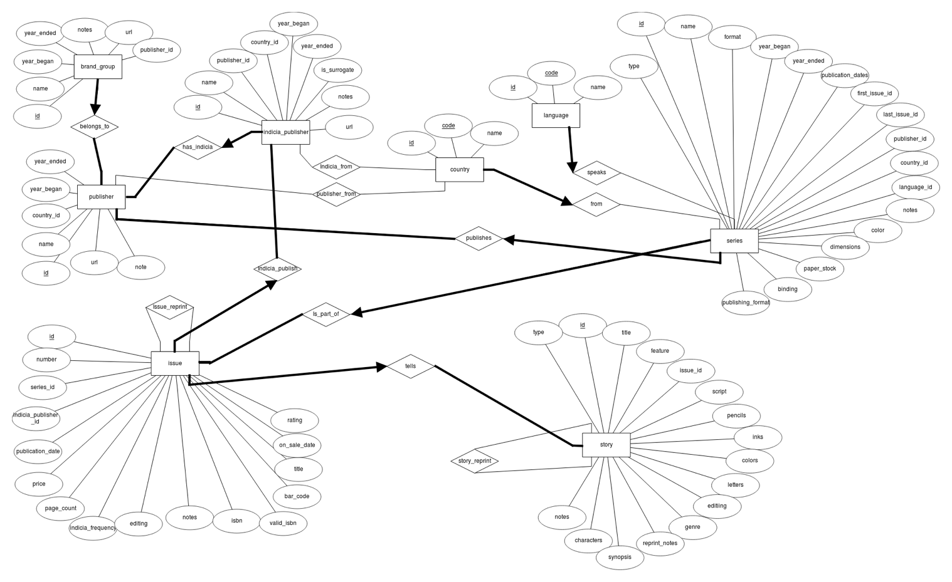
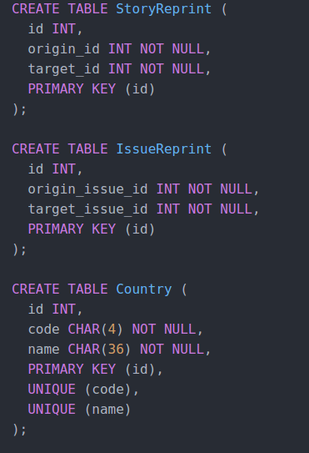
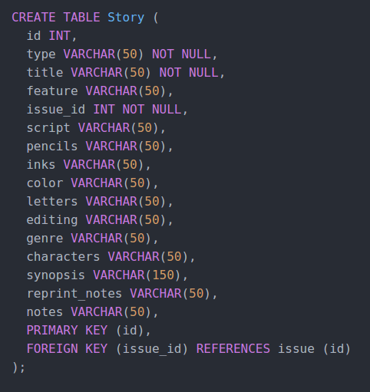
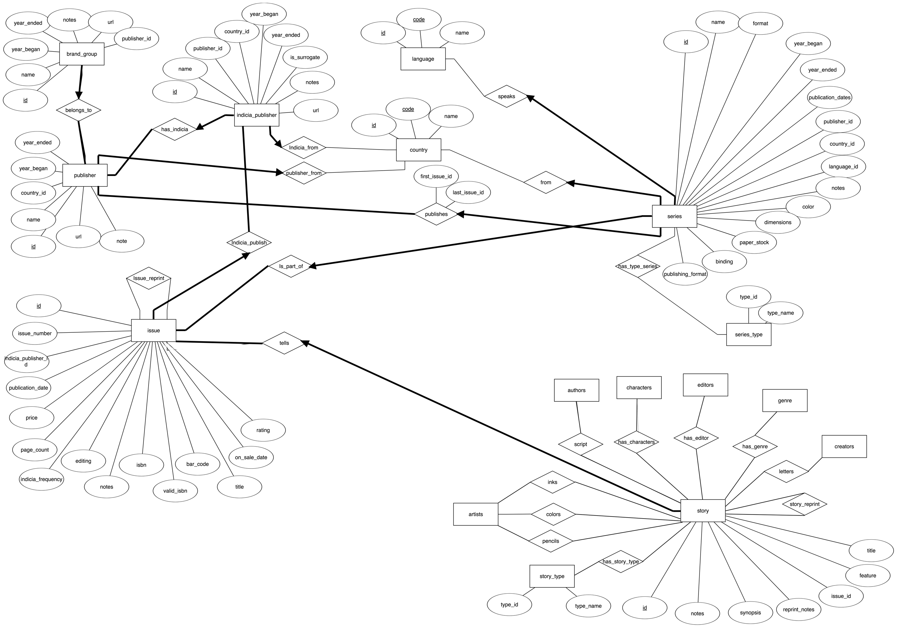
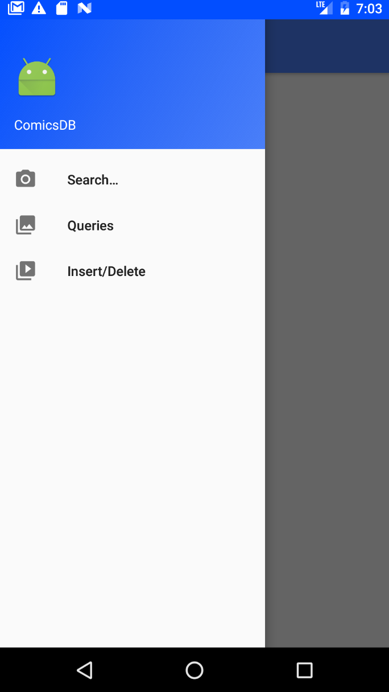
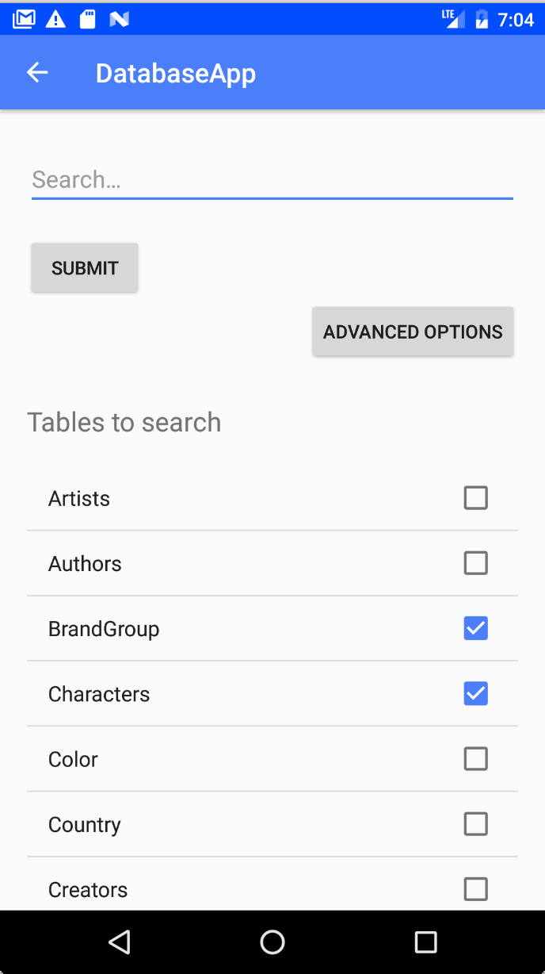
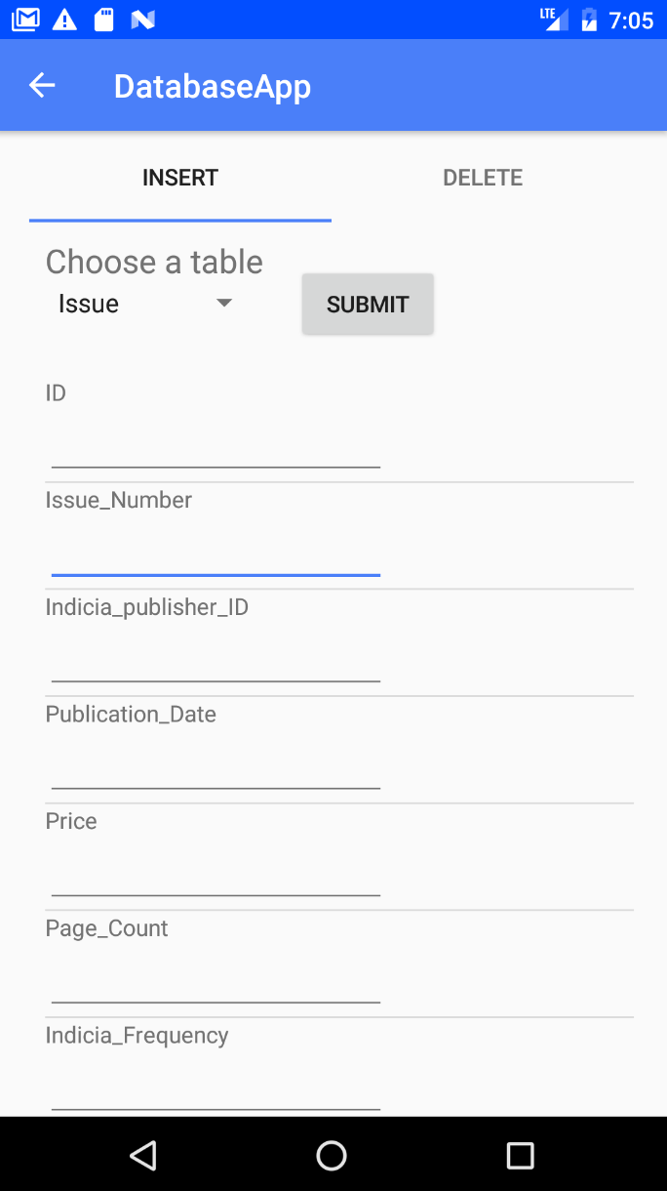
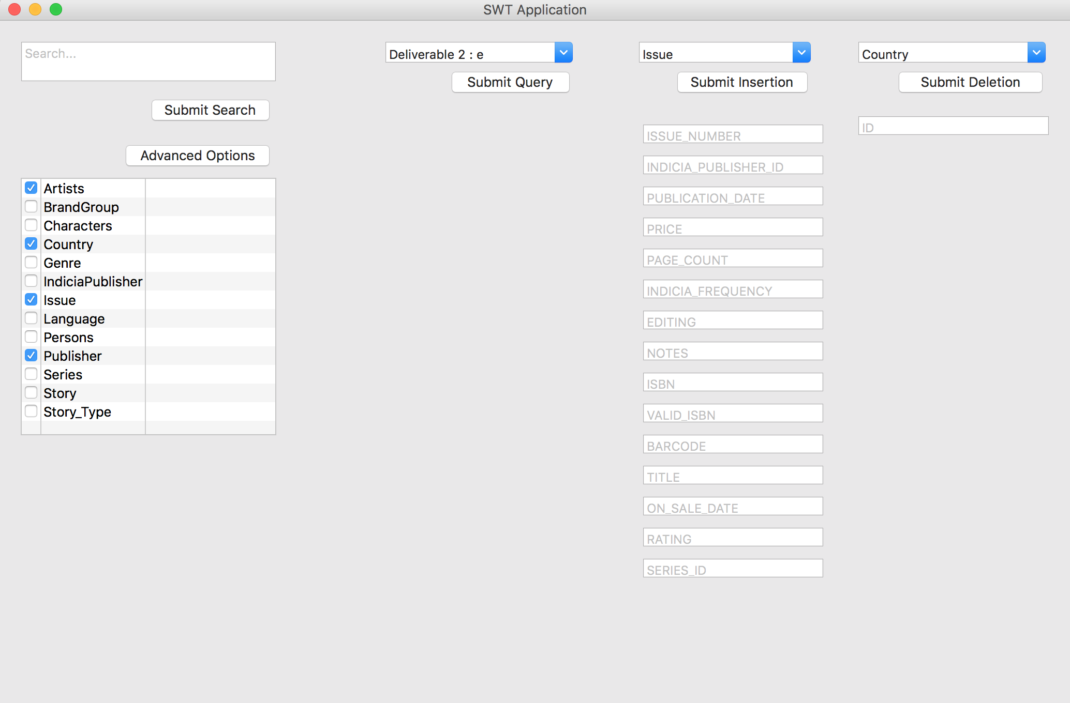
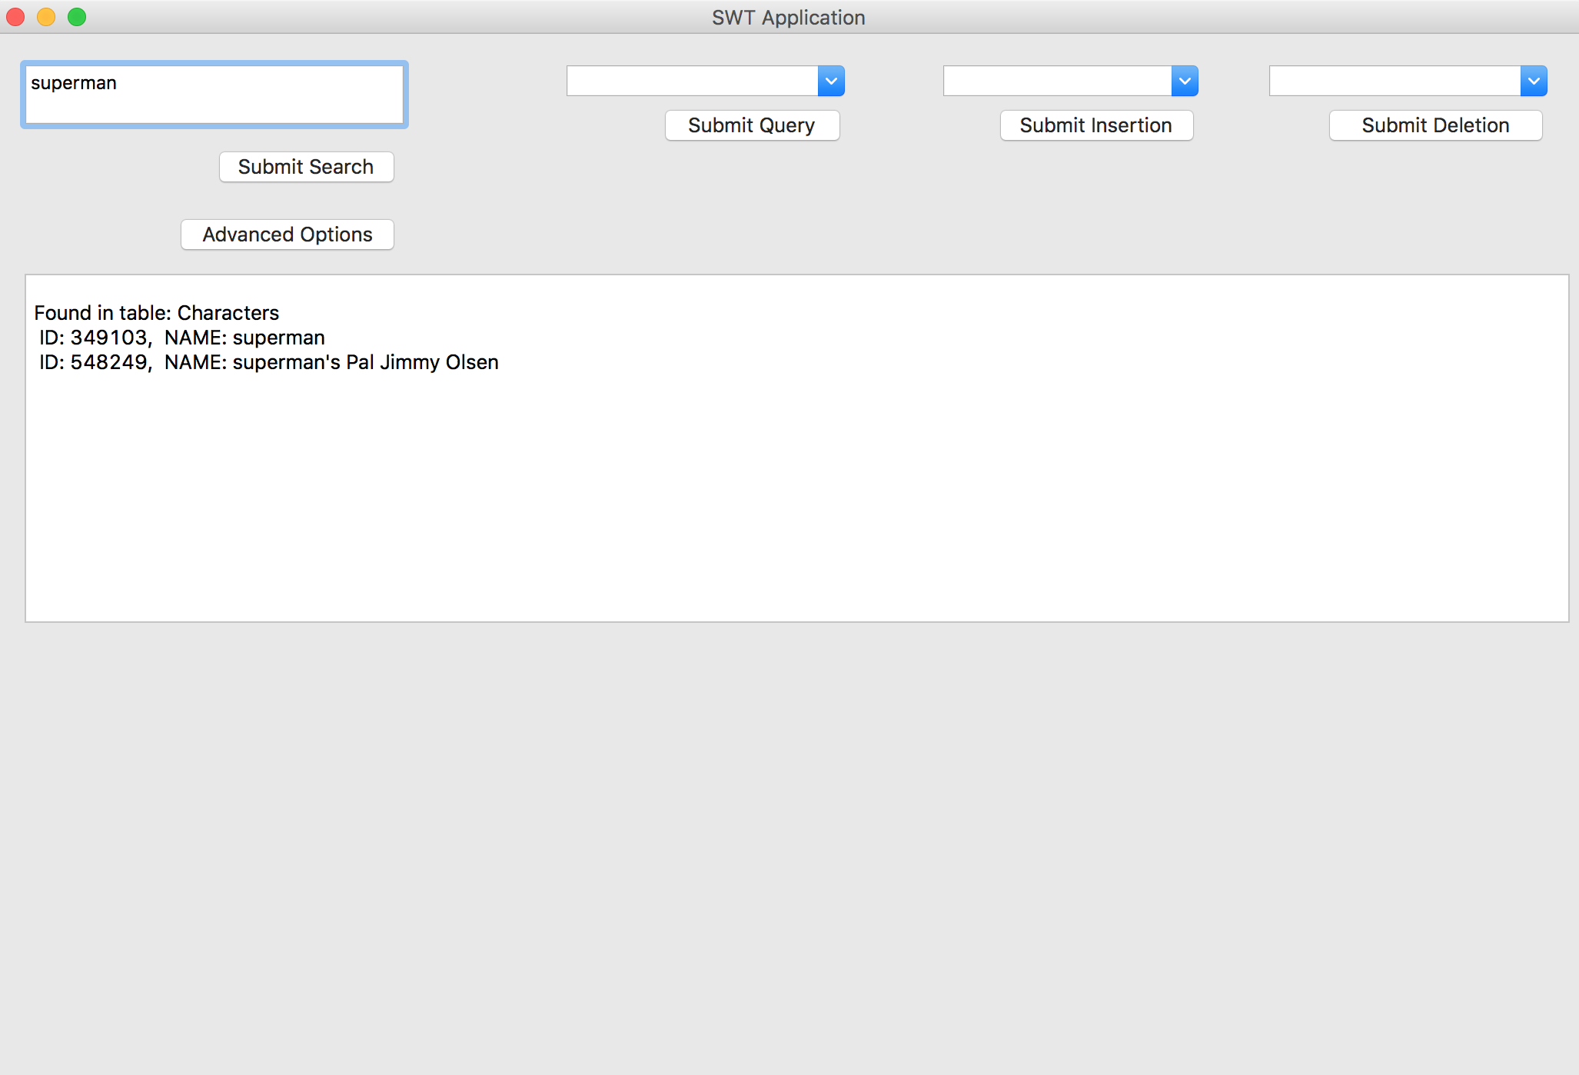

Databases Project – Spring 2017
Prof. Anastasia Ailamaki
Team No: 15
Names: Colin Branca, Jules Courtois, Yoan Martin
Contents
Deliverable 1 2
Assumptions 2
Entity Relationship Schema 2
Schema 2
Description 2
Relational Schema 3
ER schema to Relational schema 3
DDL 4
Deliverable 2 4
Schema 5
Description and Changes : 5
Data Loading 6
Query Implementation 6
Interface 8
General Comments 9
General Comments 16

Deliverable 1

Assumptions
When we create the tables, we assume that each CHAR has a max size. No longer elements will be added later.

Entity Relationship Schema

Schema

Description
There are two main parts in the schema: Books with Story, Issue and Series and Company with Publisher, Indicia Publisher and Brand Group. Let’s first describe each part before explaining the connections between them.
Books: This part is describing a book in the more general sense. The physical book is an issue. It tells a story and it is part of a series. For example, Harry Potter is a famous series. Harry Potter and the Philosopher’s Stone is a story from this series. Finally, the book with ISBN X is a physical book telling this story. Since these three components are highly connected. There are a lot of constraints between them.
- An issue tells at least a story.
- A story must be told by exactly one issue.
- Each series has at least one issue.
- An issue is part of exactly one series.

Company: This part is describing the company which publish some books. The main company is the publisher. It has smallest companies, the indicia publishers and it holds some brand group. For example, Marvel is the general company. It holds a brand group called Thor and the physical books are published by an indicia publisher, Thor Entertaining Group, which is part of Marvel. As for the book part, the company part has also a lot of constraints.
- Each publisher has at least one brand group.
- Each brand group belongs to exactly one publisher.
- Each publisher has at least one indicia publisher.
- Each indicia publisher is part of exactly one publisher.

Then, there are some connections between these two parts. The publisher publishes a series. It means that the publisher creates a series but the issues are printed by the indicia publisher. Here are the constraints related to these connections.
- A publisher publishes at least one series.
- A series is published by exactly one publisher.
- An indicia publisher publishes at least one issue.
- An issue is published by exactly one indicia publisher.

Finally, there are some smallest relationships. Firstly, the publisher, the indicia publisher and the series come from a country and the series have a language. Secondly, there is a reprint relationship between two stories or two issues. We consider only two constraints.
- A publisher, indicia publisher or series comes from exactly one country.
- A series has exactly one language.

N.B. We do not create a story_type and series_publication_type entity since these data contain only one attribute if we exclude the id. To simplify the schema, we add an attribute type containing the name of the type in the Story/Series entity.

Relational Schema

ER schema to Relational schema
To create the table, we simply took each entity or each relationship and we translate them into a table. We took care to respect the constraints using NOT NULL or PRIMARY KEY to state the “at least” constraint and we permit each “at most” relation to appear in only one column in the connected table.

DDL

For this deliverable, we design the schema together. Then we split the work individually. Colin Branca and Jules Courtois wrote the SQL commands to create the tables and Yoan Martin wrote this pdf document.

Deliverable 2

Schema

Description and Changes :

First of all, we had made a few mistakes in the direction and nature of the constraints which we have corrected, for example with the “Country” entity. Each Indica_Publisher or Series originates from exactly one country, whereas a country does not require to produce even one of either.

The other big change is around the “Story” entity : we have created numerous new entities and relations which represent some of the attributes in the original database like the people who worked on each story based on their role, the genre of the story, or the characters featured in it. At first, we divided the people into artists, authors, editors and typesetters, for which we created the corresponding N-to-N relations as seen on the diagram. But after some reflexion and looking more into the data, we've realized that some authors are also artists or editors, and some artists are also typesetters which creates a duplication of the data. We are looking into changing this for the next version of the project, maybe by creating a “People” table and using ISA relationships.

To parse the original data and create the new tables, we had to write extra scripts in Python which automatically turned the story table into multiple smaller tables, and removed duplicates.

Query Implementation

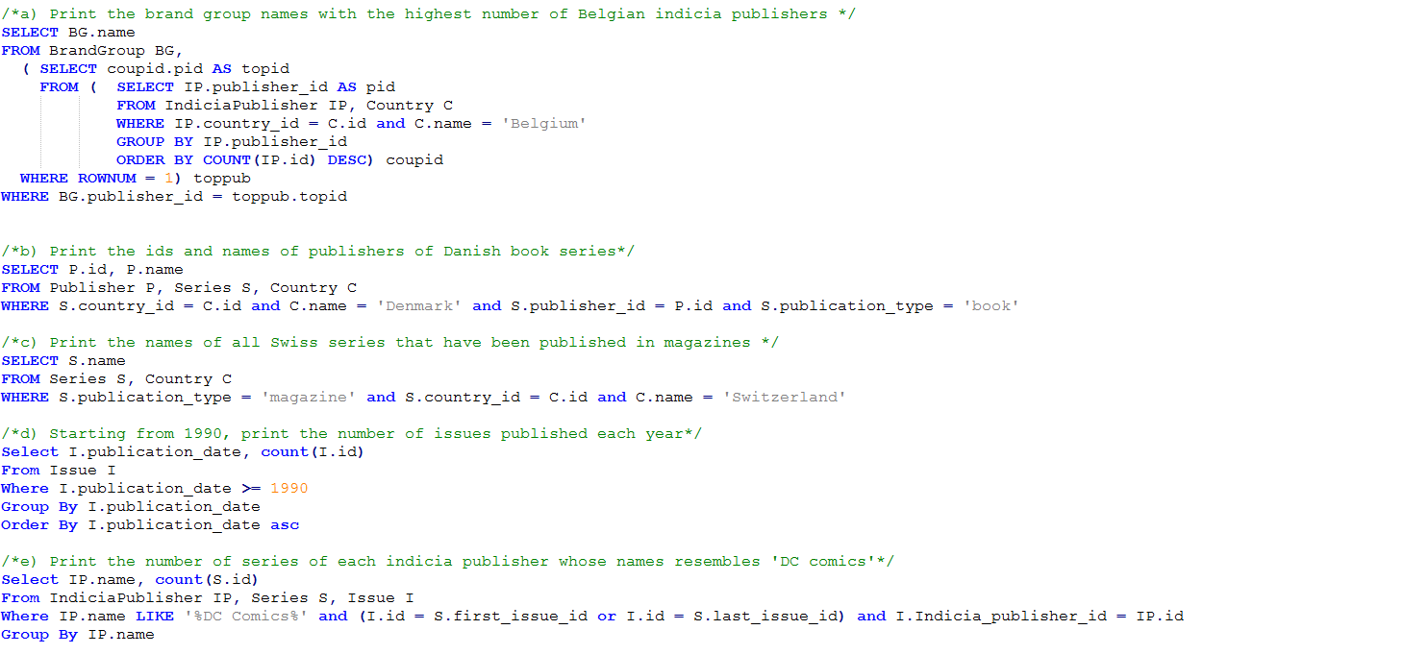
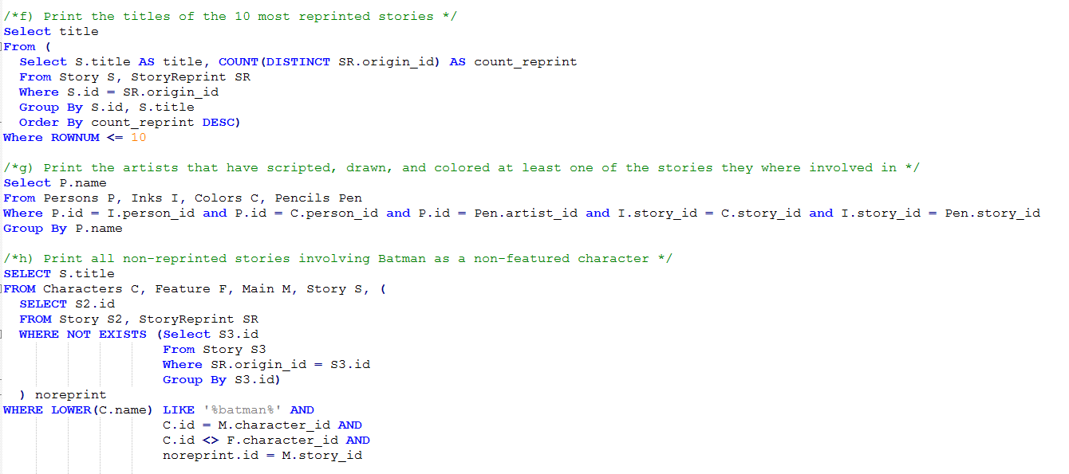

Interface
For the interface, we use an android application. The navigation in the app is entirely made using the top-left menu button. The user is able to select what he wants to do with the database and he is redirected to the corresponding activity. The frontend part of the application is working well. Unfortunately, we encounter problems with the database connection. So the biggest part of the work for the last deliverable is to work on the backend.

General Comments
We have met some difficulties due to the data format, for example in dates and how to compare them, or inconsistencies in the names of the authors or even the actual initial database. This will require some work before having a fully functional import.

Concerning the work attribution, Yoan Martin did the Interface, Jules Courtois coded some scripts to clean the dataset and Colin Branca corrected the work done for the last milestone and wrote the SQL queries.

Deliverable 3

Interface

Unfortunately, the user interface presented in the last deliverable was not our final choice. The android application permits to create a simple and user-friendly interface. But we dealt with problem regarding the connection to the database. The connection with the server is different with an android application and a simple Java Applet. When we encountered this difficulty, we had the choice to use an intermediate web-server between our app and the database server or to recycle our Java code and build a new interface in a Java Applet. We selected this last choice. So, our new interface is just a simple window containing four columns (Search, Preselected Queries, Insertion, Deletion).
For searching, the user is able to provide any element and select any desirable table. We simple get the search from the user and use it to create an SQL query. If the user does not select any table, we perform the search over every tables. Note that we are not looking for every attribute in a table. We selected only the user-understandable attribute. For example, in the table Language, we perform the search query in the name attribute but not in the id. We consider that the user is not interested to look for database-related attributes, so we focus only on user-friendly attributes.
For selecting a preselected query, the user has a simple menu in which he can chose the desirable query. Note that for the last query, we display a new text field. Then the user is able to provide the id of an issue and finally we can perform our query like all the others.
For the insertion, the user has a menu to select the table in which he would like to delete an element. Then, we dynamically create some text fields for each attribute. Finally, the user enters the different value in each field and we perform the insertion.
For the deletion, this is our less user-friendly part. Since the user does not have every required attribute value to delete an element. We only provide a deletion using an ID. The idea is that the user search for the desirable element. He looks into the result to find the correct ID. And then, he performs the deletion using a menu to select the correct table and then entering the value of the ID.

Queries for Deliverable 3
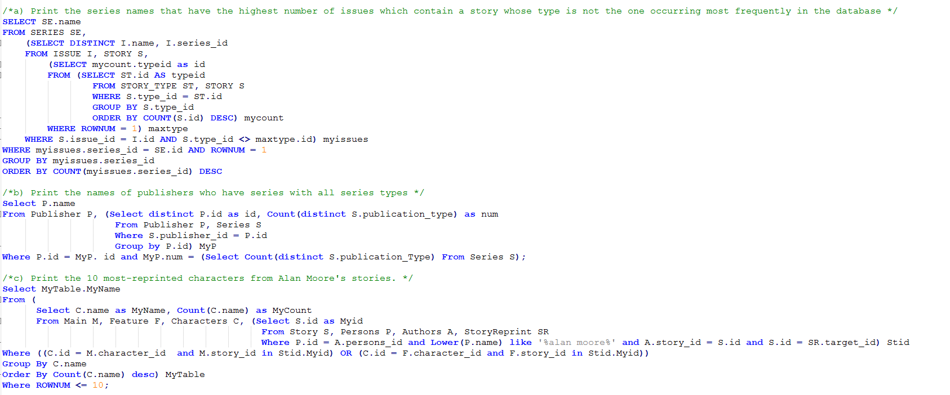

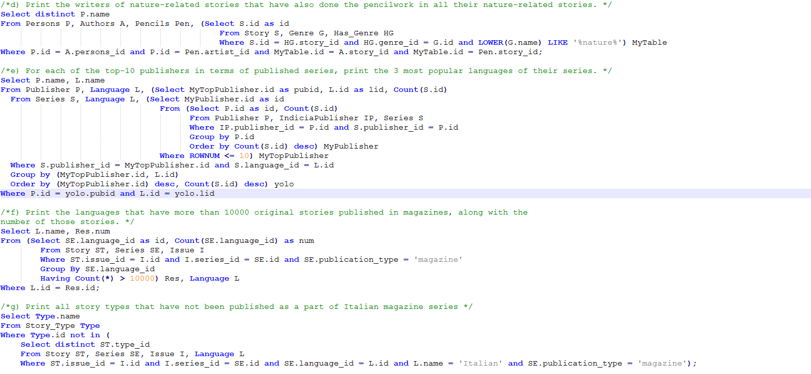

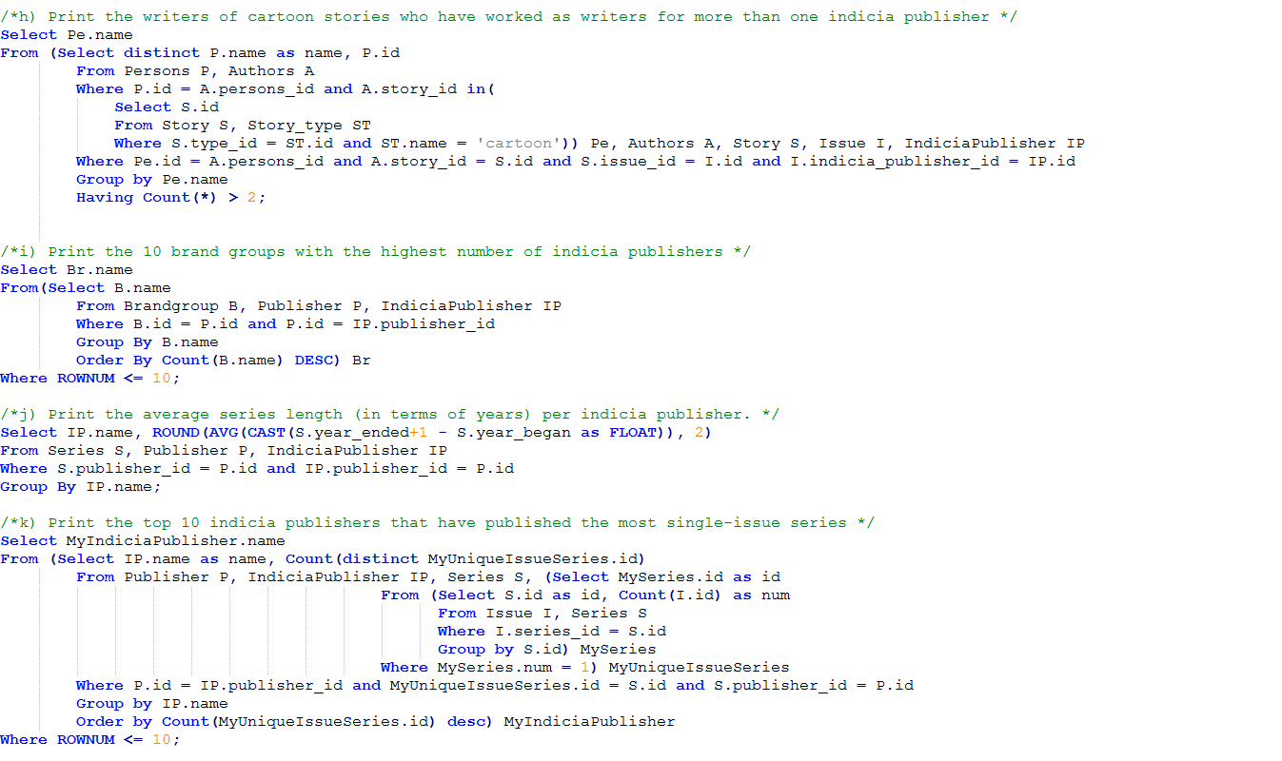
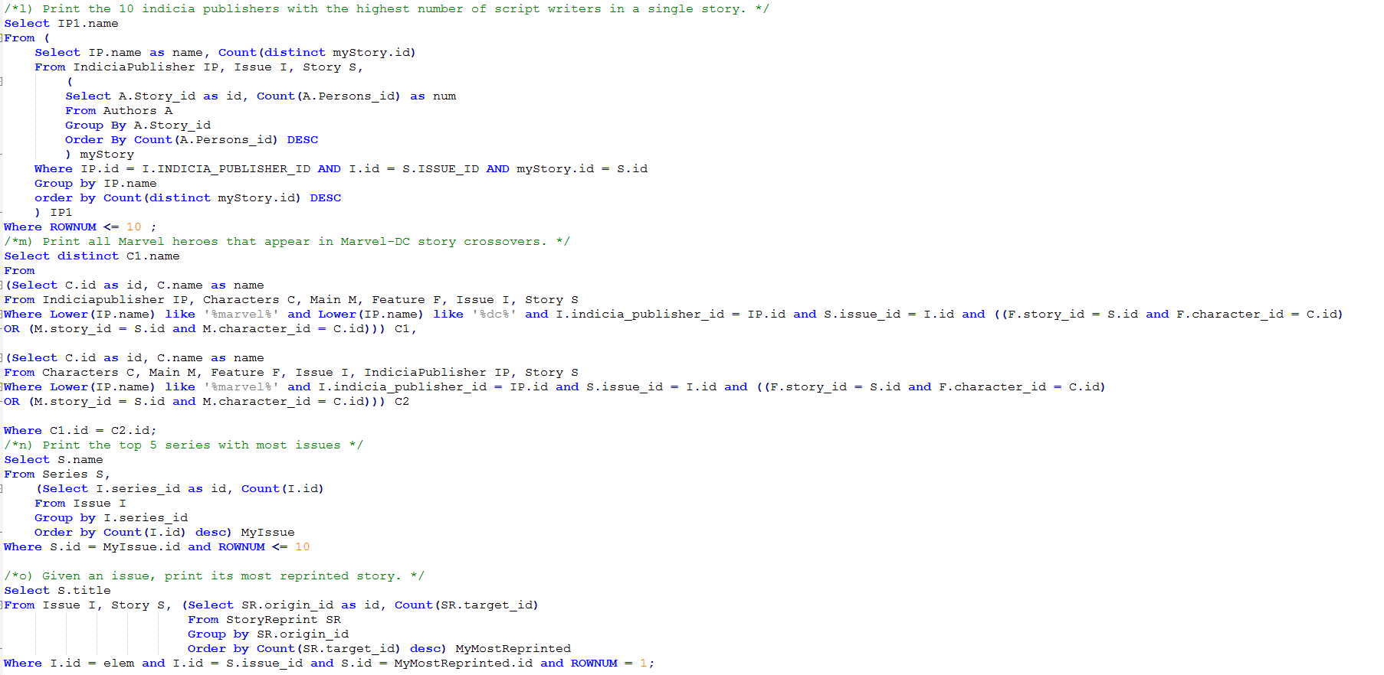

Requests Runtimes: (ms)

A
B | 122
C | 134171
D | 2377
E | 472
F | 4244
G | 1233
H | 3540
I | 117
J | 165
K | 2046
L | 3621
M
N | 710
O | ~70

Indexes :

Multiple queries require searching and comparing character or persons names, for example query M and C. To increase efficiency, we decided to index the columns for the names in Characters and Persons. We also did the same for the Genre column, for example in query D to search faster for the string “%nature%”

Detailed query runtimes:

Query D:
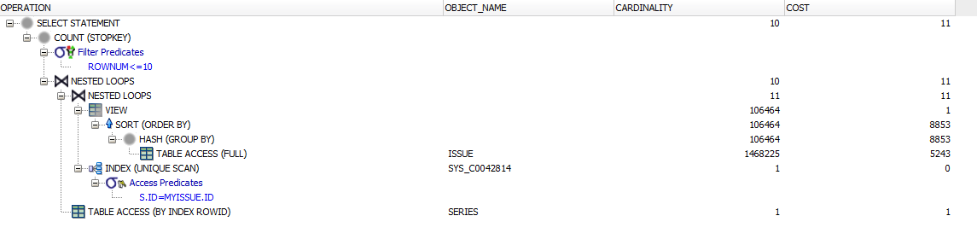
This is quite a simple query, with a unique Group By statement. Approximately 33% of the computation time is taken by the hash, which is reduced by the indexing on the Genre name.

Query G:

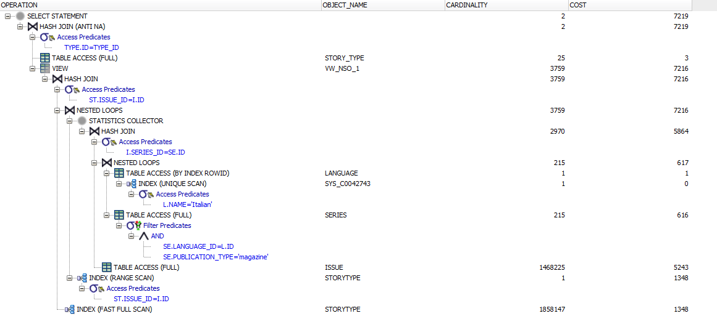

Query N:

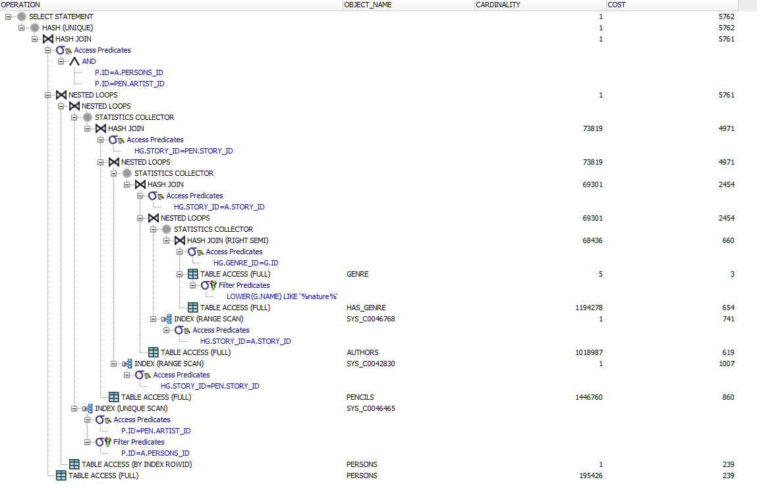

General Comments
Concerning the work attribution, Yoan Martin finished the Interface, Jules Courtois and Colin Branca finished the cleaning of the dataset and imported all the data into the database. Finally, we worked together to write the queries.

