Advanced Catering Solutions: QAmC Q-Pack

Contents:

* Q-Pack handheld device
* Charger and USB cable

Q-Pack Overview:

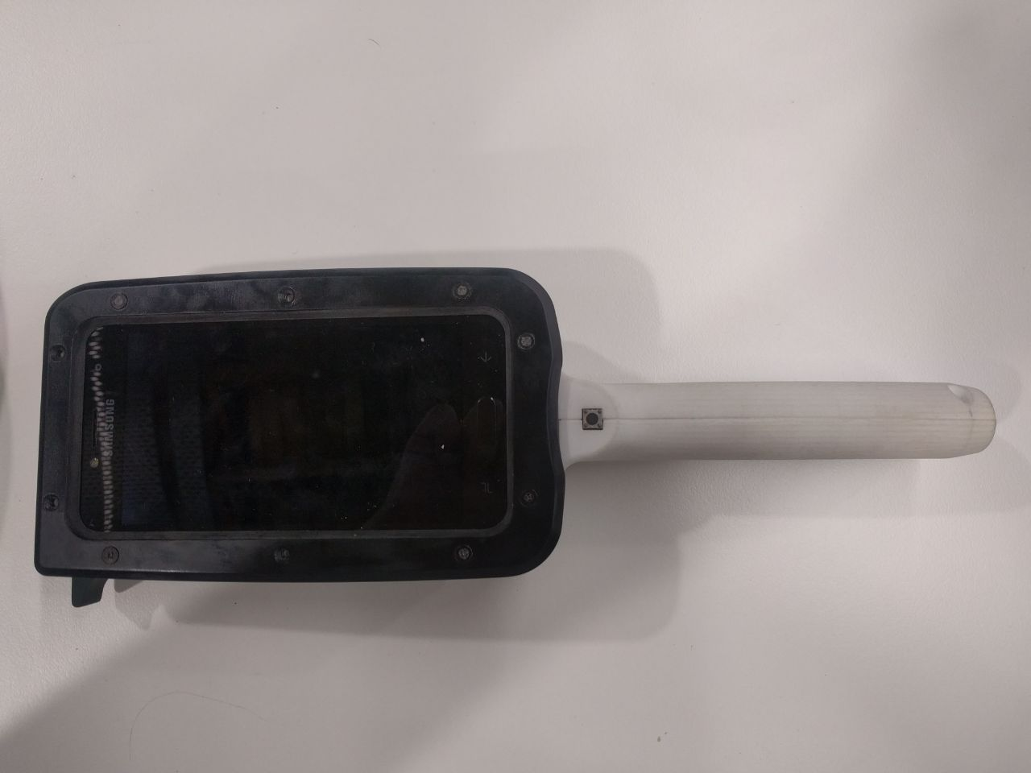

1

1 Thumb button

2 Trigger button

3 On/Off button

4 IR Sensor

5 Laser

6 Barcode scanner

7 Probe

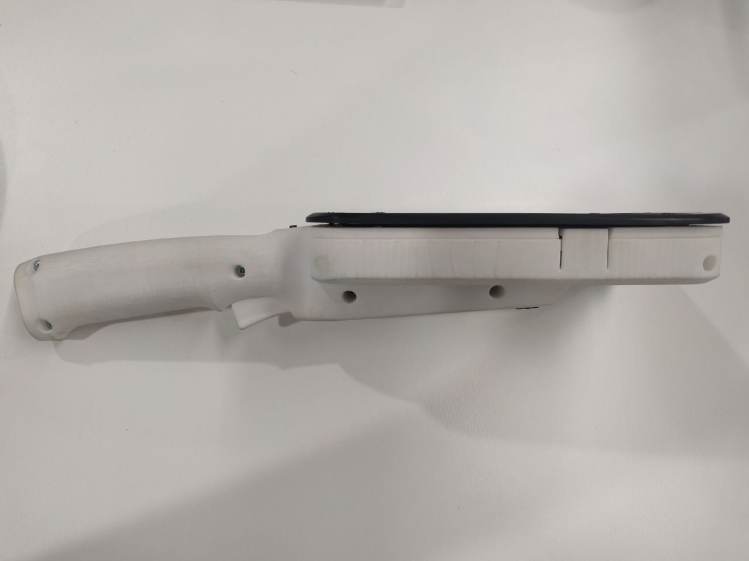

3

2

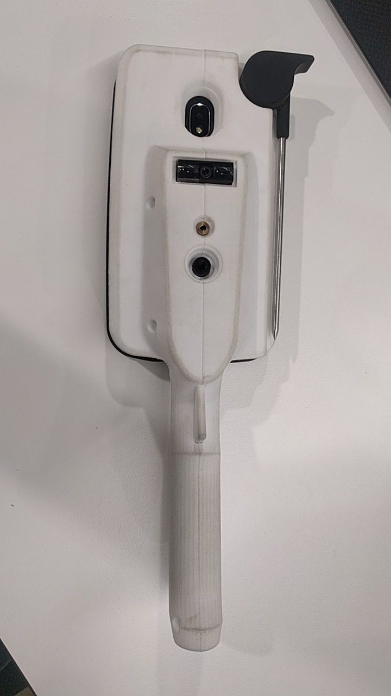

73

6

5

4

The device comes with a test app to simply activate all hardware functions without any limitations the finished application would impose on their activation.

1. Charge until phone turns on (if necessary)
2. Turn on phone with On/Off button
3. Start Q-Pack Test App
4. Allow the app to access the USB device if a request to do so pops up
5. The app should connect automatically after that. If not, press Q-Pack Start
6. Any press of the trigger button will now activate all hardware devices simultaneously. Any read values are shown in the log of the test app