Title

# This is a title

This is $LATEX_{text}$ and an equation:

$$f\left(k\right)=\left({n \atop k}\right)p^{k}{\left(1−p\right)}^{n−k}$$

## This is a subtitle

This is a reference to an article [1] and a book [2].

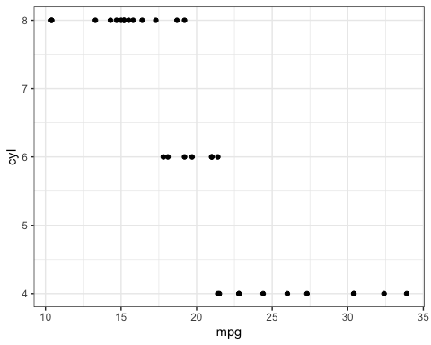

Figure 1: This is a caption for a figure

And this is a reference to Fig. 1.

# References

[1] Doe & Doe. ‘An article title’. *Journal of Templates* **90,** (2022). DOI: [10.1103/physrevb.90.054105](https://doi.org/10.1103/physrevb.90.054105)

[2] Ashcroft & Mermin. ‘*Solid state physics*’. (Holt Saunders, New York, 1976).