Chess Rules
- The board must always be setup with a white square in each bottom right hand corner.
- The Queen always starts on her own colour ie. White Queen on White Square.
- The Knight is the only piece that can jump over pieces
- A pawn may move forward 2 squares on its 1st move.
- A pawn can only take by moving 1 square forward diagonally to right or left.
- A pawn cannot move backwards.
- A pawn that reaches the opposite side of the board may be promoted to another piece, usually a Queen
- When a pawn moves forward 2 squares on its 1st move and passes an opponents pawn on either side, the opponents pawn may take the pawn on the next move as though it had only moved 1 square. ( En-Passent )

Check, Checkmate and Stalemate
- The King is in Check when an opposing piece threatens the King in a way that it would be able to take the King on the next move.
- The King is never actually taken, pieces must be moved to clear the threat / check.
- You cannot move your pieces to put your King into check.
- Checkmate wins the game when the King is in check and no legal move can be made.
- Stalemate is a drawn game when the King is not in check but no legal move can be made.
- Stalemate occurs when neither side has sufficient pieces to make a checkmate.
- Stalemate occurs when the same sequence of moves is repeated 3 times
Checkmate Stalemate ( Draw )
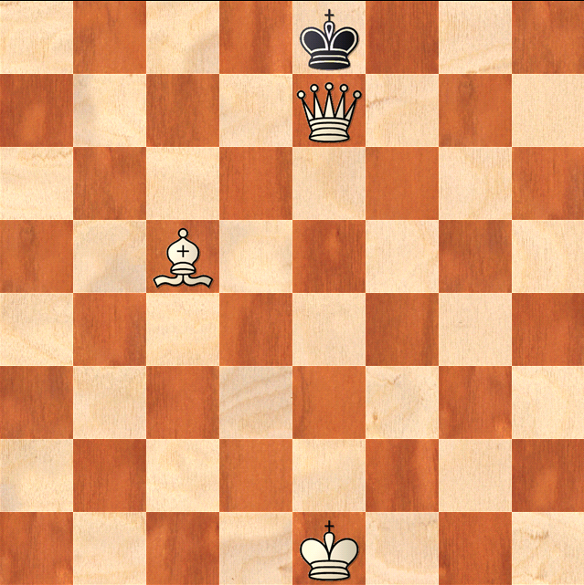
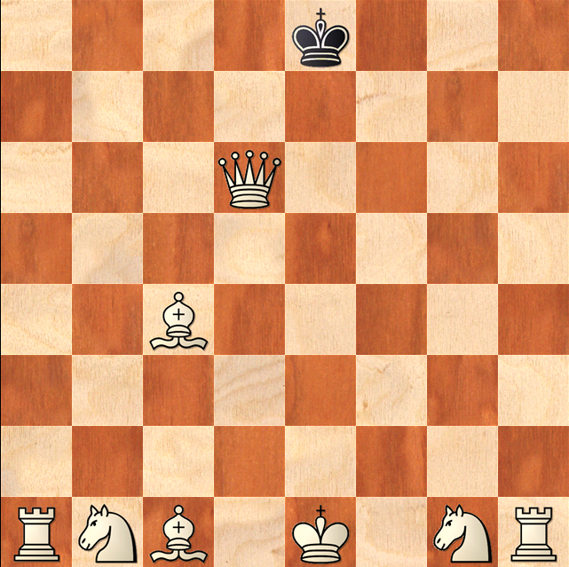

Castling
- Castling is a special move that allows the King and Castle to jump over each other. The King moves 2 spaces to left or right and the Castle Jumps over and sits next to the King.
- Castling can only be performed if
King and Castle have not already moved
There are no pieces between the King and the Castle
The King is Not In Check, Will Not Pass Through Check and Will Not Move Into Check.
