023 White to Move
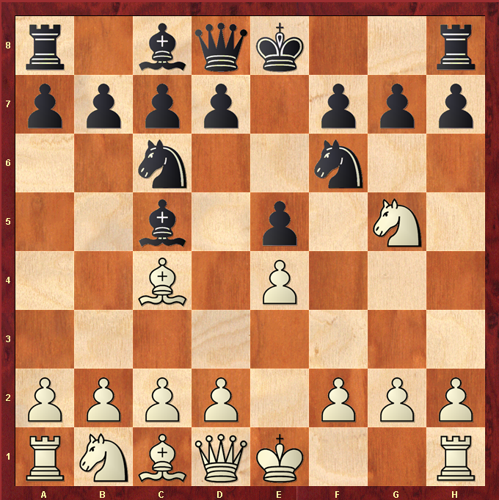

Best Move – NxF7
- White Knight Forks the Queen and Rook
- Black King cannot take the Knight because he would put himself in check from Whites Bishop ( “protecting the knight” )
- Black must save the Queen by moving to E7
- White wins the Rook
- Black may try and trap and capture the White Knight, but with a Rook worth 5 points and a Knight worth 3 points it is still a good trade.

