031 White to Move
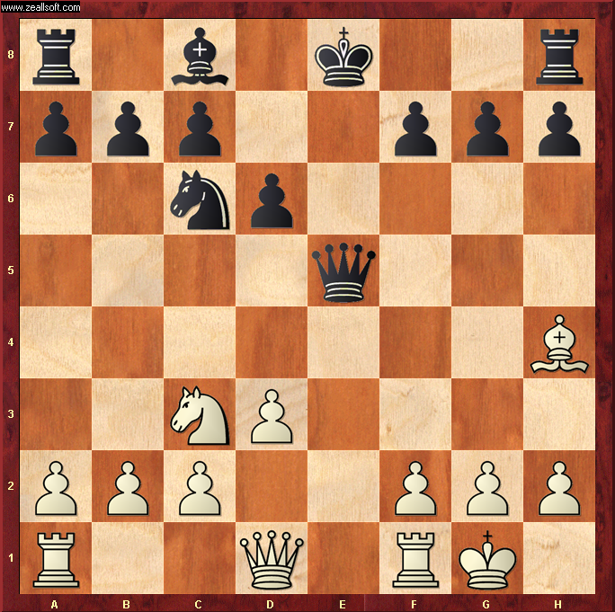

Best Move – RE1!
- White Rook to E1 “PINS” the Black Queen to her King. Good move, bye bye Queeny!
- Black Queen cannot move off the E File because the Black King would be in check from the Rook
- Black has no pieces that can block the attack
- Whatever Black does next move, Blacks Queen will be lost
- Blacks best option is to castle Kings side to allow Rook to attack the open file. But not much hope for Black !

