062 White to Move

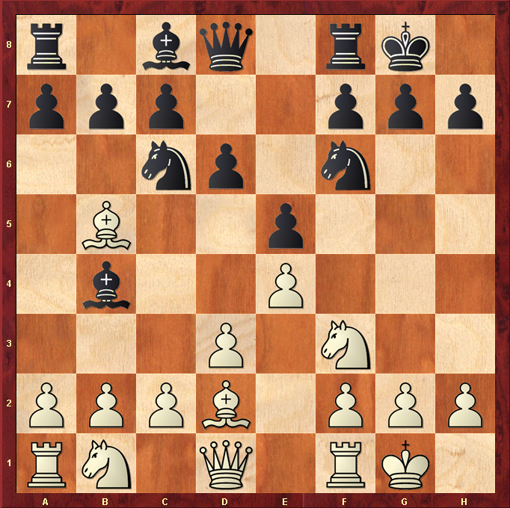

Hint : Remove defender

