090 White to Move
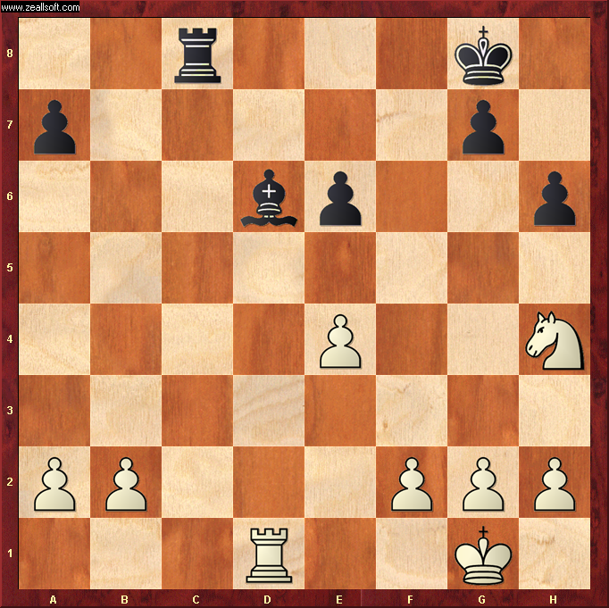

Best Move – G3 ( PawnG3 )
- Black Bishop looks tempting to Whites Rook. ☹
- If White takes the Bishop, Black will win by bringing Rook to C1 with Whites King trapped behind his pawn wall ( “Back Rank Mate” )
- Whites best move is to push G-Pawn up to G3 which releases G2 as a flight square for the King
- This allows White Rook to move off the back line without fear of instant game-over
- The 3 Pawn pyramid F2,G3,H2 is a strong defence for the King to hide inside.

