094 White to Move
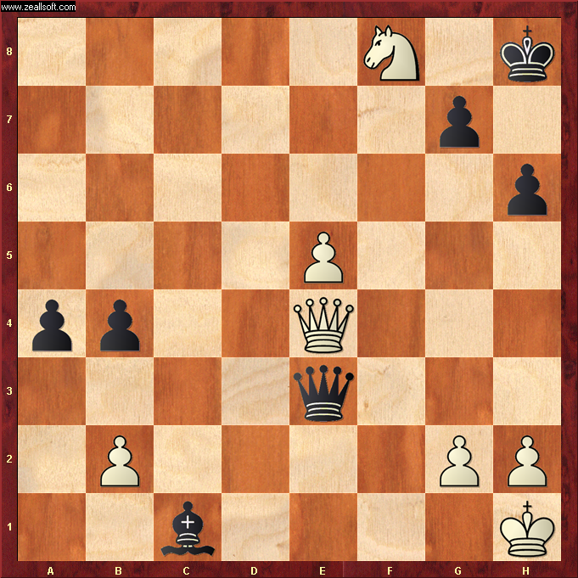

Solution – QH7#

Queen is defended by Knight so King cannot take

Black King is in check from Queen and has nowhere to move – Checkmate !

* Always try and get your Queen as close to the enemy King as possible, but with a guard of course.

