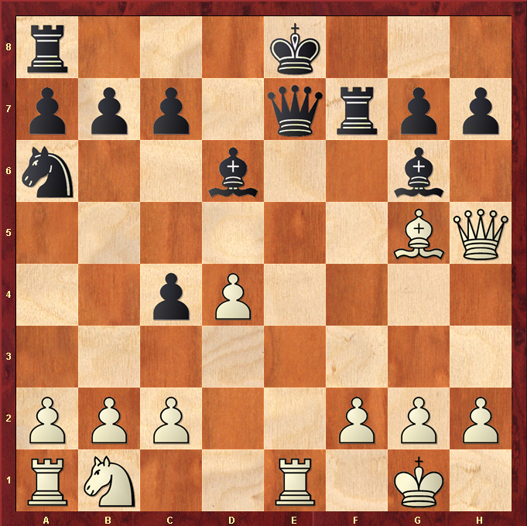
502 White to Move – Qg4 ?

