Top Tactics - FORK
- A fork is when a piece is attacking 2 unguarded or more powerful pieces at the same time.
- Often, your opponent can only save one piece
- A fork involving the King is very powerful
- Any piece can fork, Knights are especially cheeky
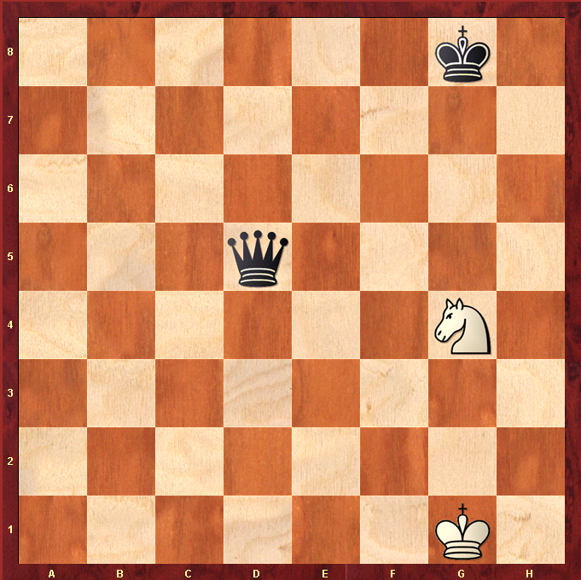
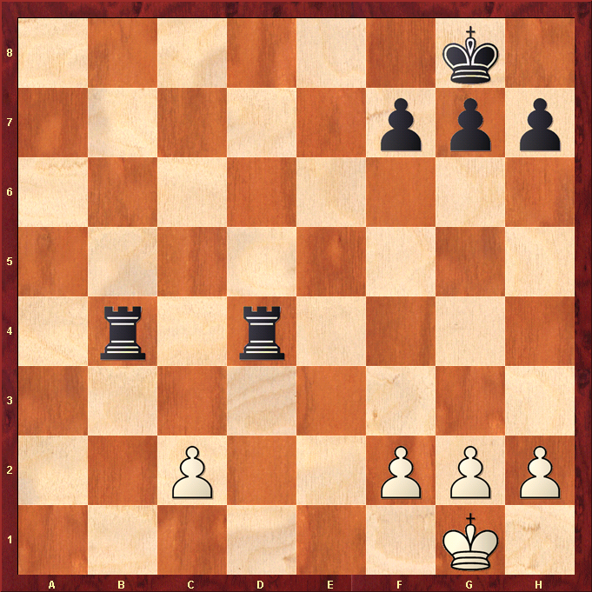
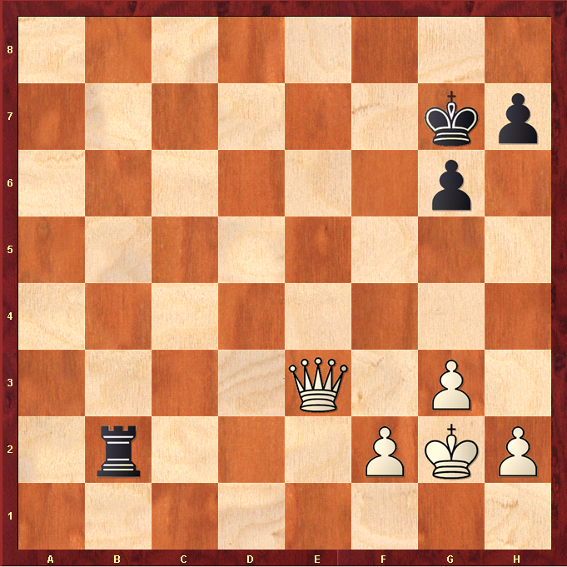

Pawn forks 2 Rooks and wins a Rook
Rook=5 Pawn=1
OK if Rooks defended
Knight forks King and Queen and wins Queen.
Knight cant be blocked
Queen = 9 Knight = 3
OK if Queen defended
Queen forks King and Rook and wins Rook.
Rook = 5 Queen = 9.
Only on unguarded Rook !

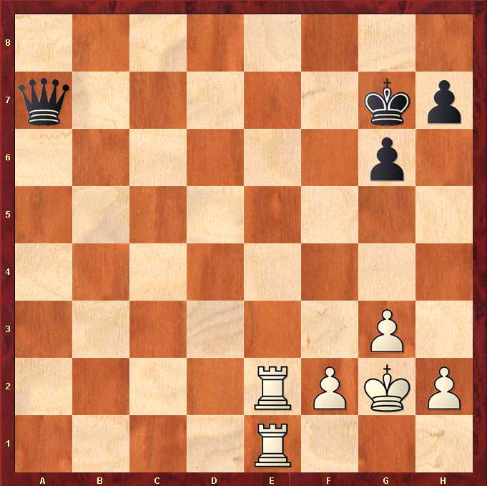
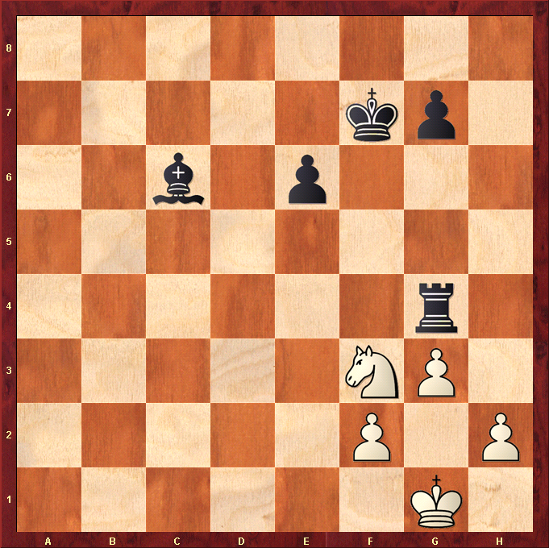
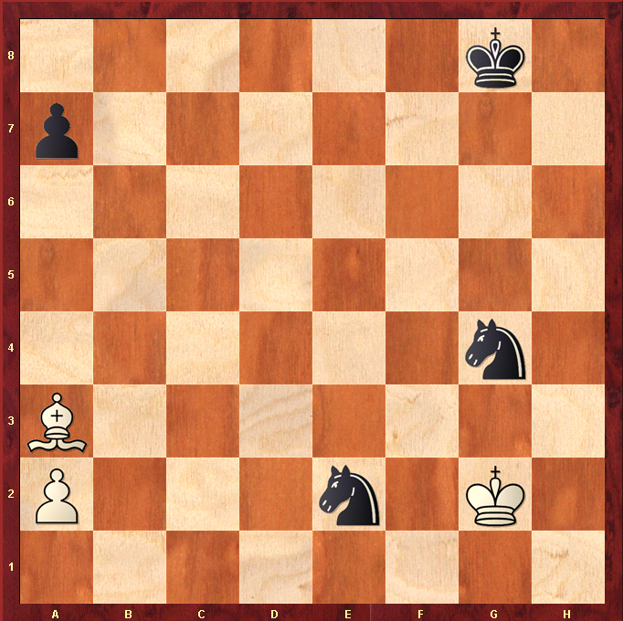
Knight forks King, Bishop and Rook winning Rook!
Bishop=3 Rook=5
OK if Rook defended
King forks 2 Knights so wins a Knight!
Only on unguarded Knights
Rook forks King and Queen, defended by Rook on e1.
Queen=9 Rook=5
OK if Queen defended

