Pos001 - Who has the better position

Can you see 3 reasons why ?

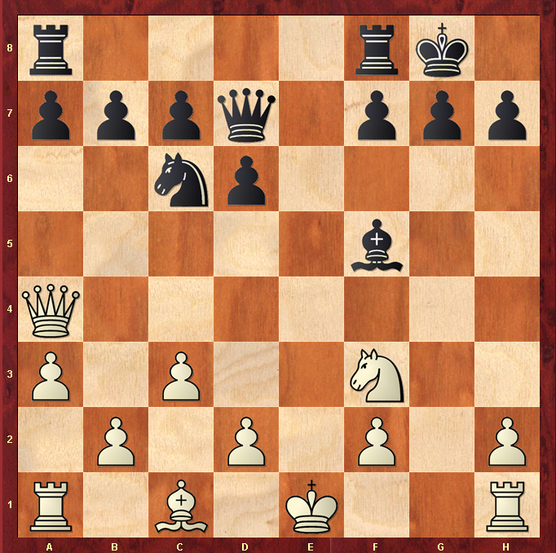

Hints :
Pieces developed ? King safety ? Blocked in pieces ? Rooks poised for action ?

