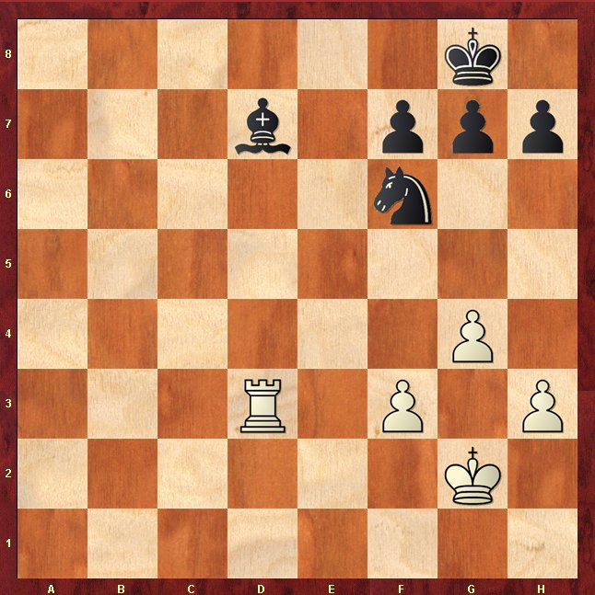
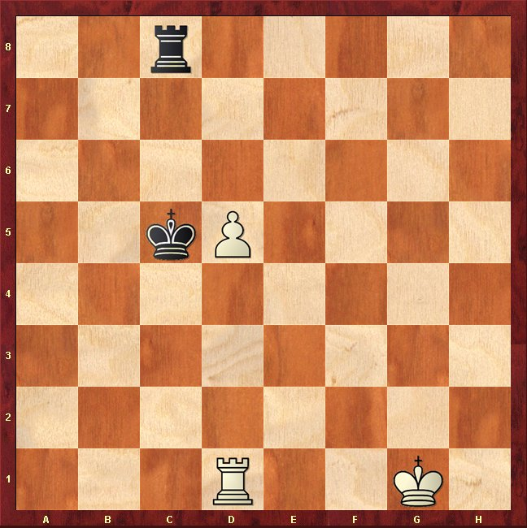
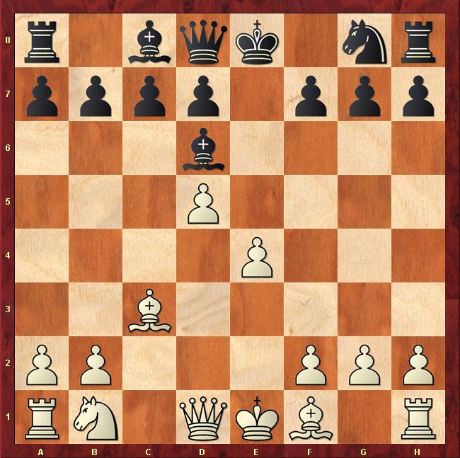
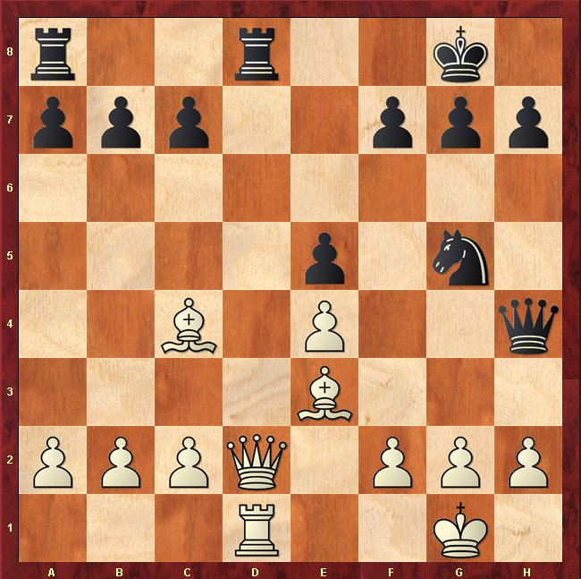
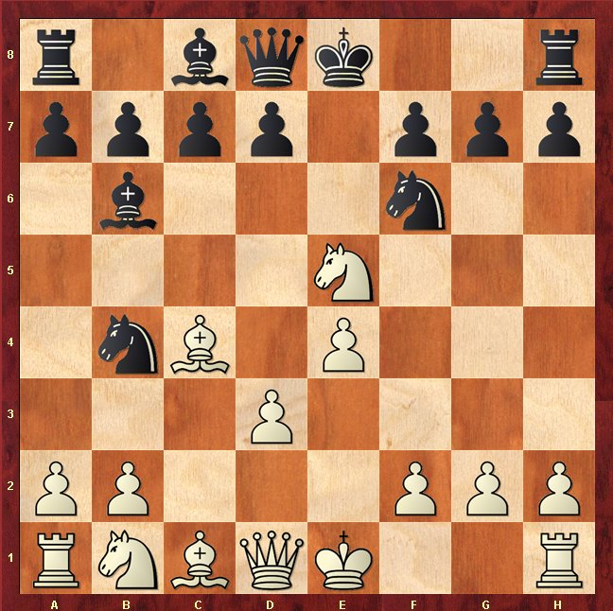
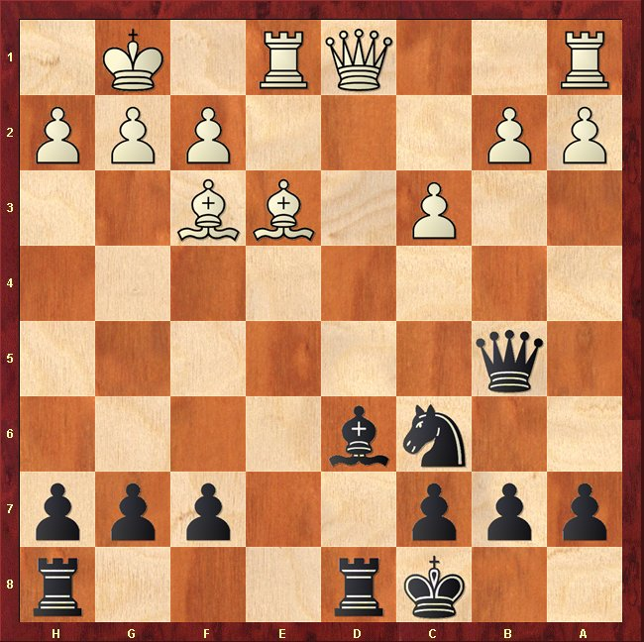

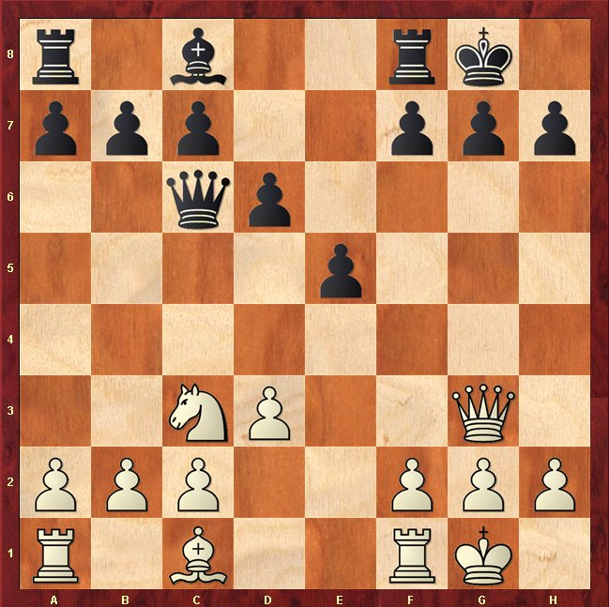
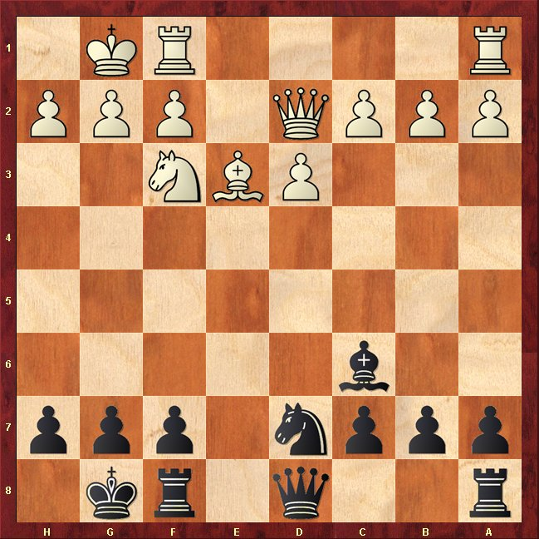
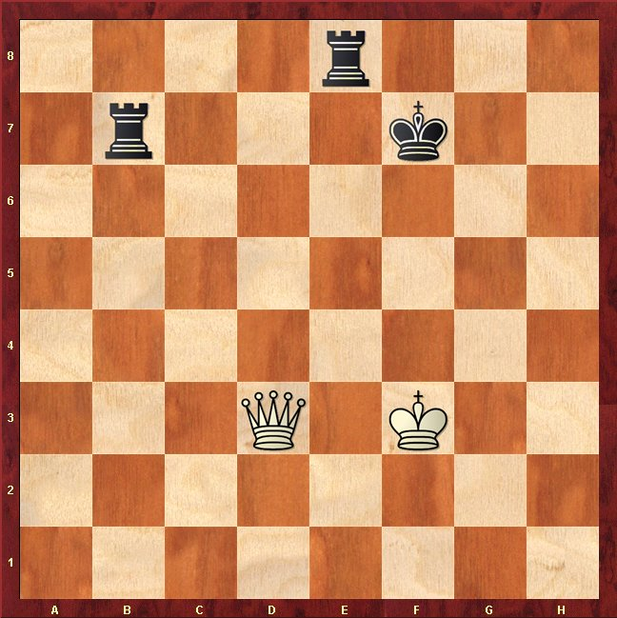
Match the “tactic” with the puzzle … circle the piece to move and where it goes to. The first one is circled, you must match it to the tactic.
a) Piece swap exposes opponents King

b) Knight fork wins Rook

c) Back Rank Mate

d) Trapped piece wins Rook

e) Pinned Pawn Lets Bishop Attack

g) Revealed attack wins Queen
f) Skewer wins Rook

h) Queen Fork wins Rook

i) Chase Away the Defender wins Bishop

Try and work them out … Bring Sheet to Pontins … Prizes for a good attempt ☺

