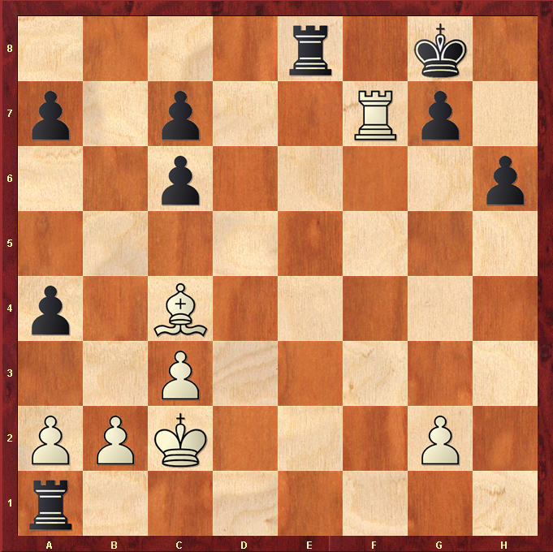
White to play.

Hint : What happens when White Rook moves off f7 ?

