White to play.

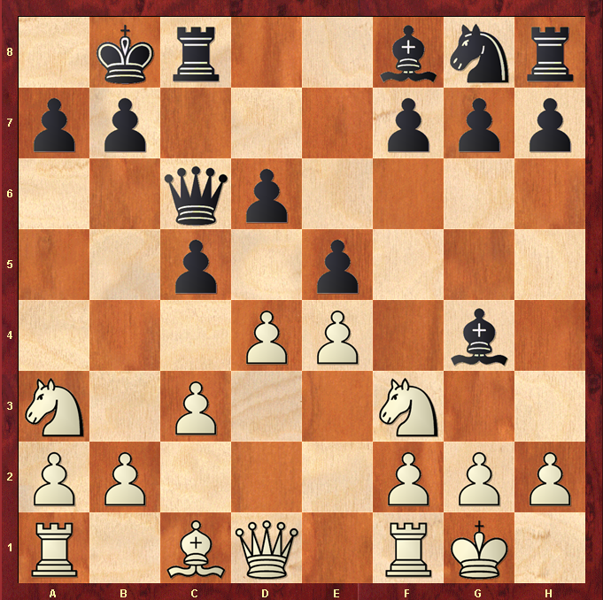

Hint : Break the pin and win a pawn for free …

