White to play.

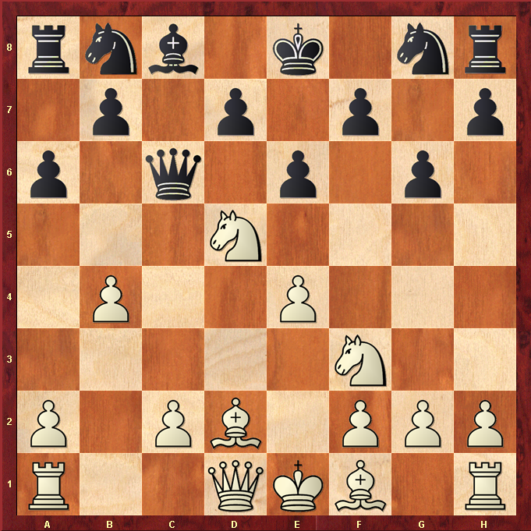

Hint : Knight c7 looks tempting, how to shift the Queen ?

