White to play.
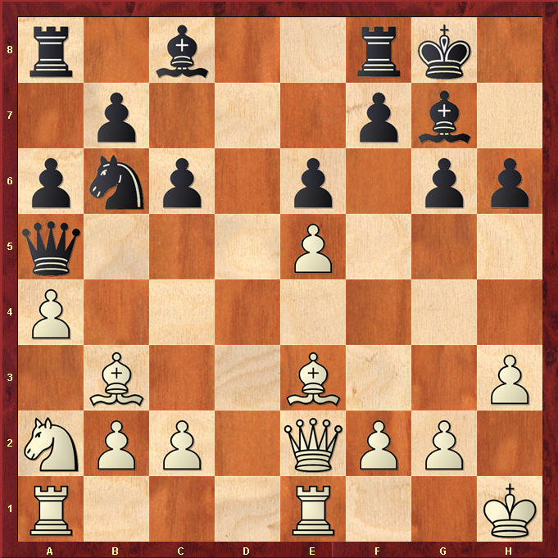

Hint : The Queen is running out of space, can you force her into a tight spot to win a piece?

